Unit 2: HTML5, JQuery and Ajax

## HTML 5 <canvas> Tag

The Canvas API provides a means for drawing graphics via JavaScript and the HTML <canvas> element. It can be used for animation, game graphics, data visualization, photo manipulation, and real-time video processing. Canvas allows you to render graphics powered by JavaScript. Some of the Canvas context methods are following:

|  |  |
| --- | --- |
| **Method** | **Description** |
| fillRect(x, y, width, height) | Draws a filled rectangle |
| strokeRect(x, y, width, height) | Draws a rectangular outline |
| clearRect(x, y, width, height) | Clears the specified rectangular area, making it fully transparent |
| moveTo(x, y) | Moves the pen to the coordinates specified by x and y |
| lineTo(x, y) | Draws a line from the current drawing position to the position specified by x and y |
| arc(x, y, r, sAngle, eAngle, anticlockwise) | Draws an arc centered at (x, y) with radius r starting at sAngle and ending at eAngle going anticlockwise (defaulting to clockwise). |
| arcTo(x1, y1, x2, y2, radius) | Draws an arc with the given control points and radius, connected to the previous point by a straight line |

## CODE:

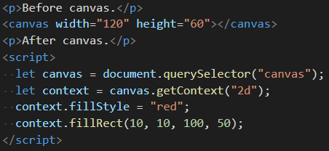

Results:



## HTML <svg>Tag

The svg element is a container that defines a new coordinate system and viewport. It is used as the outermost element of SVG documents, but it can also be used to embed a SVG fragment inside an SVG or HTML document.

The xmlns attribute changes an element (and its children) to a different XML namespace. This namespace, identified by a URL, specifies the dialect that we are currently speaking. The <circle> and <rect> tags, which do not exist in HTML, do have a meaning in SVG—they draw shapes using the style and position specified by their attributes.

These tags create DOM elements, just like HTML tags, that scripts can interact with.

## CODE:

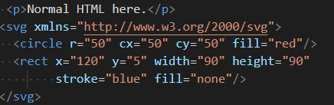

Results:

