Checklist review today:

OOP

* Abstraction
  + abstract class
  + interface
* Encapsulation
  + private variables
  + getter & setter
* Inheritance
  + extends (single class)
  + implements (multiple interfaces)
* Polymorphism
  + override (method of parent class)
  + overload (same name with diff inputs)

Exception

* checked exception
  + IO or Compile time exception
* unchecked exception
  + Runtime or Null Pointers Exception
* Handle Exception
  + try catch (finally)
  + throws
  + throw vs throws
* customize exception
  + user class extends Exception
* handle multiple exceptions
  + catch(E1){}

catch(E2){}…

* + catch(E1|E2|E3…){}

New things learned today:

Iaas, paas, saas

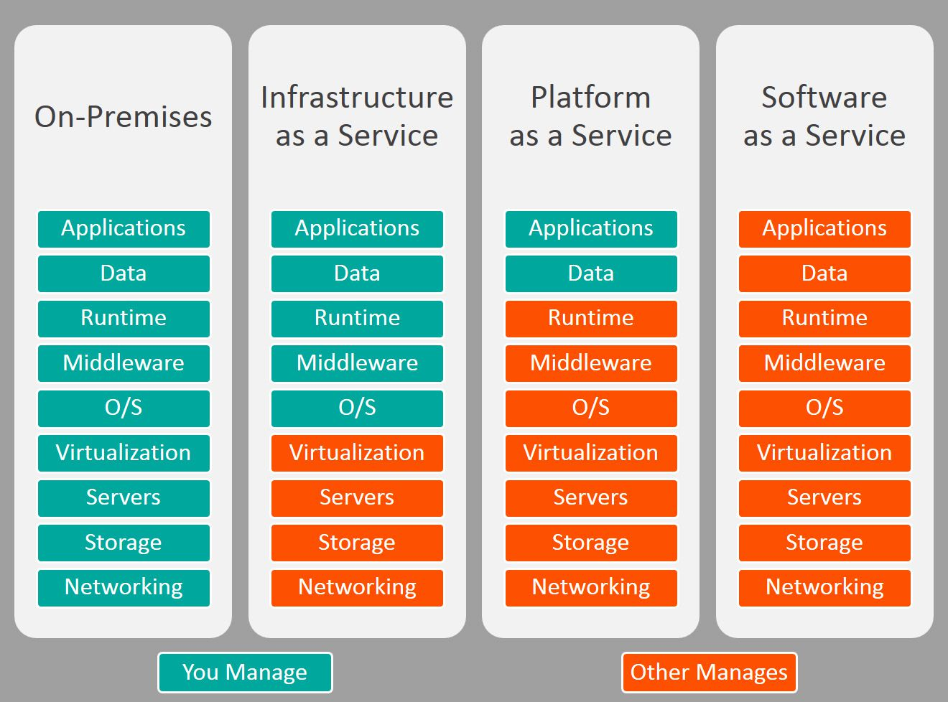

AWS

* EC2
  + iaas
* Lambda
  + saas
* S3
  + buckets(folders) - group files - like HashMap
* RDS
  + database host
* ElastiCache
  + redis
  + Memcached
* VPC
  + public network (defaultVPC) -> private network
* Route 53
  + DNS manage
* API Gateway
* SQS
  + simple queue
* SNS
  + to subscribers
* ECS
  + Elastic Container Service
  + deploy (docker images)

Learned Plan tomorrow:

* + Review Database
    - SQL
      * ACID
    - No-SQL
      * CAP
    - Database Normalization
  + Review mongoDB
    - Mongod
    - Mongos
    - config Server