Checklist review today:

Exception Handling

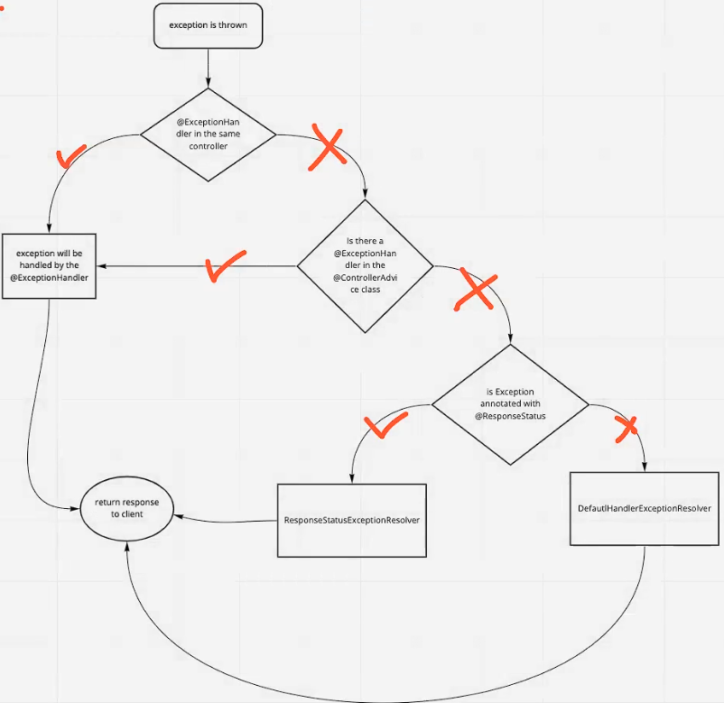

* @ExceptionHandler
  + local
* @ControllerAdvice
  + global
* @ReponseStatus

Validation

* @NotNull, @NotEmpty, @NotBlank, @Min, @Max, @Pattern, @Email …

@Valid, @Validated

Learned Plan tomorrow:

* + Review swagger