Checklist review today:

* open system interconnection model (OSI)
  + 7.application layer
    - human computer interaction layer, where application can access the network services
    - HTTP (Hypertext Transfer Protocol)
    - FTP (File Transfer Protocol)
    - POP (Post Office Protocol)
    - SMTP (Simple Mail Transfer Protocol)
    - DNS (Domain Name System)
  + 6. Presentation Layer,
    - ensure that data is in usable format and is where data encryption occurs
  + 5, Session
    - maintain connection and is for controlling ports and sessions
  + 4, transport
    - transmits data using transmission protocols: TCP, UDP
  + 3, network
    - decides which physical path the data will take
  + 2, data link layer
    - define the format of data on the network
  + 1, physical layer,
    - transmit raw bit stream over physical medium
* TCP/IP
  + application layer
    - correspond to application, presentation, session layer in OSI
  + Transport layer
    - correspond to transport layer in OSI
  + Internet layer
    - correspond to network layer in OSI
  + Network Access Layer
    - correspond to data link and physical layer in OSI

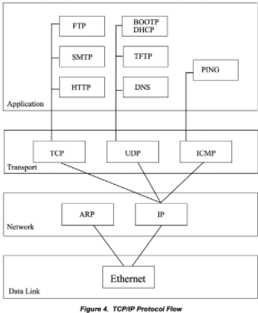

Learned Plan tomorrow:

* + Review HTTP
    - request
    - response
    - status code
    - method