Checklist review today:

Bean Scopes

* singleton
  + Scopes a single bean definition to a single object instance per Spring IoC container.

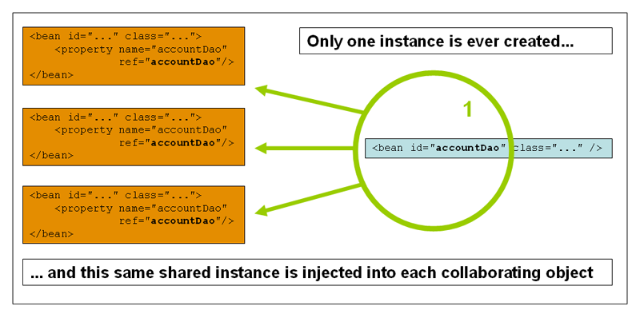

* prototype
  + Scopes a single bean definition to any number of object instances.

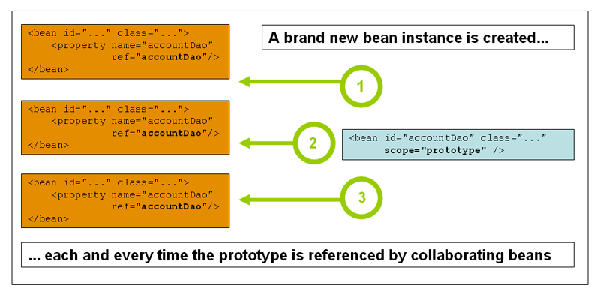

* request
  + Scopes a single bean definition to the lifecycle of a single HTTP request; that is each and every HTTP request will have its own instance of a bean created off the back of a single bean definition.
* session
  + Scopes a single bean definition to the lifecycle of a HTTP Session.
* global session
  + Scopes a single bean definition to the lifecycle of a global HTTP Session

Learned Plan tomorrow:

* + Review Spring AOP