Checklist review today:

* + HTTP request Method

|  |  |  |  |  |
| --- | --- | --- | --- | --- |
| method | safe | idempotent | cacheable | Des |
| get | yes | yes | yes | read/retrieve data from server |
| post | no | no | no | create |
| put | no | yes | no | whole update |
| delete | no | yes | no | remove |
| patch | no | no | no | partial update |

* + - safe:
      * a http method is safe if it doesn’t alter the state of the server
    - idempotent
      * if an identical request is made once or several times, the server will be the same state
    - cacheable
      * private browser cache
      * shared proxy cache (ISP)
* Tomcat
  + bin - startup, shutdown and other scripts and executables
  + common - common classes that catalina and web app can use
  + conf - config file
  + logs - app logs
  + temp - temporary variable and files
  + webapps - contains the web application
  + work - temporary storage
* Servlet

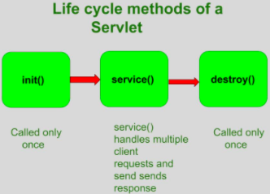

* + the servlet is initialized by calling init() method (once)
  + the servlet calls service() method to process a client’s request
    - main method to perform the actual task
    - doGet(), doPost(), doPut(), doDelete()
  + the servlet is terminated by calling the destroy() method (once)
    - close data connections,
    - stop background threads
    - write cookie lists,
    - other cleanup activities
  + finally, servlet is garbage collected by the garbage collector of the JVM

Learned Plan tomorrow:

* + Review three tier architecture
  + Review MVC
  + Review IOC
    - DI