Checklist review today:

Spring MVC

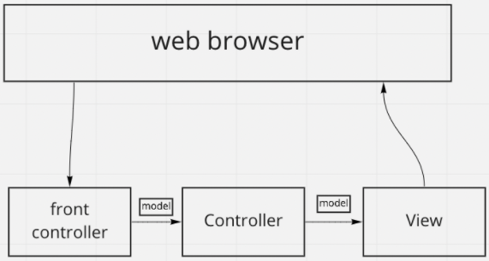

* front controller: in Spring MVC, dispatcher servlet
* controller: business logic of application. @Controller
* View: web pages, JSP
* model: contains the data of the application
* flow

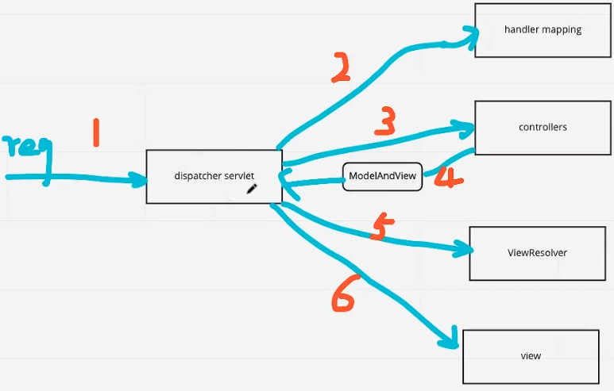

* + all incoming request is intercepted by the dispatcherServlet that work as the front controller
  + the dispatcherServlet gets an entry of handler mapping form the xml file and forwards the request to the controller
  + the controller return an object of ModelAndView
  + the dispatcherServlet checks the entry of the view resolver in xml file and invokes the specified view component.

Learned Plan tomorrow:

* + Review Spring Boot