Checklist review today:

GC (Garbage Collector)

* Execution Engine
* serial GC (single thread)
* parallel GC (multithread, default in JAVA)
* G1 GC (by rank of chunk)
* CMS GC(Concurrent Mark Sweep) G1
  + deprecated since java 9
  + completely removed in java 14

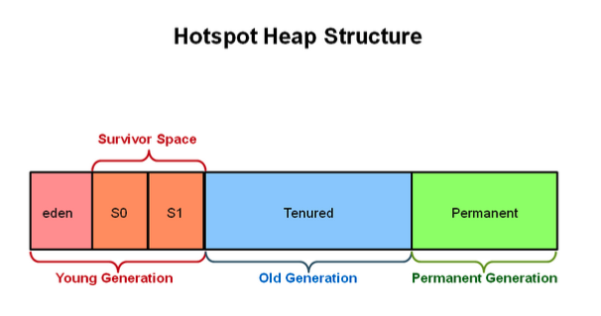

* minorGC -
  + Young Generation
  + more frequently
* majorGC -
  + Old Generation
  + sometimes

OOP

* Abstraction
  + abstract class
  + interface
* Encapsulation
  + private variables
  + getter & setter
* Inheritance
  + extends (single class)
  + implements (multiple interfaces)
* Polymorphism
  + override (method of parent class)
  + overload (same name with diff inputs)

New things learned today:

TCP/UDP

* TCP (Transmission Control Protocol)
  + Functionality
    - break application data into packets that networks can deliver
    - send packets to and accept packets from network layer
    - handle retransmission of dropped or garbled packets, -> error free data transmission
    - acknowledge all packets that arrive
  + Usage
    - secure shell (ssh)
    - FTP (File Transfer Protocol)
    - SMTP (Simple Mail Transfer Protocol),
    - POP, IMAP
    - HTTP
* UDP
  + Functionality
    - possibility of the data loss
    - less delay
    - allows small transaction
    - support bandwidth intensive application that tolerates packets loss
  + Usage
    - Voice Over IP (VoIP)
    - Streaming Video
    - Gaming
* TCP 3-way handshaking
  + SYN
    - client (SYN-SENT) -> server (SYN-RECEVED)
  + SYN-ACK
    - client (ESTABLISHED) <- server (SYN-RECEVED)
  + ACK
    - client (ESTABLISHED) -> server (ESTABLISHED)

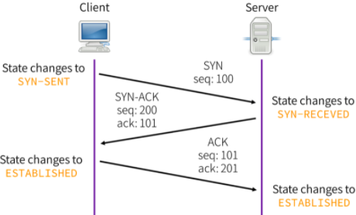

* Java Web Application
  + Tomcat, JBoss, Jetty, Apache TomEE, Oracle Weblogic

WebSpere, WildFly, Apache Geronimo, GlassFish

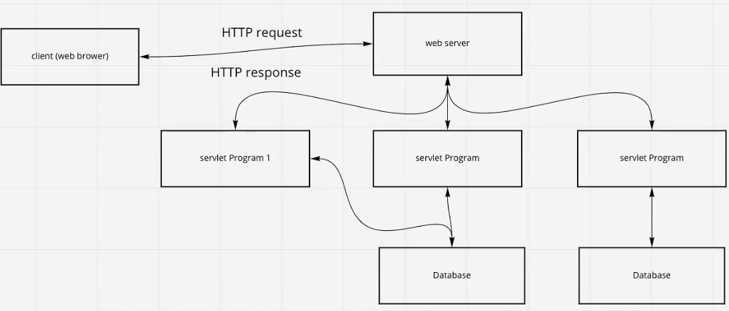

* Tomcat
  + bin - startup, shutdown and other scripts and executables
  + common - common classes that catalina and web app can use
  + conf - config file
  + logs - app logs
  + temp - temporary variable and files
  + webapps - contains the web application
  + work - temporary storage
  + install tomcat on EC2 instance
    - sudo -i
    - yum update
    - yum install tomcat
    - systemctl start tomcat
    - systemctl status tomcat
    - systemctl stop tomcatHTTP request Method
* Servlet

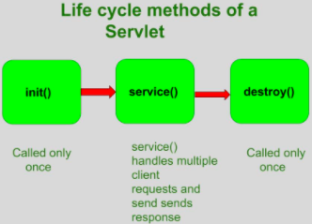

* + the servlet is initialized by calling init() method (once)
  + the servlet calls service() method to process a client’s request
    - main method to perform the actual task
    - doGet(), doPost(), doPut(), doDelete()
  + the servlet is terminated by calling the destroy() method (once)
    - close data connections,
    - stop background threads
    - write cookie lists,
    - other cleanup activities
  + finally, servlet is garbage collected by the garbage collector of the JVM
* Three tier architecture

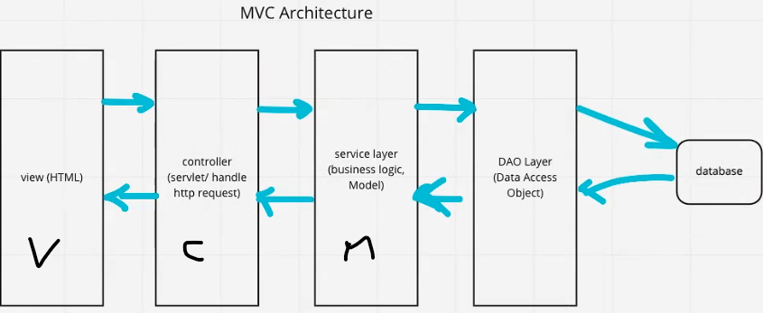

* Session
  + it is an object which provides the implementation of HttpSession interface
  + server side
* Cookie
  + Cookie is a small piece of information sent by server on client memory
  + client side
  + two types
    - session cookie: do not expire, in browser memory. As soon as the web browser is closed, the cookie gets destroyed
    - persistent cookie: have expired time, hard disk

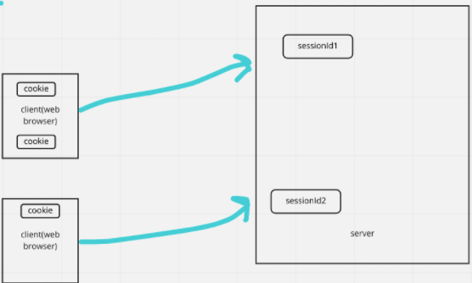

Learned Plan tomorrow:

* Review Database
  + DBMS
  + File system
  + SQL
  + Non-SQL
* Review TCP/IP
  + TCP
  + UDP