Checklist review today:

* DBMS - Database Management System
  + MySQL, SQL Server, …
* SQL - Structured Query Language
  + different DBMS has minor different SQL
* file system and database
  + DBMS
    - manage database
    - advantages:
      * no redundant data
      * efficient query processing
      * more data consistency
      * more security
    - disadvantages
      * higher cost
  + File system
    - manage files in storage medium
    - advantages:
      * less expensive
    - disadvantages:
      * redundant data
      * no efficient query processing
      * less data consistency
      * less security

sql vs no-sql

* sql
  + relational database
  + pre-defined schema
  + vertical scaling
  + ACID
  + not suited for hierarchical data store
* no-sql
  + non-relational database
  + dynamic schema
  + horizontal scaling
  + CAP
  + suited for hierarchical data store

New things learned today:

* Servlet

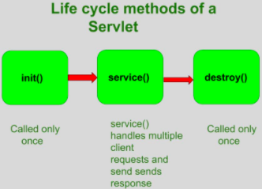

* + the servlet is initialized by calling init() method (once)
  + the servlet calls service() method to process a client’s request
    - main method to perform the actual task
    - doGet(), doPost(), doPut(), doDelete()
  + the servlet is terminated by calling the destroy() method (once)
    - close data connections,
    - stop background threads
    - write cookie lists,
    - other cleanup activities
  + finally, servlet is garbage collected by the garbage collector of the JVM

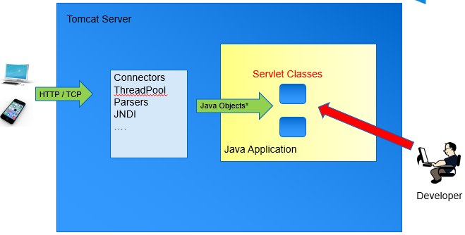

* Three Layer (tier) architecture

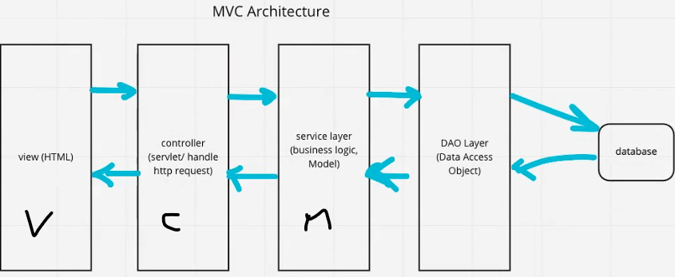

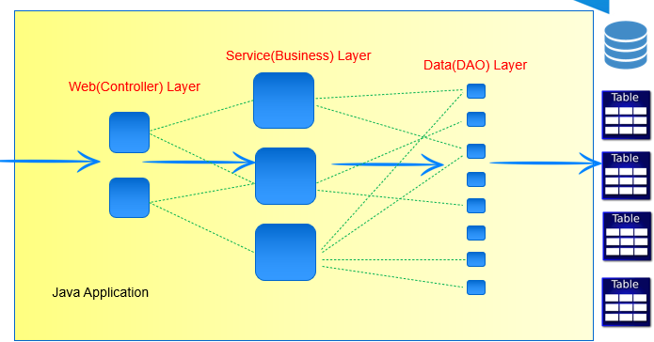

* IOC (Inversion of Control)

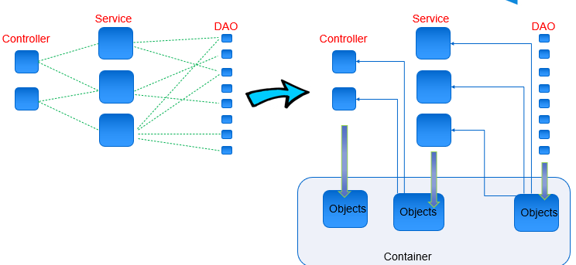

Learned Plan tomorrow:

* Review Database
  + ACID
  + CAP
  + index
* Review IOC
  + Controller
  + Service
  + DAO