Checklist review today:

Java 8 features

* lambda
  + (arguments) -> {body}
  + functional programming
  + less code
* Functional Interface
  + with only one abstract method
  + allow # of default (concrete) method
  + can define by lambda expression in main()
  + Predicate - test(T t), Fuction - apply(T t),

Consumer - accept(T t), Supplier - get()

* Stream API (can define by lambda)
  + intermedia - return a stream
    - map( -> ), filter( -> )...
    - map() // append 03/09/2022
      * applies function to each element
      * single value
      * transformed
    - flatmap() = map() + flatting
      * applies function to each element
      * stream of new values
      * flatten
  + terminal - return nun-stream
    - forEach( -> ), collect( -> )…
* Optional
  + to handle NullPointerExcception
* CompletableFuture
  + Future
    - Interface for return val of Callable<T>
    - Difficult to coordinate multiple futures
  + CompletableFuture
    - new in JAVA 8
    - deal with multiple Future

New things learned today:

Swagger – Documentation

* an open source project used to generate the rest api documents for RESTful services

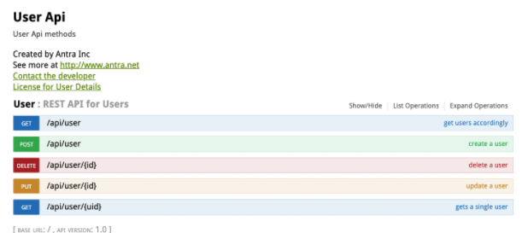

Learned Plan tomorrow:

* + Review IO Stream
    - Byte Stream
    - Character Stream
    - File
  + Serialization and deserialization
    - transient