Checklist review today:

* Lock
  + synchronized
    - block
    - method
    - static method
    - class
  + Lock interface
    - method:
      * lock(), unlock(), newCondition(), tryLock(), lockInterruptibly()
    - implements class:
      * ReentrantLock
  + ReadWriteLock interface
    - method
      * Lock readLock();
      * Lock writeLock();
    - class
      * reentrantReadWriteLock

Garbage Collector

* serial GC (single thread)
* parallel GC (multithread, default in JAVA)
* G1 GC (by rank of chunk)
* CMS GC(Concurrent Mark Sweep) G1
  + deprecated since java 9
  + completely removed in java 14

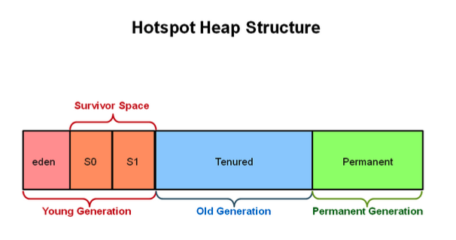

* minorGC -
  + Young Generation
  + more frequently
* majorGC -
  + Old Generation
  + sometimes

New things learned today:

Consumer

* RestTemplate
  + class
  + getForEntity(“url”. String,class),getBody()
* FeignClient (OpenFeignClient)
  + @FeignClient(“name”, “url”)
  + interface (declare)
  + @RequrestMapping(method = RequestMethod.GET)
  + ResponseEntity<String> getAge(@RequestPrama String name);
  + @EnableFeignClient
  + @Autowired

Architecture

* Monolithic Architecture
  + e.g. only three tier architecture
* Distributed Architecture
  + SOA
    - each service can work on their own (independent)
    - ESB
    - lack of scalability
    - for integration
  + Microservices
    - divide a big project to small services
    - # of services work together to achieve a purpose
    - Service Discovery (Eureka)
      * @EnableEurekaServer
    - Client-side LB(load balancer) (Ribbon)
    - Fault Tolerance
    - Api Gateway
    - Tracing / Security
* Spring Cloud Netflix

Learned Plan tomorrow:

* + Review Keywords
    - final
      * final <-> finally
      * immutable class
    - static
    - volatile
  + Review OOP
    - Abstract
    - Encapsulation
    - Inheritance
    - Polymorphism