MemCache -

in-memory cache

multithreading

Redis -

in-memory cache

single threading + multicomplexing

(Single Thread I/O Multiplex)

multicomplex:

- take many threads and share a single connection.

- letting the client library take communication from those threads and intelligently merge it into a single connection.

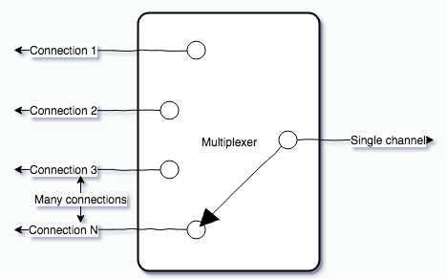

- When using a multiplexer, all commands are pressed into the same connection at all times, so unrelated threads with unrelated Redis commands are sent immediately to the server, no waiting for a connection from the pool to be available or any responses to come back

Amazon ElastiCache -

Amazon ElastiCache is a fully managed in-memory data store and cache service by Amazon Web Services (AWS). The service improves the performance of web applications by retrieving information from managed in-memory caches, instead of relying entirely on slower disk-based databases. ElastiCache supports two open-source in-memory caching engines: Memcached and Redis (also called "ElastiCache for Redis").