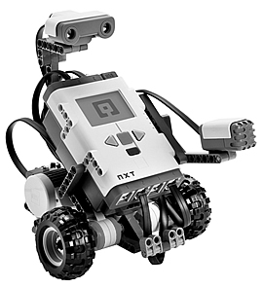FIRST Lego League

The Lego robotics program is designed to get children excited about science, math and technology. Teams design, build and program an autonomous robot (using the LEGO® MINDSTORMS® robot set) to score points on a 4x8 foot playing surface. This year’s challenge also encompasses a student research project around the theme “Into Orbit”.

**Who:** Open to all 6th-8th grade students. We will have multiple teams if we get enough coaches, and there will be 5-8 students on each team. Each team will need to have two coaches, and the coaches do not need to know programming.

**When:** Team meeting day/time/frequency will be dependent on coach arrangement. **Student must be available for the competition.**

**Where:** We will meet at Lake Middle School or other location as determined by coach.

**Cost:** $90 registration fee. Covers the cost of registering the teams with First Lego League and High Tech Kids as well as the set up kit.

For more information, please contact Holly Maudsley at hollymaudsley@yahoo.com

Please complete the bottom portion if you would like to be registered for FIRST Lego League, and return to Lake Middle School, Attn: Chula Albrecht, 3133 Pioneer Drive, Woodbury, MN 55125

Child’s Name: ________________________________ Grade: ______________________

Has child participated with FLL previously? _____________________________________

Parent name:_________________________ Home phone:_______________________

Email:___________________________________________________________________

Are you able to help coach/mentor: __________________________________________

Do you have a Mindstorms Robot or familiarity with programming? _________________