Rev. | Date |  | Description |  |  | Name
A | 20 Aug. 2012  03 Nov. 2013 |  | Initial Document |  |  | Yona Mahler  Chaim Filiba
B | June 2014 |  | Requirements changes according to specification that rose from development.  Added new features: video, CFE, Spectral analysis. |  |  | Dr. Mayera Elizur
C | 18 Jan 2017  11 Oct 2018 |  | Updates for the Initial release version of the CerebraLine |  |  | Anat Dayan
D | 05/01/2021 |  | Adaption doc to release version  Update Product Manager & VP R&D names  It was decided to change the name of the product from CerebraLine System to CerebraLine |  |  | Ben Manoach

CONFIDENTIAL DOCUMENT
The reproduction and distribution of this document is forbidden without written authorization from Mennen medical LTD

Product Manager: Ben Manoach |  |  |  | Date: | Signature:
V.P. R&D: Roman Galibov |  |  |  | Date: | Signature:
Marketing Requirements
CerebraLine
Size |  | Document Number: |  |  |  |  | Rev.
Letter |  | DIC-341-000 |  |  |  |  | D

Table of Contents
1. Introduction 4
1.1 Indications for Use 4
1.2 Use Environment 4
1.3 Target Users 4
1.4 Device type 4
1.5 EMC and Safety 4
1.6 CerebraLine Module description: 4
2. General Hardware 5
2.1 Host Machine: 5
2.2 Printer options (Not for initial release) 5
3. General Software Requirements 5
3.1 Data storage 5
3.2 Administrative data (settings, saved patient list etc.) 5
Access (MDB) or SQLServer Express. 5
3.3 Capacity in terms of days and patients – 5
3.4 Backward compatibility 5
3.5 Startup 6
3.6 Exit to Windows and Shutdown 6
3.7 Antivirus and Firewall 6
3.8 Multi-language support (Not to be implemented in initial release). 6
3.9 Regional Settings support 7
3.10 Watchdog 7
3.11 Recovery from power failure or intentional shutdown 7
3.12 Software Protection 7
4. GUI 8
General Remarks 8
4.1 Font – should support all langeuges. 8
4.2 Borders and title bar of the main windows of the application will be disabled. 8
4.3 Main windows of the application will be stretched to full screen. Sub-panel will be 8
4.4 All elements will be compatible with the chosen operating system. 8
4.5 The size and the shape of elements like buttons, check boxes, list boxes etc. will be 8
4.6 Where applicable, a sound and/or a graphic animation will be associated with element 8
4.7 Application resolution will be 1280x1024 pixels or a dynamic scaling (4/3) – as decided. 8
4.8 The application should support the following touch actions: 8
5. Admit screen 9
5.1 General 9
5.2 Admit screen layout 9
5.3 Wallpaper – Will be Green . 9
5.4 Set your display preferences - Not for initial release 9
5.5 Upper Bar – Right Field 9
5.6 Upper Bar – Left & Middle Field 9
5.7 Lower Bar. 10
5.8 Start Monitoring 10
5.9 Patients 12
5.10 Settings 15
6. aEEG and EEG monitoring screen 21
6.1 General 21
6.2 Screen layout (see next page) 21
7. Vital Signs: Not for Initial Release 34
8. Connectivity to the CritiCool: This option is Canceled 34
9. Video Feature: 35
9.1 General: 35
9.2 The "Live Display" video window 35
9.3 The "Playback Display" video window 36
9.4 Events/Sections 36
9.5 Video Features 36
10. Spectral Analysis – TBD in future versions. 37

Introduction

Indications for Use
The intended use of the CerebraLine is to monitor the state of the brain by acquisition of EEG signals, and display the stored EEG in a compressed form of Amplitude Integrated EEG - aEEG .

Use Environment
The CerebraLine is to be used in hospital. It is not for home care.

Target Users
The United States’ federal law restricts the sale and use of this instrument to qualified medical personnel only. Physicians with expertise in neurology and/or neonatal neurology will be responsible for the operation of the device and the interpretation of the stored EEG and aEEG data.

Device type
A noninvasive, stand alone, monitoring device.

EMC and Safety
Regulatory requirements for safety and electromagnetic compatibility (EMC) must be met.

CerebraLine Module description:
The CerebraLine has the ability to connect 1 reference lead and 4 differential leads (A,B,C, D). The differential leads are calculated from pairs, and should be called: channel 1 (CH1) (A-B for sites C3-P3), channel 2 (CH2) (C-D for C4-P4), and channel 3 (CH3) (B-C for sites P3-P4). The Software should also be able to calculate the cross channel to be called channel 4 (CH4) (A-D for sites C3-C4).

The module should be marked only for the connecting sites: C3, P3, C4, and P4. (F3 & F4 as optional).Therefore the user could choose which sites to connect and to read the results accordingly on the display.
If one channel is connected – either P3-P4 or C3-C4 sites can be connected to the CH1 (or CH2) on the module and the display. Including the Ref electrode.
If 2 channels are connected – use all C-P options, and all three channels CH1,CH2,CH3 will be measured. Including the Ref electrode. In addition, the CH4 will be calculated automatically.

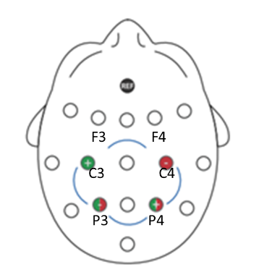

General Hardware

Host Machine:
The host machine will be panel PC with an integrated 19” display.

Printer options
(Not for initial release)
    - Printer – local printer
    - Network printer

General Software Requirements

Data storage
Database or files.

Administrative data (settings, saved patient list etc.)

Access (MDB) or SQLServer Express.
The disk should be divided to 2 partitions: system and application partition and data partition. System partition should be at least 10GB.

Capacity in terms of days and patients –
Single level defined by the maximum monitoring hours that can be stored in the data partition.

Backward compatibility
    - Compatibility with the monitors’ family - CerebraLine should have a unique device ID, unit name, and device name. It is recommended that one of the names should contain a pre-determined prefix to indicate that the monitor is CerebraLine. - Not for Initial Release
    - In a mix environment with Mennen monitors, CerebraLine should communicate with other Mennen devices using Mennen proprietary protocol. Not for initial release
    - A decision should be made regarding automatic acquisition of IP address using the monitors’ protocol. Not for initial release
    - Enguard – Standard Enguard should be able to remote view the CerebraLine. Not to be implemented in initial release.
    - aEEG Viewer should be able to view data that is stored in CerebraLine. – should be implemented in two ways:
3.4.5.1 Built into the system – for saved patients
3.4.5.2 Transferred via USB and/or via a WEB connection as a file/folder that could be shown and analyzed on a separate viewer on PC. Not to be implemented in initial release.
    - A Remote viewer should be available in some way, to be able to review online patients in a remote place. Not for initial version.

Startup
    - As a general rule, CerebraLine should boot up directly to the application.
    - The active corners in Windows 10 should be disabled.
    - Resizing and moving main windows should be disabled.
    - Boot process should be rapid.

Exit to Windows and Shutdown
    - The application should have a password protected option for Exit to Windows.
    - Shutdown and Restart will be executed from within the application. The application will request the user to approve action.

Antivirus and Firewall
    - Antivirus and Firewall – should be defined
    - Exclude all ports that required for the network communication of the CerebraLine.

Multi-language support (Not to be implemented in initial release).
    - The application should support other langueges as well as English. Not to be implemented in initial release.
    - Should have an external utility for the translation process..
    - The default keyboard layout and GUI of the standard installation will be English.
    - The application will include a Language setting.
    - When a user selects a language, the application will execute automatically the following:
      - Change keyboard layout
      - Where applicable, change GUI translation
      - Where applicable, change direction from left to right
      - If required, the application will reboot the machine.
      - Where applicable, use Windows mechanism to handle language change.
      - Initial Languages:
          - English
          - Spanish
          - French
          - Italian
          - German
          - Portuguese
          - Swedish

Regional Settings support
    - The application will include Regional Settings option. This option will be responsible for date and time formats, height, weight.
    - Use Windows mechanism to handle Regional Settings changes.

Watchdog
    - It is recommended to use ready-made watchdog software. This package is a bullet-proof solution against malfunction of hardware and software in a process level.

Recovery from power failure or intentional shutdown
Note: We should bear in mind that as a general rule, Windows based machines are intolerable in case of power failure or abrupt shutdown!
    - The application should maintain a state machine so in case of power failure or abrupt shutdown, the application will return exactly to last state before shutdown.
    - When booting up from power failure or abrupt shutdown, the application should identify that last shutdown was not normal. As a result, the application should initiate procedures to ensure integrity of system, application, and data files.
    - The event should be marked in the patient data file and be visible to the user.
    - The event should be logged in the application’s log file.

Software Protection
A software protection scheme should be applied to prevent reverse engineering and/or system duplication.
In case of an external device (HUB) – should not affect the system work if taken out.

GUI

General Remarks

Font – should support all langeuges.

Borders and title bar of the main windows of the application will be disabled.

Main windows of the application will be stretched to full screen. Sub-panel will be
displayed on top.

All elements will be compatible with the chosen operating system.

The size and the shape of elements like buttons, check boxes, list boxes etc. will be
suitable for use with touch screen. The size of these elements will not be less than
8x8mm.

Where applicable, a sound and/or a graphic animation will be associated with element
when its state changes.

Application resolution will be 1280x1024 pixels or a dynamic scaling (4/3) – as decided.

The application should support the following touch actions:
    - Activation - To select or activate something, touch it.
    - Typing - To type something, such as a name, password, or search terms, just touch where you want to type. An adapted virtual keyboard pops up that lets you type into the field. The keyboard layout will correlate to the setting Language (see section 3.8.5).
    - Touch & hold - Touch & hold an item on the screen by touching it and not lifting your finger until an action occurs.
    - Drag - Touch & hold an item for a moment and then, without lifting your finger, move your finger on the screen until you reach the target position.
    - Swipe or slide - Quickly move your finger across the surface of the screen, without pausing when you first touch (so you don't drag something instead).
    - Double-tap - Tap quickly twice on a webpage, map, or other screen to zoom.
    - Pinch - You can zoom in and out by placing two fingers on the screen at once and pinching them together (to zoom out) or spreading them apart (to zoom in).

Admit screen

General
This screen will be the initial screen and the default screen when CerebraLine will be in discharge mode.
When the application starts the Admit screen is displayed.
The screen should contain three buttons:
Start Monitoring - Open patient registration popup window
Patients - Open Patient List screen
Settings - Open Settings screen

Admit screen layout

Start Monitoring
Patients | Settings

Wallpaper – Will be Green .

Set your display preferences - Not for initial release
The user can define the display settings before connecting the electrodes. Otherwise the system will do it automaticaly according to the connected electrodes.

Upper Bar – Right Field
Device name/number; Unit/Department Name; Room/Bed no'; the area should be active. When the user will touch & hold, the application will open the data panel with the ability to edit.

Upper Bar – Left & Middle Field
As Default will show "Welcome" and when active will show "Monitoring".
Technical alarms – the application should display here any alarm that will prevent monitoring a patient as in the following list. In this case the Start Monitoring Button should be dimmed (not active). The alarm status should be updated online. If there is more than one alarm, then opening the top row down will show all alarms:
      - Module not connected - White on red background – blinking. No audible alarm.
      - Module not responding - White on red background – blinking. No audible alarm.
      - Disk is full - Full means that the space left allow less than 72 hrs of monitoring. White on red background – blinking. Audible alarm. The user will have to free space that will enough for additional 72 hrs in order that the alarm will disappear. An alarm message will be given.

Lower Bar.
This bar will be visible all the times and will include (preliminary):

    - On/Off Button – The user can shutdown the system by pressing the button. A message should appear and ask to confirm.
    - Back icon – will be used to return the focus to the previous level. When the object is root object the Back icon will be changed to a different icon. This button will bring up password protected buttons menu: Exit to Windows, Restart, and Shutdown.
    - Snapshot – when touching this icon, the application will save a snapshot of screen in jpg format. The file name will be as follows: if no patient details where found then date & time. The picture will be stored under the Gallery picture of the specific case.
    - Time –Time in a format that is controlled by Regional Settings.
    - Battery status – indication of the charging status of the battery. The status will be updated online.

Start Monitoring
When the "start monitoring" is pressed, The first step will be to enter the patient details into a window for "Patient details" as follows:
- Last Name, First Name, Middle Name
- Case number
- ID Number
- Date of Birth
- Age (GSA), Apgar score from 1 to 10 (at 0 & 5 minutes)
- Gender
- Height (Lenth), Weight, BMI

With the following options:
- Cancel the patient – Will lead back to the Start/admit screen
- Skip & Start Monitoring Now – Will lead directly to the main monitoring screen.
- Next – Will lead to the connect electrode screen

Note: the patient demographics could be changed through the monitoring session, when it is the current patient that is monitored. Following discharging the patient, the editing option will inabled.

The second step will be to connect the electrodes.

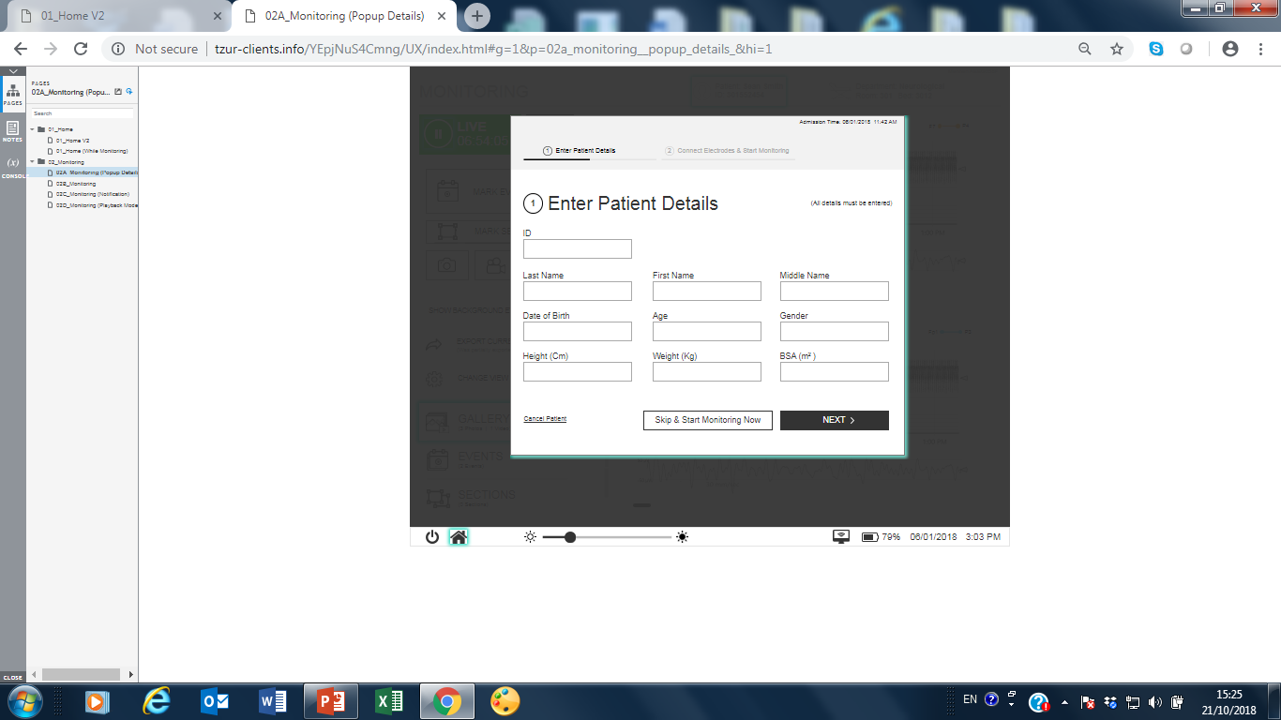

The "Connect Electrodes" Window:
The "connect electrodes" window will open and allow the user to choose the channels that will be connected. The REF electrode must be connected in addition to at least one channel.
The window will show the channels connected and a green V sign will indicate that the channel is connected to the module. If there is no connection between the module and the PC, there wont be an indictication of a V sign. If the ref electrode is not connected, there should be an error message "Connect Ref", and none V signs.
In addition there will be a small spot beside the Ref line to indicate as follows: Green as connected and red as not connected.
The Start Monitoring button will be activated upon electrode connection. The button will remain as deemed until at least one channel was chosen. If ref is not connected, the button
will remain deemed.

The Connected electrodes will be shown on the graphic head. The user can define the sites that are connected and the name of the channels.
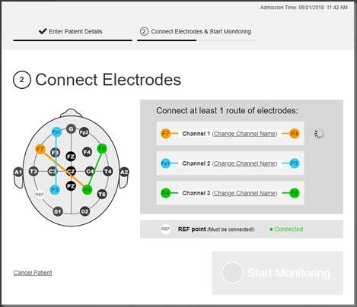

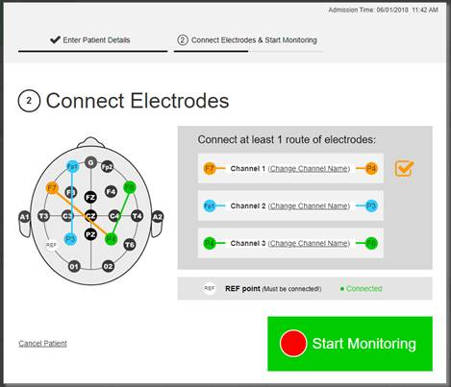

Following the connection of the electrodes, when all channels are confirmed, the user will be able to press on the start monitoring butoon and the system will display the aEEG/EEG main monitoring screen (see section 6)

Patients
Pressing on Patients will open the patient list window. The cabability of the archive will be up to 72hrs space free + 1 week (including video). According to this a number of patients that can be saved would be calculated.
When this limit will exceed, a message will apear saying that in 72hrs the oldest saved patient will be deleted.
Pressing on a patient will open the "built in viewer" shown as a monitoring screen on a playback mode, as follows:

View aEEG –

Action – open the selected patient’s data.
1. The viewer should be built-in the system, so that the user can open the case in between cases. The review of the case should include all screen shots of events and raw data. (as detailed in the Export section)
2. Another option will be to export the case via a USB and/or via other network options so that it could be opened on aEEG Viewer on PC which will be displayed the same as on the system.
3. Another option will be to enable the transport of the screenshots, events summary list and/or aEEG sections by transforming them to PDF.

View Gallery–

Action - open a sub-panel where the user will select the patient’s Screenshots, Events, and/or sections that he wants to view. Including Video.

The selection of the snapshot will be thumbnail based. There will a caption with each thumbnail. The caption will include the file name. The application will be configure to monitor and display the content of a specific folder as active 3x2cm borderless thumbnails. Touching a thumbnail will open a jpg viewer with the selected thumbnail. When closing viewer, the focus will return to the sub-panel. Back will return the focus to the table panel.
The gallery will include the video full disclosure, Events (1 minute backward and 1 minute forward, summary of 2 minutes), Sections and screen shots.

Export – Will open a sub-panel with 2 options: Copy to USB. USB will be available only if the setting Disable USB is unchecked and the export will be directly to the Network option.
Packaging – the package will include the following:
- Patient demographic data – including GSA, weight, date of birth, first name, last name, Patient ID.
- Start and end time stamp
- All relevant EEG channels
- All relevant aEEG channels only as Gray Scale* (including calculated channels).
*The aEEG wave form could not be exported in regular use, but only by Mennen's SW technician.
- All relevant Quality level
- Event list summary and sections list.
- Auto run and the current viewer. Auto run should point to the viewer for automatic activation with data included in the package (not including snapshots). The current viewer should be modified in a way that it will run “out of the box”.
- Video –only event shots (2 minutes)
- Screenshots
- At the end of the "Packaging" process, the system will indicate that the process was successfully done.

Copy to USB
- The application will scan the USB drive to check if an identified USB is inserted.
- If no USB was identified and/or inserted, the user should be notified with the message “Insert USB key”.
- When accepting the message, the USB port should be checked again.
- To cancel operation the user will have to touch the back icon. The focus will return to the selection panel.
- If a USB was inserted, the application will start to copy the above package to the USB key.
- A progress bar with a percentage caption should be displayed.
- In case that the copy ended successfully, the following message should be displayed “Copy success. Disconnect USB Key”.
- In case of failure, display the message “Copy to USB key failed”.
- When accepting messages, the focus will return to table panel.
- An export log should be initiated to allow the reviewer to know if and when the case was exported.

Delete –
The Delete Options popup window should contain the following check boxes:
- Delete all monitoring data and patient record
- or partial delete of:
- Sections
- Screenshots
- Video
- Events

The Delete Options popup window should also contain the Delete button.
When user touches the Delete button the application should delete the selected data and information.
Cancel form this panel should be done by X icon.

Database storage
- The Full disclosure data for each case is limited to about 7 days.
After 6.5 days the application will inform about Monitoring period case about to end alarm. In this situation the user recommended to save and create a new case.
In save and discharge option after 6.5 days it is possible in save and discharge panel to save current patient data and create a new case for current patient with all current patient details and display option. After 6 days + 20 hours the application will save and create a new case automatically.
- If patient id is empty the application will create new patient id with admit time. The format of patient id is “yyyymmdd_hhmmss”. (i.e 20210615_182213 – 15/6/2021 18:22:13)
- When patient will have several cases the cases will be mark with sequence number start with 1.
- The case number will be displayed related to patient id in parenthesis.

- The whole database should be enough to save minimum 100 whole cases (including EEG/aEEG Signals, events video shots and screen shots.

Settings
When the user will touch this button, the settings window will open.
The Settings screen is divided to the following portions:
• On the top the settings type buttons
• On the center the settings definitions panels

Settings options
      - System Setting
      - Display Setting –
        - Video option
        - Vital Signs option – Not for initial release

- Display settings
When the user touches this icon, the following options will pop-up on the right:
- Display Options
- Filter options
- Channel Options
- Video
- Back to default
The selected button should be in a different color that other buttons.
- Display Options:
EEG Display Option
EEG gain – The user will be able to select one of the following: 10, 20,50,70, 100, 200 microvolt/cm. Default – 70.
Sweep speed - The user will be able to select one of the following: 15, 30 mm/Sec. Default – 15.

aEEG Display Option
aEEG Range - The user will be able to select one of the following: 100, 200 microvolt.
Default – 100.
aEEG Colors – The user will be able to select one of the following: Blue on White or White on Black
Default: Blue on White

Show Quality Line - Switch (on/off)
Show Quality Background - Switch (on/off)
- Filter Options:
Filters
Low pass filter – the user will be able to select one of the following: 70, 50, 35, 15 Hz. Default – 70.
High pass filter – the user will to select one of the following: 0.3, 0.5, 1.5 Hz.
Default – 0.5.

- Channel Option:
The name of the four channels and the sites can be also defined by the user.

- Video:
Video panel should contains 3 radio buttons options:
• Video Disable
• Video will not start recording automatically - Default
• Video will automatically start recording when new patient monitoring starts
When the system settings video option disabled only Video Disable option is enabled.

- Default Setting:
The system will have a default configuration for the display settings.
When the user chooses to exit the Display settings, the system will save the new settings until it will be changed again.
On the display setting panel there could be an ability to "Back to Default".
- System Setting
When the user will touch this icon, he will be requested to enter password, the 9 options will appear with a correct password.

General Behavior –
The System Settings panel will be divided to two portions:
- On the left the System Options Buttons
- On the center the System Options definitions portions.

Modify Elements can be done only by user password or Mennen password.

Network – The following options will be available:
- Device Name – Text field: aEEG + last 4 charchters from MAC address. Changing this field is equivalent to changing Windows computer name.
- Unit Name - Text field. 8 characters. Default – Mennen. Changing this field is equivalent to changing Windows workgroup name.
- Device ID – Informational text according to Mennen’s communication protocol.
- Hospital Name – Text field. 25 chars. This field is for local use only and it is not a part of Mennen protocol.
- IP address – This is a read only option. An available IP address will be displayed
- Export path – address + test botton

Sound -
Sound Events – The Sound Options portion should contain the following:
- Silence buttons (sec): 30, 60, 90, 120 and 300
The selected button should be in a different color that other buttons. This definition needs for alarm silence.
  - Sounds List The Sounds List should contain the list of the system sounds. Each item in the list is associated with the sound record.
Each item should contain:
• Sound name
• Sound file name
• Change button
Some items also contain: Repetition duration
The Change Sound Event popup window- should contain the following:
• Sound File drop down list
• Play sound button
• ON / OFF buttons
• Repetition duration buttons (for relevant events only):
10, 20, 30, 40, 50 and 60 seconds.
The selected button should be in a different color that other buttons.
• Save button
• Close (X) button
Video – Video panel will contains the following buttons:
Video Disable
Video Enable – Video Enable is default
Storage – The Storage Information portion should contain the list of local drives
information. Each item in the list associated with one local drive.
Each item should contain the following information:
• Local drive letter
• Total space
• Free space
• Estimated Capacity With Video
• Estimated Capacity Without Video
Regional Settings – The following options should be available:

Language – When selecting this option, a sub-panel will be opened with all the languages that are supported by the application. Selecting a language means changing the GUI language and keyboard layout. The default language should be English (United States). Changing language might require rebooting the device. The user must be notified and accept.

Notch Filter – sub-panel selection between 50Hz and 60Hz.

Measuring units - sub-panel selection between Metric System and Anglo-Saxon System. This setting is responsible for length and weight units.

Date and time –
The Date and Time options portion should contain the following:
- System date and time presentation - Read-only
- Date Format drop down box
- Time Zone drop down box
- Change date and time button
- Use 24-hour format turn on / off switch
- Adjust for daylight saving not supported and should be off in windows 10

The Date Format drop down box should contain the following items:
- MM/DD/YYYY
- DD/MM/YYYY
- YYYY/MM/DD
The Time Zone drop down box should contain the time zone list according the Windows definitions.

Change date and time button- Open Change date and time popup window.

The Change Date and Time popup window should contain the following:
- Month drop down list
- Day drop down list
- Year drop down list
- Hour drop down list
- Minute drop down list
- AM / PM buttons (only if the Use 24-hour format is off)
- Save button
- Close (X) button

When user touches the Save button the application should change the system date and time according selection and close the window.

Notes –
The Notes is predefining notes for mark events and mark section titles.
The Notes Options portion should contain the following:
• Notes List with multi selection option
• Functional buttons
The Notes List should contain the list of the system notes. Each item in the list is associated with the note record.
Each item should contain the followed:
- Selection item (when multi selection is active)
- Note name
- Rename button
- Delete button

When user touch the Rename button the Change Note Name popup window opens.

When user touches the Delete button the related notes will be deleted.

Touch and hold or Right click button on one of note item will open selection box column for all notes at the left side of list. This operation will check the selected item. The last uncheck item on list will hide this column.
The multi selection mode is used only for delete operation.

Rename Note Popup window
The Change Note Name popup window should contain the following:
- Note Name edit field
- Save button
- Close (X) button
When user touches the Save button the application should change the note name according the edit field text and close the window.
The Notes name should limited to 20 characters length.

New Note Popup Window
The New Note popup window should contain the following:
- New note name edit field
- Save button
- Close (X) button
When user click the Save button the application should add a new note to the notes list according the edit field text and close the window.
The Notes name should limited to 20 characters length.

Delete Multiple Notes
The Delete multiple note option is active only if multiple notes are selected. This operation done by delete button.
The number of selected notes will be displayed at the bottom of the screen next to Cancel button.
Press on Cancel button to exit from Multi-selection mode.

Change password –
This portion should contain the ability to change the user password.
The Current password and the new password should be entered.
The minimum characters length is 4 characters.
Mennen Fixed Password: 2334
User Default Password: 4321

About device -
The About Device Information portion should contain the following:
SW version of application
CL module version (FE version)
CL FDS Version
CL video Version

Export log files – Selecting this option will open sub-panel where the user will have to select the log files to be exported and the destination. The selection of the log files will be thumbnails based. The application will be configure to monitor and display the content of a specific folder. The available log files will be displayed as buttons with check boxes. Multi-selection will be possible. The navigation and selection of the destination will be file system based. Upon approval the log files should be packed in zip format and saved on destination.

Export snapshots files - Selecting this option will open sub-panel where the user will have to select: the image files to be exported and the destination. The selection of the image files will be thumbnails based. The application will be configure to monitor and display the content of a specific folder as active 3x2cm borderless thumbnails with check boxes. Multi-selection will be possible. The navigation and selection of the destination will be file system based. Upon approval the image files should be packed in zip format and saved on destination.

Table fields: Admission date & time, Patient ID, Patient’s first name, Patient surname, Total monitoring hours, No. of events, Total space (MB), Exported y/n. all fields are information only.
Panel size – according to no. of patients till full screen minus top and bottom bars. In this case the table will be scrollable (slide up & down). Titles will remain visible at all times.
Table features – Sort, Grouping, Field Order, Search
Sort - Can be sorted by each field (ascending and descending). Default sort - date and time (descending). There should be an indication regarding main sort field and order.
Grouping - Can be grouped by identical data (for Example: same date).
Field Order - Dynamic fields order.
VSearch – Simple search - Every field is searchable. Advanced search – combination of fields. Using characters * and ? is allowed.
Actions for each line – 3D buttons - View aEEG, View snapshots, Export, Delete
- System Options
Video On/Off- available if the Video option is enabled in System setup

aEEG and EEG monitoring screen

General
This screen will be displayed after the user touches the Start Monitoring from the connect electrodes screen. The acquisition of data will start immediately.

Screen layout (see next page)
    - General
      - Top and bottom bars will remain visible at all times. Touching back will reveal the Start monitoring screen.
      - Background of working area – White
      - Additional Panels will be vertical, covering the Main Menu area. Movement – from bottom up till covering completely Main Menu area. Sliding items up and down will be possible. Movement – from top down.
      - Each panel/object not included in the root layout, will have a timeout. Recommended timeout:

Playback to Live mode: 5 min of inactivity.

Panels: 1 min of inactivity.

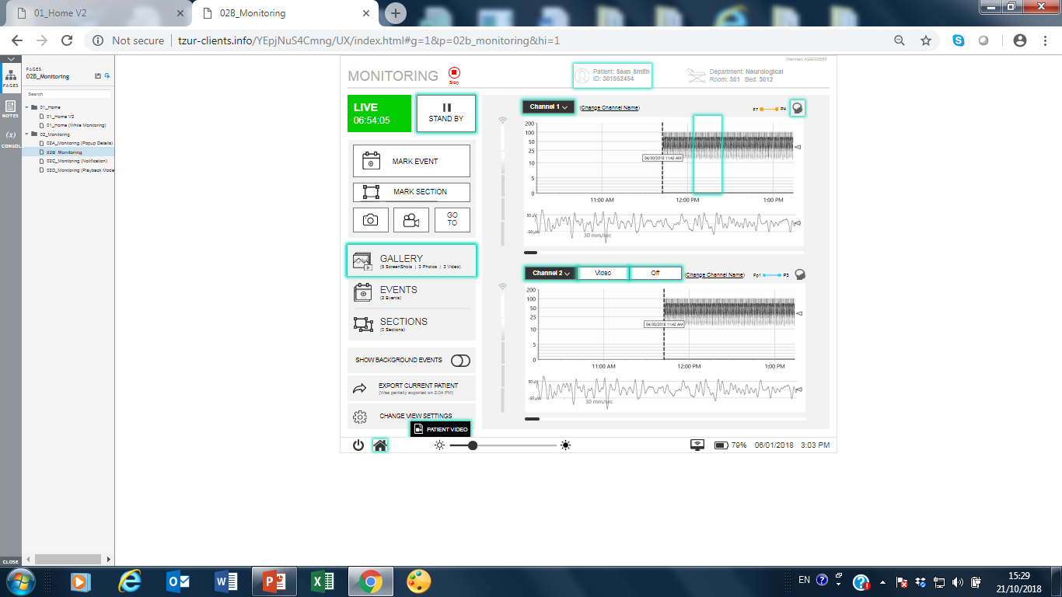

    - Top bar – each section should have a unique color scheme.
      - System Status: Monitoring
      - Department name and Device name – information only. Values cannot be changed in this screen. See section 5.5.4 For more details.
      - Patient name + ID

Default state – empty.

Action – touch.

Result – display Patient admission panel.

Patient details field – Will open a wide window with All patient details: Patient ID, SurName, First Name, Middle Name, Date of Birth, Sex, Doctor Name, Height, Weight. Fields length and type – same as in the monitors. Note: first 3 fields are mandatory in case that the user wants to save patient data in save patient list. Virtual keyboard will be field type sensitive (date, numeric, text). An additional Edit button should enable to change and save the patient details.

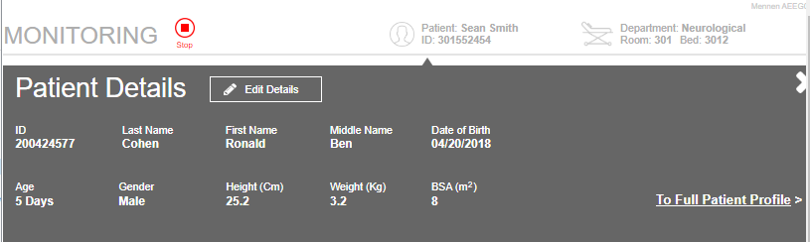

Panel buttons –Save – save data and returns the focus to main screen. Changes will be reflected automatically in the label. X – exit without save, a confirmation button will appear when trying to exit without saving the data

Panel messages – After saving data, subsequent changes to patient data will generate warning ("Save Changes?") message. Only after accepting the message the user will be able to change data. In any case monitoring data will be continuous.
    - Technical alarms – for details see section 5.5.5 In addition, new alarms:

Low quality – alarm will be displayed if quality is low for 3 consecutive min. the alarm will indicate the faulting channel.

Lead fault – Message will be displayed if any of the leads of the specific displayed channels are disconnected and an Audible Alarm will be sounded.

The Alarms will be shown with a red Background, as follows -
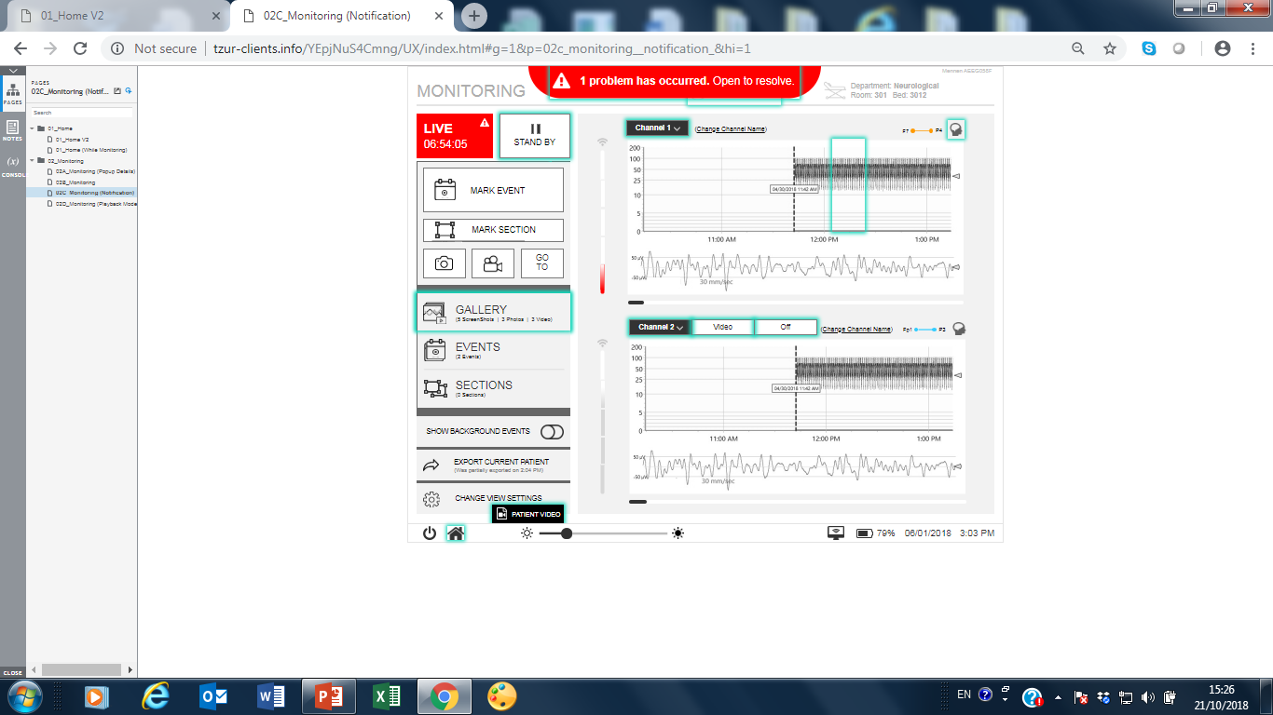

When pressing on the red area the alarm message will be larger with a detailed message, as follows –
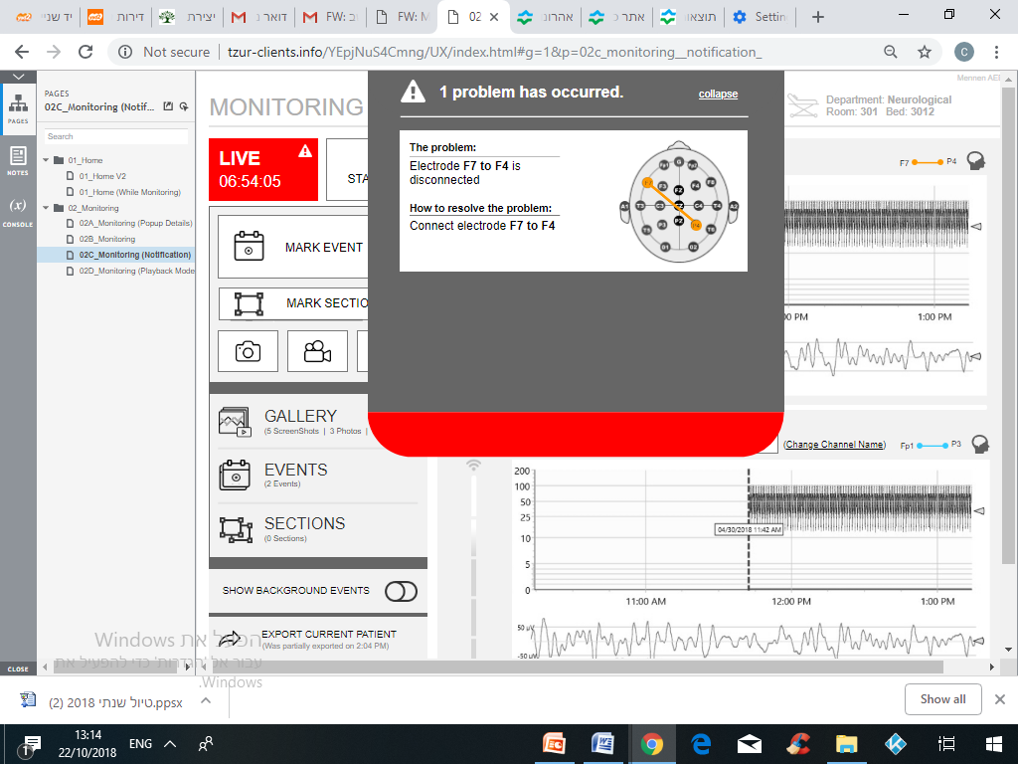

Alarm Sounds

State | wav file ** | Repetition | Control | Message | User control | System Setting
Each Touch action - Ping | Vladislav | Each touch | On / Off |  | On / Off
Save & Discharge, Transfer to USB – At end of transfer (same for both) | C1old.wav | Once | Always |  | Master alarm  volume
Change of panel : Real time / History | C3.wav | Once | Always |  | Master alarm  volume
Standby – Repetitive sound | C3.wav | Default: 20 sec | Silence  Default  120 sec |  | - Silence  - Master alarm  volume | Repetition: sec  10,20,30,40,50,60  Silence : sec  30, 60, 90, 120, 300
Lead XX fault, *) | T2.wav | Default: 20 sec | Silence  Default  120 sec | Lead XX fault | - Silence  - Master alarm  volume | Repetition: sec  10,20,30,40,50,60  Silence : sec  30, 60, 90, 120, 300
Channel XX *  Low Quality | T2.wav | Default: 20 sec | Silence  Default  120 sec | Channel XX low quality | - Silence  - Master alarm  volume | Repetition: sec  10,20,30,40,50,60  Silence : sec  30, 60, 90, 120, 300
No CerebraLine | dong.wav | Once |  | CerebraLine not connected
CerebraLine not responding | dong.wav | Once |  | CerebraLine No comm
Memory full - less that 72 hrs of monitoring. | dong.wav | Default: 20 sec | Silence  Default  120 sec | Memory full | - Silence  - Master alarm  volume | Repetition: sec  10,20,30,40,50,60  Silence : sec  30, 60, 90, 120, 300
Battery is near empty – power is less than 14%. | dong.wav | Default: 20 sec | Silence  Default  120 sec | Battery Low | - Silence  - Master alarm  volume | Repetition: sec  10,20,30,40,50,60  Silence : sec  30, 60, 90, 120, 300
Clinical Alarms – Family of sounds for future application | TBD
To insert Video Alarms!!

* Display both near the channel waveform, and in the general Technical alarm area.
** In the code allow to replace *.wav prior to device release for marketing

Alarm colors
Note that we have decided in Mennen not to follow exactly the standard
Alarm messages : White font on Red background
Black font on Yellow background
Black on Cyan

 | Priority | Color  Standard | Mennen Color | Flashing frequency
C1 | High - Clinical | Red flashing | Red flashing | 0,4 Hz to 2,8 Hz 20 % to 60 % on
C2 | Medium - Clinical | Yellow | Red flashing | 0,4 Hz to 0,8 Hz 20 % to 60 % on
C3 | low - Clinical | Yellow constant | Yellow | 0,4 Hz to 0,8 Hz 20 % to 60 % on
C4 | Very low - clinical |  | Yellow constant
T | Technical | Cyan | Cyan

    - Bottom bar – from left to right. Left side – icon based buttons. Right side – information only. No actions.

Stop monitoring button – bring up 5 buttons menu: Save & Discharge, Discharge and delete, Restart, Shutdown, Exit to Windows.

Save & Discharge – All patient data will be moved to saved patient data area. Patient details will be written to saved patients’ table (see section 5.6). Focus will return to Admit screen. A progress bar (percentage completed) should be displayed during the process. Must have at least one patient’s identification.

Discharge – discard all patient data. Focus will return to Admit screen. A warning message should be displayed regarding discarding all patient data. The user must accept before procedure continues.

Restart, Shutdown, and Exit to Windows – 3 password protected options. In this case when the device boot again, it will return to the monitoring screen.
      - Snapshot button – Print screen and save file in jpg format.
      - Silence – silence the alarms for 15 min. Default – audible alarms. Touching the button will silence the alarms, add red X to the icon on the button. Touch the button again or after 15 min will cause the alarms to be audible again, return the icon to its default state and cancel the message in the operational messages area.
    - Working area – The working area include the waveforms area and the Menu area.

      - Waveform area – Each channel is comprised from 2 curves: aEEG + EEG:
The name of the Channel could be edited. Default will show: Channel 1 (CH1) for C3-P3, Channel 2 (CH2) for C4-P4, Channel 3 (CH3) for P3-P4, and Channel 4 (CH4).
By Push and Hold on the Title of the channel:
- The channels should be named as default: channel 1,2,3,4
- The user should be able to Rename the channel from a pre-defined list. Build lists for channels 1 & 2: Left, Right and Frontal, Central, Parietal, occipital and for channels 3 & 4: Cross Frontal, Cross Central, Cross Parietal, Cross Occipital.
- The user should be able to change the displayed channel. If he chooses a channel that is already displayed, an error should be shown.
- Once the channels were renamed, the system should save the names with the case details, so that after save & Discharge – the names will be shown as configured also on the viewer.
- If the process of renaming is done the second time – the user should have the ability to save the new name from the changing time point. (This is for users that would like to change the position of the electrodes in the same case.
- Add a picture of the connected leads that have compiled the channel displayed. Something like this (example only) :

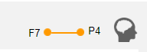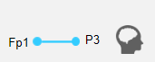

It should be very small.
The user can turn off/hide this display.

      - Wave forms display Dimensions
- Length - 60mm per hour (aEEG). Display only full hours. Minimum – 3 hours. Recommended – 4 hours (240mm). 240mm is equivalent to 16sec of EEG at sweep speed of 15mm/sec and 8sec at sweep speed of 30mm/sec.
- Height – aEEG – 50mm. EEG – 40mm.

      - Position
- Horizontal - +10mm from screen right border. 10mm for channel label (vertical scripting).
There should be the ability to show up to 3 channels on one screen:
Each with 3 hours panel.
- 1 channel vertical - ±45mm from the middle of the working area.
- 2 channels vertical – upper channel - ±45mm from the middle of the upper half of the working area. Lower channel - ±45mm from the middle of the lower half of the working area.

Toolbars – adjust toolbars position in accordance to channels position.

      - Scale – Color – light grey. Lines should be drawn on top of the aEEG or EEG graph.
- aEEG Vertical Lines – Every 30 and 10 min.
- aEEG Horizontal lines
- Linear part of aEEG semi-logarithmic scale should be between 0 and 10 μVolt. The horizontal lines should represent 1, 2, 3, 4 ,5, 10 μVolt
- When the full range of aEEG is set to 100 μVolt (100% of panel hight), draw additional horizontal lines that divide the logarithmic part of aEEG semi-logarithmic scale between 10 and 100 as follows: 10 (50%), 25 (70%), 50(80%), and 100 (100%) μVolt.
- When the full range of aEEG is set to 200 μVolt (100% of panel hight), draw additional horizontal lines that divide the logarithmic part of aEEG semi-logarithmic scale between 10 and 100 as follows: 10 (50%), 50 (74%), 100 (87%), and 200 (100%) μVolt.
- Scale vlaues should be on both sides of the aEEG box.
- EEG vertical lines –
- EEG horizontal lines - top and bottom of the scale.

      - Time indication
- 1 or 2 channel display – under the waveform
- 3 channels display- under the waveform (Not in initial release)
- Indications – 1st bar: current time, current time minus 3h, cursor time (playback mode). 2nd bar: position of the aEEG display slice relatively to the whole monitoring time span.
3rd Bar – Indication for the position of the EEG display relatively to the aEEG.

      - aEEG grayscale drawing (Live activated)

Direction – push from right to left.

Animation – drawing needle (same as in Natus CFM) on right border + 1mm.

aEEG grayscale - 1mm represents 1 minute. The aEEG resolution will be four (4) lines per mm, or 15 seconds per line. CerebraLine will send for every point, Gray scale by merging the information collected during the 15 seconds of aEEG.

Quality – draw Quality line in the selected quality color. Quality = 0 (good) on the lower limit of the aEEG box. Quality = 5 (bad or fault) at 43mm. Note: do not show quality scale or values. Alternatively, (per user choice), use line with blending colors from green (good quality) to bright orange and red (bad quality). The line will indicate the quality at cursor position. Line size – 5mm on 50mm.
The quality line will show the quality number as in the following table:
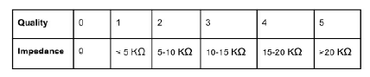
At the upper right of the aEEG scale there should be a Marker that when the mouse is pressed the quality scale menu is shown – with it numbers and colors.

CerebraLine technical alarms (Lead fault etc.) – when detecting technical alarm, leave drawing area empty on light yellow background. Set automatically “{technical alarm} start” and “{technical alarm} end” markers at the borders of this section.

Standby on/off – when setting Standby to on, leave drawing area empty on light yellow background till the user set the Standby mode to off. Set automatically “Standby start” and “Standby end” markers at the borders of this section.

Quality level 4-5 – when detecting low quality level, use light pink as the background color for the section. Foreground – grayscale.

Cursor –
- Vertical (Time): width – one min of EEG trace. Color – grey. Position – right most (now time).
Can be activated and/or changed with a touch

      - EEG drawing (Live activated)

Direction – sweep from right to left.

Animation – drawing needle (same as in Natus CFM) on right border + 1mm.

EEG curve - 1mm aEEG represents 1 minute EEG. The aEEG resolution will be four (4) lines per mm, or 15 seconds per line. CerebraLine will send for every point, Gray scale by merging the information collected during the 15 seconds of aEEG.

Color scheme – Defaults or as selected by user

CerebraLine technical alarms (Lead fault etc.) – when detecting technical alarm, leave drawing area empty on light yellow background.

Standby on/off – when setting Standby to on, leave drawing area empty on light yellow background till the user set the Standby mode to off.

Quality level 4-5 – when detecting low quality level, use light pink as the background color for the section. Foreground – black.

      - Playback Mode – General

Activation - the following actions will activate playback mode automatically:
      - Slide graph to the left or to the right
      - Mark Event
      - Mark Section – by positioning the curser on a time point the section will automatically select the 3 hours retroactive
When selecting a section – an automatic snapshot should be taken
      - Go to – if not using the slide graph - TBD in future versions
      - Standby mode is on – like a "disconnecting" mode in the monitors
      - Touching one of the movement buttons on the bottom of the screen
      - Through Patient case list – when there is no data acquisition.

Return to Live - the following actions will return Live mode automatically:
      - Change mode to Live by touching Live button.

Indications
      - The inscription on the Live button will change to Playback. Colors – White on bright red.
      - Default message “Playback mode” in the operational messages area.
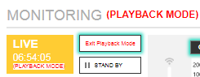

Built-in functions
      - Slow slide (drag) – finger doesn’t leave touch. Trace movement follows finger movement.
      - Fast slide – finger leaves touch on every move. Trace movement speed is relative to the speed of the finger movement.
      - Quick touch – in fast slide mode: stop sliding.
      - Touch and hold – position the cursor under the finger. Show ±8sec EEG relative to cursor position.
      - Fine cursor positioning – drag the cursor handle to the requested position. Cursor blinks during operation. EEG moves in parallel.

Toolbar buttons – white on purple
EEG cursor position. Touch to scroll the EEG cursor backward or forward in the EEG tracing in 1-second increments
Scroll about 1 second! Touch to scroll the EEG tracing backward or forward in approximately 1-hour increments.
Scroll to the beginning/end of case. Touch to scroll the EEG tracing backward or forward to the beginning or to the end of the case
Notes: Time bars will be updated in real time.
aEEG trace moves in parallel.
Toolbar title – EEG controls

    - Main Menu area – Icon based 3D buttons menu. Items:
The Menu include the following: this area is made from the following parts:
      - Modes (Start/End/Pause)
      - Actions menu (Section, Mark Event, go to, video, snapshot)
      - Gallery Menu (screenshots) - click to review the saved screenshots
      - Events – click to review the saved Events
      - Sections – click to review saved sections
      - Show background quality (on/off switch botton)
      - Export current patient - TBD in future versions
      - Settings
      - Video view box

      - Modes
- Live/Start – Live shows current monitoring data (data acquisition is on)
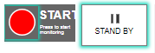
- Standby/Pause - data acquisition is off.
- Playback – for current and/or saved patients - viewing historical data. For current case – the application still continues to collect new data (data acquisition is on). At the end of playback, application returns to Live.
For a saved patient – available only on a Non-monitoring state.

- When a technical alarm message is on and there is no signal and/or low quality signal – the Live will turn to red.

      - Mark event
Marker layout - Marker will appear in the same position on all channels even if the channel is not currently displayed. Marker will be displayed only on the aEEG trace. Line type: broken line. Color: bright green. Width: 1 minute/column.

Process:

Touch mark event button, will bring the Event Name pannel on the left side of the screen

A marker will appear on all displayed aEEG traces (on the right side of the box).

The marker will have a handle for fine positioning - TBD in future versions

Event name box allow to select a prest name or to manually enter a name

While moving the marker, the marker will blink.

Save and Cancel buttons will be placed on the bottom of the panel

Touching SAVE buttons will save the marker in the event list. The panel will scroll down automatically to reveal the Main Menu.

Upon the insertion of an Event, the name of the Event will appear both on the aEEG display and in the Event list.

A colored whole line (from the bottom to the top of the scale) should mark specifically the time of the Event.

There should be an ability to configure the event list. This should be enabled even when monitoring. In addition previous inserted manual events should be automatically inserted into the event list.

      - Save Section
Section layout - Section will appear in the same position on all channels even if the channel is not currently display. Section will be displayed only on the aEEG trace. Borders type: whole line. Border Color: Black. Border Width: 1 column. Section area background color: Blue
Process:
      - Touch Mark Section button.
      - Automatically the system will select the whole active screen and color the background with the section color. User should insert a name for the section (manual and/or from the event list)
      - Upon saving the section, the system will create a screenshot for the section and save it under the section name.
      - There should be a print button so that the user will press in order to print (if a printer is connected) and/or to automatically send it to the patient medical record through the network. Or this should be automatically done upon saving the section - TBD in future versions
      - The section should be timed stamped by "start time" and "end time" according to the time.
      - Each time the user presses "Save Section" the area of 3 hours previous to the time point will be saved as a Section,
      - Touching Save Section button will bring up the Event Names panel. The panel will cover the Main Menu area. The panel will be button based and scrollable. Operational messages area: “Select section name”. Touching one of the buttons will save the section in the Sections list. The panel will scroll down automatically to reveal the Main Menu. Clear Operational messages area.
      - There should be an Event & Section list for each case so that the user can go to he event/section time point and review. This should be enabled in real time and/or when unconnected to a patient.

      - Gallery – Touching this button will open a thumbnail based panel with all the snapshots available. The user will be able to view, select, delete selected, Export Selected, show on graph. Back will return the focus to the monitoring screen.

      - Events – Events list - touching this icon will open events list panel. Touching back will return the focus to the monitoring screen.
      - each event on the list will have Event start date & time, Event Name, Event end date & time,.
      - Panel size – cover the left side menu
      - Actions for each line –Delete or Rename
  - Delete – action – delete the event
  - Rename– Will open a pop up widow and allow to select a name from the list or key in a new name
      - Sections – Sections list – The same as the Events list
      - Show Background quality – to show the quality as the background for the grayscale.
      - Change view settings – Will open the Settings panel
      - Standby on/off – start / stop data acquisition. Default – start. This is a toggle button. When standby is set to off, Live button inscription will set to standby. Colors – white on bright dark green, blinking. Live button will be disable. Standby on will return the system to Live mode.

Vital Signs: Not for Initial Release
A System option should be available for connecting a CFE or Vitalogik to the Panel PC. This will enable the Physician to operate the aEEG Parameters easily on the Panel PC but to also see the parameters on the Monitor simulatnously with the other Vital signs. This can help the physician for the intrepretation of the aEEG data.

The CFE/VitaLogik option should enable to display Vital signs- numeric values of: NIBP, Saturation, Apnea events, HR, RR.

7.2 All monitoring data should be integrated into the Viewer – to be shown in real time and when not connected.

7.3 An interface to other monitors and/or WEB based data collectors for inccorporating the Vital signs - numeric values into the Panel PC 7,2,1 – same as 7.1.1

Connectivity to the CritiCool: This option is Canceled
The system could be connected to the Criticool/CritiCool mini
8.1 the Panel PC will display the Cooling details – as VS – integrated into each time point.

Video Feature:

General:
A Video camera should be attached to the Panel PC to enable filming the Patient during the session of aEEG recording.
The Video should be shown on part of the Main Screen. At the left side panel.
    - The option should be turned ON/OFF thruogh the Settings of the Panel PC - password protected.
The Main Screen should be adaptable to the video configuration -including Video or not-including video. Users who did not purchase the video option should still have a nice Main Screen ( and not an empty area where the video should have been).
    - The option will include the software and a USB camera. Should be tested for safety and cyber security etc.
    - The camera application will be rolled through the CerbreLine GUI software.
    - The Video application will include two panels: The "Live Display" and the "Playback Display".
    - When the system displays 2 channels, the video could be shown on the lower part of the screen, instead of the channel. This could be manualy chosen by the user.
    - The time system will be according UTC (enrolled also on the monitoring application), and not as local time. That will be for attending time changes at Summer/Winter times.

The "Live Display" video window
    - The panel will be located on the left side of the display
    - The video should be automaticly aligned to the patient case, controlled through the EEG monitioring, and to the same time zone (UTC).
    - The control will be the same as for the case: PAUSE/START (ADMIT)/ DISCHARGE.
Following the ADMIT (START) there will be an option to PAUSE and RESUME the video, in accordance to the actual EEG monitoring.
In DISCHARGE there is no reference to any patient/case.
    - The video full disclosure collecting time will be minimum 24 hours and maximum of 1 week – in parallel to the EEG collection data.
    - In DISCHARGE the system should save as much data as possible – Full Diasclosure and/or EVENTS. This should be decided according to the computer capacity.
EVENTS – should be at least 1 minute before and after the time point that the event was marked.
Therefore, the user should mark events before DISCHARGE.
In the case of only EVENTS saving, there should be an ability to export the Full disclosure to an external device, such as a USB etc.

The "Playback Display" video window
    - Should play the playback of the full disclosure/EVENTS of the monitored case. Could be controlled by Play/Stop/Pause keys, and/or jump to the specific time point. This should be in parallel to the EEG monitoring history display.
    - The playback should be played in parallel to the EEG history display, and turned on automaticly when the user turn the GUI to history.
    - The Playback should enable a whole full disclosure display and/or only events. The events should be up to 2 minutes (1 minute before and after the event had been marked).
    - The palyback display will be in parallel to the history EEG view. Therefore, time areas that were not recorded will be shown as a black screen.
    - Upon playback while monitoring, the live window will remain open on the side of the screen – to enable the user to verify the recording.

Events/Sections
    - The events will be marked according to the EEG/aEEG and/or the video at Live and/or during the playback.
    - When pressing on an existing event the screen will go automaticly to the playback screen to the axact time point and display the specific event – as EEG/aEEG and video.
The curser on the EEG/aEEG waveforms should show the time point through the event. The grascale will be moving and the curser will always remain in its place.
    - When an Event is marked, a 60 seconds video before and after the event time point will be recorded will be saved.
    - When choosing a section, the system will automaticely save the recorded video under the section, which will enable the user to see the video while following the monitored section.
    - The section recorded video (only the 2 minutes event video during the section) could be saved upon discharge.

Video Features
    - The video recording should be enough to see Babyies movements and if possible hand or lip tremors.
    - An option for a still picture capture – to be seen through the gallery.
    - Zoom in/out - Not for initial release.
    - A message should alert the user when there is no more room for storage of video events/sections.
    - Upon Saving and discharge the system will save only events and sections.
    - On Discharge, when openeing a patient case, there should be an ability to save and/or delete video sections for that specific petient. Therefoe, the export of a patient should alow (or not) the export of the video. In addition, Deleting a patient will delet all video as well.

Spectral Analysis – TBD in future versions.

