WiFiDeck
User Guide · functions, monitor mode, testing & resources
A complete tour of WiFiDeck: what every function does, how to test it, what to expect, a deep take on monitor mode, and curated learning resources so you can go deeper on the Wi-Fi security concepts underneath.
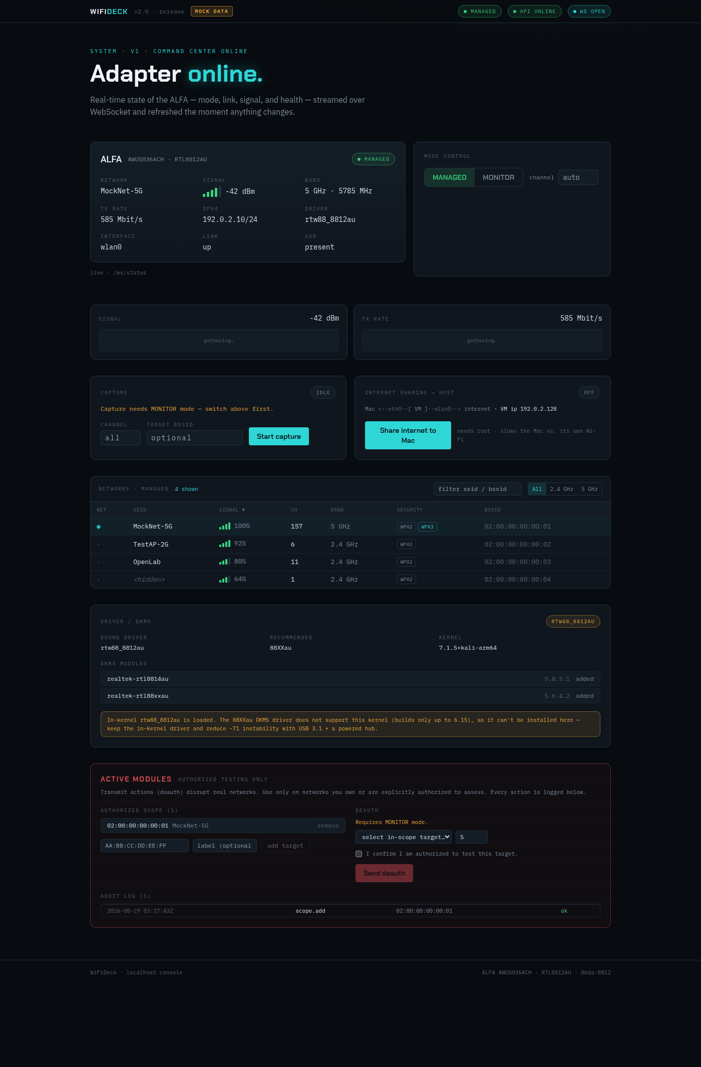
The WiFiDeck dashboard — live adapter state, scan, capture, crack, defense.
LEGAL FIRST. Everything offensive here (monitor capture, deauth, handshake/PMKID cracking) is legal ONLY on networks you own or have written permission to test. In Canada see Criminal Code s. 342.1 (unauthorized use of a computer) and s. 430(1.1) (mischief to computer data). Use your own lab AP.

1. What WiFiDeck is
A local, browser-based command center for a USB Wi-Fi adapter (the ALFA AWUS036ACH / RTL8812AU, and similar). It shows live adapter state, scans for networks, captures WPA handshakes / PMKIDs, verifies and cracks them against a wordlist, and runs authorization-gated active tests — all from one dark, real-time dashboard that talks to a small FastAPI backend over WebSockets.
It runs on two platforms from one codebase — it detects the OS and adapts:
 | macOS (native, primary) | Linux (VM or bare metal)
RF backend | libusb driver (rtl8812au-macos) | kernel driver + nl80211 / iw / airodump
Managed mode (join networks) | No (not possible) | Yes
Monitor RX (sniff frames) | Yes (2.4 + 5 GHz) | Yes (with a working driver)
Raw injection (deauth) | Yes (primitive proven) | Yes
"Scan" | brief monitor capture -> beacons | managed nmcli OR monitor airodump
Root needed? | No (runs as your user) | Yes (mode/capture/deauth/share)

macOS forbids third-party Wi-Fi kexts on Apple Silicon, so a userspace libusb driver can't be a system Wi-Fi interface — hence no managed mode. On Linux, monitor RX needs a driver that truly delivers frames: the in-tree rtw88 advertises monitor for the RTL8812AU but delivers no RX — use the aircrack rtl8812au DKMS driver on a kernel <= 6.15.

2. The core concept: MANAGED vs MONITOR mode
This is the single most important idea in the whole tool.
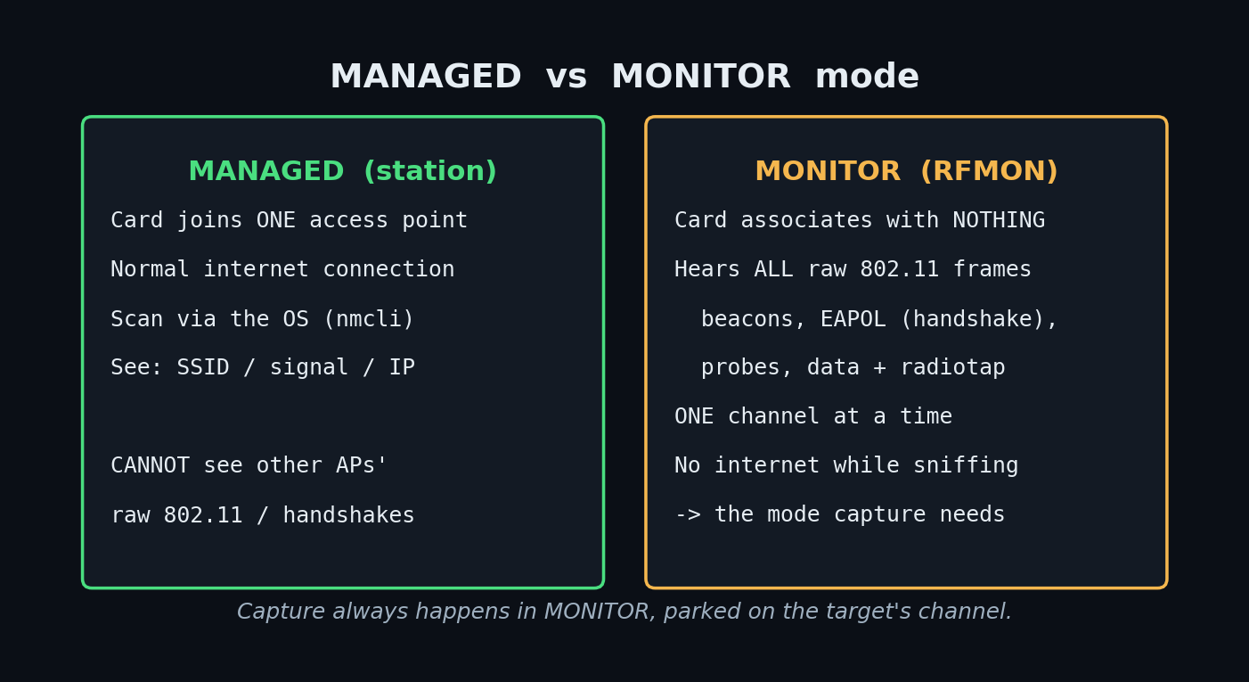

Managed mode (station / client)
The normal way a Wi-Fi card works. The card associates with one access point, follows its channel, and the OS handles encryption, so you get a normal internet connection. You can join/leave networks, scan by asking the OS (nmcli on Linux), and see your link's SSID / signal / IP / TX-rate. What you CANNOT do: see other people's raw 802.11 frames — the card only hands the OS the decrypted traffic for the network it joined, so handshakes and management frames are filtered out.

Monitor mode (RFMON / promiscuous 802.11)
The card stops associating and reports every raw 802.11 frame it hears on the channel it's parked on — beacons, probes, association and authentication/EAPOL (handshake) frames, data frames, from ALL nearby APs and clients, each wrapped in a radiotap header (channel, signal, rates). This is the mode that makes sniffing and capture possible. Trade-offs: no internet while in monitor; you only hear one channel at a time (a capture on ch 6 will not see an AP on ch 44 — set the card to the target's channel); and on this adapter monitor can't enumerate SSIDs by name the way managed does.

How WiFiDeck bridges the gap
- Linux: the instant you switch MANAGED -> MONITOR, the backend first runs one fresh managed scan and snapshots it. That remembered list (each entry keeps its channel) fills the deauth/capture pickers while you're in monitor. A scan failure never blocks the switch.
- macOS: no managed mode to snapshot, so the Scan (monitor) panel does a brief (~5 s) capture on a channel, parses the beacons it heard, and fills the Target picker.
Practical model: managed = "what network am I on?"; monitor = "what frames can I hear on this one channel?". Capture always happens in monitor, on the target's channel.

How to test the mode switch (Linux, real hardware)
1. Run WIFIDECK_SUDO=1 ./wifideck and open the dashboard.
2. Adapter status shows MANAGED. Scan -> you see the network list.
3. Click MONITOR in Mode Control. Expect a brief transition, then status shows MONITOR, the top-rail mode pill turns amber, and the Target picker is populated from the snapshot taken a second earlier.
4. Click MANAGED to switch back; the network list refreshes live again.
A second switch requested mid-transition returns HTTP 409 (busy) by design — the state machine serializes switches so the radio can't be corrupted. On macOS there is no MANAGED/MONITOR toggle (the UI hides it because the radio reports managed:false); use the Scan (monitor) panel instead.

3. Every function — how to test, what to expect
Fastest way to explore ALL of them with no hardware is mock mode:
WIFIDECK_MOCK=1 ./wifideck # MOCK DATA badge; every panel has fixtures
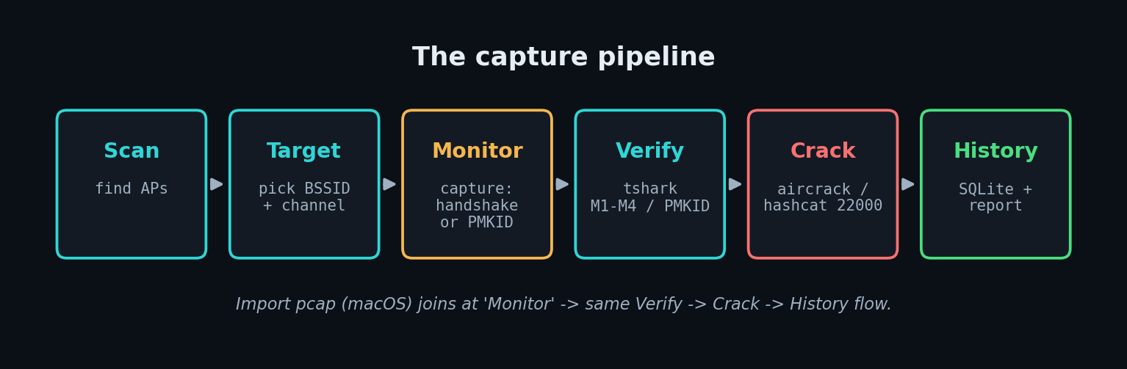
The capture pipeline, end to end.

3.1 Adapter Status
Endpoint: GET /api/status · WS /ws/status
What: Live USB presence, driver, interface, mode, link state, SSID, IP, signal (dBm), TX-rate, and a health verdict (OK / DISCONNECTED / DEGRADED, incl. the -71 dBm weak-signal flag).
How to test: Just open the app; unplug the adapter (Linux).
What to expect: The card updates the instant anything changes (streamed, not polled); the banner flips to ADAPTER DISCONNECTED within a beat.

3.2 Mode Control
Endpoint: POST /api/mode
What: The MANAGED <-> MONITOR switch (Linux). Hidden on monitor-only radios (macOS).
How to test: See section 2.
What to expect: See section 2.

3.3 Scan / Network Table
Endpoint: WS /ws/scan · POST /api/scan/once
What: The list of networks — managed nmcli, monitor airodump (Linux), or the macOS beacon-scan. Columns: SSID, signal, CH, band, security, BSSID; sort, filter, filter by band.
How to test: Scan near any AP.
What to expect: For an enterprise SSID you'll see the same name on several rows — normal (multiple APs + multi-BSSID virtual APs); each row is a distinct BSSID+channel you can target. The security column classifies WPA2 / WPA3 / WPA3-transition / OWE / OPEN / 802.1X.

3.4 Posture (security classification)
What: Flags what each network's security means for capture — WPA2-PSK is offline-crackable if you catch a handshake; WPA3-SAE is NOT; WPA3-transition can often be downgraded to WPA2; OWE/OPEN have no PSK to crack.
How to test: Look at the SECURITY chips.
What to expect: Color-coded tone + a one-line 'what this means' note on the selected target.

3.5 Target selector
What: Pick the network once; the choice (BSSID + channel) is shared by deauth and guided capture, so you don't re-select per function.
How to test: Pick a row.
What to expect: Confirmation chips (SSID · ch · band · security · BSSID). If empty in monitor: 'switch to MANAGED once to scan, then come back.'

3.6 Connect
Endpoint: POST /api/connect
What: (Linux, managed) click an SSID to join/leave; NetworkManager stores the password.
How to test: Connect to your own AP.
What to expect: Status shows the SSID + an IP; a Disconnect button on the active row.

3.7 Capture
Endpoint: POST /api/capture · WS /ws/capture
What: The heart of it. Handshake mode runs airodump-ng locked to the target channel and waits for a client's 4-way handshake (EAPOL M1-M4) — pair with a deauth to force a reconnect. PMKID mode runs hcxdumptool to solicit a PMKID straight from the AP — no client needed.
How to test: Switch to MONITOR (Linux) -> set the target's channel -> start a handshake capture -> briefly deauth a phone on that AP -> watch frames climb. Or start PMKID and wait.
What to expect: A live session with a frame counter and, on success, HANDSHAKE ✓ or PMKID ✓ and an exportable .pcap. Mock mode fabricates a session so you can see the whole flow.

3.8 Import pcap
Endpoint: POST /api/capture/import
What: Adopt a pcap captured elsewhere (e.g. the macOS capture.py -o out.pcap) as a capture session — copied in, scanned for handshake/PMKID, recorded to history — so it flows through verify -> crack -> report. This is the macOS capture bridge.
How to test: Capture a pcap on macOS, paste its path (+ optional BSSID), Import.
What to expect: 'imported — handshake: yes/no', and a new History row.

3.9 Verify
What: tshark confirms a capture actually contains a complete 4-way handshake (M1-M4) or a PMKID BEFORE you waste time cracking.
How to test: Import/capture, then verify.
What to expect: An explicit M1-M4 / PMKID readout; a partial handshake is flagged as not crackable.

3.10 Cracking
Endpoint: POST /api/crack · WS /ws/crack
What: Run aircrack-ng or hashcat (mode 22000, the modern WPA format) against a wordlist. Scope-gated, live progress.
How to test: Point it at a wordlist (e.g. a tiny list containing your lab AP's known password) and your captured handshake.
What to expect: Live progress and, on success, the recovered key; the outcome is written to History.
Note: Cracking only recovers weak/guessable passphrases from a wordlist — it is NOT a magic WPA2 break, and it does NOT work on WPA3-SAE.

3.11 Active — Deauth
Endpoint: POST /api/active/deauth
What: Send 802.11 deauthentication frames to knock a client off so it reconnects and you catch its handshake. OFF by default; arm with WIFIDECK_SUDO=1 WIFIDECK_ENABLE_ACTIVE=1 ./wifideck.
How to test: Pick your target, confirm once.
What to expect: Every action is audited (who/when/what BSSID) and requires an explicit confirm.
Note: Deauth is a WPA2 technique; 802.11w / PMF (mandatory in WPA3) protects management frames, so deauth is rejected — which is exactly why WPA3 matters.

3.12 Guided flow
Endpoint: POST /api/flow
What: One gated workflow chaining it end to end: monitor -> capture -> (deauth) -> handshake -> export, with a step tracker.
How to test: Pick a target, start the flow.
What to expect: Each step lights up as it completes; the flow stops on the first failure and says why.

3.13 Stations
Endpoint: GET /api/stations
What: Clients (stations) seen associated to APs during a monitor scan — tells you which AP actually has clients worth deauthing.
How to test: Monitor-scan near an active AP.
What to expect: A client list with the BSSID each is talking to.

3.14 Watchdog
Endpoint: WS /ws/watchdog
What: Auto-recovers the ALFA's -71/USB-drop wedges (driver reload -> USB reset -> reconnect).
How to test: Enable it, then induce a drop.
What to expect: An events timeline showing the recovery steps.

3.15 WIDS-lite (defense)
Endpoint: WS /ws/wids
What: The defensive side — detects evil-twin APs (same SSID, new BSSID) and deauth floods, with an alerts timeline. Set a baseline of 'known good' first.
How to test: Baseline, then run a deauth from another device.
What to expect: A deauth-flood alert. Great for learning what an attack looks like from the defender's chair.

3.16 Anomaly · Metrics · Share · History · Report · Schedule · Integrations
- Anomaly — flags odd signal/behaviour patterns.
- Metrics — signal & TX-rate sparklines over time.
- Share (Linux) — NAT the adapter's uplink to your host, with copyable route/DNS commands.
- History (SQLite) — past capture sessions + crack outcomes, persisted across restarts. Test: import a pcap, restart the backend, reopen — the row is still there.
- Report — an HTML summary of your sessions/findings.
- Schedule — run captures/scans on a timer.
- Integrations — webhook / ntfy / Slack notifications; the panel has a Send test button.

4. Testing playbooks

4.1 Zero-hardware tour (any OS, 2 minutes)
WIFIDECK_MOCK=1 ./wifideck
Click through every panel. A MOCK DATA badge is shown; nothing touches real radios. Best way to learn the UI and the capture->verify->crack->history flow.

4.2 Live recon on macOS (your own AP)
- Set up the libusb driver once (see MACOS-SETUP).
- ./wifideck -> top rail shows macOS; Radio Doctor shows the libusb backend.
- Scan (monitor) on your AP's channel -> APs fill the Target picker.
- Capture with capture.py -o out.pcap on your channel -> Import pcap -> Verify -> Crack (against a wordlist you control).

4.3 Live recon on Linux (your own AP)
- Working DKMS driver on a kernel <= 6.15 (see HARDWARE).
- WIFIDECK_SUDO=1 WIFIDECK_ENABLE_ACTIVE=1 ./wifideck.
- Scan (managed) -> pick your AP as Target -> switch MONITOR (channel remembered) -> Capture (handshake) -> Deauth your own phone once -> handshake ✓ -> Verify -> Crack.

4.4 What success and failure look like
- Good capture: frame counter climbs; HANDSHAKE ✓ / PMKID ✓; pcap exportable; History row.
- No handshake: counter climbs but no ✓ — usually wrong channel, no client on that AP, or PMF blocking deauth. Fix the channel first.
- Crack 'not found': the passphrase isn't in your wordlist (expected for strong passwords), or the network is WPA3-SAE (not offline-crackable).

5. The honest truth: WPA2 vs WPA3
WPA2-PSK: capture a 4-way handshake (or a PMKID) -> run a dictionary/brute-force attack OFFLINE. You're only limited by how guessable the password is and your GPU. This is what WiFiDeck's capture->crack pipeline does.
WPA3-SAE ("Dragonfly"): replaces the crackable handshake with a zero-knowledge exchange — there is no captured value you can take offline and brute-force. No known practical offline crack of a correctly configured WPA3-SAE network. The real-world attacks are:
- Transition-mode downgrade: many 'WPA3' networks also accept WPA2 for old clients; you attack the WPA2 side. Pure WPA3-only closes this.
- Dragonblood (2019): side-channel/downgrade bugs in early WPA3 implementations — largely patched.
- PMF/802.11w: WPA3 mandates protected management frames, so deauth doesn't work, which breaks the classic handshake-forcing trick.
Takeaway: WPA3 didn't 'get cracked' — it removed the offline-crackable artifact. The lesson is defensive as much as offensive.

6. Additional resources

Books
- Kali Linux Wireless Penetration Testing (Buchanan / Ramachandran, Packt) — hands-on airmon/airodump/aircrack — closest to what WiFiDeck automates.
- The Hacker Playbook 3 (Peter Kim) — practical methodology incl. a Wi-Fi chapter.
- 802.11 Wireless Networks: The Definitive Guide (Matthew Gast, O'Reilly) — the protocol bible: frames, management vs data, the 4-way handshake — read this to truly understand monitor mode.
- Hacking Exposed Wireless (Cache / Wright / Liu) — attacks + defenses across Wi-Fi / Bluetooth.
- CWNA / CWSP Study Guides (Sybex) — vendor-neutral certs; CWNA for RF/802.11 fundamentals, CWSP for security depth.

Videos / channels
- Vivek Ramachandran — WLAN Security Megaprimer — https://www.youtube.com/playlist?list=PLA25FCB53DD770262 — the classic free monitor-mode/aircrack video course.
- David Bombal — Wi-Fi hacking — https://www.youtube.com/@davidbombal — ALFA adapters, hashcat, tool-author interviews; beginner-friendly.
- NetworkChuck — https://www.youtube.com/@NetworkChuck — approachable Wi-Fi / Kali intros.
- Hak5 — https://www.youtube.com/@hak5 — Wi-Fi Pineapple / deauth demos; good for seeing attacks live.
- DEF CON talks — https://www.youtube.com/@DEFCONConference — search 'WPA3', 'Dragonblood', '802.11'.

Websites / docs / tools
- Aircrack-ng wiki — https://www.aircrack-ng.org/doku.php — canonical docs for the tools under the hood.
- hashcat wiki — https://hashcat.net/wiki/ — the WPA/PMKID mode 22000 format and usage.
- hcxdumptool — https://github.com/ZerBea/hcxdumptool — clientless PMKID capture (WiFiDeck's PMKID mode).
- Wireshark — https://www.wireshark.org/ — open a WiFiDeck .pcap, filter 'eapol' to see M1-M4 yourself.
- Wi-Fi Alliance — security — https://www.wi-fi.org/discover-wi-fi/security — official WPA3 overview.
- Dragonblood (Mathy Vanhoef) — https://wpa3.mathyvanhoef.com/ — WPA3 attack research; also read up on KRACK (his WPA2 attack).
- Kali Linux docs — https://www.kali.org/docs/ — drivers, wireless setup.
- aircrack-ng/rtl8812au (DKMS driver) — https://github.com/aircrack-ng/rtl8812au — the Linux driver for this chip.

Safe places to practice (don't touch networks you don't own)
- Your own lab AP — a cheap travel router or spare home router with a known weak passphrase you set is the ideal target.
- Hack The Box / TryHackMe — guided labs (mostly host/web, some wireless theory).
- CTFs — search 'wireless CTF', '802.11 pcap challenge'; practice handshake analysis in Wireshark without transmitting anything.

Concepts worth searching as you go
802.11 frame types · 4-way handshake / EAPOL · PMKID · radiotap header · beacon vs probe · BSSID vs SSID vs ESSID · multi-BSSID / virtual AP · monitor mode / RFMON · channel vs frequency / 2.4 vs 5 GHz · PMF / 802.11w · WPA2-PSK vs WPA3-SAE · hashcat mode 22000 · deauthentication attack · evil twin · KRACK · Dragonblood.

7. Troubleshooting quick hits
- No networks in the Target picker (monitor). Switch to MANAGED once to snapshot a scan (Linux), or use Scan (monitor) (macOS). Confirm you're on the target's channel.
- Handshake never completes. Wrong channel, no client on that AP, or PMF is blocking deauth (WPA3). Try PMKID.
- 'iw: No such file / managed failed' on macOS. Expected — macOS has no managed mode; the toggle is hidden and Scan is monitor-based.
- Adapter 'off the bus' after a capture (macOS). A known post-capture wedge — physically replug the ALFA.
- Crack finds nothing. Password not in the wordlist, or it's WPA3-SAE.

WiFiDeck · localhost console · generated from docs/USER-GUIDE.md

