Safer To Be Me
Nine out of ten attendees rated #SaferToBeMe as “very good” or “excellent”
Eight out of ten rated the event organisation as “very good” or “excellent”
Eight out of ten rated event communication as “very good” or “excellent”

Campaigner training
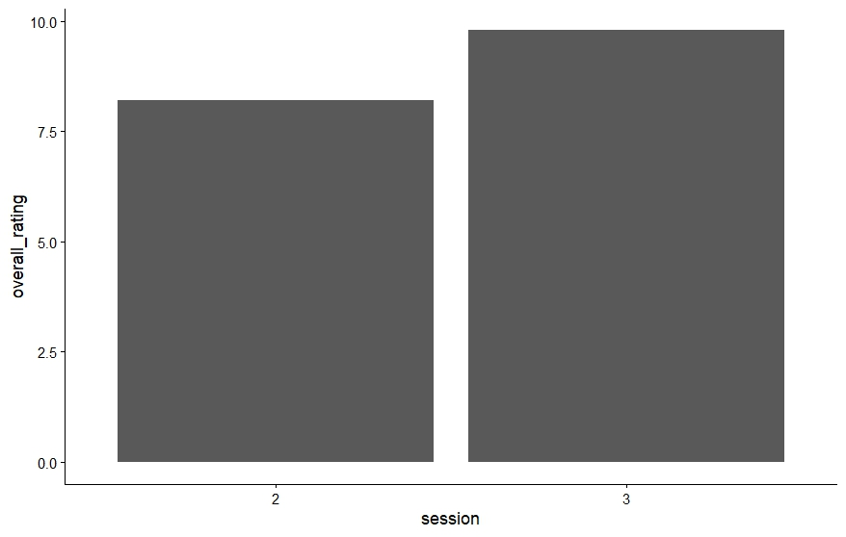
The number of participants who rated the training 10 more than doubled across all measures.

