Name: LEORDAN CARMONA Date: OCTOBER 1,2020

Sched: **_________________**

1. Enumeration

I.a. Give at least 5 advantages and 5 disadvantages of having a database integrated in your system/business.

Advantages:

1. **Increase productivity**
2. **Manage data and information better**
3. **Process more efficiently**
4. **Helps in decision making**
5. **Customer service satisfaction**

Disadvantages:

1. **Big storage**
2. **Increased costs**
3. **Management complexity**
4. **Frequent upgrade/replacement cycles**
5. **Maintaining currency**
6. ERD

II.a. Name every given cardinality (8pts)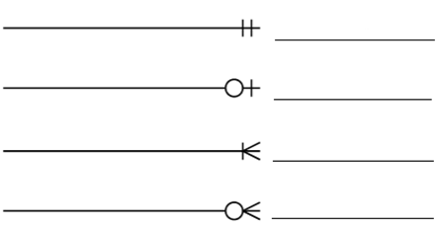

1. **Mandatory one**
2. **Optional one**
3. **Mandatory many**
4. **Optional many**

II.b. Illustrate the ERD. Assuming USC asked you to design a data model for the enrollment module.

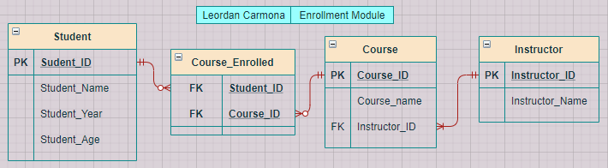

1. Normalization

Normalize the given table. (15 pts)

|  |  |  |  |
| --- | --- | --- | --- |
| Full name | Physical Address | Courses Handled | Masteral Degree |
| Patrick Elalto | Bldg 2, Room 24A, Banawa Residence | SD 205, IT 1102, IT 1101 | MSIT |
| Edrian Guanzon | B1 L1, Mapua St, Lungsod | SD 206, IT 1102 | MSCS |
| Gran Sabandal | Tabunok | SD 206, IT 1101, IT 3102 | MSCS |

2nf

|  |  |  |  |  |  |  |  |  |  |  |  |  |  |  |  |  |  |  |  |  |
| --- | --- | --- | --- | --- | --- | --- | --- | --- | --- | --- | --- | --- | --- | --- | --- | --- | --- | --- | --- | --- |
| |  |  | | --- | --- | | Full Name | Physical Address | | Patrick Elalto | Bldg 2, Room 24A, Banawa Residence | | Edrian Guanzon | B1 L1, Mapua St, Lungsod | | Gran Sabandal | Tabunok |  |  |  |  | | --- | --- | --- | | Full Name | Courses Handled | Masteral Degree | | Patrick Elalto | SD 205, IT 1102, IT 1101 | MSIT | | Edrian Guanzon | SD 206, IT 1102 | MSCS | | Gran Sabandal | SD 206, IT 1101, IT 3102 | MSCS | |

3nf

|  |  |
| --- | --- |
| Full name | Physical Address |
| Patrick Elalto | Bldg 2, Room 24A, Banawa Residence |
| Edrian Guanzon | B1 L1, Mapua St, Lungsod |
| Gran Sabandal | Tabunok |

|  |  |
| --- | --- |
| Full name | Courses Handled |
| Patrick Elalto | SD 205, IT 1102, IT 1101 |
| Edrian Guanzon | SD 206, IT 1102 |
| Gran Sabandal | SD 206, IT 1101, IT 3102 |

|  |  |
| --- | --- |
| Full name | Masteral Degree |
| Patrick Elalto | MSIT |
| Edrian Guanzon | MSCS |
| Gran Sabandal | MSCS |

1. SQL

IV.a. Write the sql queries.

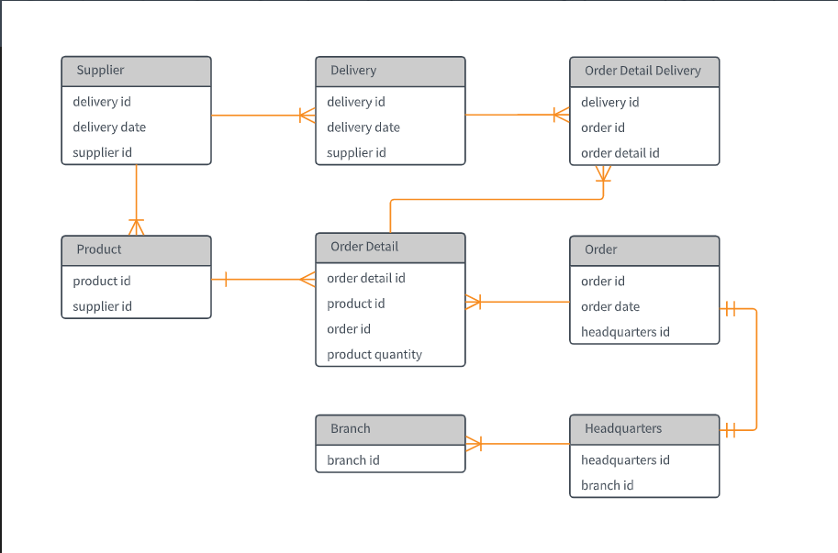

Refer to the diagram given.

1. The buyer bought two different items from different stores. Write the query that will add to the database.

**INSERT INTO Product (ProductName)**

**VALUES (‘item1’),(‘item2’);**

1. Assuming the original date of delivery was moved from 9/11/20 to 9/22/20. Write the query that will change the delivery date. (note: mm/dd/yy)

**UPDATE Delivery  
SET delivery_date = '9/11/20', delivery_date = '9/22/20'  
WHERE delivery_id = 1;**

1. The buyer changed her mind right after she checked out and decided to cancel her order. Write the query that will cancel her order.

**DELETE FROM Order WHERE order_id = 1;**

1. The supplies got delayed. The expected date of arrival was 10/10/20 but due to the delay, it was pushed further a month. Write the sql query that will change the arrival date. (note: mm/dd/yy)

**UPDATE Supplier  
SET delivery_date = '10/10/20', delivery_date = '11/10/20'  
WHERE supplier_id = 1;**

1. Assuming the store owner opened a new branch. Write the sql query that will add another branch in the database.

**INSERT INTO Branch (branchName)**

**VALUES (‘anotherBranch’);**

1. Perform a **left join** query with **Order Detail** and **Order Detail Delivery.**

**SELECT Order_detail.order_detail.id, Order_detail_delivery.delivery_id  
FROM Order_detail  
LEFT JOIN Order_detail_delivery ON Order_detail.orderID = Order_detail_delivery.orderID**

1. Perform an **inner join** query with **Product** and Order **Detail**.

**SELECT Product.ProductID, OrderDetail.OrderDetailID  
FROM Product  
INNER JOIN OrderDetail ON Product.ProductID = OrderDetail.ProductID;**