LEORDAN CARMONA

PN-Student

Instructions: Write the necessary queries on this page, as well as a screenshot of the response of the query on your command line

e.g: Find the number of documents on the database:

db.persons.find().count()

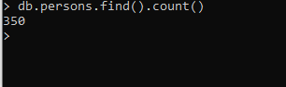

1. Add a document to the Database with the following parameters
   1. Name: yourName
   2. isActive: true
   3. age: yourAge
   4. gender: yourGender
   5. eyeColor: yourEyeColor
   6. favoriteFruit: array of favorite fruits
   7. company :

{title:”PN”

email:”USC email”

phone:”number”

location:

{country:”Philippines”,

Address:”Talamban, Cebu City”

}

}

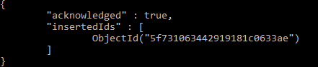

1. Add a document with the same parameters above but this time insert the information of 3 of your classmates with one query

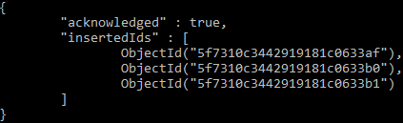

1. Find all the documents with the gender female

db.persons.find({gender:"female"})

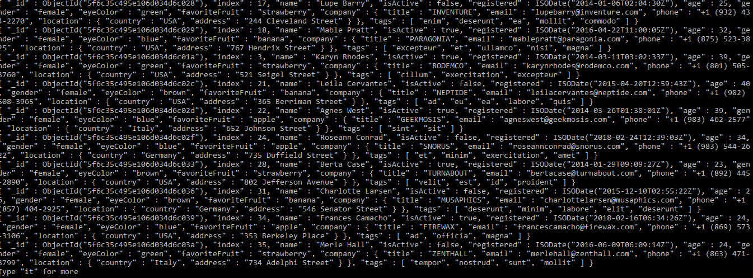

1. Find all the documents with the gender female and an age between 20 to 35

db.persons.find({ $and: [{ gender: "female" }, { age: { $gt:20 ,$lt: 35 }}]})

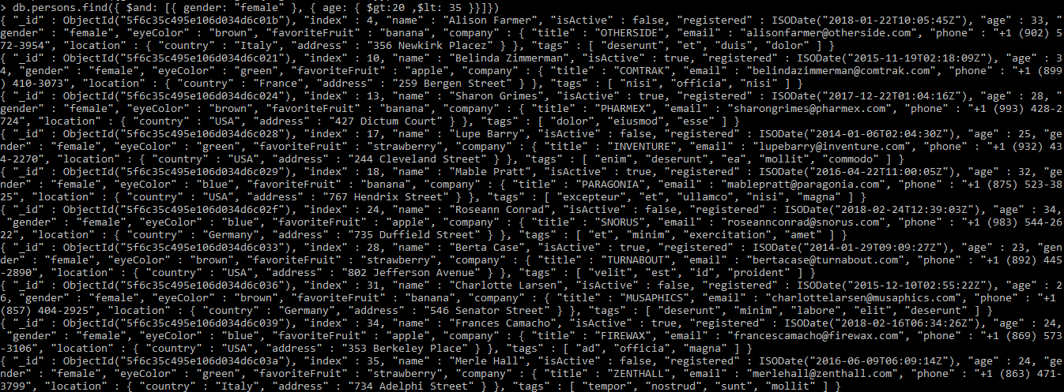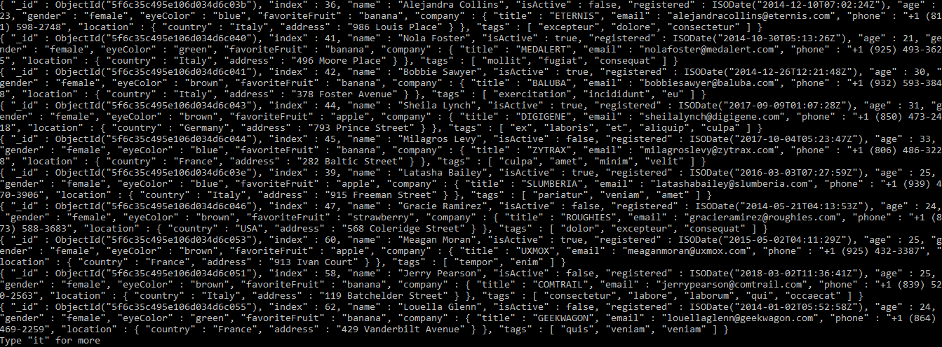

1. Find all documents with the company title “CANDECOR”

db.persons.find({"company.title":"CANDECOR"})



1. Find the NUMBER of documents with the eye color of blue

db.persons.find({eyeColor:"blue"}).count()



1. Find the documents with a favorite fruit of banana

db.persons.find({favoriteFruit:"banana"})

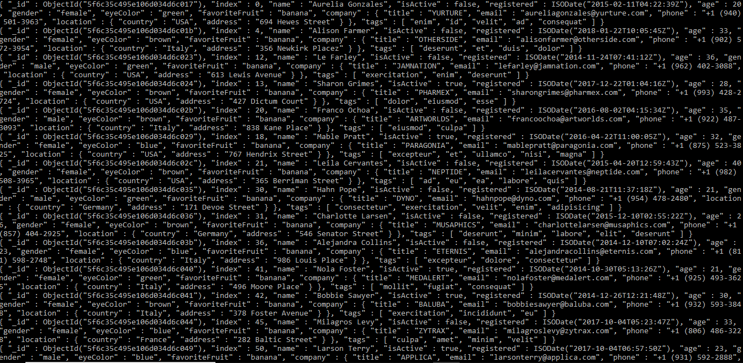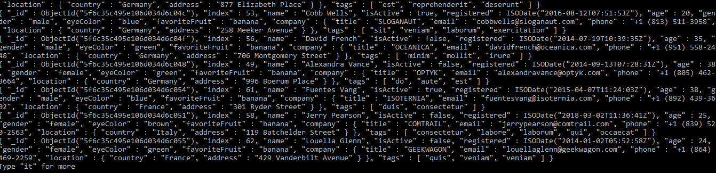

1. Find the NUMBER of documents with isActive:true

db.persons.find({isActive:true}).count()



1. Find the documents with isActive: true and of a gender male

db.persons.find({ $and: [{ isActive: true, gender: "male"}]})

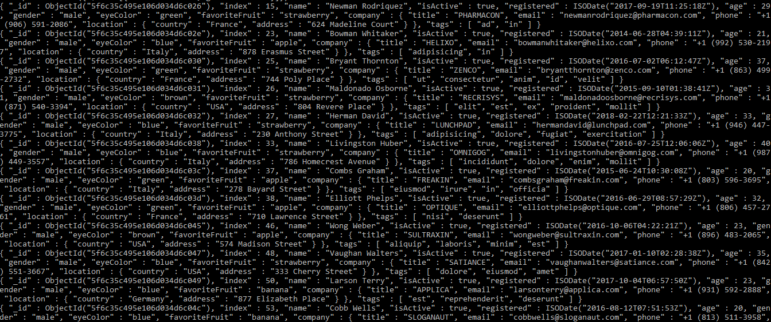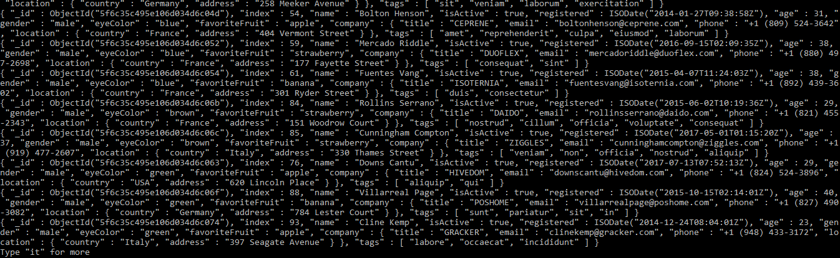

1. Find the documents with isActive: false , gender female, and an Age between the range 25 to 40

db.persons.find({ $and: [{isActive: false, gender: "female" }, { age: { $gt:25 ,$lt: 40 }}]})

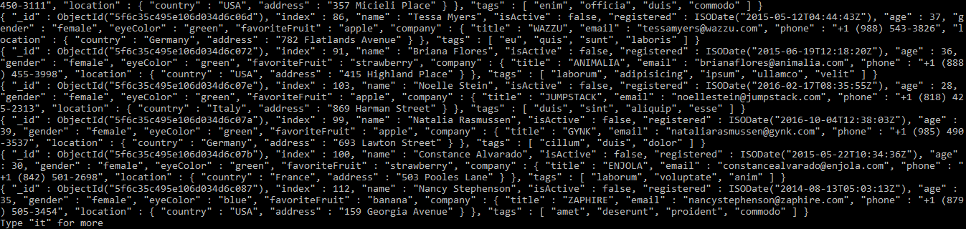

1. Find the documents that have both tags : “pariatur” and “veniam”

db.persons.find({tags: {$elemMatch: {$eq: "pariatur",$eq: "veniam"}}})

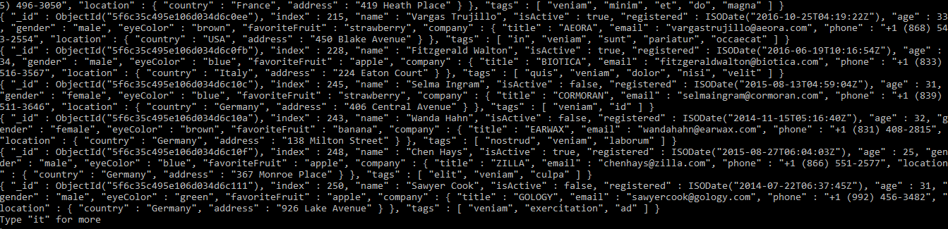

1. Find the documents that have either gender Male or eye color of Green

db.persons.find({ $or: [{ eyeColor: "green", gender: "male"}]})

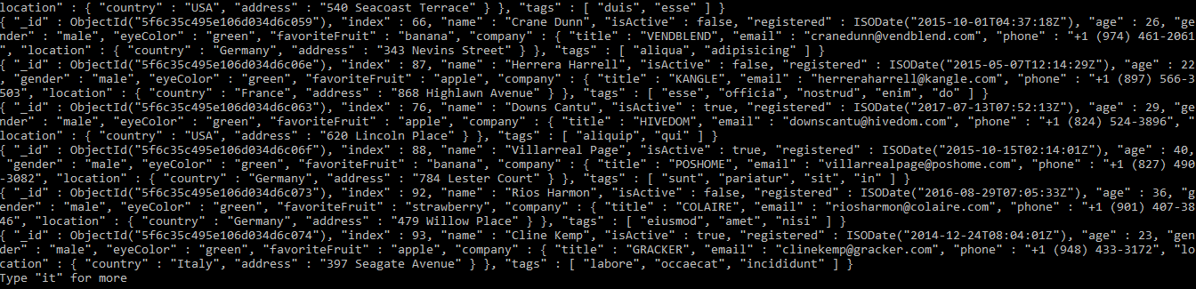

1. Find the documents with the age EITHER below 28 or above 35, thus documents with age 29,30,31,32,33,34 should not be included

db.persons.find({$or: [{age:{$lt: 28}},{age: {$gt: 35}}]})

