**Diet Health Scoring Bot – Problem Definition and Project Goals**

**Huachen Qu 304201050, Yangyushan Li 3041891687**

The Diet Health Scoring Bot addresses the problem that many people lack easy feedback on how healthy a particular meal is. Users simply input a list of foods and portions, and the bot computes a basic nutrient breakdown and a “health score” for that meal. This directly applies the USDA Dietary Guidelines (e.g. MyPlate recommendations) to everyday meals. By framing complex nutrition rules in simple scores and suggestions, the bot makes official guidelines more understandable to the general public. For example, USDA MyPlate encourages filling ~50% of the plate with fruits/vegetables and limits calories from added sugar and saturated fat; the bot uses these principles to judge each meal.

Solving this problem is useful because it raises awareness of balanced eating and nutrient content in daily life. Instead of guessing, a user sees calories, protein, fat, carbs, and fiber for their meal, plus a 0–10 health score based on USDA targets. This educates users about portions and nutrient density. The expected outcome is a working demonstration (not a certified medical tool) that shows how generative AI can promote healthy eating. We aim to produce clear, actionable feedback (e.g. “This meal is low on fiber; consider adding vegetables”) and a numeric score similar to USDA’s Healthy Eating Index (HEI) approach. The final model will illustrate these ideas for an AI course, helping students see how AI can translate dietary science into everyday advice.

**Project Design**

* **Generative AI Component:** The core system uses a large language model acting as a dietitian. Based on the user’s meal input and calculated nutrient data, it generates a short summary, a 0–10 health score, and improvement suggestions, evaluating macronutrient ratios and fiber intake against USDA standards.. Recent studies show AI chatbots can generate nutritionally adequate plans but may struggle with macro balance, so our prompts will explicitly check macros against USDA ranges to guide the model.
* **Prompt Engineering:** The system uses task-specific, structured prompts for two key stages:
  + Food Parsing Prompt – The first prompt instructs the LLM to extract all distinct food items and amounts from free-form user input, standardize them to USDA FoodData Central naming conventions, and estimate portions when unspecified. The output is required to be a valid JSON array, ensuring consistent and machine-readable parsing without extra text.
  + Nutrition Scoring Prompt – After retrieving nutrient data from the USDA API, the second prompt presents a structured nutritional summary to the LLM and explicitly asks for a health score from 0–10 along with a brief explanation.
* **Text Processing Pipeline:** Our script takes the user’s meal description in natural language, uses a DeepSeek large language model to extract and standardize each food item and its estimated amount, then queries the USDA FoodData Central API to retrieve detailed nutritional information such as calories, protein, fat, carbohydrates, and fiber for each item; it compiles these nutrient details into a summary and sends them back to the DeepSeek model, which evaluates the meal’s nutritional quality and returns a score out of 10 along with a brief explanation, finally displaying this analysis to the user.

**Implementation and Results**

* **Input/Output Format:** The user **input** will be a plain-text meal description, e.g. “1 cup oatmeal, 200ml milk, 1 banana, 1 tsp honey.” The system will parse this list (possibly via a simple NLP step) into individual foods and quantities. The **output** will be a user-friendly summary, such as:
  + *Health Score: 7/10*
  + *Suggestion: Add a source of protein (e.g. nuts or yogurt) to balance macronutrients*
  + We have an example output in appendix
* **Strength and Weakness:** Our system excels at accurately parsing varied meal descriptions into structured food items with stable JSON output and sensible quantity estimates, then delivering nutrient analyses that highlight strengths, weaknesses, and actionable health advice. It works well across simple and complex meals, with intuitive scoring and explanations that are easy for users to understand.

However, occasional USDA mismatches can produce inaccurate or incomplete nutrition data, especially for combo meals, and the lack of uncertainty indicators may mislead users when estimates are used. The scoring method is also not fully transparent, which could limit trust for more discerning audiences.

**Critical Reflection**

The Diet Health Scoring Bot shows how generative AI can connect nutritional science with everyday food choices, offering instant feedback. However, its practical use faces several challenges. First, accuracy depends heavily on the USDA FoodData Central database, which works well for single ingredients but often misrepresents mixed or processed foods. Portion estimates based on defaults (e.g., “medium banana = 100g”) can skew results by 10–30%, and the database underrepresents regional or culturally specific foods, limiting global applicability.

The scoring algorithm’s opacity is another concern. Users see a numerical score without knowing how nutrients are weighted, which can erode trust. Despite USDA-based prompts, the system can produce contextually unsuitable suggestions, such as recommending fish for vegan meals. Reducing nutrition to a single score risks oversimplification, which may harm individuals with eating disorders. USDA guidelines also reflect a Western-centric model that may not fit all diets, underscoring the need for cultural sensitivity and clear disclaimers to avoid liability.

Technically, the system focuses on macronutrients while ignoring micronutrients essential for health. It evaluates meals in isolation, without user-specific context like age, activity level, or medical conditions, meaning a “healthy” meal for one person may not suit another. Structured prompts work in most cases but falter with vague inputs (“a big bowl of cereal”), revealing fragility in parsing.

Finally, the scores lack validation against professional dietitian assessments and have no mechanism to measure long-term behavioral impact. Addressing data quality, transparency, ethics, context, and validation will be essential to move from a classroom prototype to a safe, effective, and culturally inclusive tool, requiring collaboration among nutrition experts, ethicists, AI developers, and diverse user groups.

**Conclusion**

The implemented system demonstrates how generative AI can provide actionable nutritional feedback. By combining DeepSeek's language understanding with USDA nutritional data, we've created a practical tool for dietary awareness. Future improvements will focus on data accuracy and explanatory transparency while maintaining the user-friendly approach. This implementation serves as an effective demonstration of how AI can bridge nutritional science and everyday eating habits.

**Sources:** USDA guidelines on balanced diets and nutrient targets; FoodData Central nutrition database info.

**Appendix**

**Code Running Screenshot:**

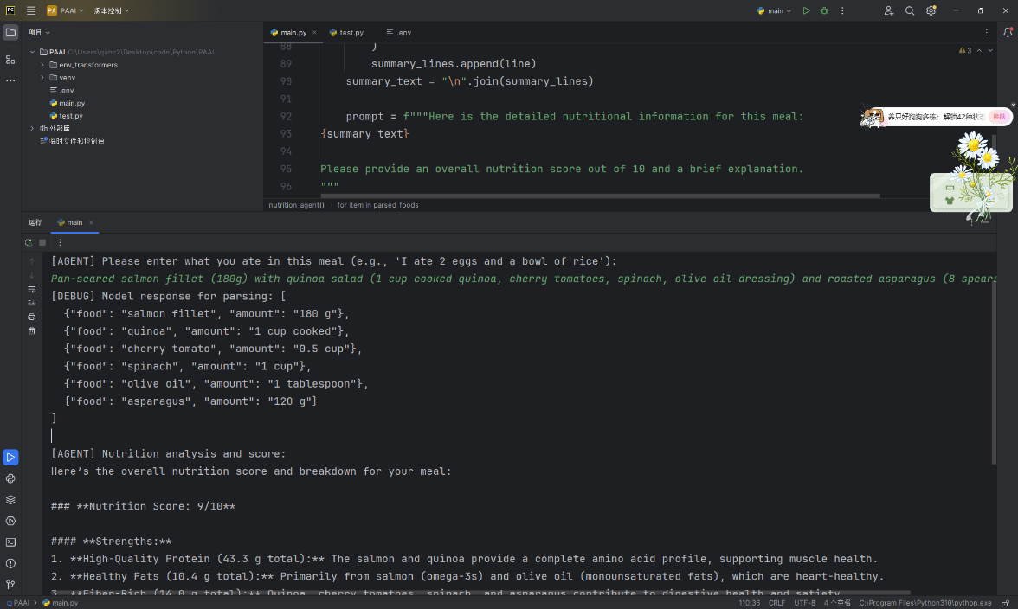

**Github repository:** <https://github.com/GPAbsltD/PAAI_final_project_nutrition_agent>

**Testcase example (A screenshot of a parr of *testcase.docs*. Can be found in the repository):**

