**Diet Health Scoring Bot – Problem Definition and Project Goals**

The Diet Health Scoring Bot addresses the problem that many people lack easy feedback on how healthy a particular meal is. Users simply input a list of foods and portions, and the bot computes a basic nutrient breakdown and a “health score” for that meal. This directly applies the USDA Dietary Guidelines (e.g. MyPlate recommendations) to everyday meals. By framing complex nutrition rules in simple scores and suggestions, the bot makes official guidelines more understandable to the general public. For example, USDA MyPlate encourages filling ~50% of the plate with fruits/vegetables and limits calories from added sugar and saturated fat; the bot uses these principles to judge each meal.

Solving this problem is useful because it raises awareness of balanced eating and nutrient content in daily life. Instead of guessing, a user sees calories, protein, fat, carbs, and fiber for their meal, plus a 0–10 health score based on USDA targets. This educates users about portions and nutrient density. The expected outcome is a working demonstration (not a certified medical tool) that shows how generative AI can promote healthy eating. We aim to produce clear, actionable feedback (e.g. “This meal is low on fiber; consider adding vegetables”) and a numeric score similar to USDA’s Healthy Eating Index (HEI) approach. The final model will illustrate these ideas for an AI course, helping students see how AI can translate dietary science into everyday advice.

**Project Design**

* **Generative AI Component:** The core system uses a large language model acting as a dietitian. Based on the user’s meal input and calculated nutrient data, it generates a short summary, a 0–10 health score, and improvement suggestions, evaluating macronutrient ratios and fiber intake against USDA standards.. Recent studies show AI chatbots can generate nutritionally adequate plans but may struggle with macro balance, so our prompts will explicitly check macros against USDA ranges to guide the model.
* **Prompt Engineering:** The system uses task-specific, structured prompts for two key stages:
  + Food Parsing Prompt – The first prompt instructs the LLM to extract all distinct food items and amounts from free-form user input, standardize them to USDA FoodData Central naming conventions, and estimate portions when unspecified. The output is required to be a valid JSON array, ensuring consistent and machine-readable parsing without extra text.
  + Nutrition Scoring Prompt – After retrieving nutrient data from the USDA API, the second prompt presents a structured nutritional summary to the LLM and explicitly asks for a health score from 0–10 along with a brief explanation.
* **Text Processing Pipeline:** Our script takes the user’s meal description in natural language, uses a DeepSeek large language model to extract and standardize each food item and its estimated amount, then queries the USDA FoodData Central API to retrieve detailed nutritional information such as calories, protein, fat, carbohydrates, and fiber for each item; it compiles these nutrient details into a summary and sends them back to the DeepSeek model, which evaluates the meal’s nutritional quality and returns a score out of 10 along with a brief explanation, finally displaying this analysis to the user.

**Implementation and Results**

* **Input/Output Format:** The user **input** will be a plain-text meal description, e.g. “1 cup oatmeal, 200ml milk, 1 banana, 1 tsp honey.” The system will parse this list (possibly via a simple NLP step) into individual foods and quantities. The **output** will be a user-friendly summary, such as:
  + *Health Score: 7/10*
  + *Suggestion: Add a source of protein (e.g. nuts or yogurt) to balance macronutrients*
  + We have an example output in appendix
* **Strength and Weakness:** Our system excels at accurately parsing varied meal descriptions into structured food items with stable JSON output and sensible quantity estimates, then delivering nutrient analyses that highlight strengths, weaknesses, and actionable health advice. It works well across simple and complex meals, with intuitive scoring and explanations that are easy for users to understand.

However, occasional USDA mismatches can produce inaccurate or incomplete nutrition data, especially for combo meals, and the lack of uncertainty indicators may mislead users when estimates are used. The scoring method is also not fully transparent, which could limit trust for more discerning audiences.

**Critical Reflection**

The Diet Health Scoring Bot project effectively showcases the potential of generative AI to bridge the gap between complex nutritional science and everyday dietary awareness, providing immediate feedback on meal choices. However, a critical examination reveals significant challenges and areas demanding careful consideration for any future development or real-world application. A primary concern revolves around the reliability of the underlying data. The system's accuracy is heavily dependent on the USDA FoodData Central database. While robust for many single ingredients, it struggles significantly with accurately representing combination or processed foods (like "lasagna" or "chicken stir-fry"), often leading to potentially inaccurate estimates based on simplified component assumptions. Furthermore, the reliance on portion estimation heuristics when quantities are omitted by the user introduces notable inaccuracies; default values (e.g., "medium banana = 100g") ignore natural variations in food size, potentially skewing nutrient calculations by 10-30% or more. This limitation is compounded by the underrepresentation of regional, cultural, or less common foods outside the standard US diet, hindering the system's global applicability and inclusivity.

Beyond data limitations, the opacity of the scoring algorithm itself presents a substantial hurdle. The "black box" nature of the LLM-based scoring process inherently lacks transparency. Users receive a numerical score (e.g., "7/10") but are given no insight into the underlying weighting logic – how much protein contributes versus fiber or saturated fat. This obscurity can erode user trust, particularly among more discerning audiences. While prompt engineering aims to anchor the scoring in USDA principles, the model remains susceptible to generating impractical or contextually inappropriate suggestions, as observed during testing (e.g., suggesting "add salmon" to a meal explicitly described as vegan). This highlights the inherent limitations and occasional unreliability of purely generative feedback

The project also raises important ethical and safety considerations. Reducing the intricate science of nutrition to a single score carries the risk of dangerous oversimplification. For individuals susceptible to or suffering from eating disorders, such scores could potentially trigger harmful behaviors. Although explicitly framed as a demonstration tool and not medical advice, this crucial distinction requires constant reinforcement to mitigate risk. Moreover, the explicit anchoring in USDA guidelines (like MyPlate), while evidence-based, embeds a specific Western/US-centric perspective on nutrition. Rigidly applying these standards to diverse global dietary patterns (e.g., high-carbohydrate Asian diets) risks cultural bias and may provide inappropriate assessments. This potential misalignment underscores the need for cultural sensitivity. Furthermore, without prominent and unambiguous disclaimers, there exists a liability risk that users might mistakenly rely on the bot's output as a substitute for personalized, professional dietary guidance.

Several technical constraints currently define the system's capabilities and limitations. The analysis primarily focuses on macronutrients (calories, protein, fat, carbs, fiber), excluding vital micronutrients (vitamins, minerals) which are essential for a holistic view of health. The system also evaluates meals in complete isolation, lacking any context about the user – ignoring critical factors like age, gender, activity level, existing health conditions, or overall dietary patterns. A "healthy" meal for one individual might be unsuitable for another. While structured prompts generally perform well, they remain vulnerable to failure when faced with highly irregular or ambiguous user inputs (e.g., "a big bowl of cereal," "a handful of trail mix"), exposing the fragility of the prompt engineering approach despite attempts to enforce structured JSON output.

Finally, the project faces validation shortcomings. The generated health scores currently lack formal benchmarking against assessments made by registered dietitians or nutritionists applying the same USDA principles the bot aims to emulate. More fundamentally, there is no mechanism within the project to evaluate its long-term efficacy: does receiving this AI-generated feedback actually lead users to make consistently healthier dietary choices over time? Addressing these critical points – data accuracy, algorithmic transparency, ethical safeguards, contextual awareness, and rigorous validation – is paramount for evolving this promising prototype beyond a course demonstration into a responsible and reliable tool. This evolution will require concerted interdisciplinary collaboration involving nutrition scientists, ethicists, AI specialists, and diverse user communities.

**Conclusion**

The implemented system demonstrates how generative AI can provide actionable nutritional feedback. By combining DeepSeek's language understanding with USDA nutritional data, we've created a practical tool for dietary awareness. Future improvements will focus on data accuracy and explanatory transparency while maintaining the user-friendly approach. This implementation serves as an effective demonstration of how AI can bridge nutritional science and everyday eating habits.

**Sources:** USDA guidelines on balanced diets and nutrient targets; FoodData Central nutrition database info.

**Appendix**

**Code Running Screenshot:**

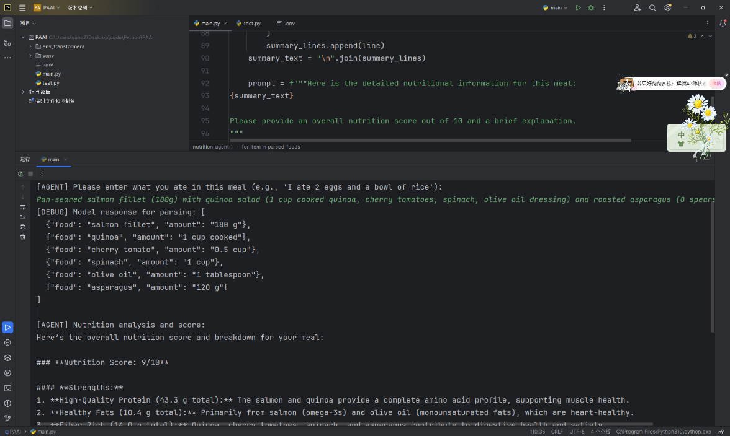

**Github repository:** <https://github.com/GPAbsltD/PAAI_final_project_nutrition_agent>

**Testcase example (A screenshot of a parr of *testcase.docs*. Can be found in the repository):**

