**Model Analysis:**

**Concepts & Principles:**

* Content Loss – Need to Fix :  
  This function helps to check how similar the generated image is to the content image. It gives the measure of how far (different) are the features of the content image and target image. We will pass the network both the desired content image and our generated image. This will return the intermediate layer outputs from our model. Then we simply take the Euclidean distance between the two intermediate representations of those images. The loss equation:

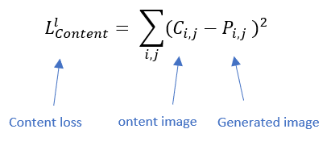

* Style Loss – Need to Fix:  
  Style Loss measures how different the generated image, in terms of style features, is from your style image. But it's not as straightforward as content loss. The style representation of an image is given by Gram Matrix. The loss equation:

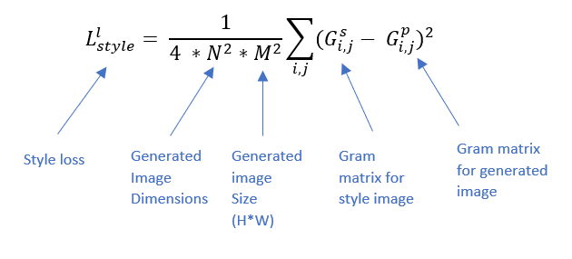

* Gram Matrix – Need to Fix:  
  The Gram Matrix G is the set of vectors in a matrix of dot products. To get the results, the matrix is multiplied by its transposed matrix, its equation is as follows:

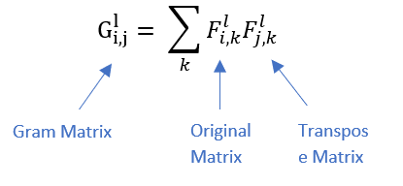

* Total variation loss – Need to Fix:  
  It was observed that optimization to reduce only the style and content losses led to highly pixelated and noisy outputs. To cover the same, total variation loss was introduced. The total variation loss is analogous to regularization loss. This is introduced for ensuring spatial continuity and smoothness in the generated image to avoid noisy and overly pixelated results. The loss equation:
* Total loss – Need to Fix:  
  Loss function for considering all elements (content loss, style loss, variation loss). The loss equation:

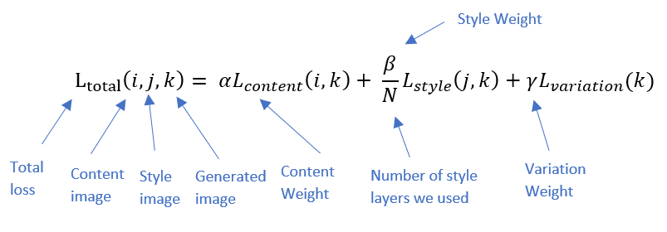

**Model Architecture:**

Are model is based on pre trained vgg19 DP model.  
We will extract style from the next layers:

* block1_conv1
* block2_conv1
* block3_conv1
* block4_conv1
* block5_conv1

And content from these layers:

* block5_conv2

Each iteration we will pass the content, style, and generated image through the model and by our loss function we will apply gradient decent to our generated image to reduce loss.

The total of iteration our model will perform is 4000.

**Elements to experiment:**

The next elements can be change and we will want to test their effect on our model result:

* α – content weight.
* β – style weight.
* γ – variation weight.
* image size.