from PIL import Image  
import numpy as np  
import glob  
import os  
import visualPercepUtils as vpu  
import matplotlib.pyplot as plt

path_input = './imgs-P1/'  
path_output = './imgs-out-P1/'  
bAllFiles = True  
bAllTests = False  
bSaveResultImgs = True  
nameTests = {'testHistEq': "Histogram equalization",  
 'testBrightenImg': 'Brighten image',  
 'testDarkenImg': 'Darken image'}  
suffixFiles = {'testHistEq': '_heq',  
 'testBrightenImg': '_br',  
 'testDarkenImg': '_dk'}  
  
if bAllFiles:  
 files = glob.glob(path_input + "*.pgm")  
else:  
 files = [path_input + 'iglesia.pgm'] # iglesia,huesos  
  
if bAllTests:  
 tests = ['testHistEq', 'testBrightenImg', 'testDarkenImg']  
else:  
 tests = ['testBrightenImg']

def histeq(im, nbins=256):  
 imhist, bins = np.histogram(im.flatten(), list(range(nbins)), density=False)  
 cdf = imhist.cumsum() # cumulative distribution function (CDF) = cummulative histogram  
 factor = 255 / cdf[-1] # cdf[-1] = last element of the cummulative sum = total number of pixels)  
 im2 = np.interp(im.flatten(), bins[:-1], factor*cdf)  
 return im2.reshape(im.shape), cdf  
  
def darkenImg(im,p=2):  
 return (im ** float(p)) / (255 ** (p - 1)) # try without the float conversion and see what happens  
  
def brightenImg(im,p=2):  
 return np.power(255.0 ** (p - 1) * im, 1. / p) # notice this NumPy function is different to the scalar math.pow(a,b)  
  
def testDarkenImg(im):  
 im2 = darkenImg(im,p=2) # Is "p=2" different here than in the function definition? Can we remove "p=" here?  
 return [im2]  
  
def testBrightenImg(im):  
 p=2  
 im2=brightenImg(im,p)  
 return [im2]  
  
def testHistEq(im):  
 im2, cdf = histeq(im)  
 return [im2, cdf]

# Exercise 2

I decided only to replace two lines. My reasoning is that those two lines deal with the image transformation previously saving (Image.fromarray) and saving the image to disk with the final path. The other two are just valid for this specific implementation and are not a good idea to include if you want this implementation to be reusable in other code, as they deal with getting the path from the original filename.

def saveImg(image, path):  
 pil_im = Image.fromarray(image.astype(np.uint8)) # from array to Image  
 pil_im.save(path)

def doTests():  
 print("Testing on", files)  
 for imfile in files:  
 im = np.array(Image.open(imfile).convert('L')) # from Image to array  
 for test in tests:  
 out = eval(test)(im)  
 im2 = out[0]  
 vpu.showImgsPlusHists(im, im2, title=nameTests[test])  
 if len(out) > 1:  
 vpu.showPlusInfo(out[1],"cumulative histogram" if test=="testHistEq" else None)  
 if bSaveResultImgs:  
 dirname, basename = os.path.dirname(imfile), os.path.basename(imfile)  
 fname, fext = os.path.splitext(basename)  
 #print(dname,basename)  
 saveImg(im2, path_output + '//' + fname + suffixFiles[test] + fext)

doTests()

Testing on ['./imgs-P1/iglesia.pgm', './imgs-P1/huesos.pgm', './imgs-P1/cabeza.pgm']  
4 None None

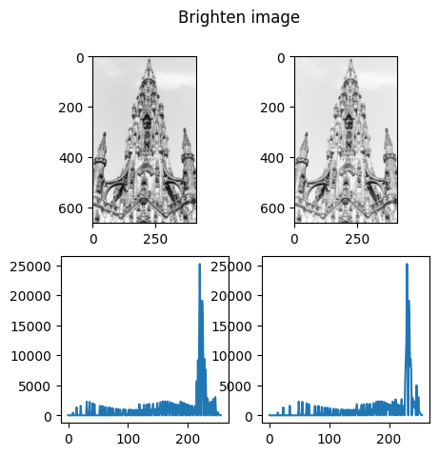

4 None None

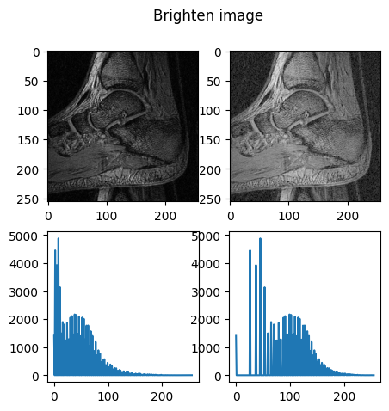

4 None None

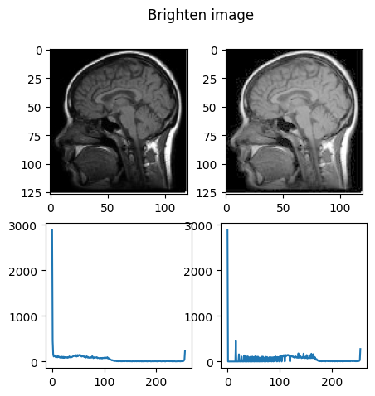

# Exercise 3

There is no need to modify the functions because of broadcasting.

im = np.array(Image.open('./imgs-P1/girl.ppm'))

def darkenImg(im,p=2):  
 return ((im ** float(p)) / (255 ** (p - 1))).astype('uint8')  
  
def brightenImg(im,p=2):  
 return np.power(255.0 ** (p - 1) * im, 1. / p).astype('uint8')

im2 = brightenImg(im)  
im3 = darkenImg(im2)

### Brighten the image

vpu.showImgsPlusHists(im, im2)

4 None None

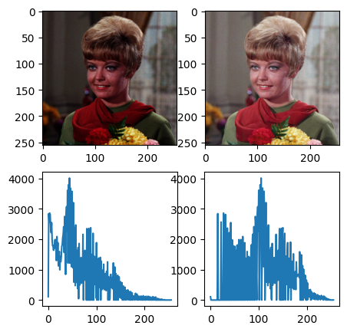

### Darken the image

vpu.showImgsPlusHists(im2, im3)

4 None None

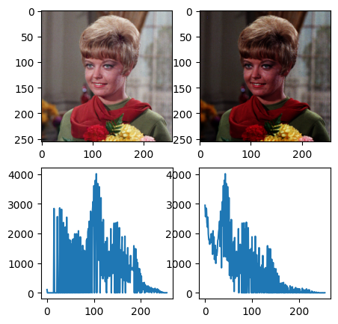

# Exercise 4

This function creates a mask with a checker pattern and then applies the inversion to the pixels selected by such mask. The first implementation is the one I did by myself at first. The second and third are improvements after the teacher told me to try to use np.meshgrid. I found two different ways of doing the same thing. The first implementation is not what the exercise asks, instead of dividing the image in cells it creates a checkerboard pattern with cells of size $ m \times n$.

def checkBoardImg(im, m, n):  
 shape = im.shape  
 im2 = im.copy()  
 horizontal = np.block([np.tile(np.repeat(np.array([-1,1]), n),shape[0]//(2*n)), np.repeat(np.array([-1,1]), n)[:shape[0]%(2*n)]])  
 vertical = np.block([np.tile(np.repeat(np.array([1,-1]), m),shape[1]//(2* m)), np.repeat(np.array([1,-1]), m)[:shape[1]%(2*m)]])  
 mask = vertical[:,np.newaxis] * horizontal  
 im2[mask<0] = 255 - im2[mask<0]  
 return im2

def checkBoardImg2(im, m, n):  
 shape = im.shape  
 im2 = im.copy()  
 a = np.zeros((m+1, n+1))  
 a[1::2, ::2] = 1  
 a[::2, 1::2] = 1  
 mask = np.kron(a, np.ones((shape[0]//m, shape[1]//n)))[:shape[0]:,:shape[1]:]  
 im2[mask==1] = 255 - im2[mask==1]  
 return im2

def checkBoardImg3(im, m, n):  
 shape = im.shape  
 im2 = im.copy()  
 x, y = np.meshgrid(np.arange(shape[1]), np.arange(shape[0]))  
 cell_x = x // (shape[1] // n)  
 cell_y = y // (shape[0] // m)  
 mask = (cell_x + cell_y) % 2  
 im2[mask==1] = 255 - im2[mask==1]  
 return im2

im2 = checkBoardImg3(im,5,3)

import matplotlib.pyplot as plt  
vpu.showInGrid([im2])

1 None None

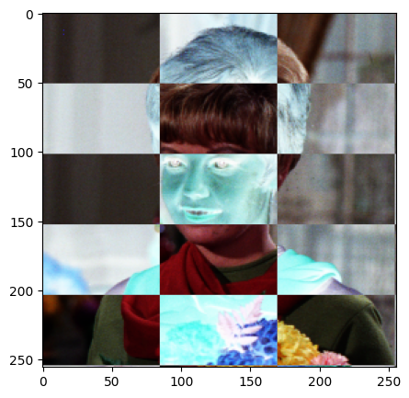

# Exercise 5

im = np.array(Image.open('./imgs-P1/iglesia.pgm'))

Split each image using np.array_split twice. Once for each dimension. Then calculate all the histograms and plot them.

def multiHist(im, n, nbins=256):  
 hists = []  
 for i in range(n):  
 quad = [M for SubA in np.array_split(im, i + 1, axis=0) for M in np.array_split(SubA, i + 1, axis=1)]  
 hists += [np.histogram(subIm.flatten(), nbins, density=False)[0] for subIm in quad]  
 return hists

hists = multiHist(im, 2, 3)  
hists

[array([ 25837, 53944, 193375]),  
 array([ 1823, 3816, 62753]),  
 array([ 3842, 7759, 56791]),  
 array([ 8995, 19490, 39701]),  
 array([10914, 21888, 35384])]

hists = multiHist(im, 2)  
vpu.showInGrid(hists)

5 None None

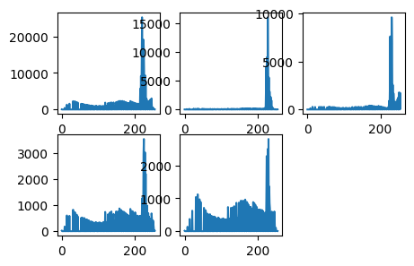

# Exercise 6

Had some trouble with this exercise. I interpreted it as a different kind of problem and instead of solving a simple two unknows equation system I divided the space between [l0, l1] so the function could take values in that range but without explicitly making the equation to take only values in that range.

def expTransf(alpha, n, l0, l1, bInc = True):  
 input = np.linspace(l0, l1, n)  
 alpha = float(alpha)  
 a = (  
 (l0 - l1)  
 / (np.exp(-alpha * l0**2) - np.exp(-alpha * l1**2))  
 )  
 b = (  
 l0 - a * np.exp(-alpha * l0**2)  
 )  
 if bInc:  
 return a * np.exp(-alpha * input**2) + b  
 return (a * np.exp(-alpha * input**2) + b)[::-1]

Plots showing different ranges and alpha values

fig = plt.figure(figsize=(17, 17))  
for i in range(0,255, 51):  
 for j in range(i+51, 256, 51):  
 ax = fig.add_subplot(5, 5, i//51*5+j//51)  
 for alpha in range(1, 10, 2):  
 x = np.linspace(i,j,j-i+1)  
 y = expTransf(alpha/10000,j-i+1,i,j)  
 plt.plot(x,y, label = f'alpha: {alpha/10000}')  
 ax.set_title(f'[{i},{j}]')  
 ax.legend(loc='lower right')  
plt.show()

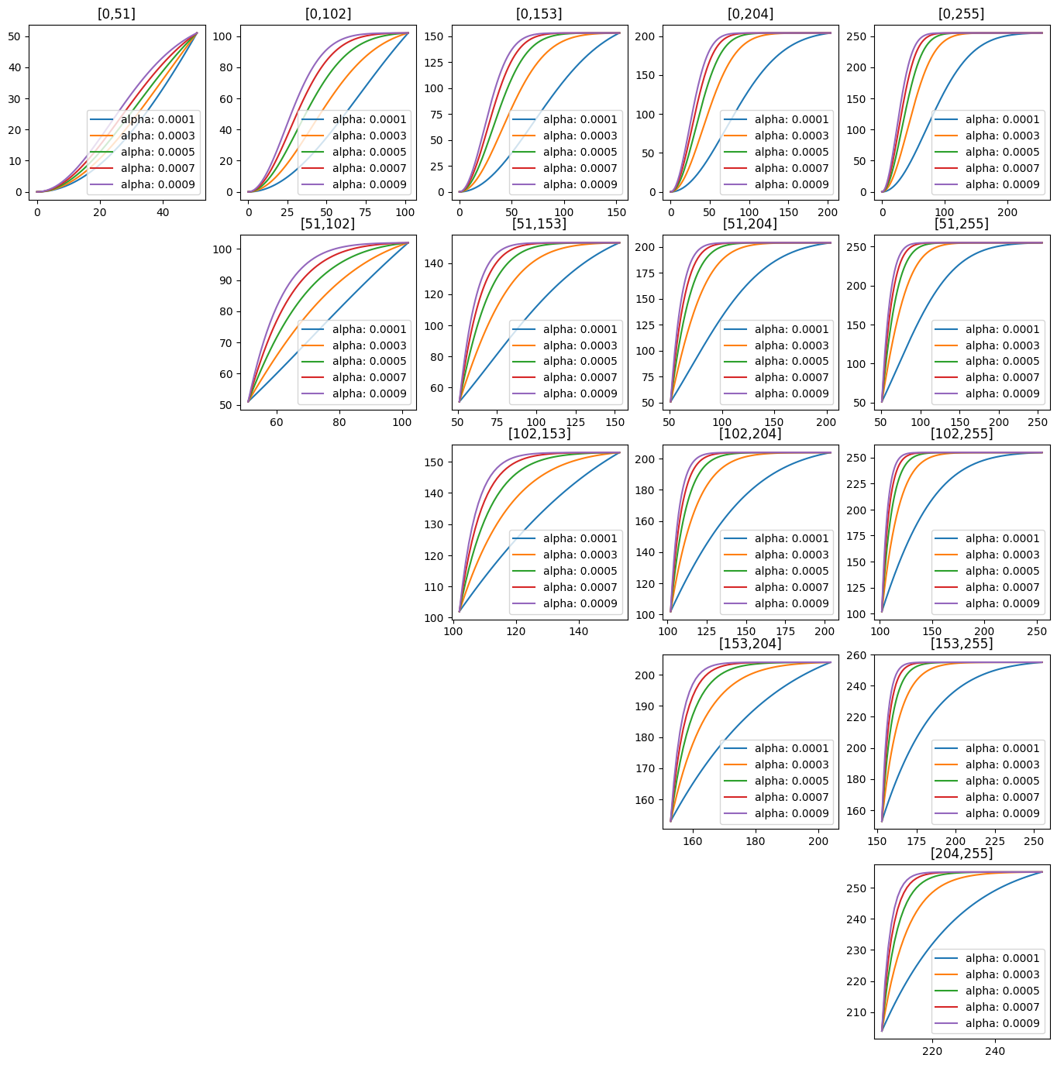

And then transform an image to test the transformation.

def transfImage(im, f):  
 transf = f.astype('uint8')  
 l0 = min(transf)  
 l1 = max(transf)  
 im2 = im.copy()  
 im2[(im2>=l0) & (im2 <= l1)] = transf[im2[(im2>=l0) & (im2 <= l1)] - l0]  
 return im2

im2 = transfImage(im, expTransf(0.0001,256,0,255, False))  
vpu.showImgsPlusHists(im, im2)

4 None None

