The Strange Case of Dr Jekyll and Mr Hyde
English homework • Leo
Hyde PEAL rewrite (in green) • Dr Jekyll profile • Chapter 4 comic strip
1. How does Stevenson present Mr Hyde?
Original paragraph
Mr Stevenson presents Mr Hyde as a very mysterious man who creates a sense of discomfort in the reader and in Utterson. As Utterson approaches him for the first time Mr Hyde would not show his face “he gives a strong feeling of deformity” he isn’t seen as human “it wasn’t a man it was like some damned juggernaut.” The quote “he gives a strong feeling of deformity” shows us that he doesn’t seem right he seems like he is all messed up physically and mentally. “It wasn’t a man it was like some damned juggernaut” shows us that he didn’t seem like a man he seemed like a overwhelming force.
Feedback I have actioned
- Writer’s name: write Stevenson, not “Mr Stevenson”.
- Accurate quotes: use the exact words from the novella and put them in the right chapter/speaker.
- Do not mix events: the “Juggernaut” and “deformity” lines come from Enfield’s story in Chapter 1, which then makes Utterson hunt for Hyde in Chapter 2.
- Embed evidence: weave quotations into your own sentences instead of dumping them next to each other.
- Academic voice: cut informal phrases like “all messed up” and “this shows us”.
- PEAL: Point, Evidence, Analysis of methods, Link back to the question.
- Methods: name techniques (metaphor, imagery, dehumanisation) and explain the effect.
- Context / reader: link Hyde to Victorian fears of hidden evil and damaged reputation.
- SPaG: full sentences, commas, capital letters, and “an overwhelming force”.
Rewritten PEAL paragraph (changes in green)
Stevenson presents Mr Hyde as a mysterious, inhuman figure who creates a strong sense of discomfort in Utterson and in the reader. Utterson’s unease begins before they even meet, when Enfield describes Hyde trampling a child: “It wasn’t like a man; it was like some damned Juggernaut.” The metaphor “Juggernaut” dehumanises Hyde, presenting him as an unstoppable crushing force rather than a person, so the violence feels sudden, shocking and impossible to control. Enfield also says that Hyde “gives a strong feeling of deformity,” even though he “couldn’t specify the point.” This vague imagery is deliberately unclear: Stevenson withholds a full description so Hyde remains hidden and uncanny, which is more frightening than a named injury because the horror cannot be explained. When Utterson later confronts him, Stevenson repeats this idea: Hyde is “pale and dwarfish” and gives “an impression of deformity without any nameable malformation.” The repeated motif of unexplained deformity suggests moral as well as physical corruption, which would disturb Victorian readers who valued respectability, self-control and a clear divide between gentlemen and criminals. Therefore Stevenson presents Hyde as mysterious on purpose, using dehumanising metaphor and incomplete description to make evil feel hidden inside civilised London, which builds tension around Utterson’s search.
Where the PEAL is
- Point: Hyde is mysterious and creates discomfort.
- Evidence: “damned Juggernaut”; “strong feeling of deformity”; “impression of deformity without any nameable malformation.”
- Analysis: metaphor, dehumanisation, vague imagery, repeated motif, Victorian context, effect on Utterson/reader.
- Link: Stevenson keeps Hyde hidden so evil feels unexplained, which builds tension.
2. Character profile: Dr Henry Jekyll
Updated using last week’s homework notes and this week’s Chapter 3 collaborative task (“Dr Jekyll Was Quite at Ease”). The profile follows the same headings as Mr Utterson and Mr Hyde.
Key Chapter 3 notes
- Heresy = a belief against religion. Lanyon treats Jekyll’s science as “unscientific balderdash” and almost as heresy.
- Hide-bound = not open to new ideas. Jekyll calls Lanyon a “hide-bound pedant” because Lanyon will not accept Jekyll’s experiments.
- Utterson is still worried about Jekyll’s will, which leaves everything to Hyde.
- Jekyll tells Utterson not to worry and claims he can be rid of Hyde whenever he chooses.
- The chapter title is ironic: Jekyll seems “quite at ease,” but he is secretive, “very low,” and desperate to protect Hyde.
Concept | Summary | Quotes
Character name | Dr Henry Jekyll — a respected Victorian doctor and gentleman. | “the doctor” / “Henry Jekyll”
Appearance | He looks like a successful, kind man in middle age, but Stevenson adds a hint that he is not completely open. This “slyish cast” is an early clue of duality. | “a large, well-made, smooth-faced man of fifty, with something of a slyish cast perhaps, but every mark of capacity and kindness”
Personality | He is sociable, charming and generous as a host, but also secretive, proud and defensive about Hyde. He wants Utterson’s loyalty without telling the truth. | “I am very low, Utterson”; he speaks “a trifle thickly”
Life | He is wealthy, has a grand house with a laboratory, and holds dinner parties for other gentlemen. Science is central to his life, which causes the quarrel with Lanyon. | his house is a site of “wealth and comfort”
Relationships with other characters | Close friend of Utterson; old friend of Lanyon, but they have fallen out over Jekyll’s “scientific heresies.” He claims a “great interest” in “poor Hyde,” which Utterson cannot understand. | “I have really a very great interest in poor Hyde.” Lanyon: “too fanciful for me.” Jekyll on Lanyon: “hide-bound pedant”
What he says | He begs Utterson to let the will stand and to help Hyde if Jekyll disappears. He insists Hyde is not a problem he cannot control, which later proves untrue. | “the moment I choose, I can be rid of Mr Hyde”; “I have a very great interest in poor Hyde”; “I implore you to let it sleep.”
What he does | After the dinner guests leave, he takes Utterson aside, makes him promise to honour the will, and tries to shut down the investigation. He appears calm in public but is managing a secret. | He makes Utterson “promise” to help Hyde “if I am taken away.”
Context | Jekyll is the model Victorian gentleman: status, charity, reputation. Stevenson uses him to show that respectability can hide sin. His science vs Lanyon also reflects Victorian debates about religion, reason and dangerous new ideas. | Lanyon calls Jekyll’s work “unscientific balderdash.”
Role in the plot | Chapter 3 makes Jekyll look “at ease,” but it actually deepens the mystery: why would a good doctor protect Hyde? This keeps Utterson investigating and prepares the later reveal of duality. | Title: “Dr Jekyll Was Quite at Ease” (ironic)
Extra notes / questions | Is Jekyll lying when he says he can be rid of Hyde? Why call Hyde “poor”? Does the “slyish cast” mean the reader should not fully trust him even in Chapter 3? | “poor Hyde” suggests pity or guilt.
Link to last week: like Utterson, Jekyll cares about reputation and friendship. Unlike Utterson, Jekyll already knows Hyde’s secret, so his calm manners in Chapter 3 are a performance. This week’s collaborative focus (Chapter 3) shows the duality theme before the Carew murder: the public doctor vs the private man who protects Hyde.
3. Chapter 4: The Carew Murder Case
Finished reading Chapter 4. Glossary, scene breakdown, six-panel comic strip, then the Grade 7–9 style questions.
Glossary from Chapter 4
Word | Meaning
insensate | without feeling, sense or mercy — Hyde’s violence is mindless
tempest | a violent storm — used as an image for Hyde’s attack
ape-like fury | animal, primitive rage (links Hyde to degeneration)
fog | Gothic weather that hides crime and the truth in London
Soho | a poorer, less respectable area — contrast with Carew’s gentleman world
cheque-book | proof Hyde had money and a gentleman’s identity to hide behind
Scenes I divided the chapter into (6 scenes)
- Scene 1 — The maid at the window: A maid, sitting by her window “in a dream of musing,” looks out on a foggy London night around 11pm and sees two men in the lane.
- Scene 2 — Carew’s polite greeting: An aged, beautiful gentleman (Sir Danvers Carew) speaks to a smaller man (Hyde) with “a very pretty manner of politeness.”
- Scene 3 — The murder: Hyde explodes into “ape-like fury,” beats Carew to death with Utterson’s gift-cane, and leaves him “insensate.” The cane breaks under the “storm of blows.”
- Scene 4 — Aftermath: The maid faints from horror. When she recovers she raises the alarm. Police find the broken stick and a sealed envelope addressed to Utterson.
- Scene 5 — Utterson identifies Carew: Next morning Utterson recognises the body and the cane. He tells Inspector Newcomen he can take them to Hyde’s address.
- Scene 6 — The Soho search / Hyde vanishes: They go through foggy Soho to Hyde’s rooms: surprisingly luxurious, but wrecked. A burnt cheque-book is found. Hyde has disappeared.
Comic strip (rough visual of the six scenes)
Each panel has a caption plus a speech or thought bubble, matching the six-box layout from class.
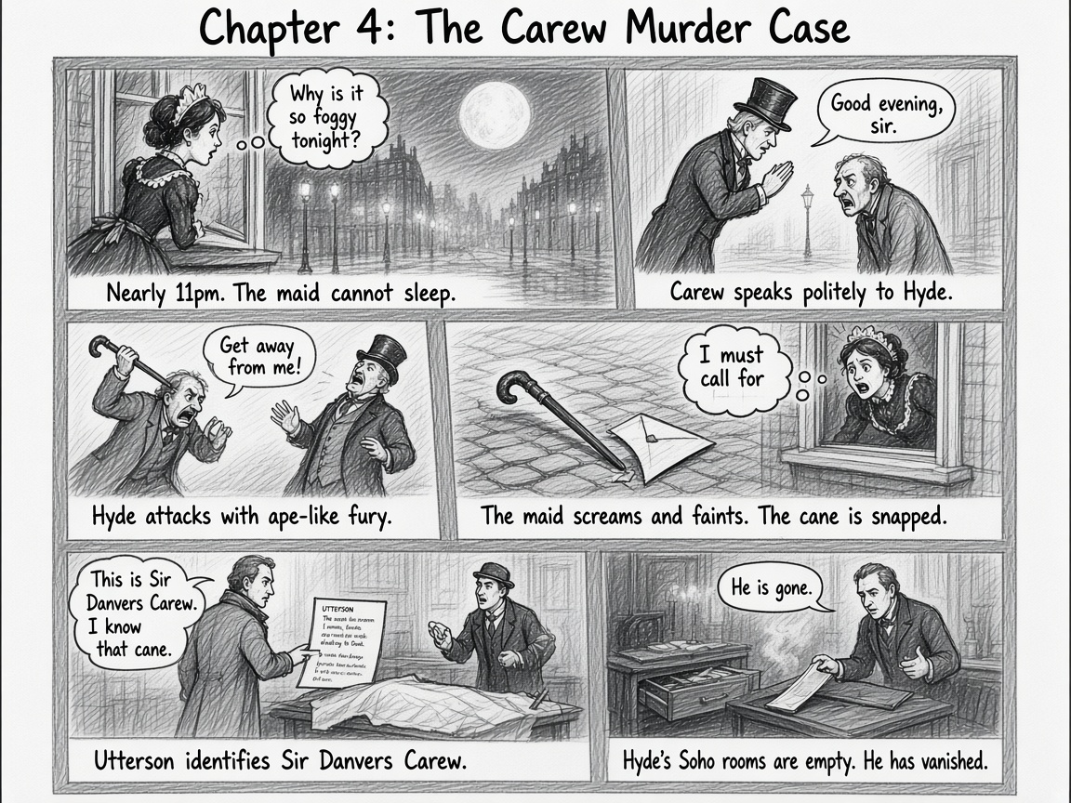
Panel captions and bubbles (written version)
- 1 Caption: Nearly 11pm. The maid cannot sleep. Thought: “Why is it so foggy tonight?”
- 2 Caption: Carew speaks politely to Hyde. Carew: “Good evening, sir.”
- 3 Caption: Hyde attacks with ape-like fury. Hyde: “Get away from me!”
- 4 Caption: The maid screams and faints. The cane is snapped. Maid: “I must call for help!”
- 5 Caption: Utterson identifies Sir Danvers Carew. Utterson: “This is Sir Danvers Carew. I know that cane.”
- 6 Caption: Hyde’s Soho rooms are empty. He has vanished. Inspector: “He is gone.”
Aiming for a 7, 8 or 9 — style of writing in Chapter 4
How does the style of writing change throughout the chapter?
The style moves from Gothic description to a more factual, case-file tone. The opening of the murder is atmospheric and emotional: Stevenson slows down on the setting, the maid’s feelings, and the horror of the attack so the reader experiences the shock. After the crime, the writing becomes more like a police report. We get times, names, addresses, the broken stick, the envelope and the search of Hyde’s rooms. This change fits Utterson’s point of view as a lawyer: the novella turns a nightmare into an investigation. It also makes Hyde seem even more frightening, because the facts cannot explain why he killed a polite gentleman for almost no reason.
Where is it more descriptive and why?
It is most descriptive in the murder scene and in the journey through foggy Soho. Stevenson uses violent imagery (“ape-like fury,” a “storm of blows,” the body “insensate”) and weather imagery (the moon, the “great chocolate-coloured pall” of fog) to make Hyde seem animal, sudden and evil. The description of Carew as an “aged and beautiful gentleman” with “an innocent and old-world kindness of disposition” makes the attack feel more shocking: a respected MP is destroyed by something that does not belong in civilised society. The Soho fog is descriptive because it hides Hyde and turns London into a Gothic labyrinth, suggesting that crime and dual lives are buried in the city.
Where is it more factual and why?
It is more factual when the police and Utterson take over: the maid’s witness statement, the letter addressed to Mr Utterson, the identification of the body, Inspector Newcomen, Hyde’s exact address, the burnt cheque-book and the empty rooms. Stevenson does this because the chapter is called “The Carew Murder Case”: it is written like evidence. The facts also prove Hyde’s guilt (the broken half of Utterson’s cane) while showing he has escaped, which keeps the mystery going. The contrast is deliberate — description makes us feel horror; facts make the horror official, public and impossible for gentlemen like Utterson to ignore.
Appendix — earlier notes kept from this document
Glossary (whole novella so far)
word | meaning
countenance | face or expression
austere | strict and plain
emulously | wanting to be as good as someone
coquetry | flirting
tramp | to walk heavily
iniquity | wicked behaviour
deformity | an unusual feature
disreputable | not respected
heresy | a belief against religion
pedant | someone who cares too much about rules
Original Utterson PEAL (kept)
utterson is a typical victorian gentleman because he is serious respectable and loyal he is a lawyer and people trust him he has a rugged countenance that was never lighted by a smile this shows he looks stern and keeps his feelings private he also stays loyal to jekyll and tries to help him this shows he is a respectable victorian gentleman
Mr Utterson profile (kept)
concept | summary | quotes
character name | mr utterson
appearance | he looks stern and does not smile much | rugged countenance
personality | quiet loyal serious and kind | somehow lovable
life | he is a lawyer and jekylls friend | mr utterson the lawyer
relationships with other characters | he is friends with jekyll enfield and lanyon | old friend of dr jekyll
what he says | he wants to find hyde | if he be mr hyde i shall be mr seek
what he does | he looks for hyde and tries to help jekyll | mr seek
context | he cares about respectability and reputation | good influence
role in the plot | he investigates hyde | mr seek
extra notes questions | is he too loyal to jekyll
Mr Hyde profile (kept)
concept | summary | quotes
character name | mr hyde
appearance | he is small pale and strange | pale and dwarfish
personality | violent cruel and frightening | ape like fury
life | he has rooms in soho and gets money from jekyll | the heir of henry jekyll
relationships with other characters | he is connected to jekyll and utterson investigates him | young man hyde
what he says | he speaks in a husky whispering voice | how did you know me
what he does | he tramples a child and murders carew | ape like fury
context | he is a gothic villain and represents hidden evil | satans signature
role in the plot | he causes the mystery and makes utterson investigate | mr seek

