Zookeeper学习笔记

##### Zookeeper架构

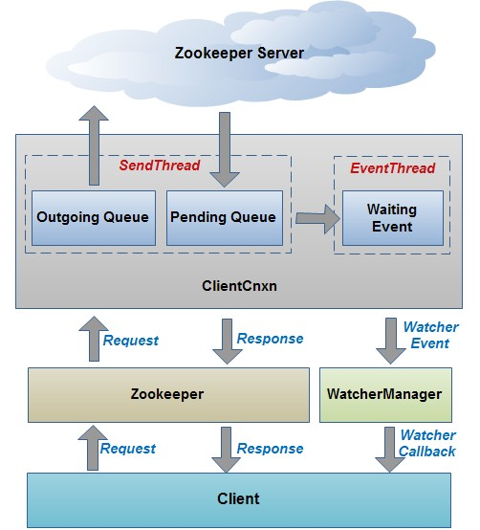

##### 选举方式：

1. FastLeaderElection
2. LeaderElection
3. AuthFastLeaderElection