UNIVERSITY OF LAY ADVENTISTS OF KIGALI
UNILAK Rwamagana Campus


ID Finder Rwanda
Milestone 3 System Design and Prototype Report
Software Engineering and User Centred Design
Prepared by
MISIGARO Thomas | M04930/2025
SIBOBUGINGO Leonidas | M04070/2025
November 2026

1 System design
We designed ID Finder Rwanda around two tasks. A finder reports an identity document and receives a reference. The owner searches using the name printed on the document or its exact ID number. A possible match shows the document type, general found area and report reference.

Architecture and decisions
We chose one responsive web application for both tasks. For the implementation demo, we propose PHP on Apache and a MySQL database. The server validates report details and photo uploads, saves related records and limits repeated searches. We keep the full ID number, finder phone number and uploaded photo private.
Our ADR slide records five decisions: platform, technology stack, database, guest access and photo storage. We chose guest access to avoid adding a sign-up step to the demo. We store photos privately on the server and keep a storage key in each report. We considered cloud storage but chose local storage to avoid another service dependency.

Database model in third normal form
We modelled four entities: DOCUMENT_TYPE, ID_DOCUMENT, FINDER and FOUND_REPORT. Each document belongs to one document type. Each report links one document to one finder and stores the found location, date, photo storage key and submission time. The type name and finder contact details live in their own tables, so reports can reference those details without repeating them.

Sequence of reporting and search
Our sequence diagram begins when the finder submits the ID details, location, contact details and photo. The application validates the submission, saves the report and returns its reference. When an owner searches, the application looks up matching records and returns a limited result or a no-match message.
The three editable draw.io files and the single-slide ADR accompany this report in the M3 design folder.

2 Prototype and wireframes
We connected ten mobile screens in Figma. From Home, the finder can open the report form, attach a sample photo, review the details and submit. The confirmation screen displays IDF-0001 and provides a route to search.
The owner can run a sample search by name or exact ID number. Both matching examples open the same limited result. The unmatched example shows a no-match message and gives the owner a way to try again.
Open the ID Finder clickable prototype
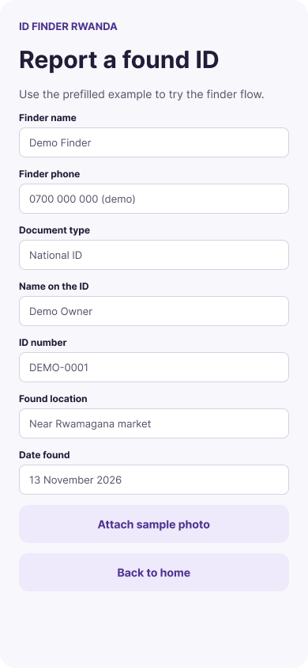 | 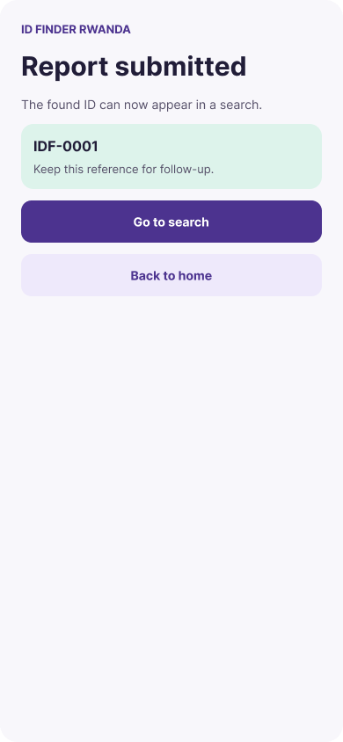 | 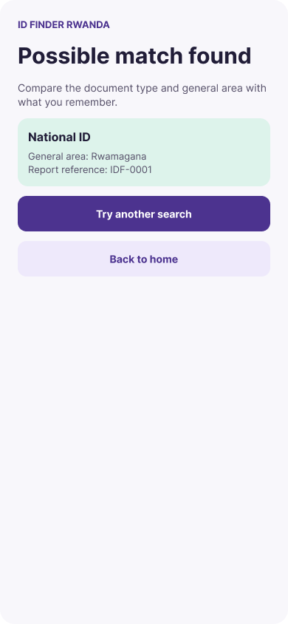
Figure 1. Found ID form, submission confirmation and possible match.
We exported all ten screens as numbered PNG files. The wireframes folder includes the home screen, reporting screens, search examples and both result states.

3 Review and next steps

Team walkthrough
We opened the shared prototype and checked that its buttons could be used. The walkthrough confirmed that the prototype was reachable from the shared link. The connected screens use prepared examples to simulate form entry, photo attachment, submission and lookup.

External usability testing
External usability testing is pending. We plan to ask participants to complete a found-ID report, locate a possible match and recover from a search with no result. We will record whether participants finish without help, where they hesitate and whether they understand the information shown on a match.
We will use those observations to decide which labels, instructions or navigation need revision. After making changes, we will repeat the affected tasks and record what changed.

Implementation handoff
For M4, we plan to connect the report form to the database, validate uploads and store photos privately. We will also implement the name and exact-number lookups and verify that search responses contain only the fields shown in the prototype.

