**Project Proposal:**

**CART KING**

(The Culinary Shopping Companion)

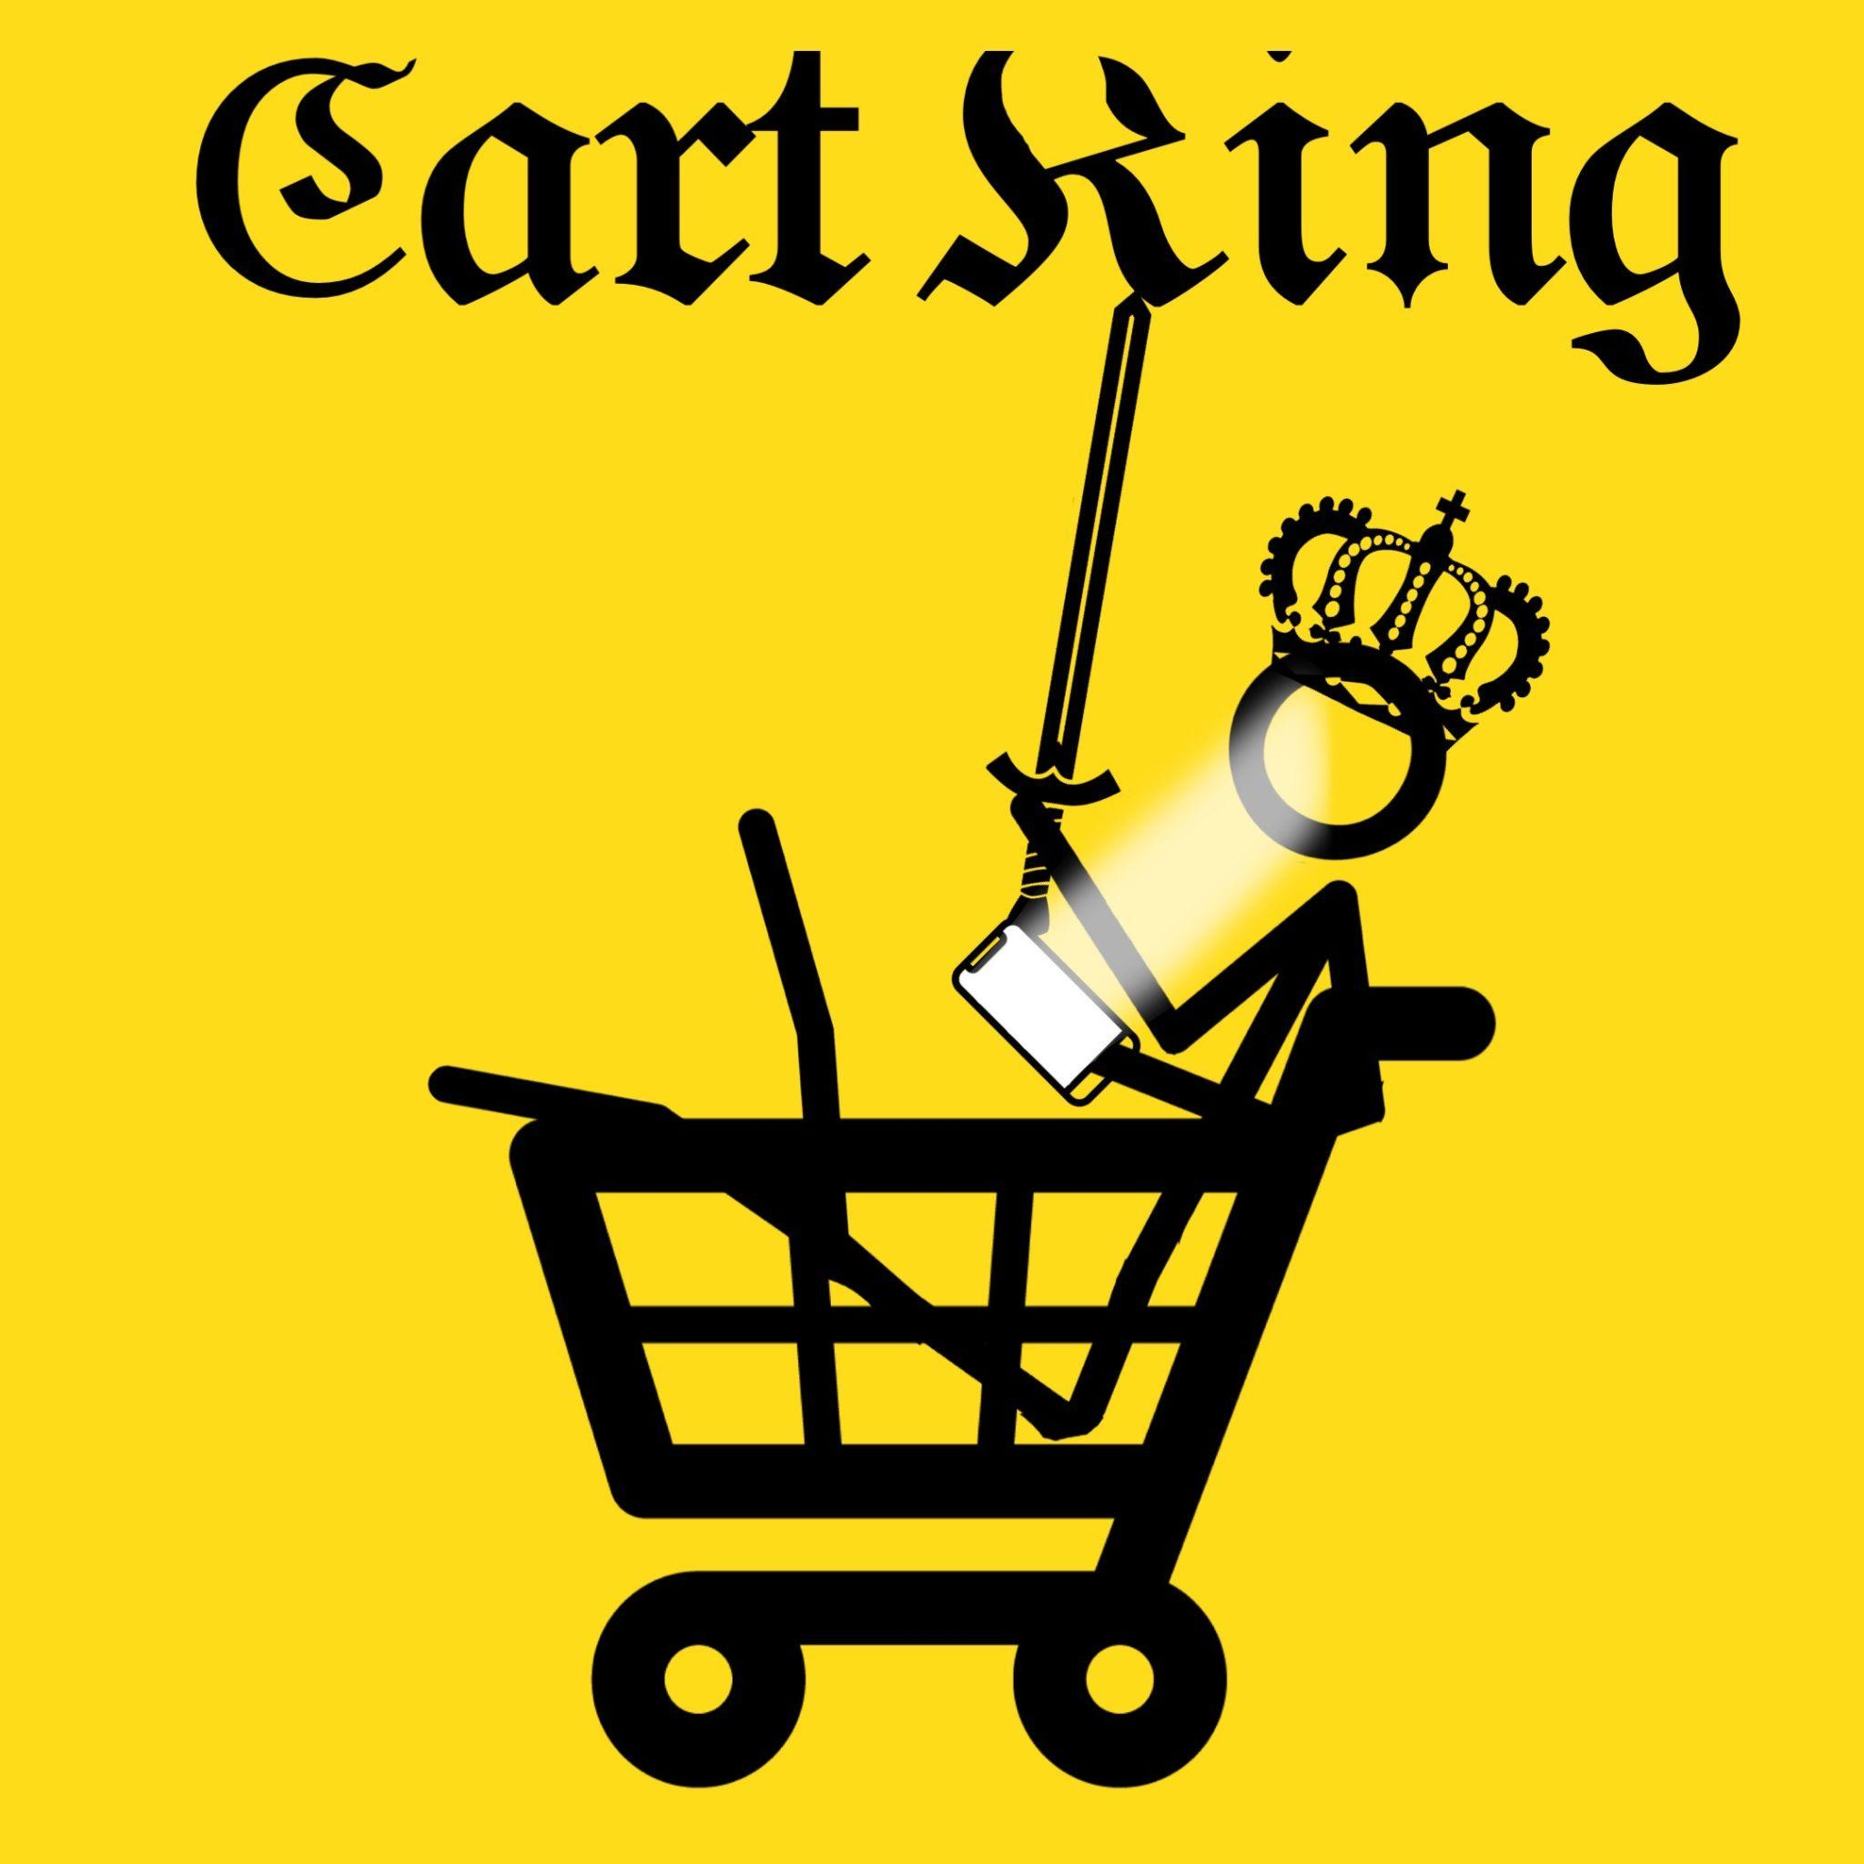

**TEAM 1:**

Mao Tabuchi (301266182)

Sona Sheena Biju (301238987)

Rachael Ajayi (301146832)

Nabin Dotel (301281044)

Gian Desiderio (301296686)

Aryan Badial(301289684)

Software Development Project 1 (COMP 231)

Eduardo Santana Severino

21th Jan, 2024

# Table of Content

**Table of Content 2**

**A. Executive Summary 3**

**B. Business Objectives 3**

**Business Need 3**

**Business Opportunity 3**

**Business Objectives 4**

**Product Description (Solution) 4**

**Deliverables 5**

**C. Project Description 5**

**Technical requirements 5**

**D. Project Approval Form 7**

**E. Team member’s signatures 7**

# **A. Executive Summary**

Introducing Cart King, an innovative grocery app that transforms how you shop and cook. Unlike conventional services, Cart King offers users a unique platform that simplifies ingredient procurement and enhances culinary skills through innovative features. The application provides a diverse range of recipes, each accompanied by a direct shopping link for seamless and convenient ingredient purchases.

Powered by AI, it personalized recommendations, creates convenient shopping lists, and offers engaging video tutorials to enhance your cooking skills. With its innovative features and user-friendly interface, Cart King redefines the way people approach cooking and grocery shopping, making it an indispensable tool for food enthusiasts.

Beyond its functionality, Cart King fosters community by encouraging users to share and discover delightful recipes. This collaborative aspect adds a social dimension to the application, creating a vibrant platform for culinary enthusiasts.

# **B. Business Objectives**

## **Business Need**

Cart King was founded in response to market demand for a more convenient and varied grocery shopping experience. As the demand for such solutions increased, there was a potential to develop a platform that went beyond traditional supermarket applications. Cart King was born out of a desire to diversify and innovate the supermarket buying scene. Recognizing the trend of rising interest in culinary discovery and community interaction, Cart King intends to create a lively culinary community where users can share and discover new recipes, fostering a sense of connection and inspiration among its members.

## **Business Opportunity**

Cart King's vision extends to collaborating with local businesses, forming partnerships with local grocery stores, and supporting the local economy. This not only expands the user base but also provides customers with a more diverse range of items. Another significant opportunity is the addition of premium features such as advanced recipe suggestions, unique discounts, and personalized culinary content. This strategic approach enables Cart King to generate revenue while also adding value to users who are prepared to invest in a better experience. Furthermore, data collected through user interactions provides an opportunity to get significant insights into customer behavior, preferences, and market trends, allowing for more informed decision-making.

## **Business Objectives**

Cart King seeks to increase user engagement by 20% per month through recipe exploration and community participation. They aim to establish partnerships with at least 50 local grocery stores within the first year to improve product availability.

Cart King intends to launch a premium subscription model that targets 10% of its user base, generates 15% income, and improves customer satisfaction by 15%. AI-powered features and a comprehensive data analytics system are also critical for ongoing optimization and growth, in line with the company's vision for a leading grocery and culinary platform.

## **Product Description (Solution)**

**Solution description:**

In alignment with the identified business needs, objectives, and opportunities, Cart King is a web application that offers a variety of personalized recipes by AI to the customers and provides information about the link for the ingredient procurement. Cart King sets itself unique from traditional grocery apps by using AI intelligence to create healthily balanced meal ideas. This responds to the market's demand for new grocery solutions while remaining consistent to improve and broaden the shopping experience. The incorporation of AI guarantees that users receive personalized recipe suggestions, making their culinary journey more interesting and delightful. Furthermore, Cart King directly addresses the need to reduce wasteful food expenditures, providing a solution that is consistent with the current focus on sustainability.

**Benefits:**

* Balanced meal menus by AI
* Purposeful Shopping
* Time-Efficient Meal Planning
* Cost Savings and Budget-Friendly Options

**Criteria for Success:**

* 10% Increase in App Users Within 6 Months
* Over 100 reviews and 75% of user satisfaction

## **Deliverables**

**Deliverables include:**

* User-friendly web application for browsing and selecting ingredients and recipes
* Linked ingredients for the selected recipes (this includes the quantity of ingredients required)
* Responsive web design for various devices
* Frontend, backend and database will be deployed on one cloud provider

**Deliverables excludes:**

* non-culinary elements / inorganic materials

# **C**. **Deliverable overview**

Cart King stands out by leveraging AI to create healthily balanced meal ideas, addressing market demands for innovative grocery solutions. The AI guarantees personalized recipe suggestions, making the culinary journey interesting and delightful. The application also contributes to sustainability by reducing wasteful food expenditures.

## **Technical requirements**

**Frontend (React):**

**Deliverables:**

* Intuitive user interface for seamless navigation.
* Responsive design for optimal user experience across devices.
* Integration of personalized recipe suggestions and direct shopping links.

**Backend (Node.js and Express):**

**Deliverables:**

* AI-driven recommendation system for precise recipe suggestions.
* RESTful API endpoints for communication between frontend and database.
* Implementation of user authentication and data security measures.

**Database (MongoDB):**

**Deliverables:**

* Storage of user profiles, preferences, and personalized recipe data.
* Efficient handling of direct shopping links and ingredient information.
* Integration with the backend for seamless data retrieval and updates.

**Deployment (Render):**

**Deliverables:**

* Application deployment on a designated cloud provider for scalability and reliability.
* Cloud-based infrastructure to support the frontend, backend, and database components.

The use of React ensures a modern and interactive user interface, while Node.js and Express provide a robust and scalable backend for AI-driven features. MongoDB, a NoSQL database, allows for efficient storage and retrieval of user and recipe data. The deployment on a specific cloud provider(Render) ensures optimal performance, scalability, and reliability.

**Cart King’s Scope Includes:**

* Making the Cart King mobile app user-friendly.
* Using AI to provide customized recipe recommendations.
* Including direct shopping links to make purchasing ingredients simple.
* Including video lessons to improve culinary abilities.
* Community Integration for a user-friendly platform for sharing.

**Cart King’s Scope Does Not Include:**

* Actual grocery delivery.
* Including non-culinary elements.

**Completion Criteria (Deliverables):**

* Introducing an intuitive user experience for the Cart King app.
* An AI system that offers precise recipe recommendations.
* Seamless links for direct shopping.
* Cooking skills tutorials through videos.
* Wide Range of Non-Menu Items

**Measures of Project Success:**

* In three months, a 20% rise in user engagement is to be attained.
* Achieving a 15% increase in monthly active users in less than six months.
* 4.5 out of 5 on average, indicating positive user satisfaction.
* user comments pointing to a simplified and easy-to-use process.

# **D. Project Approval Form**

I, Eduardo Santana Severino, have reviewed the information contained in this document and approved the project proposal.

__________________________ _________________________

Signature Date

# **E. Team member’s signatures**

Mao Tabuchi 22th Jan 2024

Signature Date



Gian Desiderio 22th Jan 2024

Signature Date



Nabin Dotel 22th Jan 2024

Signature Date



Sona Sheena Biju 22th Jan 2024 

Signature Date

Rachael Ajayi 22th Jan 2024

Signature Date



Aryan Badial 23th Jan 2024

Signature Date