標題：線上投資分析
製作人：四資四乙 1102137201 孫尉甯
製作工具：HTML5、CSS、JavaScript、PHP5.5
測試環境需求(Requirements)：需安裝WAMPServer
測試說明：將檔案解壓縮到wamp64/www底下，並執行WAMPServer
輸入localhost/webstock-compare即可測試。
其他說明：
可以從以下網址進入：https://goo.gl/zsKrDm
或是掃描壓縮檔內的QR Code
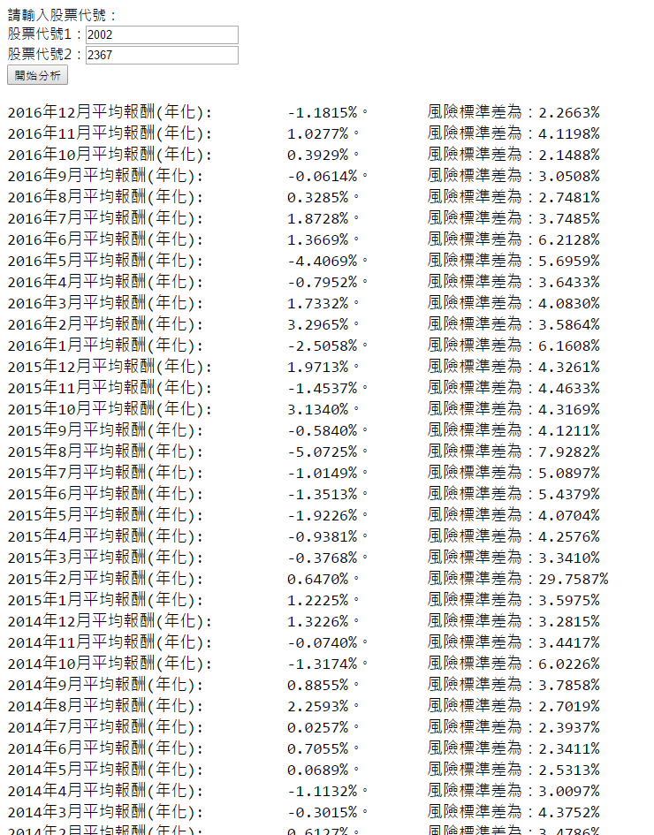
預覽：
以下是程式碼內容：
1.index.html
<!DOCTYPE html>
<html>
<head>
<title>線上投資分析</title>
<meta charset="utf-8">
<link rel="stylesheet" type="text/css" href="./homepage.css">
<script type="text/javascript" src="./analyze.js"></script>
<script type="text/javascript" src="./math.js"></script>
</head>
<body>
請輸入股票代號：
<div id="stock1">
股票代號1：<input type="text" id="stock1-input">
</div>
<div id="stock2">
股票代號2：<input type="text" id="stock2-input">
</div>
<button id="sendTrigger" onclick="startCompare()">開始分析</button>
<div id="loading-area"></div>
<pre id="Avgmonth-opt"></pre>
<div id="std-opt"></div>
</body>
</html>
2.analyze.js
function startCompare() {
var stock1 = document.getElementById('stock1-input');
var stock2 = document.getElementById('stock2-input');
var s1Value = stock1.value;
var s2Value = stock2.value;
loadphp(s1Value,s2Value);
}

var stock1json,stock2json;
var stock1str=[],stock2str=[];
var stockresult = document.getElementById("result-area");

function loadphp(str1,str2){
var xhttp = new XMLHttpRequest();
xhttp.onreadystatechange = function() {
if (this.readyState === 4 && this.status === 200) {
var type = this.getResponseHeader("Content-Type");
var catchJSON = JSON.parse(this.responseText);
var temp = null ;
stock1json = catchJSON.obj1;
stock2json = catchJSON.obj2;
convertTostring(stock1json,"1");
convertTostring(stock2json,"2");
AllCalc();
}
};
xhttp.open("GET", "csvdecrypt.php?s1="+str1+"&s2="+str2, true);
xhttp.send();
}

function convertTostring(json,number){
var json = JSON.parse(json);
var tempDate = json["Date"];
var tempPrice = json["Adj Close"];
for (var i = 0 ; i < tempPrice.length ; i++) {

if (number === "1") {
stock1str[i] = [];
}
else if (number === "2") {
stock2str[i] = [];
}
for (var j = 0; j < 2; j++) {
if (number === "1") {
if (j === 0) {
stock1str[i][j] = tempDate[i];
}
else{
stock1str[i][j] = tempPrice[i];
}
}
else if (number === "2") {
if (j === 0) {
stock2str[i][j] = tempDate[i];
}
else{
stock2str[i][j] = tempPrice[i];
}
}
}
}
}

function AllCalc(){
var curdate1 = null;
var curdate2 = null;
var judgeUsingDate = null;
var shortestLength = null;
var iLength=0;
var r1,r2,rpSum = 0,AvgPerMonth = [],TotalAvg = 0,AvgTime = [],rpArr = [],rpStd = [];
var std = 0;
if (stock1str.length > stock2str.length) {
iLength = stock2str.length;
}
else if(stock1str.length < stock2str.length){
iLength = stock1str.length;
}
else if(stock1str.length === stock2str.length){
iLength = stock1str.length;
}
var curMonth = null;
var AvgCount = 0;
var rpArrCount = 0;
for (var i = 0; i < iLength - 1; i++) {

curdate1 = new Date(stock1str[i][0]);
curdate2 = new Date(stock2str[i][0]);
if (curMonth === null) {
if (iLength === stock1str.length) {
curMonth = curdate1.getMonth();
curYear = curdate1.getFullYear();
}
else{
curMonth = curdate2.getMonth();
curYear = curdate2.getFullYear();
}
}
if (iLength === stock1str.length) {
judgeUsingDate = curdate1;
}
else{
judgeUsingDate = curdate2;
}
if(curdate1.getTime() === curdate2.getTime() && curMonth != curdate1.getMonth() || (curdate1.getFullYear() === 2010 && curdate1.getMonth() === 0 && curdate1.getDate() === 5 || curdate2.getFullYear() === 2010 && curdate2.getMonth() === 0 && curdate2.getDate() === 5)){
AvgPerMonth[AvgCount] = rpSum / (daysInMonth(curdate1.getFullYear(),curMonth));
AvgTime[AvgCount] = curYear + "年" + (curMonth+1) + "月平均報酬(年化): ";
rpStd[AvgCount] = math.std(rpArr) * math.sqrt(12);
AvgCount += 1;
rpSum = 0;
rpArrCount = 0;
curMonth = curdate1.getMonth();
curYear = curdate1.getFullYear();
rCalc(stock1str[i][1],stock1str[i+1][1],stock2str[i][1],stock2str[i+1][1]);
}
else if(curdate1.getTime() === curdate2.getTime() && curMonth === curdate1.getMonth()){
rCalc(stock1str[i][1],stock1str[i+1][1],stock2str[i][1],stock2str[i+1][1]);
}
else{
var stockTemp1,stockTemp2,funcParam;
if (curdate1.getTime() > curdate2.getTime()) {
funcParam = "1";
}
else{
funcParam = "2";
}
for (var j = i; j < iLength-1; j++) {
if (curdate1.getTime() > curdate2.getTime()) {
curdate1 = new Date(stock1str[j][0]);
stockTemp1 = stock1str[j][1];
stockTemp2 = stock1str[j+1][1];
}
else if(curdate1.getTime() < curdate2.getTime()){
curdate2 = new Date(stock2str[j][0]);
stockTemp1 = stock2str[j][1];
stockTemp2 = stock2str[j+1][1];
}
else{
break;
}
}
if (funcParam === "1") {
rCalc(stockTemp1,stockTemp2,stock2str[i][1],stock2str[i+1][1]);
}
else if(funcParam === "2"){
rCalc(stock1str[i][1],stock1str[i+1][1],stockTemp1,stockTemp2);
}
}
}
function rCalc(p10,p11,p20,p21){
r1 = math.log(p10/p11);
r2 = math.log(p20/p21);
rpSum += 0.5*r1+0.5*r2;
rpArr[rpArrCount] = 0.5*r1+0.5*r2;
rpArrCount += 1;
}
var AvgMOpt = "";
var AvgToYear = [];
for (var i = 0; i < AvgPerMonth.length; i++) {
AvgToYear[i] = AvgPerMonth[i]*12;
AvgMOpt += AvgTime[i] + " " + (AvgPerMonth[i]*12*100).toFixed(4) + "%。 風險標準差為：" + (rpStd[i]*100).toFixed(4) + "%<br>";
}
std = math.std(AvgToYear)*math.sqrt(12)*100;
document.getElementById("Avgmonth-opt").innerHTML = AvgMOpt ;
}

function daysInMonth(year, month) {
return new Date(year, month, 0).getDate();
}
3.homepage.css
pre{
font-size: 18px;
}
4.csvdecrypt.php
<?php
$stock1 = $_GET['s1'];
$stock2 = $_GET['s2'];

$stock1html = "http://chart.finance.yahoo.com/table.csv?s=" . $stock1 . ".TW&a=0&b=4&c=2010&d=11&e=30&f=2016&g=d&ignore=.csv";
$stock2html = "http://chart.finance.yahoo.com/table.csv?s=" . $stock2 . ".TW&a=0&b=4&c=2010&d=11&e=30&f=2016&g=d&ignore=.csv";
$result1 = array();
if (($handle = fopen($stock1html, "r")) !== FALSE) {
$column_headers = fgetcsv($handle); // read the row.
foreach($column_headers as $header) {
$result1[$header] = array();
}

while (($data = fgetcsv($handle)) !== FALSE) {
$i = 0;
foreach($result1 as &$column) {

$column[] = $data[$i++];
}

}
fclose($handle);
}
$json1 = json_encode($result1);

$result2 = array();
if (($handle = fopen($stock2html, "r")) !== FALSE) {
$column_headers = fgetcsv($handle);
foreach($column_headers as $header) {
$result2[$header] = array();
}

while (($data = fgetcsv($handle)) !== FALSE) {
$i = 0;
foreach($result2 as &$column) {

$column[] = $data[$i++];
}

}
fclose($handle);
}
$json2 = json_encode($result2);

$jsonarr = array("obj1" => $json1 , "obj2" => $json2);
echo json_encode($jsonarr);
?>

