Storage Capacity Analysis

Nicolas Genibre

September 26, 2016

## Introduction

What is the Storage Capacity looks like for the NetApp cluster in Fort Lauderdale Laboratory?

For this Analysis we implemented the NetApp Perfstat tool to run on a schedule, for 16 days, and captured 48 iterations of 15 minutes each day using the following to determine capacity:

df -x -m (pre and prostats); df -A -m (pre and prostats); sysstat_x_1sec ; sysstat_x_5sec

## Clean Data

The raw data is composed of 32 files, 16 files per NetApp controller. Each files are plain text output containing the iterations for a day.

We're cleaning the data with the help of shell scripts to transform the data into a csv type file:

aggr.sh; vol.sh and the result is in the data directory as aggr.csv and vol.csv

myaggr <- read.csv("../data/aggr.csv")  
  
myvol <- read.csv("../data/vol.csv")

The **Time** is expressed in epoch date. There are two **Filers** in the Cluster.

**Total**, **Used** and **Free** capacity are measurements in MB. The **Ratio** is the expression in percentage of Used versus Total.

## Aggregate

library(dplyr)  
library(ggplot2)

head(myaggr)

## Time Filer Aggregate Total Used Free UsageRatio  
## 1 1472245275 netapp-02 n2_aggr0 376181 334807 41373 89  
## 2 1472245275 netapp-02 n2_aggr1 29718342 22655655 7062686 76  
## 3 1472247100 netapp-02 n2_aggr0 376181 334807 41373 89  
## 4 1472247100 netapp-02 n2_aggr1 29718342 22620766 7097575 76  
## 5 1472248921 netapp-02 n2_aggr0 376181 334807 41373 89  
## 6 1472248921 netapp-02 n2_aggr1 29718342 22661474 7056868 76

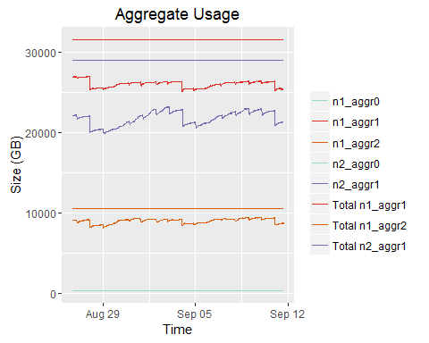

The Aggregate' used capacity has not change much from the beginning to the end of the data collection.

According the linear model we see a slight decrease of Aggregate 1 and increase of Aggregate 2 on Filer 1 over time. On Filer 2 the increase is larger for the Arggregate 2.

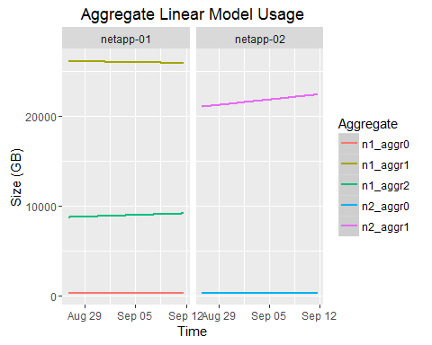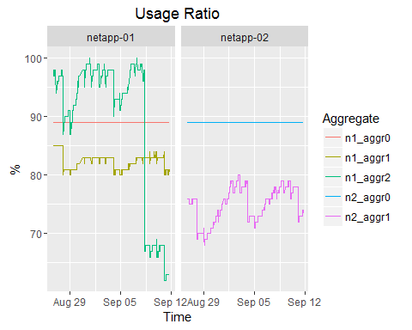

Aggregates are kept under the 85% threshold. During the collection we can see that one of the Aggregate on Filer 1 was increased.

## Volume

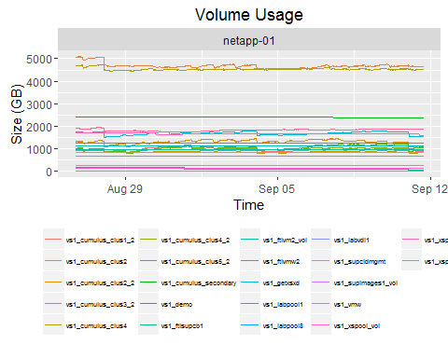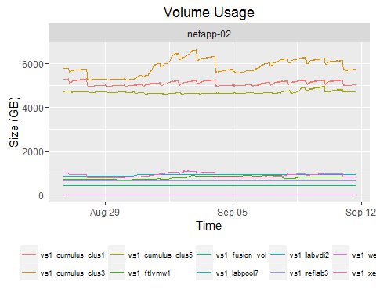

The top 5 volumes using the most capacity, and that are the most active, are the Cumulus volume, as we expected.

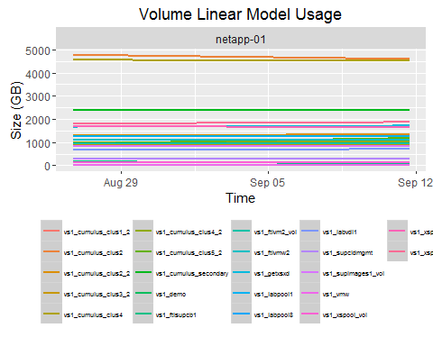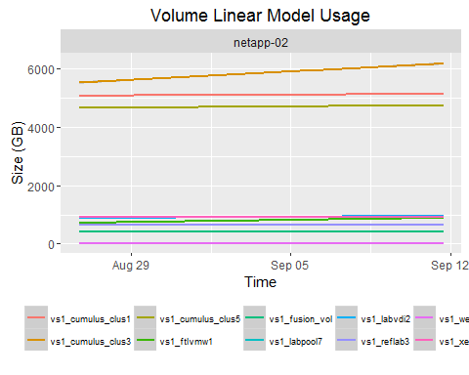

According the Model one volume, vs1_cumulus_clus3, has shown the biggest increase during its activity

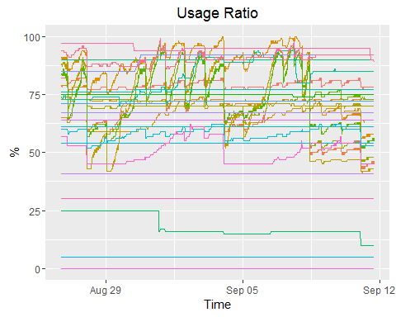

The volumes vs1_labvdi2, vs1_ftlvmw1, vs1_xspool3, vs1_ftlvm2_vol are above the 85% threshold and that happens during the all period of the data collection.