Diagramme de classe

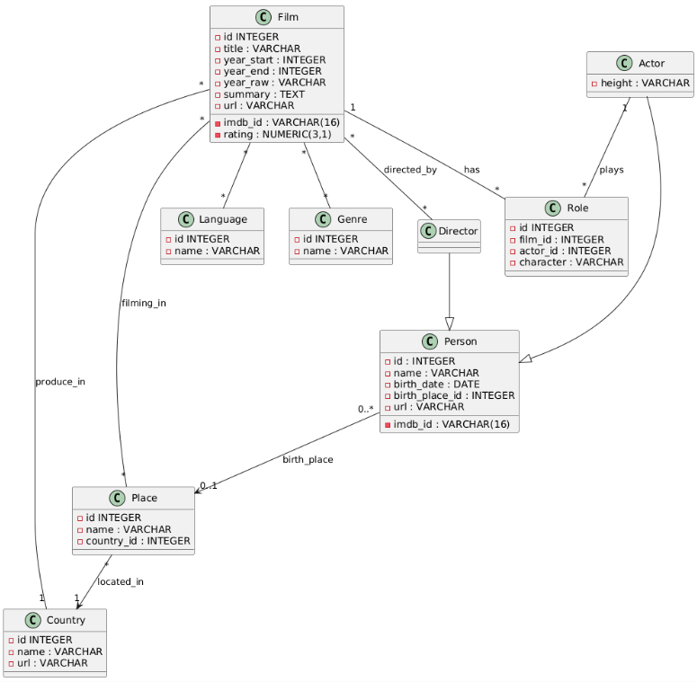

J’ai pas fait d’Énumération pour les langages et les genres pour en intégrer potentiellement des nouveaux au fur et à mesure.
Si j’ai mis la relation << Person "0..*" --> "0..1" Place : birth_place >>, c’est parce le fichier csv peut ne pas transmettre de lieu de naissance pour une personne.

Modèle Physique de données

-- TABLE LIEU
CREATE TABLE place (
id INTEGER PRIMARY KEY AUTO_INCREMENT,
name VARCHAR(255) NOT NULL UNIQUE,
country_id INTEGER REFERENCES country(id) ON DELETE SET NULL
);

-- TABLE PAYS
CREATE TABLE country (
id INTEGER PRIMARY KEY AUTO_INCREMENT,
name VARCHAR(128) NOT NULL UNIQUE,
url VARCHAR(255)
);

-- TABLE LANGAGE
CREATE TABLE language (
id INTEGER PRIMARY KEY AUTO_INCREMENT,
name VARCHAR(128) NOT NULL UNIQUE
);

-- TABLE GENRE
CREATE TABLE genre (
id INTEGER PRIMARY KEY AUTO_INCREMENT,
name VARCHAR(128) NOT NULL UNIQUE
);

-- TABLE ROLE
CREATE TABLE role (
id INTEGER PRIMARY KEY AUTO_INCREMENT,
film_id INTEGER NOT NULL REFERENCES film(id) ON DELETE CASCADE,
actor_id INTEGER NOT NULL REFERENCES actor(id) ON DELETE CASCADE,
character VARCHAR(255),
);

-- TABLE FILM
CREATE TABLE film (
id INTEGER PRIMARY KEY AUTO_INCREMENT,
imdb_id VARCHAR(16) UNIQUE,
title VARCHAR(512) NOT NULL,
year_start INTEGER,
year_end INTEGER,
year_raw VARCHAR(64),
rating NUMERIC(3,1),
summary TEXT,
url VARCHAR(255),
producer_country_id INTEGER REFERENCES country(id) ON DELETE SET NULL

);

-- TABLE PERSONNE
CREATE TABLE person (
id INTEGER PRIMARY KEY AUTO_INCREMENT,
imdb_id VARCHAR(16) UNIQUE,
name VARCHAR(255) NOT NULL,
birth_date DATE,
birth_place_id INTEGER REFERENCES place(id) ON DELETE SET NULL,
url VARCHAR(255)
);

-- TABLE ACTEUR
CREATE TABLE actor (
id INTEGER PRIMARY KEY REFERENCES person(id) ON DELETE CASCADE,
height VARCHAR(6)
);

-- TABLE REALISATEUR
CREATE TABLE director (
id INTEGER PRIMARY KEY REFERENCES person(id) ON DELETE CASCADE
);

-- DIFFERENTES TABLES DE RELATIONS
CREATE TABLE film_genre (
film_id INTEGER NOT NULL REFERENCES film(id) ON DELETE CASCADE,
genre_id INTEGER NOT NULL REFERENCES genre(id) ON DELETE CASCADE,
PRIMARY KEY (film_id, genre_id)
);

CREATE TABLE film_language (
film_id INTEGER NOT NULL REFERENCES film(id) ON DELETE CASCADE,
language_id INTEGER NOT NULL REFERENCES language(id) ON DELETE CASCADE,
PRIMARY KEY (film_id, language_id)
);

CREATE TABLE film_director (
film_id INTEGER NOT NULL REFERENCES film(id) ON DELETE CASCADE,
director_id INTEGER NOT NULL REFERENCES director(id) ON DELETE CASCADE,
PRIMARY KEY (film_id, director_id)
);

CREATE TABLE film_place (
film_id INTEGER NOT NULL REFERENCES film(id) ON DELETE CASCADE,
place_id INTEGER NOT NULL REFERENCES place(id) ON DELETE CASCADE,
PRIMARY KEY (film_id, place_id)
);

