Step 1:

Access Learning Hub then find you book you want to download -> Course preview like picture bellow

You’ve to note the book code at the URL

You will see total of page at right bottom corner.

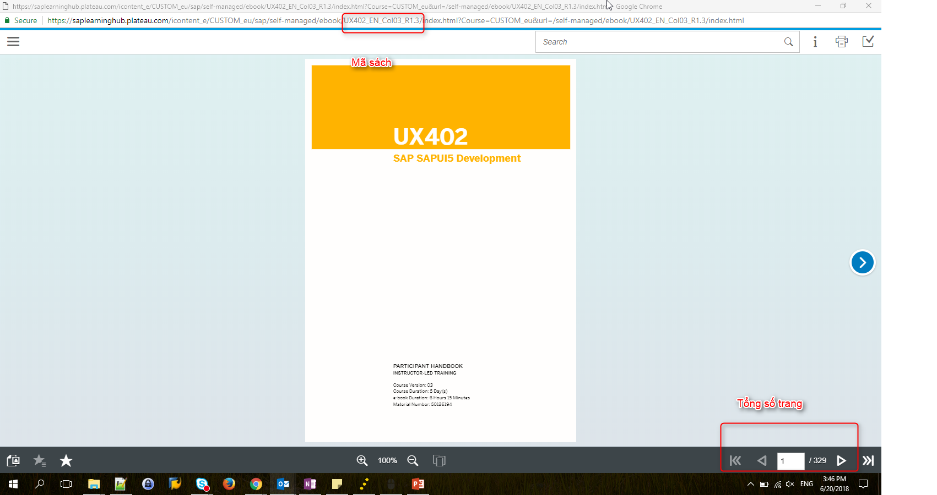

Step 1:  Then open dlSLHub.html (same browser you’ve login to sap hub)

Input1: Book Code

Input2: Total of Page

Then click Get book

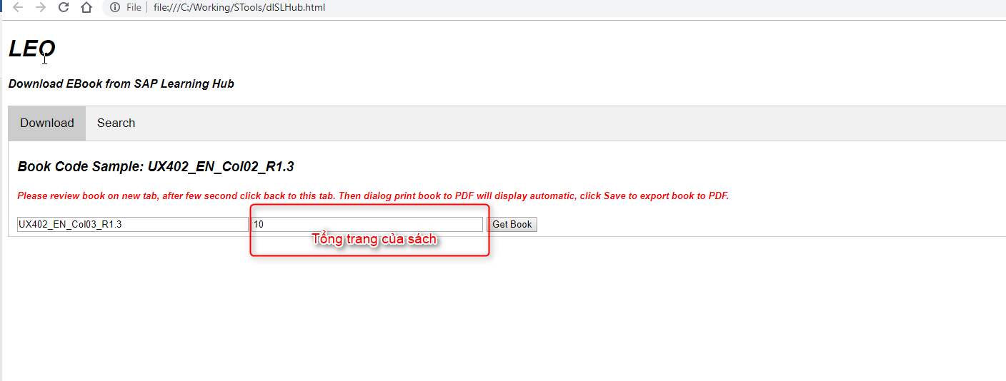

Step 2: wait a moment then save to PDF

