CS497 Assignment5

1. ML Web Server Description
   * This server processes a request by the client and sends a response. Web servers use GET and POST methods to take care of these tasks. This web servers receives a request from the client by receiving an uploaded image that will then run through a trained TensorFlow model that uses a combination of TensorFlow, Keras and numpy Machine Learning libraries and framework. The POST method sends data for prediction to determine what the image uploaded is.
2. Testing the Web Server and Clients
   * To run the server, simply open the folder where the server.py is located via command prompt or terminal. From here, you can execute the server.py file using the command: “python server.py” You can tell the server is running successfully with the message: “\* Running on http://127.0.0.1:5000/ (Press CTRL+C to quit)”
   * To run the client, simple open the folder where the client.bat file is located. This should be in the same location as the server.py file is. From here you can execute the client.bat file using the command: “client <imagename.png>” The second parameter is the name of the image file you are trying to upload.
   * Once executed, the client will receive a response from the server with an introductory description of the application, my name right underneath, today’s date, today’s time and the prediction of what the uploaded image is.
3. Screen Captures of Test Run
   * Running Server.py

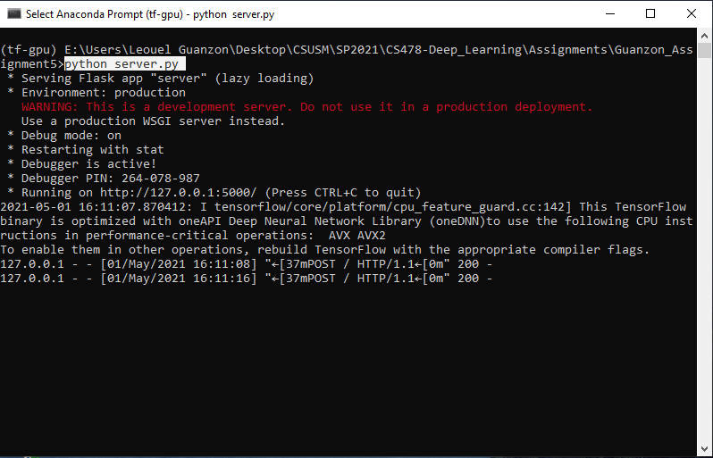

* + Client

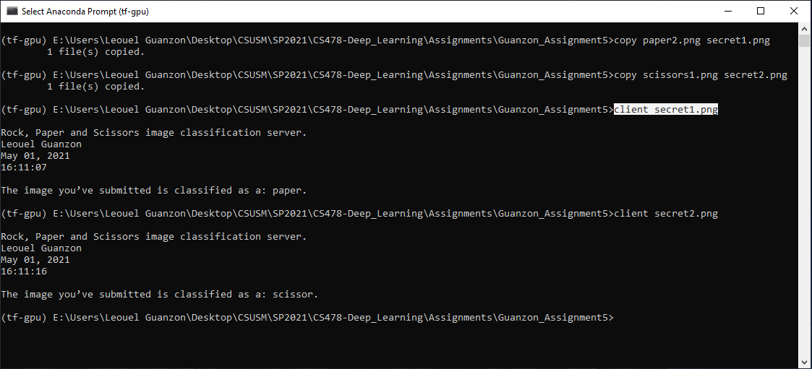

* + 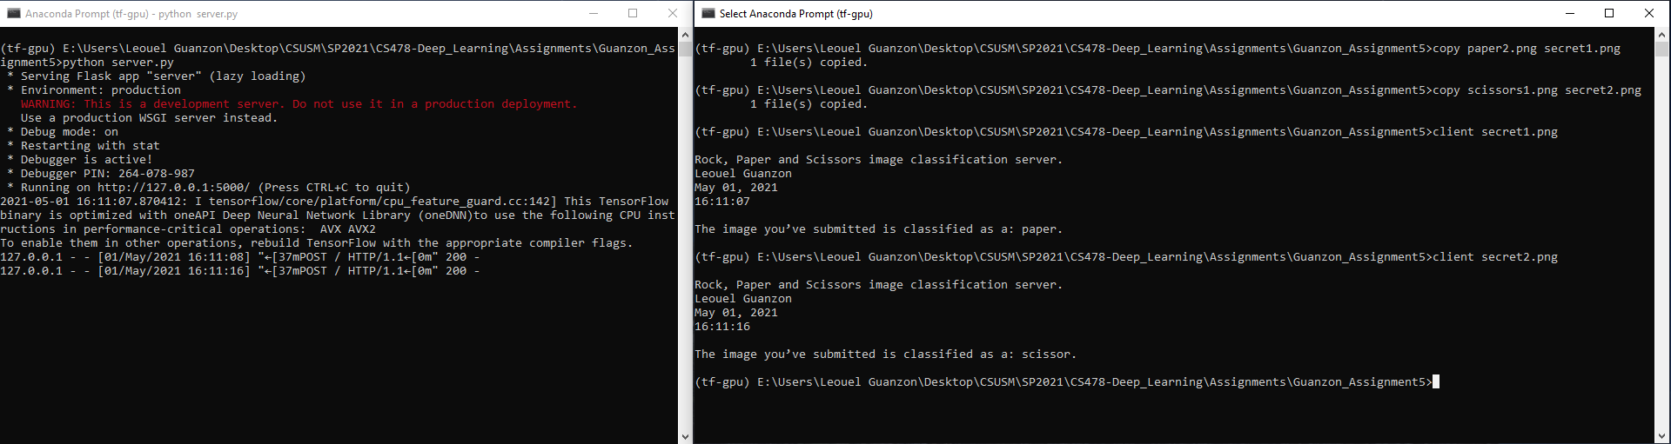Both Server and Client interactions