Introduction

Over the past 30 years, substantial effort has been directed to the estimation of 3D density-contrast distributions from gravity data inversion. Usually the inversion methods, like that of Li and Oldenburg (1998), produce blurred images of anomalous sources. On the other hand, methods for producing sharp images have been developed by Portniaguine and Zhdanov (2002) and Silva Dias et al. (2009). All previously mentioned methods require the solution of large linear systems, which can be computationally challenging for large problems. Attempts to overcome this problem include: the method of René (1986) that obtains 2D sharp and compact bodies by successively incorporating cells around pre-specified cells called “seeds” with known density contrasts; and the method of Camacho et al. (2000) that recovers sharp 3D bodies by means of a systematic search algorithm. We present a new 3D gravity gradient tensor inversion that uses “seeds” around which the density anomalies grow, like René (1986), and imposes compactness of the solution using a regularizing function like that of Silva Dias et al. (2009). Tests on synthetic data and on field data collected over iron deposits located in the Quadrilátero Ferrífero, southeastern region of Brazil, confirmed the potential of the method in producing sharp images of the ore body.

Forward modeling
Consider a data set composed of N observations of the anomalous gravity gradient tensor (GGT). We assume that these observations are due to density anomalies confined in a three-dimensional region R of the subsurface. In order to express these density anomalies as discrete values, the region R is divided into M juxtaposed right rectangular prisms composing the interpretative model. In this way, the GGT caused by the density anomalies can be approximated as the sum of the contribution of each prism using the formulas of Nagy, et al. (2000). Consider that each prism has a constant density contrast. It follows that the relationship between the GGT and the density contrast of each prism is linear and can be expressed in matrix notation as
, (1)
where d is the theoretical data vector, p is the parameter vector containing the density contrast of each prism, and G is the Jacobian matrix of partial derivatives with respect to the parameters.
Inverse problem

Solving the equation system shown in (1) for the vector p is an ill-posed problem and thus requires additional constraints. The chosen constraints for our method are that the solution is compact and concentrated around pre-specified prisms, henceforth referred to as “seeds”. These conditions can be imposed by means of a regularizing function. Following this approach, we formulate the inverse problem as finding the minimum of the goal function

, (2)

where µ is a regularizing parameter. The function is a measure of the data misfit and is a regularizing function similar to that of Silva Dias et al. (2009).

, (3)

where is the ith element of the parameter vector p, is a small and positive constant, is the distance between the ith prism and the seed to which it was accreted, and is the power to which is raised. This regularizing function serves a similar purpose to the “Reject” criterion of Rene (1986).

The minimum of the goal function is sought systematically by accreting prisms around the given set of “seeds”. This accretion consists of setting the density contrast of the prism equal to the density contrast of the seed to which it is accreted. Since different density contrasts can be assigned to each “seed”, our method can be used to solve for an arbitrary number of density anomalies each with a different density contrast.

Algorithm

Our algorithm requires a set of N_{S} seeds specified by the user beforehand. These seeds should be chosen according to prior information about the density anomalies, such as geologic models, well logs and previous inversions. Each seed consists of a prism of the interpretative model and thus the sth seed is described by a density contrast value and a position index in the parameter vector.

The algorithm starts with an initial estimate with all elements set to zero. Next, the seeds are included in the initial estimate by setting . An iteration of the algorithm consists of trying to grow each of the N_{S} seeds by performing the accretion of one of its neighbouring prisms. The accretion of a prism to the sth seed is performed in three steps. First, each available neighbour of the seed is temporarily added to the estimate, one at a time, and the data-misfit function and the goal function are evaluated for the current estimate including the neighbor. Each neighbor is added to the estimate with the density contrast of the sth seed. Second, a neighbor is chosen that both reduces the data-misfit function and provides the smallest value of the goal function. This chosen neighbor is then added permanently to the estimate. If none of the neighbors meets this criterion then the sth seed doesn’t grow in this iteration. Third, the neighbors of the accreted prism are appended to the sth seed’s neighbor list and the values of the goal and data-misfit functions are updated. These three accretion steps are repeated for each seed. After all seeds have tried to grow a new iteration is started. This process continues until none of the seeds are able to grow, which stops the algorithm and signifies that the data-misfit function cannot decrease further. Figure 1 shows a 2D sketch of three stages of the algorithm: the starting configuration; the end of the first iteration; and the final solution.

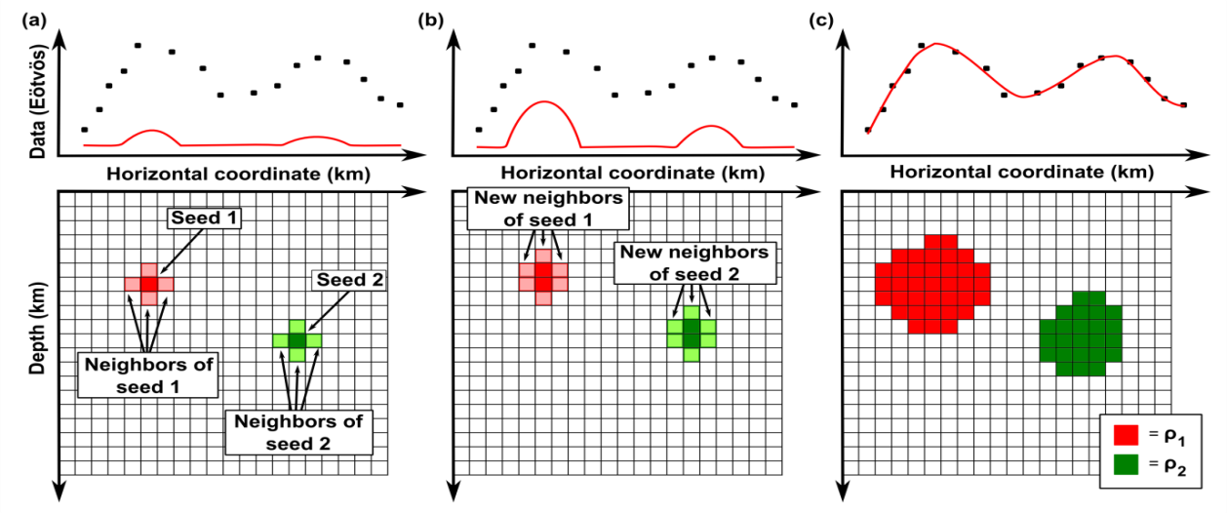

Figure 1 2D sketch of three stages of the algorithm. (a) Starting configuration using two seeds, one shown in dark red and the other in dark green. The neighbours of the red and green seeds are shown in light red and light green, respectively. (b) State of the solution after the first iteration. (c) The final result of the inversion after the algorithm stops showing compact bodies.
One of the main advantages of our algorithm is that it does not require that an equation system be solved. More importantly, the full Jacobian matrix G is unnecessary at any one time since the search is limited to neighbouring prisms of the current solution. Therefore, the columns of G can be calculated on demand as new neighbours are added during an accretion. This technique is known in computer science as “lazy evaluation”. Furthermore, after a prism is accreted to the solution the corresponding column of the Jacobian matrix is no longer needed and can be deleted to save computer memory. This results in fast inversion times and low memory usage, allowing the inversion of large data sets using fine meshes without the need for supercomputers or data compression algorithms (Portniaguine and Zhdanov, 2002).

Application to synthetic data

Figure 2 shows the synthetic FTG (Full Tensor Gradiometry) data produced by a model composed of four right rectangular prisms with different density contrasts, depths and geometries (Figure 3a). All six components were calculated at 150 meter height in order to simulate an airborne survey. Furthermore, a pseudorandom Gaussian error with zero mean and standard deviation of 2 Eötvös was added to the synthetic data to represent measurement errors. Each tensor component was calculated on 2500 points, totalling a data set of 15,000 measurements. Using this data set, an inversion was performed using the 18 seeds shown in Figure 3b and an interpretative model composed of 25,000 juxtaposed rectangular prisms. The inversion results in Figure 3c show that our method yields compact results that very closely resemble the true form of the four prisms, regardless of their depth. Also, when ran on a computer with an Intel Centrino 2.0 GHz processor, the total time needed for the inversion was approximately 7 minutes.

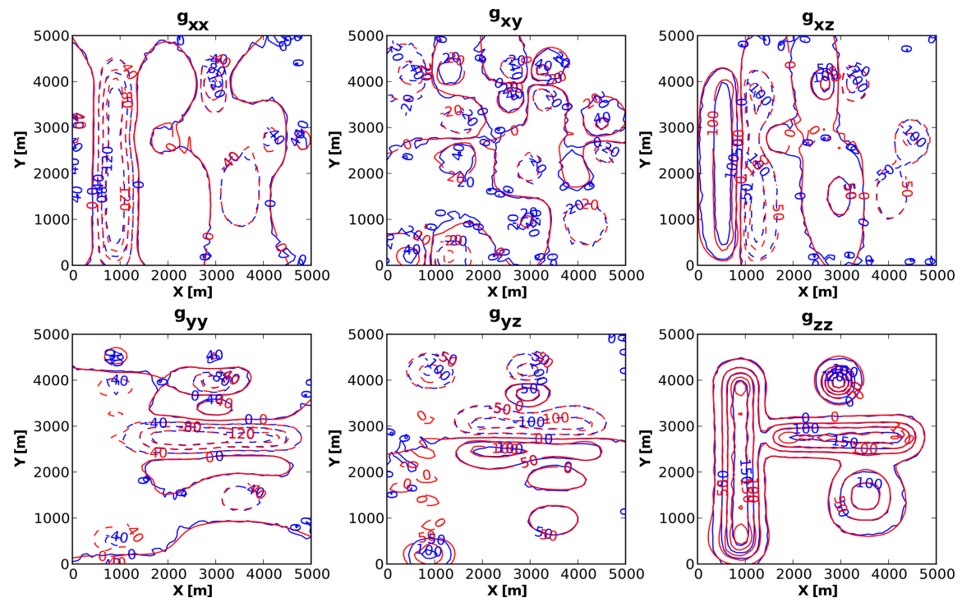

Figure 2 Test using noise-corrupted synthetic FTG data. Synthetic data shown in blue lines and data predicted by the inversion in red lines.

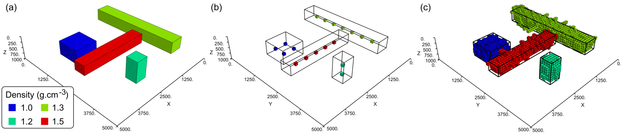

Figure 3 Test using synthetic FTG. (a) Synthetic model composed of four right rectangular prisms. (b) Seeds provided to the inversion algorithm. (c) Inversion result. The black lines in (b) and (c) are the contour of the simulated prisms shown in (a).

Application to real data
We apply our algorithm to an FTG survey over iron ore deposits of the Cauê Itabirite in Minas Gerais, Brazil. As a preliminary study, we only used the component (Figure 4a) in the inversion. The data set contains 482 measurements and was terrain corrected using a density of . In the inversion we use a 3D mesh composed of 62,519 prisms that included the topography of the area (Figure 4c) and a set of six seeds shown in Figure 5a. The location of the seeds was chosen based on the component map and previous geologic models of the area. Meanwhile, their density contrast was chosen assuming that the iron ore deposits have a density of , which results in a density contrast of . Figure 4b shows that the data predicted by the inversion fits the large scale features of the measured data reasonably well, taking into account that few seeds were used. In order to obtain a better data fit more seeds would have to be provided, requiring additional geologic information, such as well logs, that were as of yet unavailable. Figures 5b and 5c show the estimated 3D density model which is composed of a series of compact geologic bodies that agree with previous interpretations (Martinez et al., 2010).
Conclusions
We have presented a new method for the 3D inversion of gravity gradient data that uses a systematic search algorithm. Prior information is incorporated into the solution by means of prismatic elements called “seeds” around which the solution is concentrated. Large data sets and fine interpretative models can be easily handled by implementing a “lazy evaluation” of the Jacobian matrix. Synthetic and field data tests show that our method is able to recover compact bodies with different density contrasts that produce strongly interfering gravitational effects. Moreover, our method is able to handle irregularly sampled data and irregular meshes that incorporate the topography of the area.

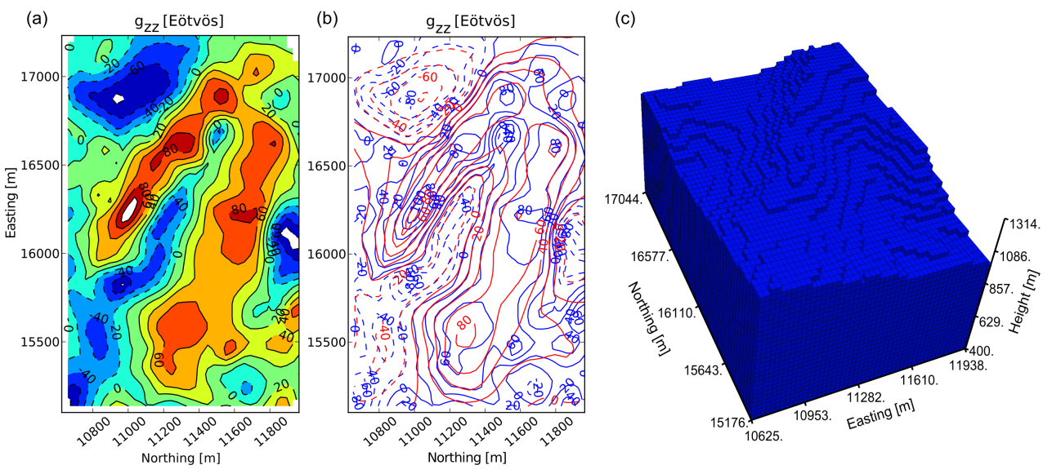

Figure 4 Application to real FTG data. (a) component data used in the preliminary inversion. (b) Measured data in blue lines and data predicted by the inversion in red lines. (c) Interpretative model mesh including the topography of the region.
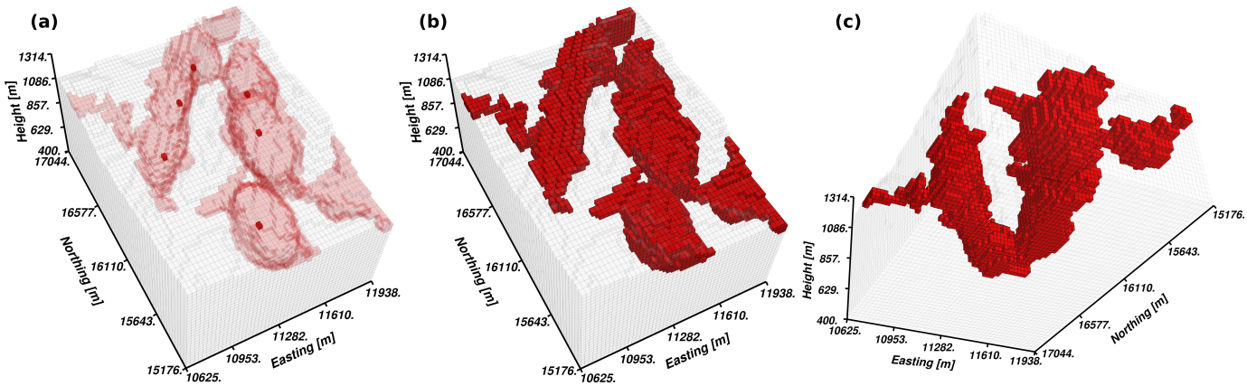
Figure 5 Inversion result from the application to real FTG data. (a) Dark red cells represent the seeds provided to the inversion algorithm while light red cells represent the inversion result. (b) Top view of the inversion result. (c) Bottom view of the inversion result. Only prisms with positive density contrast of are shown.
Acknowledgements
This research is supported by the Brazilian agencies CNPq and CAPES. We thank Vale for permission to use the real FTG data.
References
Camacho, A. G., Montesinos, F. G. and Vieira, R. [2000] Gravity inversion by means of growing bodies. Geophysics, 65(1), 95–101.
Li, Y. and Oldenburg, D. W. [1998] 3-D inversion of gravity data. Geophysics, 63(1), 109-119.
Martinez, C., Li, Y., Krahenbuhl, R. and Braga, M. [2010] 3D Inversion of airborne gravity gradiomentry for iron ore exploration in Brazil. 80th Annual International Meeting, SEG, Expanded Abstracts, 1753–1757.
Nagy, D., Papp, G., Benedek, J. [2000] The gravitational potential and its derivatives for the prism. Journal of Geodesy, 74, 552–560.
Portniaguine, O., Zhdanov, M. S. [2002] 3-D magnetic inversion with data compression and image focusing. Geophysics, 67(5), 1532–1541.
René, R. M. [1986] Gravity inversion using open, reject, and “shape-of-anomaly” fill criteria: Geophysics, 51(4), 988–994.
Silva Dias, F. J. S., Barbosa, V.C.F. and Silva, J.B.C [2009] 3D gravity inversion through an adaptive-learning procedure. Geophysics, 74(3), I9–I21.

