Supplementary Figures
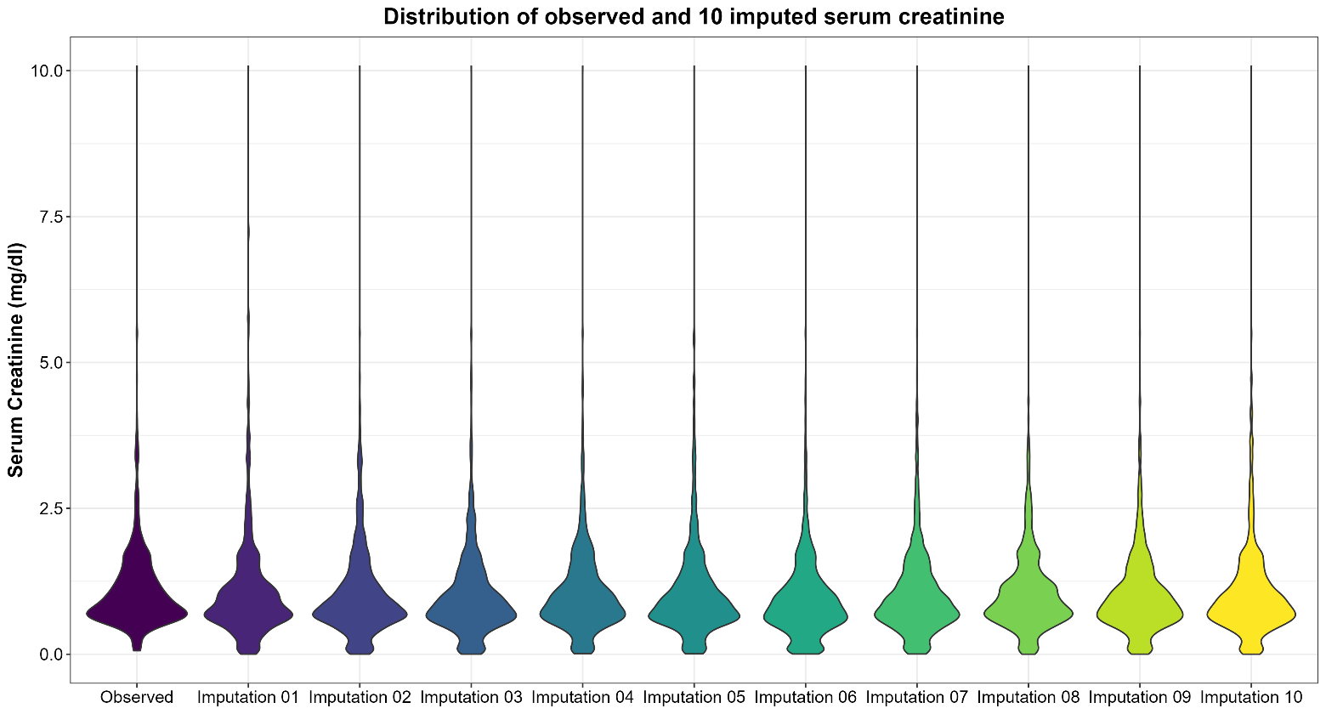
Fig. S1. Violin plot showing the distribution of 10 imputed sets of serum creatinine values and the observed one.

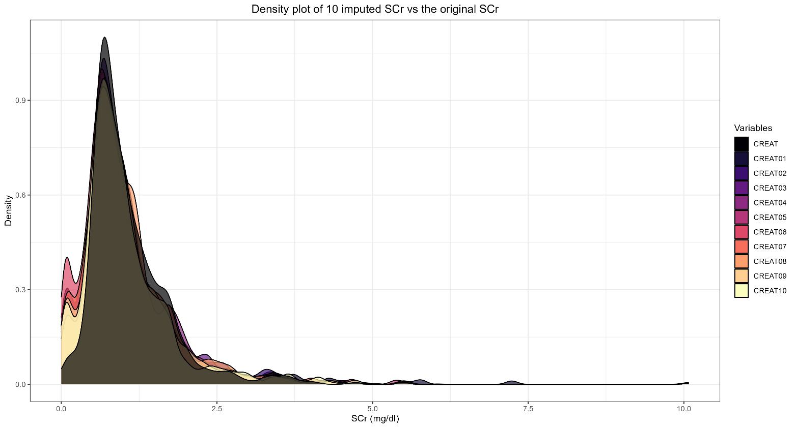
Fig. S2. Density plot showing the distribution of 10 imputed sets of serum creatinine values and the observed one.

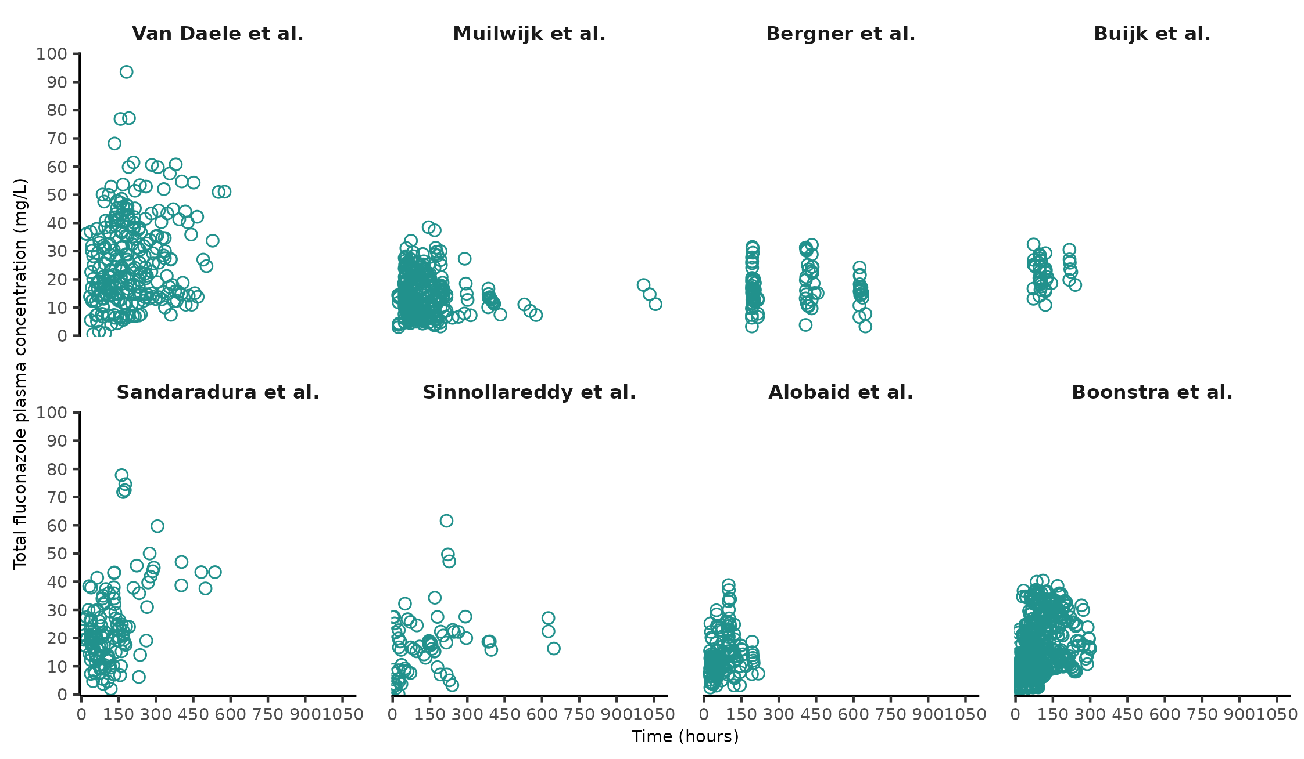Fig. S3. Observed concentration vs Time per study centre.
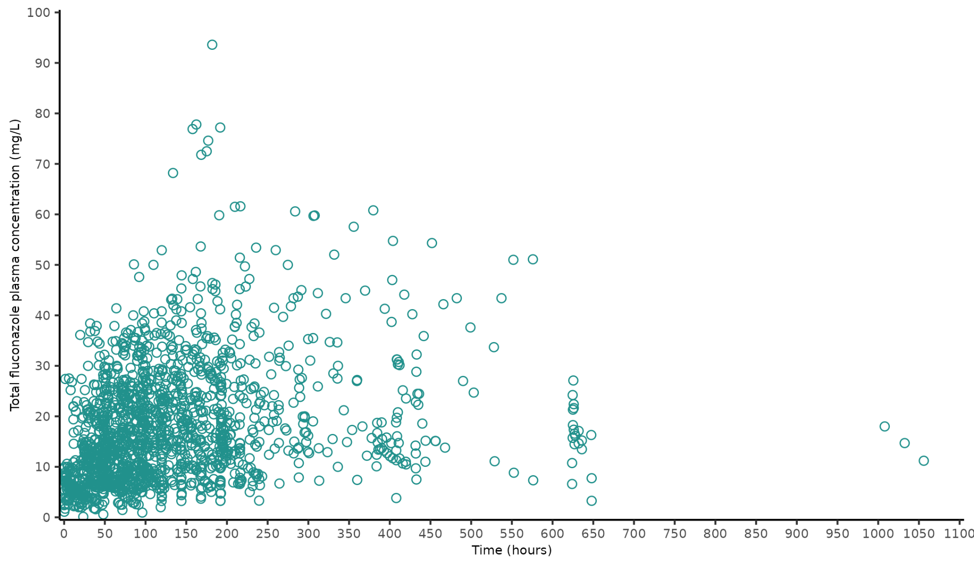
Fig. S4. Observed concentration vs Time of the overall data.
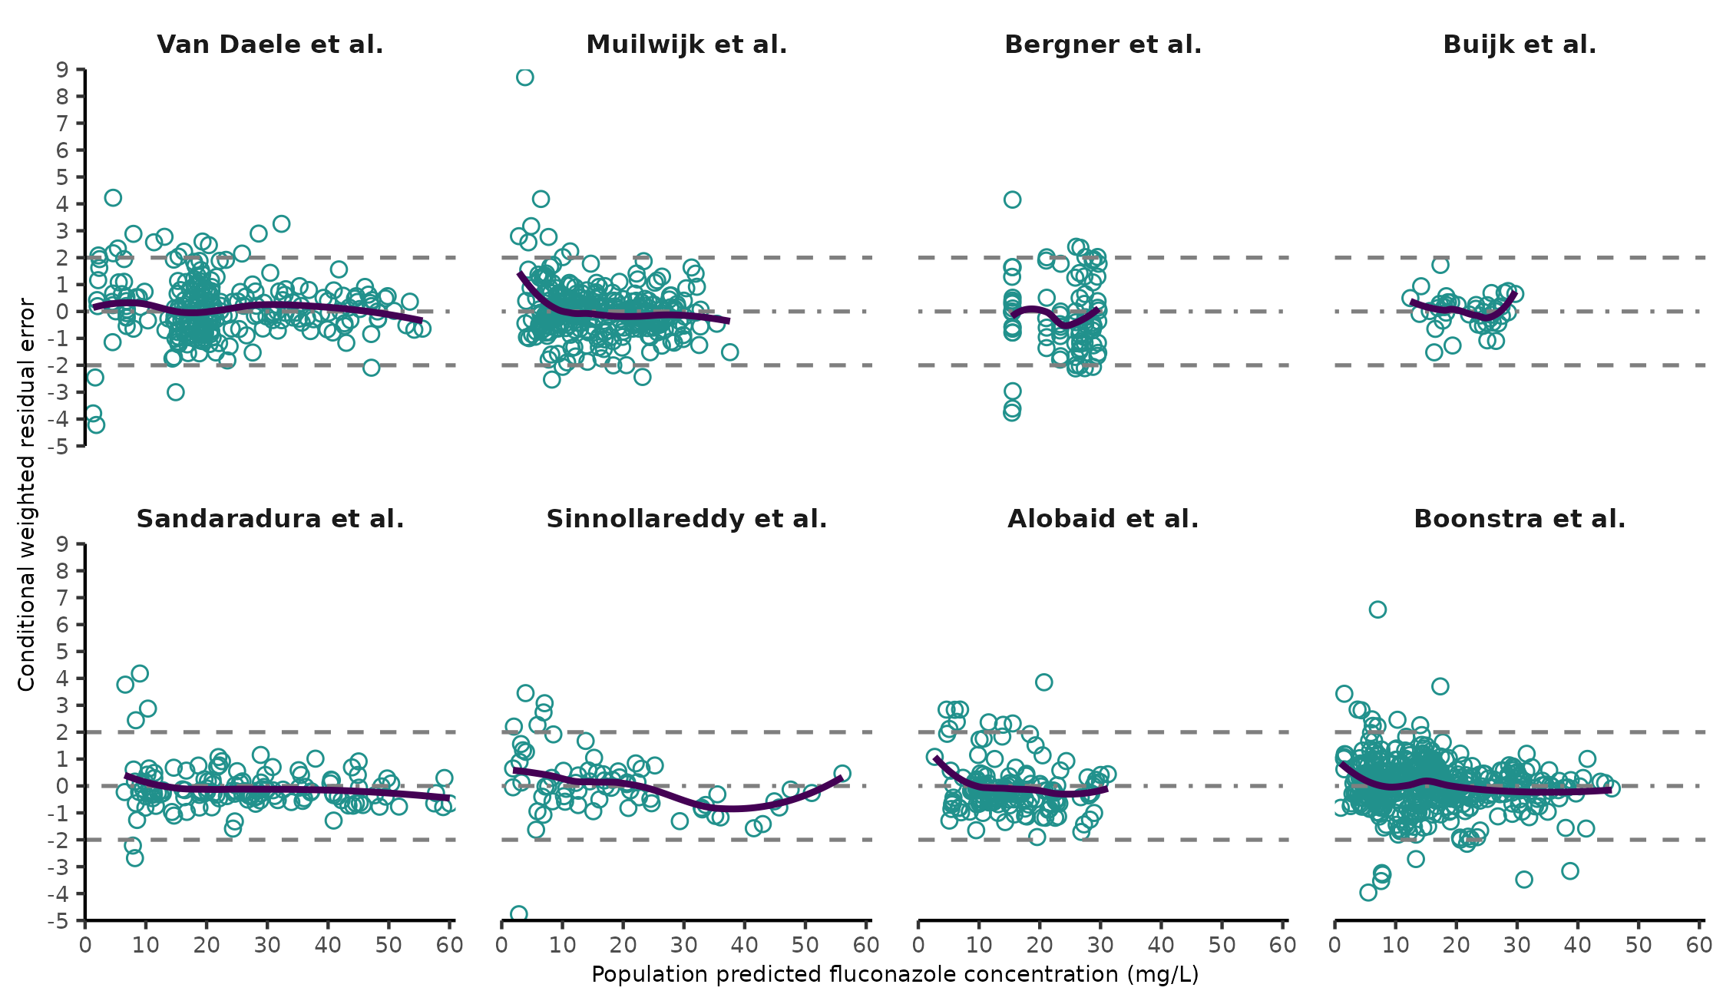
Fig. S5. Conditional weighted residual error vs population predicted concentration per study centre.
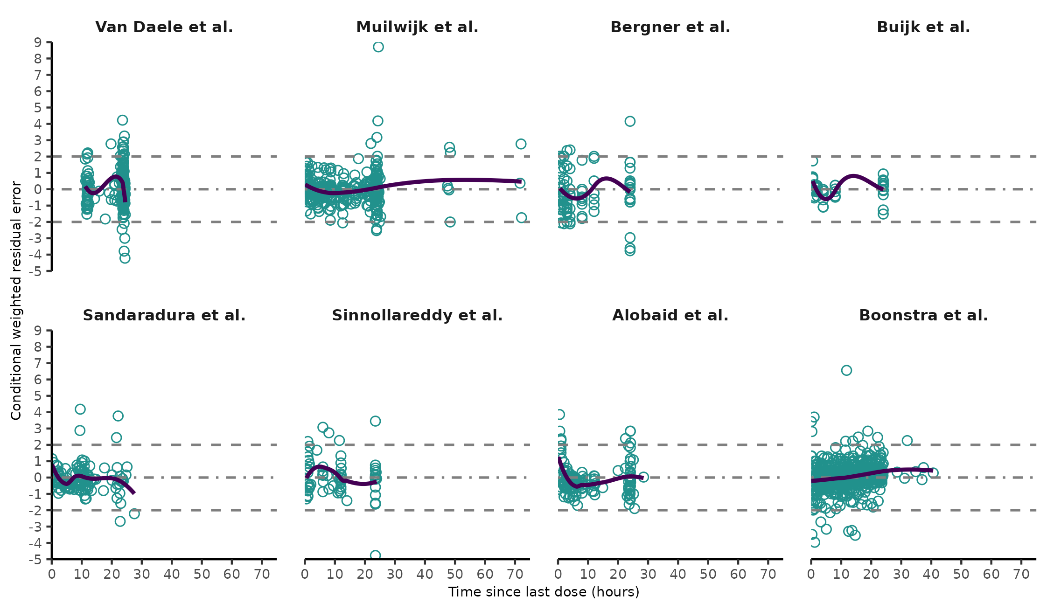
Fig. S6. Conditional weighted residual error vs time since last dose (hours) per study centre.
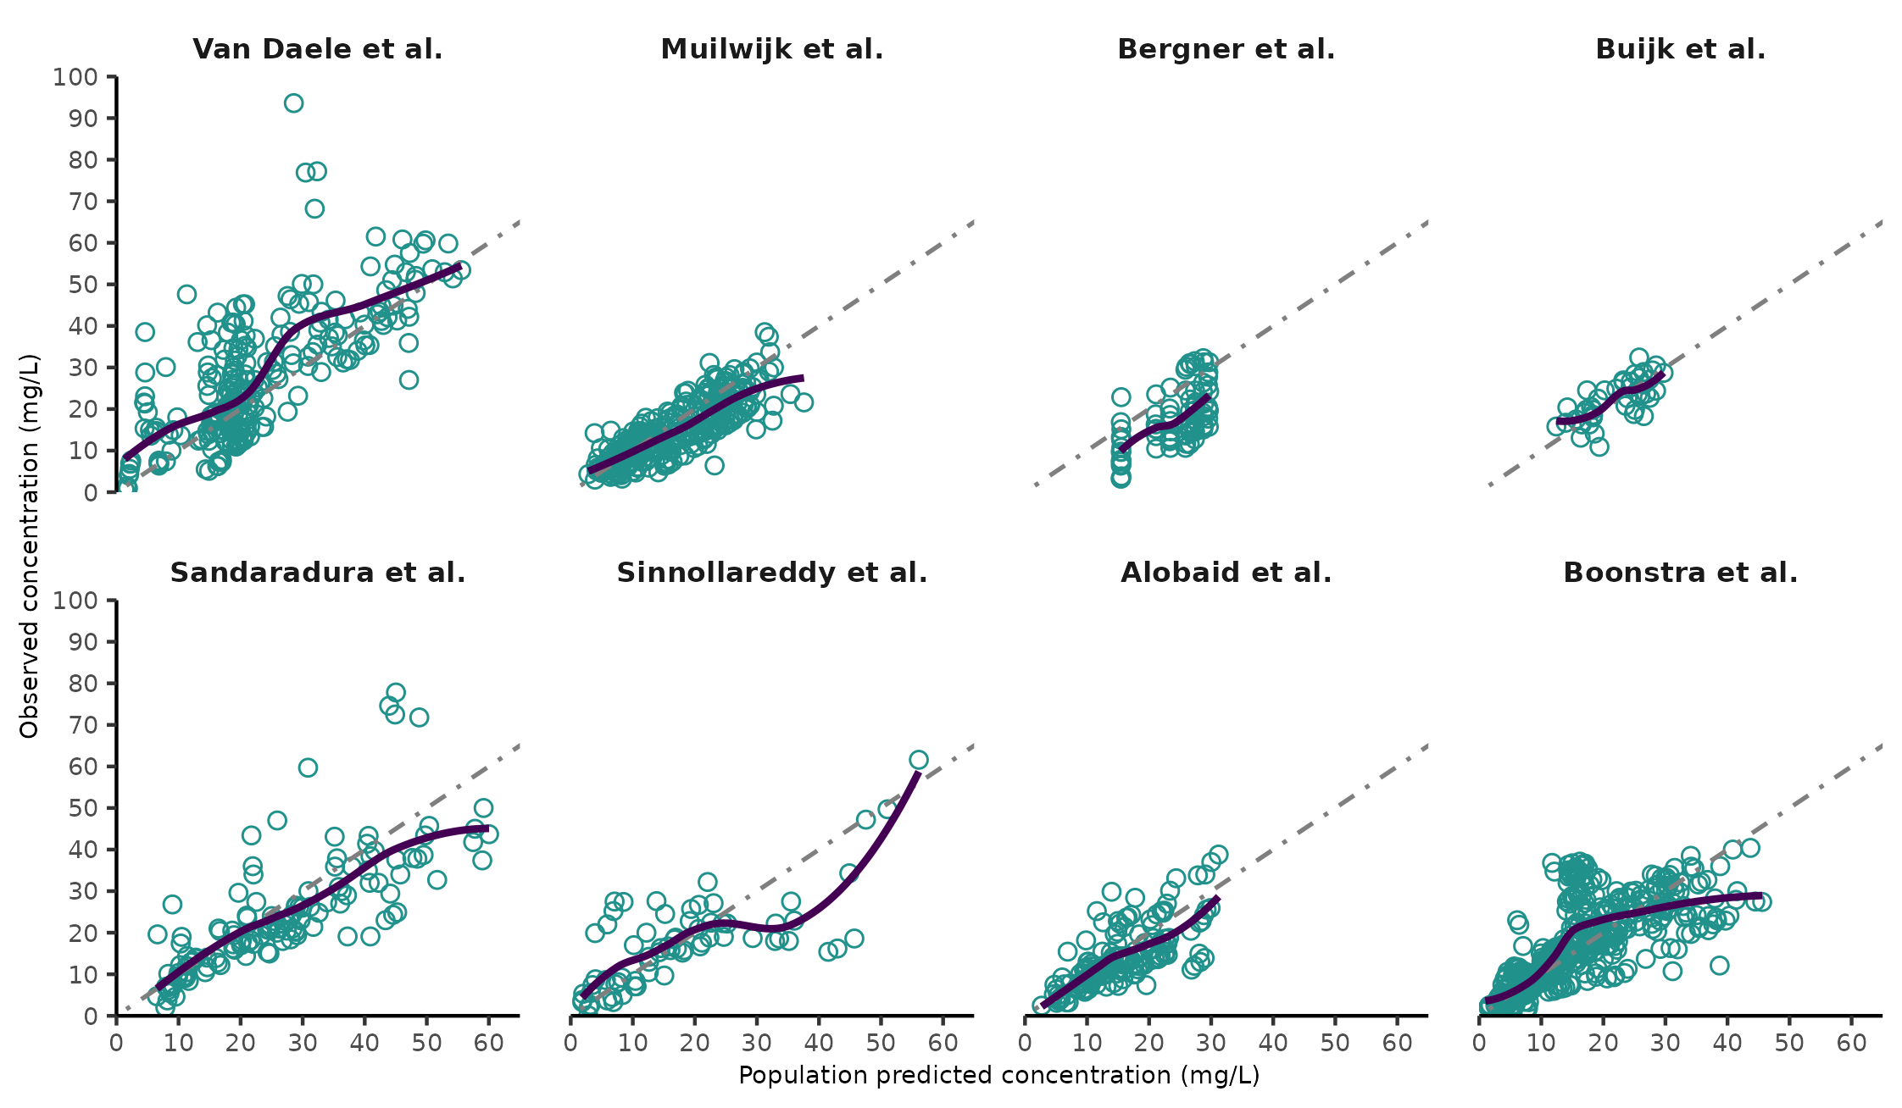
Fig. S7. Observed concentration vs Population predicted concentration per study centre.
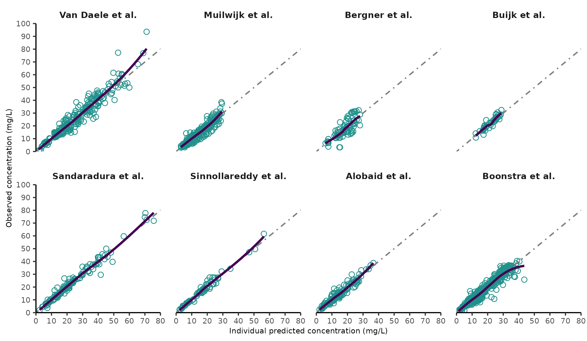
Fig. S8. Observed concentration vs Individual predicted concentration per study centre.
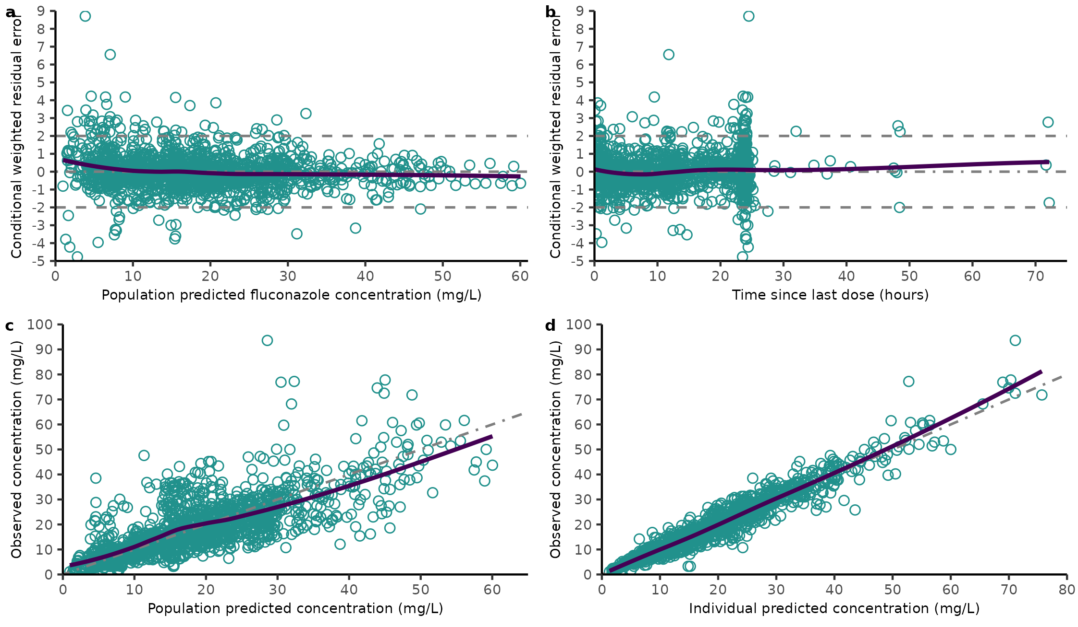Fig. S9. Goodness-of-fit plots of the overall data.
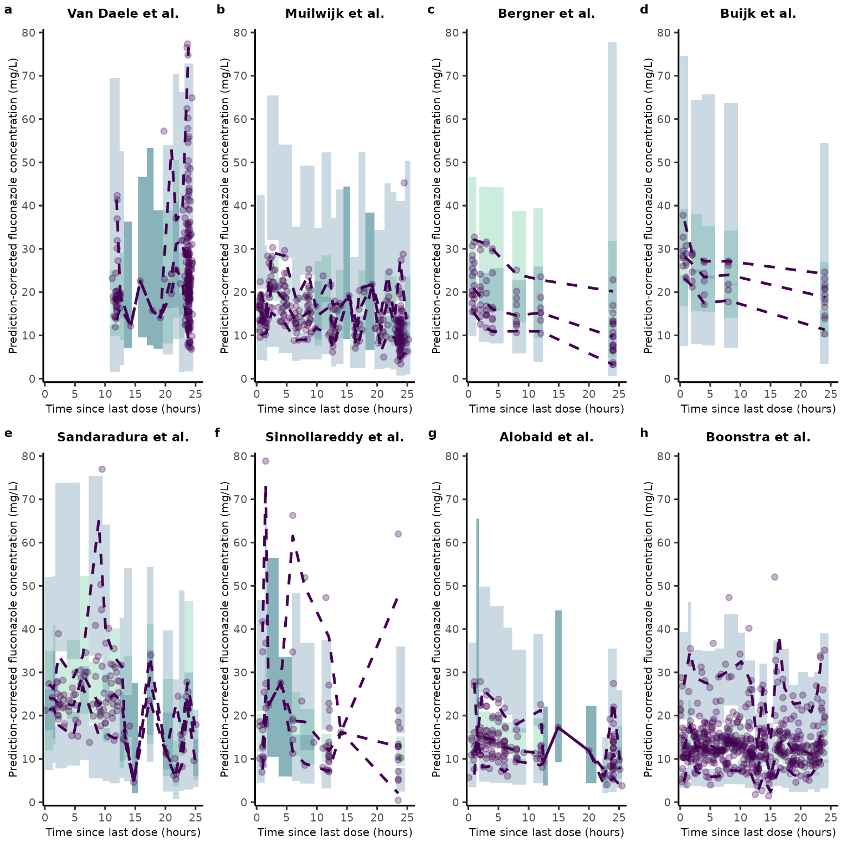

Fig. S10. pcVPC of the predictive popPK model per study centre. Purple dots represent the observed fluconazole concentrations. The horizontal dashed purple line, from top to bottom, are the 2.5th, 50th and 97.5th percentiles of the observed data, respectively. The vertical dashed green line illustrates the start of fluconazole infusion. The light green and dark green shaded areas indicate the 95% prediction intervals of the 50th, and 2.5th as well as 97.5th percentiles, respectively, of the simulated data (n=1000). 26/1616 data points were excluded for aesthetic reasons.

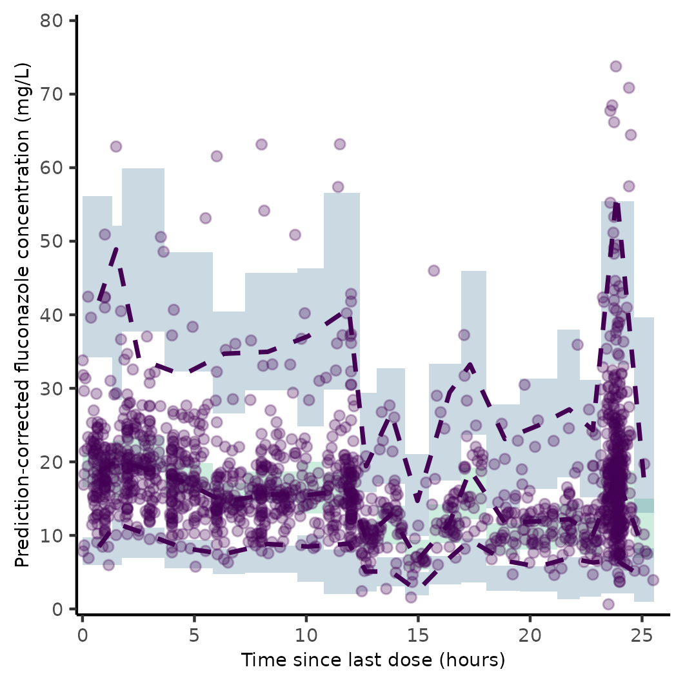
Fig. S11. pcVPC of the predictive pooled popPK model. Purple dots represent the observed fluconazole concentrations. The horizontal dashed purple line, from top to bottom, are the 2.5th, 50th and 97.5th percentiles of the observed data, respectively. The vertical dashed green line illustrates the start of fluconazole infusion. The light green and dark green shaded areas indicate the 95% prediction intervals of the 50th, and 2.5th as well as 97.5th percentiles, respectively, of the simulated data (n=1000). 26/1616 data points were excluded for aesthetic reasons.

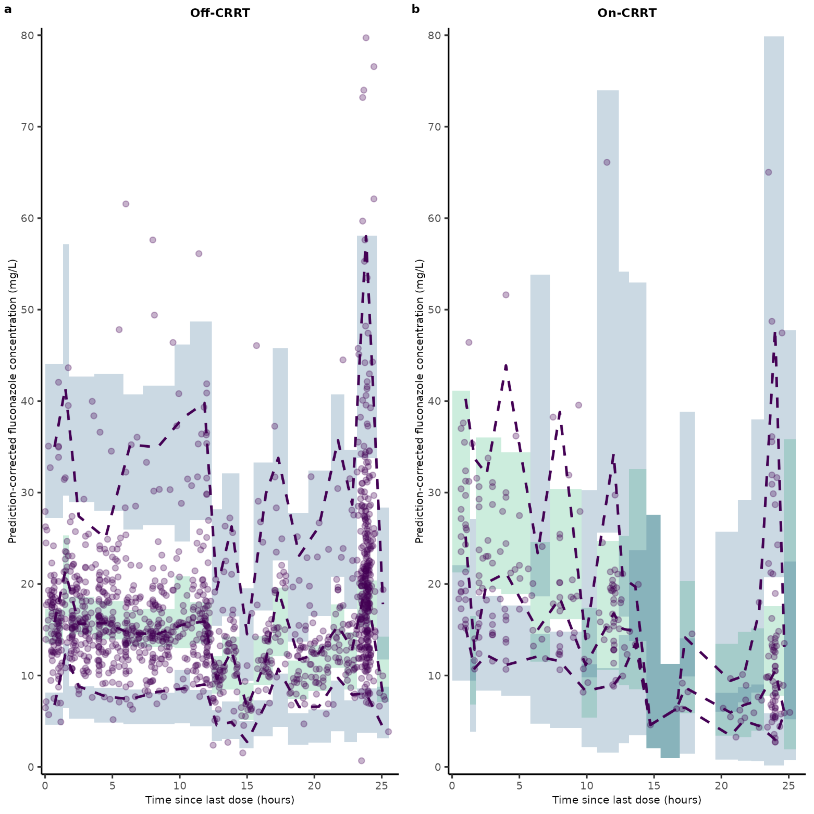
Fig. S12. pcVPC of the predictive popPK model per CRRT status. Purple dots represent the observed fluconazole concentrations. The horizontal dashed purple line, from top to bottom, are the 2.5th, 50th and 97.5th percentiles of the observed data, respectively. The vertical dashed green line illustrates the start of fluconazole infusion. The light green and dark green shaded areas indicate the 95% prediction intervals of the 50th, and 2.5th as well as 97.5th percentiles, respectively, of the simulated data (n=1000). 26/1616 data points were excluded for aesthetic reasons. CRRT: continuous renal replacement therapy.

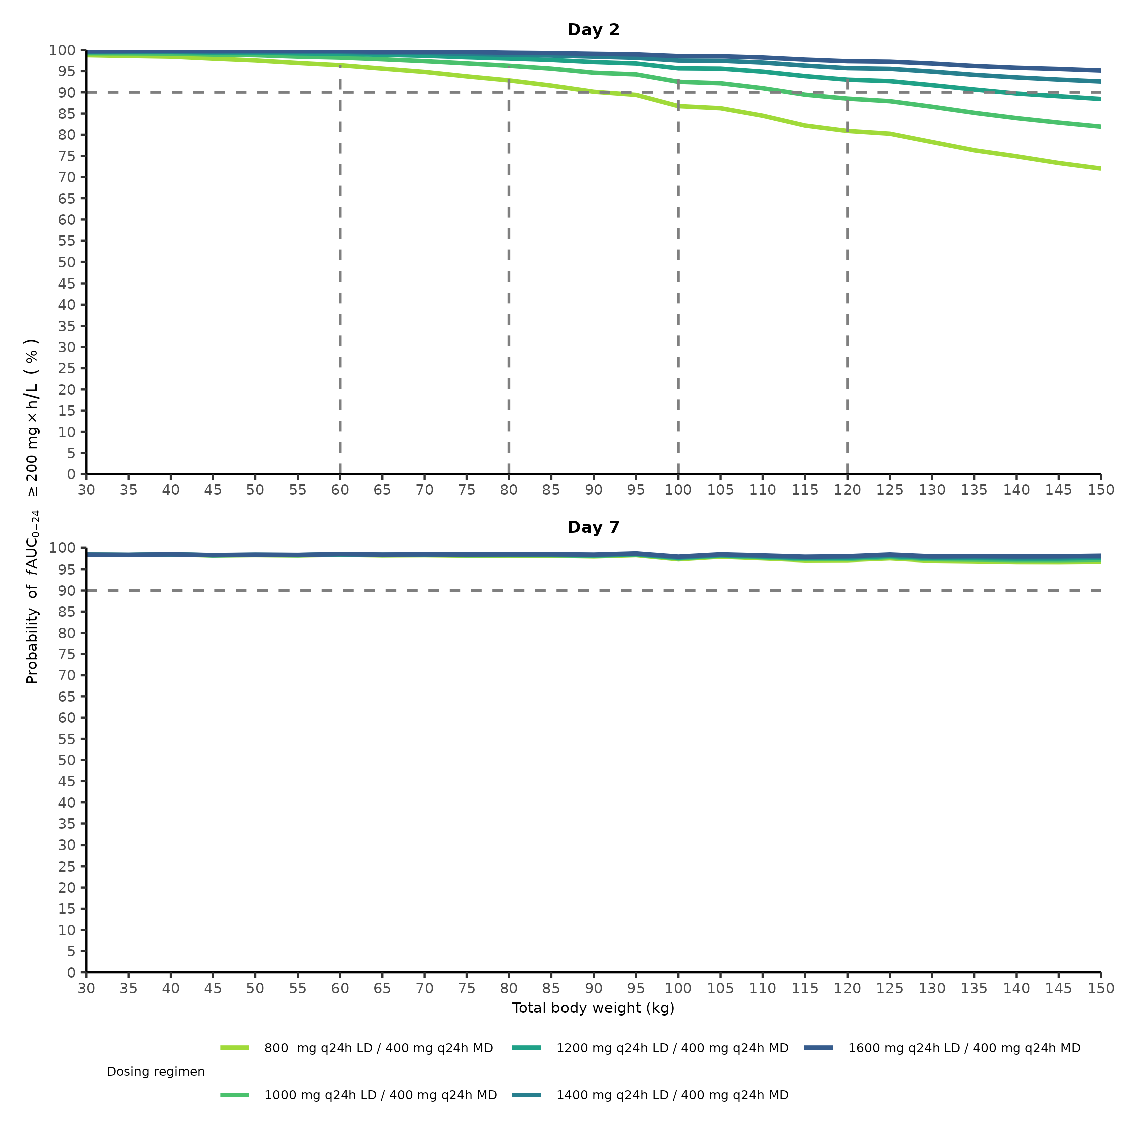
Fig. S13. Probability of target attainment of fAUC₀₋₂₄ 200 mg×h/L vs body weight over time when not on CRRT. CRRT: continuous renal replacement therapy; fAUC₀₋₂₄: area under the unbound concentration–time curve for 24 hours; LD: loading dose; MD: maintenance dose.

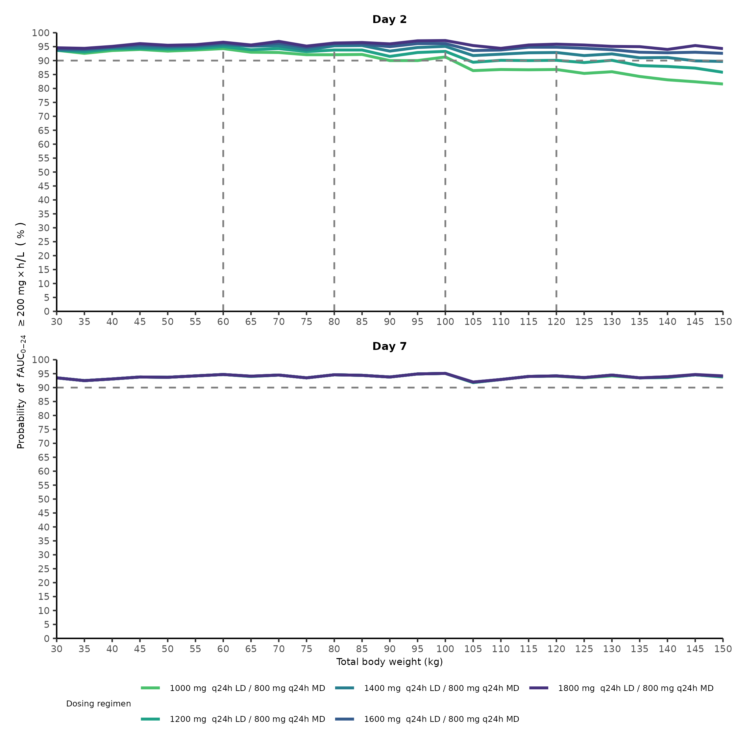
Fig. S14. Probability of target attainment of fAUC₀₋₂₄ 200 mg×h/L vs body weight over time when on CRRT. CRRT: continuous renal replacement therapy; fAUC₀₋₂₄: area under the unbound concentration–time curve for 24 hours; LD: loading dose; MD: maintenance dose.

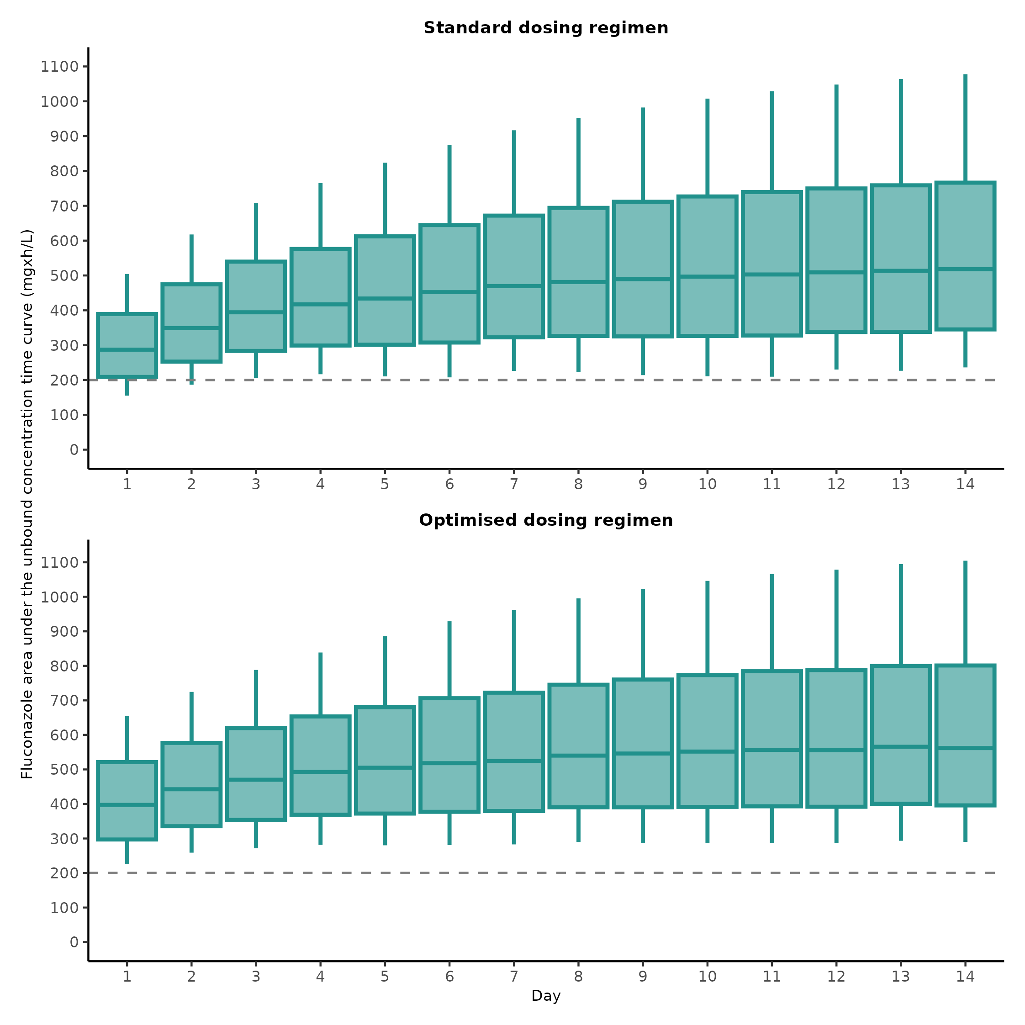
Fig. S15. fAUC₀₋₂₄ over time at the population level between standard and optimised dosing regimens. fAUC₀₋₂₄: area under the unbound concentration–time curve for 24 hours. The whiskers show the 10th and 90th percentiles of the population.

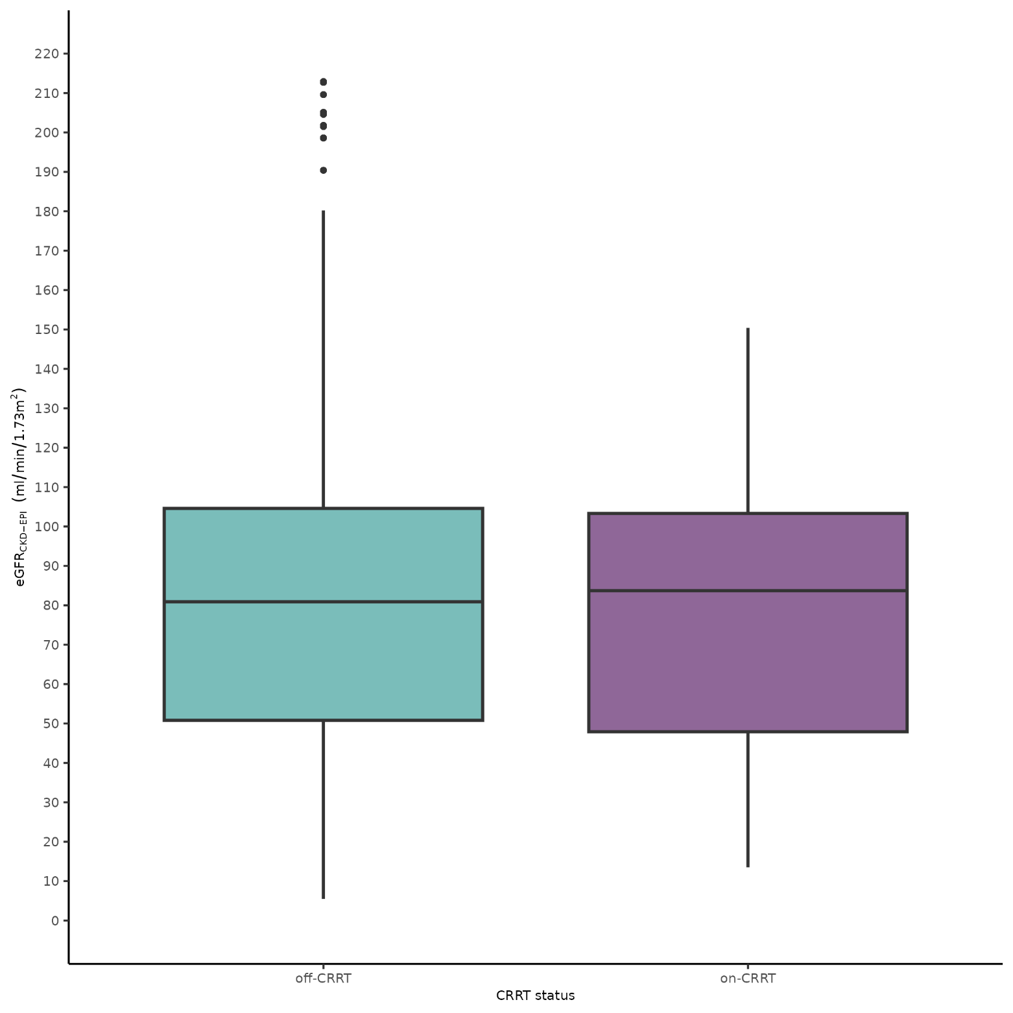
Fig. S16. eGFR_{CKD-EPI} distribution by CRRT status in the virtual population. eGFR_{CKD-EPI}: estimated glomerular filtration rate (calculated using the Chronic Kidney Disease Epidemiology Collaboration equation). CRRT: continuous renal replacement therapy.

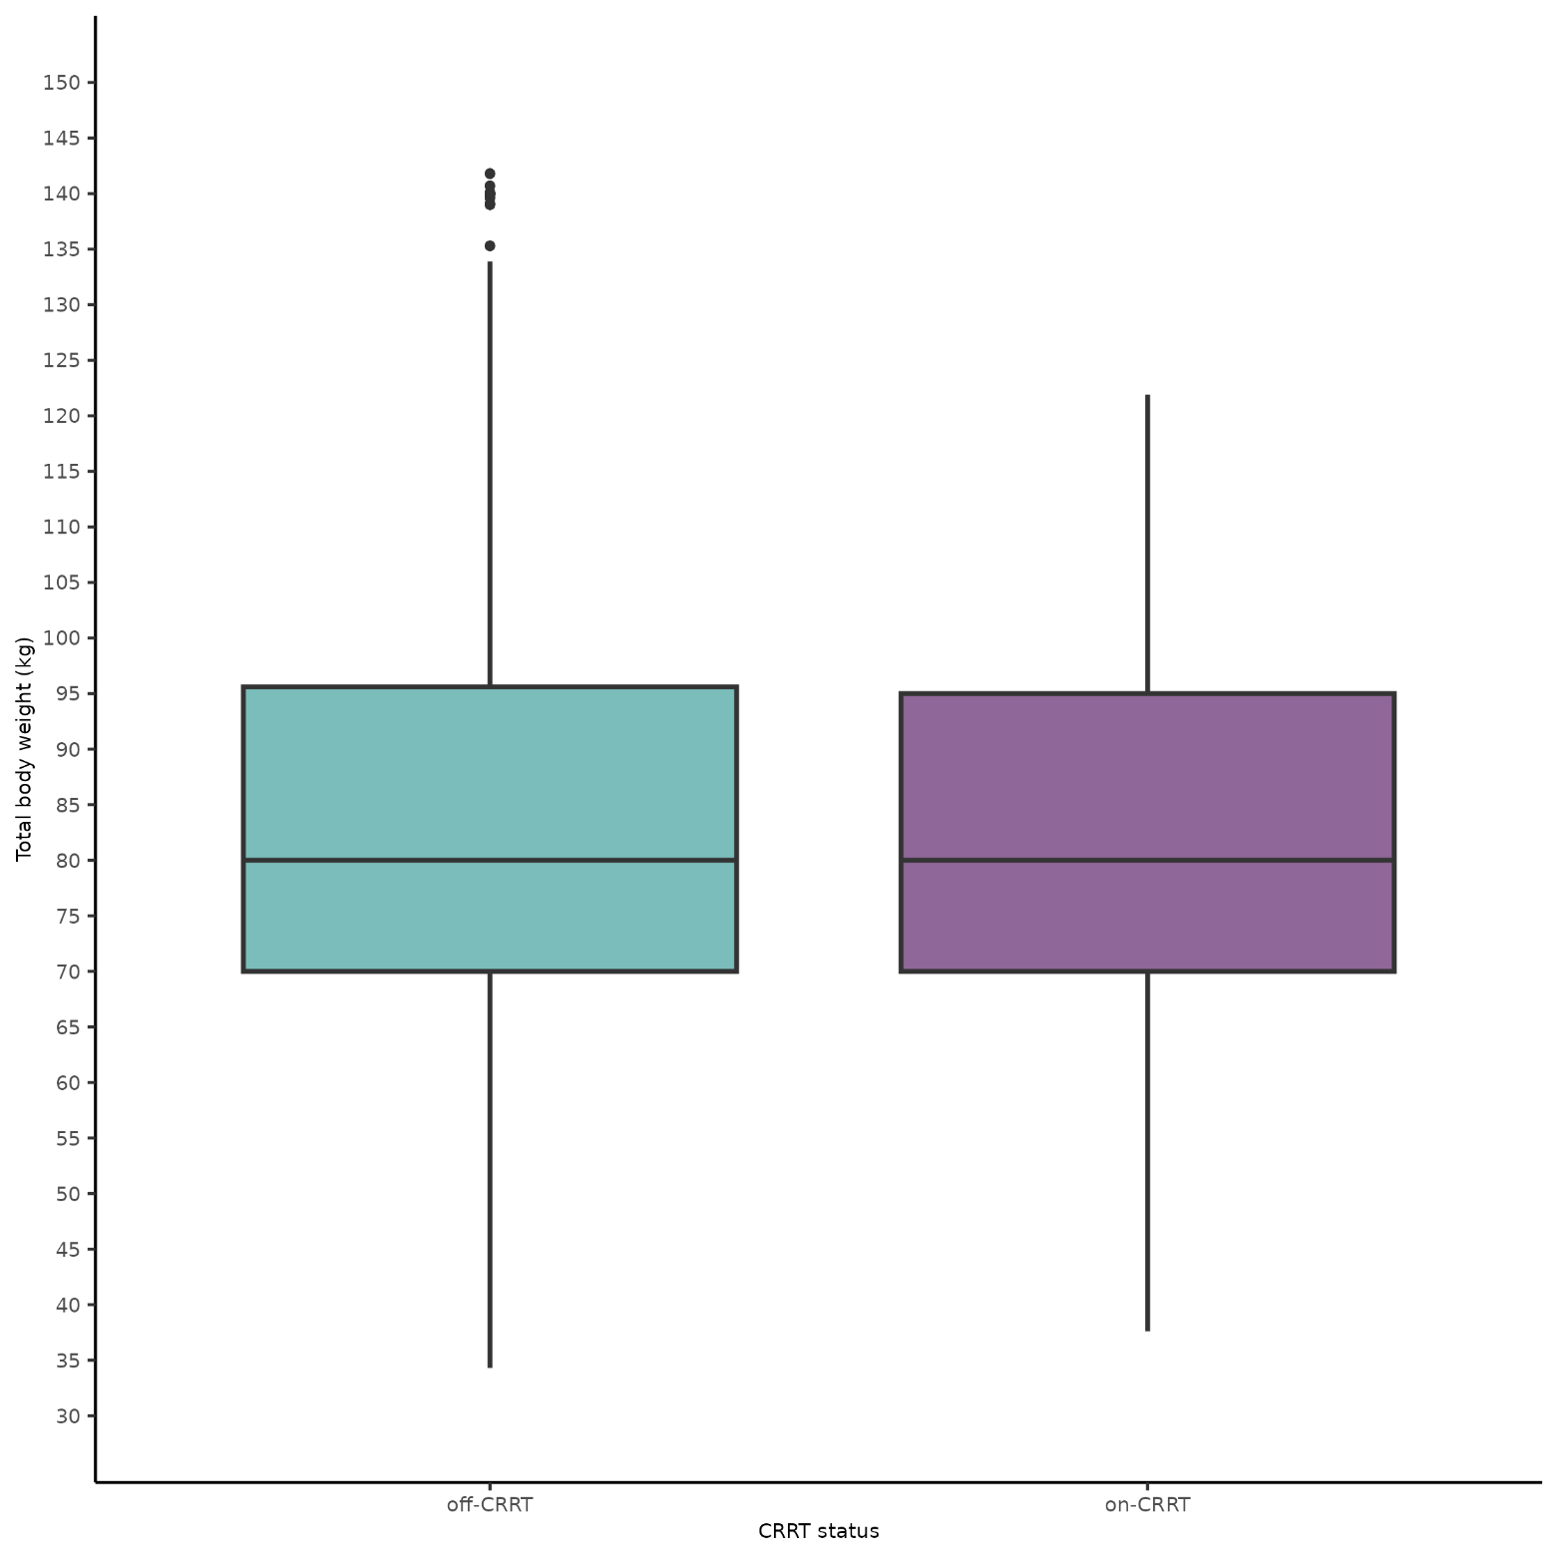
Fig. S17. Total body weight distribution by CRRT status in the virtual population. CRRT: continuous renal replacement therapy.

Supplementary Code

NONMEM control stream
$PROBLEM
;; 1. Based on;: run001
;; 2. Description: 2l.pan imputation 01, dataset 01
;; x1. Author: My-Luong Vuong
$INPUT ID TIME AMT RATE DV MDV EVID CRRT BW01 BW02 BW03 BW04 BW05 BW06 BW07 BW08 BW09 BW10 BW11 BW12 BW13 BW14 BW15 BW16 BW17 BW18 CKDEPI01 CKDEPI02 CKDEPI03 CKDEPI04 CKDEPI05 CKDEPI06 CKDEPI07 CKDEPI08 CKDEPI09 CKDEPI10 CKDEPI11 CKDEPI12 CKDEPI13 CKDEPI14 CKDEPI15 CKDEPI16 CKDEPI17 CKDEPI18
$DATA Fluco_revised_imputed_01.csv IGNORE=@
$SUBROUTINES ADVAN13 TOL=9; always ADVAN13 & TOL9
$MODEL
NCOMP = 3 ;2COMP model (1 central and 1 AUC)
COMP= (CENTRAL, DEFDOSE, DEFOBS) ;central
COMP= (PERIPH)
COMP=(AUC)
$PK; In this way of coding, CL when CRRT = 1 represents the total of both CLr and CLd, and when CRRT = 0, it represents CLr only.
;;;CL_CKDEPI-DEFINITION START
CLCKDEPI=((CKDEPI01/80)**THETA(6))
;;;CL_CKDEPI-DEFINITION END

;;;CL-RELATION START
CLCOV=CLCKDEPI;if you have multiple covariates on clearance, you should code this way. E.g, CLCOV=CLCKDEPI+CLBW
;;;CL-RELATION END

;;; V1-BW-DEFINITION START
V1BW=((BW01/80)**THETA(7))
;;; V1-BW-DEFINITION END

;;; V1-RELATION START
V1COV=V1BW
;;; V1-RELATION END

IF (CRRT.EQ.1) TVCL = THETA(1); This is infact the total of both CLr and CLd
IF (CRRT.EQ.1) CL = TVCL * EXP(ETA(1));
IF (CRRT.EQ.0) TVCL = THETA(2) * CLCOV; This is CLr only with covariate CKDEPI
IF (CRRT.EQ.0) CL = TVCL * EXP(ETA(2));

TVV1 = THETA(3) * V1COV
V1 = TVV1 * EXP(ETA(3));

TVQ=THETA(4)
Q=TVQ

TVV2=THETA(5)
V2=TVV2

S1=V1
K12 = Q/V1
K21 = Q/V2
K=CL/V1

AUC1 = AMT/CL

$DES
DADT(1) = -K*A(1)+K21*A(2)-K12*A(1)
DADT(2) = -K21*A(2)+K12*A(1)
DADT(3) = A(1)/S1
AUC2= A(3)

$ERROR
IPRED=A(1)/S1
W=SQRT(SIGMA(1,1)*IPRED**2 + SIGMA(2,2))
Y=IPRED * (1+EPS(1))+ EPS(2)
IRES=DV-IPRED
IWRES=IRES/W

$THETA
(0, 1.7) ;1_CL_CRRT
(0, 0.641) ;2_CLr
(0, 38.2) ;3_V1
(0, 13.4) ;4_Q
(0, 9.02) ;5_V2
(0, 0.401) ;6_CKDEPI_on_CLr
(0, 1) ;7_BW_on_V1

$OMEGA
0.177 ;1_IIV_CLcrrt
$OMEGA BLOCK(2)
0.259 ;2_IIV_CLr
0.105 0.295 ;3_IIV_V1

$SIGMA
0.0275 ;1_PropErr
0 FIX ;2_AddErr

$ESTIMATION METHOD=1 INTERACTION MAXEVAL=9999 NSIG=2 SIGL=5 PRINT=1 POSTHOC NOABORT
$COV PRINT=E
$TABLE ID TIME MDV DV EVID AMT RATE CL V1 V2 Q PRED BW01 CKDEPI01 IPRED ETA(1) ETA(2) ETA(3) CRRT CWRES IWRES ONEHEADER NOPRINT FILE=mi_mod_01.npctab.dta

Real-world virtual population generation R code
## Create dataset for conc-time plot -----------------------------------

### Generate BW, CKDEPI, and CRRT -------------------------------

# load the dataset
dosing_CRRT <- read.csv("Supplementary Dataset.csv")

## create a dataset of 1000 patients from dosing_CRRT dataset

# Create a new dataset with only patient 13
dosing_CRRT_13 <- dosing_CRRT[dosing_CRRT$ID == 13, ]

# Create 987 copies of the patient 13 dataset and assign IDs 14-1000
new_patients <- lapply(14:1000, function(id){
new_df <- dosing_CRRT_13
new_df$ID <- id
return(new_df)
})

# Combine the new dataset with the original dataset
dosing_CRRT <- rbind(dosing_CRRT, do.call(rbind, new_patients))

# Rename FFM to BW
names(dosing_CRRT)[names(dosing_CRRT) == "FFM"] <- "BW"

## Assign BW to the new dataset

# for reproducibility
set.seed(123)

# Create the empirical cumulative distribution function (ECDF)
pop_BW <- Fluco_clean_revised |>
group_by(ID) |>
distinct(BW2, .keep_all = TRUE) |>
dplyr::filter(!is.na(BW2)) |>
ungroup() |>
select(BW2)
ecdf_BW <- ecdf(pop_BW$BW2)

# Generate random values from the ECDF
random_values <- runif(1000)

# Map the random values to the empirical distribution using the inverse transform sampling method
sampled_BW <- round(quantile(pop_BW$BW2, random_values), 1)

# Assign the sampled BW values to dosing_CRRT dataset
dosing_CRRT$BW <- sampled_BW[match(dosing_CRRT$ID, 1:1000)]

## Assign CKDEPI to the new dataset

# for reproducibility
set.seed(123)

# Create the empirical cumulative distribution function (ECDF)
pop_CKDEPI <- Fluco_clean_revised |>
dplyr::filter(!is.na(CKDEPI)) |>
select(CKDEPI)
ecdf_CKDEPI <- ecdf(pop_CKDEPI$CKDEPI)

# Generate random values from the ECDF
random_values <- runif(1000)

# Map the random values to the empirical distribution using the inverse transform sampling method
sampled_CKDEPI <- round(quantile(pop_CKDEPI$CKDEPI, random_values), 1)

# Assign the sampled BW values to dosing_CRRT dataset
dosing_CRRT$CKDEPI <- sampled_CKDEPI[match(dosing_CRRT$ID, 1:1000)]

## Create the dosing_CRRT dataset with 10.2% full-time CRRT, and 9% part time
## CRRT (in which 58.5% DAYS on CRRT)

# Create a dummy dataset with 1000 patient IDs and 14 days:

dummy_data <- data.frame(
ID = rep(1:1000, each = 14),
DAY = rep(1:14, times = 1000)
)

# Add the CRRT variable to the dummy dataset and assign it temporarily to 0:
dummy_data$CRRT <- 0

# Randomly select 10.2% of the patient IDs and assign their CRRT to 1:
set.seed(123)
selected_ids <- sample(unique(dummy_data$ID), size = round(0.102 * 1000))
dummy_data$CRRT[dummy_data$ID %in% selected_ids] <- 1

# Randomly select another 9% of patient IDs that are not in selected_ids:
available_ids <- setdiff(unique(dummy_data$ID), selected_ids)
selected_ids_2 <- sample(available_ids, size = round(0.09 * 1000))

# Assign 58.5% of the selected days to CRRT == 1, and the remaining to CRRT == 0
selected_days <- sample(unique(dummy_data$DAY), size = round(0.585 * 14))
dummy_data$CRRT[dummy_data$ID %in% selected_ids_2 & dummy_data$DAY %in% selected_days] <- 1

# Assign the CRRT information from the dummy dataset to the dosing_CRRT dataset based on ID and DAY:
dosing_CRRT <- merge(dosing_CRRT, dummy_data[, c("ID", "DAY", "CRRT")], by = c("ID", "DAY"), all.x = TRUE)
dosing_CRRT$CRRT.x <- NULL
colnames(dosing_CRRT)[colnames(dosing_CRRT) == "CRRT.y"] <- "CRRT"

### Updating TIME and TAD -------------------------------

## Create a dataset for conc time curve opt dosing

# Repeat the 2nd row of each ID per DAY 14 times
rows = seq(2, 41999, by = 3)
times = 14
dosing_CRRT_repeated <- dosing_CRRT[rep(rows, times),]

# Update the TAD values in dosing_CRRT
dosing_CRRT_combined <- rbind(dosing_CRRT,dosing_CRRT_repeated)
dosing_CRRT_combined <- arrange(dosing_CRRT_combined, ID, DAY, TAD, TIME)
desired_tad <- c(0, 0.1, 0.25, 0.5, 0.6, 1, 1.5, 2, 3, 4, 6, 8, 12, 18, 21, 22.5, 23.9)
dosing_CRRT_combined$TAD <- rep(desired_tad, 14000)

# Reset row names
rownames(dosing_CRRT_combined) <- 1:238000

# Remove the PEAK and TROUGH columns
dosing_CRRT_combined$PEAK <- NULL
dosing_CRRT_combined$TROUGH <- NULL

# Update TIME
dosing_CRRT_combined$TIME <- (dosing_CRRT_combined$DAY - 1) * 24 +
dosing_CRRT_combined$TAD

### Update dosing information -------------------------------

#### Optimised -------------------------------

dosing_CRRT_combined <- dosing_CRRT_combined %>%
mutate(
AMT = ifelse(TIME == 0 & BW > 120 & CRRT == 1, 1800,
ifelse(TIME == 0 & BW <= 120 & BW > 100 & CRRT == 1, 1600,
ifelse(TIME == 0 & BW <= 100 & BW > 80 & CRRT == 1, 1400,
ifelse(TIME == 0 & BW <= 80 & BW > 60 & CRRT == 1, 1200,
ifelse(TIME == 0 & BW <= 60 & CRRT == 1, 1000,
ifelse(TIME == 0 & BW > 120 & CRRT == 0, 1600,
ifelse(TIME == 0 & BW <= 120 & BW > 100 & CRRT == 0, 1400,
ifelse(TIME == 0 & BW <= 100 & BW > 80 & CRRT == 0, 1200,
ifelse(TIME == 0 & BW <= 80 & BW > 60 & CRRT == 0, 1000,
ifelse(TIME == 0 & BW <= 60 & CRRT == 0, 800,
ifelse(TIME > 0 & MDV == 1 & CRRT == 1, 800,
ifelse(TIME > 0 & MDV == 1 & CRRT == 0, 400,0 ))))
)))
)))))
)

#### Standard -------------------------------

dosing_CRRT_std <- dosing_CRRT_combined %>%
mutate(
AMT = ifelse(TIME == 0, 800,
ifelse(TIME > 0 & TAD == 0, 400, 0
)
)
)

Supplementary Table
Table S1: Virtual patients characteristics in dose-finding simulation
Covariates | Minimum value | Maximum value | Step size | N
eGFR_{CKD-EPI} (mL/min/1.73 m²) | 5 | 215 | 10 | 2200
Total body weight (kg) | 30 | 150 | 5 | 2500
eGFR_{CKD-EPI}: estimated glomerular filtration rate calculated using the Chronic Kidney Disease Epidemiology Collaboration equation; N: total number of patients

