We thank the Editor and the Reviewers for their constructive comments and suggestions. We have addressed the raised questions and comments below. Modifications are indicated in the “Ustekinumab manuscript tracked.docx” file using track changes. In our answers below, we refer to the corresponding page and line numbers in the “All Markup” display of this tracked file. The “Ustekinumab manuscript clean.docx” file is a clean version of the revised manuscript.
Referee: 1
Comments to the Author
- The authors report a PK-PD model study of vedolizumab in 83 adult Crohns disease patients who are mainly multi-drug refractory, relating drug dose to concentration, drug exposure to faecal calprotectin, and faecal calprotectin to endoscopic outcome. This modelling was then used to predict that dosing 4-weekly should increase endoscopic response rate and endoscopic remission rate, compared with 8-weekly, although both are still quite low, in the order of 20% and 5% respectively, which the authors explain as resulting from the patients being multi-drug resistant. However, I note that around 5% of patients were biologic naïve and 18% had previously only had one biologic.
We thank the reviewer for the comment. We explained the simulated low endoscopic response and remission rates as “partially because of the estimated low maximum endoscopic response and remission rates in highly refractory patients.” The term “multi-refractory” only used once in the manuscript (page 3 line 44) which was indeed inexplicit. We have replaced the term “94% multi-refractory” with “94% refractory” in the Methods section of the Abstract.
[manuscript tracked: page 3 line 44]
- line 40 - remove 'a' from before population
Adapted. [manuscript tracked: page 3 line 42]
- line 43 - change multi-refractory to multidrug-refractory
“Multi-refractory” has been revised as “refractory” according to comment [1].
- line 78 - need to explain Delphi further
The term “Delphi” stand for the Delphi-like process that used in the recent STRIDE-II study for making consensus-based recommendations for treatment targets in adults and children with IBD. The relevant sentence is rephrased.
[manuscript tracked: page 4 line 83-84]
- line 109 - "an" before ustekinumab
Adapted. [manuscript tracked: page 6 line 115]
- line 120 - include CV for the drug assays
In the manuscript, I only included the LLOQ of ustekinumab. Does this CV mean to include ULOQ for ustekinumab concentration as well? If so, this has been adapted.
Adapted. [manuscript tracked: page 6 line 126-127]
- line 128 - 'as' before SES
Adapted. [manuscript tracked: page 6 line 135]
- line 129 - 'by' at least
Adapted. [manuscript tracked: page 6 line 136]
- line 324 - I can see why maximal effect of ustekinumab might have been fixed to 1, however no IBD drugs have complete effect like this, with the real maximum probably being 0.5-0.6. This needs further explanation or changing.
We thank the reviewer for the comment. The maximal effect of ustekinumab (I_{max}) here stands for the effect of inhibiting the release of fCal. Based on our data, its possible to have fCal below LOQ (30 μg/ml) during the treatment. Then we assume completely inhibiting fCal release is possible. We initially tried to estimate this I_{max}, but the model couldn’t estimate it and gave a value near the upper boundary of 1. Thus, we fixed it to the value of 1. Similar strategy was also applied in the previously published infliximab study.¹
- Dreesen E, Berends S, Laharie D, et al. Modelling of the relationship between infliximab exposure, faecal calprotectin and endoscopic remission in patients with Crohn’s disease. Br J Clin Pharmacol. 2020;87(1):106-118. doi:10.1111/bcp.14364
- lines 328-329 - One of the main factors determining fCal and fCal target will be disease extent, as well as severity, which differs a lot between patients. This should be discussed.
We thank the reviewer for their suggestion regarding adding disease extent as a covariate affecting fCal concentration and fCal target. We fully agree that it is a logical assumption. We tested that baseline SES-CD score was not a significant covariate that affects fCal concentration. Due to the unavailability of SES-CD subscores or any other disease extent data, we were not able to further investigate on this.
- line 337 - Again, maximal effect of ustekinumab will not be 100% in terms of proportion of patients, in fact it will be much less than 100% and it will be impossible to reduce fCal to undetectable in all patients. The discussion here needs to be more practical.
We thank the reviewer for the consideration of impossible to reduce fCal to undetectable in all patients. We have rewritten the relevant statement by removing “in all patients”.
[manuscript tracked: page 15 line 363]
- lines 340-343 - There is actually no good reason to think that baseline fCal in biologic-refractory patients should be any higher than biologic-naïve at the time they commence treatment, this suggests a difference in the patient population between the two studies, or difference in fCal assay characteristics. This needs more explanation.
We appreciate the review for this important comment, and we apologize for the confusion. The baseline fCal mentioned here refers to the median baseline fCal estimated in the popPK/PD model, which was significantly different between the two studies (1550 μg/g in our model and 470 μg/g in the infliximab model). The observed median baseline fCal was similar between the two studies (1398 μg/g in our study and 1462 μg/g in the infliximab study). @Erwin, could you think of a proper explanation why the baseline fCal is estimated so differently between ustkinumab model and your infliximab model (1550 vs 470), while the actual observed fCal at baseline IS SIMILAR (1398 vs 1462)? Refer to page 15 line 365-368 in the manuscript tracked.
- line 376 - ka is not previously defined so needs definition here.
Definition of k_{a} is added.
[manuscript tracked: page 10 line 235]
Referee: 2
Comments to the Author
- I think that the description of the models could be revised to improve clarity. PopPK and PopPK-PD model are clearly acceptable terms for the PK model and fCal (driven directly by PK) models. However, describing the response/remission model as “PD model” is somewhat problematic. While I can see why it is termed “PD” (it is a pharmacodynamic measure which is not driven directly by PK) this introduces confusion with the fCal model (which is also PD). As response/remission are “outcome” measures, I think using the term “Outcome model” might be a better description for clarity.
We thank the reviewer for this valuable suggestion. We have replaced the term “PD model” with “outcome model” all over the manuscript.
- While I can see why a general covariate selection (Section 2.3.4) is presented, it does not clearly state which covariates were tested on which model(s). In addition, the final sentence then causes the reader to think that covariates were only tested on the PK model. There is also no detail on general structure of the covariate models. This section should be clarified in relation to which/how covariates were tested/modelled for each of the 3 models developed.
We thank the reviewer for pointing out this confusion. For continuous covariate data, both power and exponential parameterization were tested. All covariates were tested on the base popPK, base popPK/PD and base population outcome model. For categorical covariate data, linear parameterization was tested. Clarifications corresponding to the comment has been adapted into the manuscript.
[manuscript tracked: page 8 line 179-181]
- Similarly, it appears that standard allometric coefficients were used for the impact of weight on PK parameters (but this isn’t made clear in the methods). For many mAbs, weight coefficients are not the typical 0.75. Was estimation of coefficients tested?
We thank the reviewer for this important comment. The description of allometric scaling was mentioned in the Results section (page xx line xx). The decision of applying allometric scaling was made during model development, instead of a pre-assumption before modeling. Therefore, we considered it’s better to fit it into the Results instead of the Methods.
In our final model, we only had IIV on bioavailability (F) and clearance (CL). Therefore, we were only able to estimate the coefficients of bodyweight on CL, while not possible to estimate it for volume of distribution (V1 and V2) and intercompartment clearance (Q). The covariate modeling didn’t identify bodyweight as a significant covariate on CL. However, for mAbs, it is commonly recognized that there is a bodyweight effect on the clearance.² Although the bodyweight effect didn’t come out based on our dataset, we thought adding allometric scaling will make the model more realistic when extrapolating simulations for patients with bodyweight outside of the bodyweight range in our dataset.
Then the question came up, what would be the coefficients we are gonna to use if we can’t directly estimate it? Indeed, for many mAbs, weight coefficients are not the typical 0.75. However, there is no consensus on it. Even for the same drug, the bodyweight coefficient may varies depending on the dataset that the model was built on. For ustekinumab, the bodyweight coefficient on CL was reported as 0.64 in patients with ulcerative colitis while as 0.84 in patients with moderate to severe plaque psoriasis.^{3,4} Therefore, we were not convinced to take a reported value other than standard 0.75 for bodyweight coefficient on ustekinumab clearance. Although it’s not common, standard allometric scaling of fixing bodyweight coefficient on CL to 0.75 was also reported for mAbs.⁵ In our study, adding a standard allometric scaling resulted a decrease in OFV by 33.6 points and formed the final base model.
- Dirks NL, Meibohm B. Population pharmacokinetics of therapeutic monoclonal antibodies. Clin Pharmacokinet. 2010 Oct;49(10):633-59. doi: 10.2165/11535960-000000000-00000. PMID: 20818831.
- Xu Y, Hu C, Chen Y, et al. Population Pharmacokinetics and Exposure-Response Modeling Analyses of Ustekinumab in Adults With Moderately to Severely Active Ulcerative Colitis. J Clin Pharmacol. 2020;60(7):889-902. doi:10.1002/jcph.1582
- Zhu Y, Hu C, Lu M, et al. Population pharmacokinetic modeling of ustekinumab, a human monoclonal antibody targeting IL-12/23p40, in patients with moderate to severe plaque psoriasis. J Clin Pharmacol. 2009;49(2):162-175. doi:10.1177/0091270008329556
- Fang L, Holford NH, Hinkle G, et al. Population pharmacokinetics of hu- manized monoclonal antibody HuCC49deltaCH2 and murine antibody CC49 in colorectal cancer patients. J Clin Pharmacol 2007 Feb; 47 (2): 227-37.
- It is not overly clear how the sequential nature of the PK-> fCal -> outcome models were connected from a methodological perspective? Which of the methods described by Zhang et al. where used (eg. PPP&D)?
We thank the reviewer for this important question. For the popPK/PD mode (PK -> fCal), Individual PK Parameters (IPP) approach was used. Ustekinumab concentrations predicted based on individual PK parameter estimates were linked to the observed fCal concentrations. For the outcome model (fCal -> endoscopic outcomes), we directly linked the observed fCal to the observed endoscopic outcomes, due to the observed high PD variability between patients.
- pcVPC’s were used for the PK and PD models. However, I do not see why this was not presented for the “outcome” models (endoscopic response/remission) models. This is important as Figure 3 is not overly convincing, and the RSE for the EC50 values is very high and theoretically these values are indistinguishable from “0” and the very small change in OFV compared to models where fCal was not included.
The binary VPC plot of the outcome model was provided in the supporting information (figure S1). Although the RSE for the IC₅₀ was large in the outcome model, 0 was not included in the 95% confidence interval of IC₅₀ (refer to the bootstrap results presented in page 28 Table 2).
- Line 256 is a little confusing “individualized and assumed to be ln-normally distributed” I assume this means ln-normal IIV was included? Similarly, there is no detail in the methods for IIV in the other 2 models. Please clarify these details in the methods.
We thank the reviewer for pointing out this confusion. Here using the word “individualized” we aim to point out that BASE, IC₅₀ and k_{OUT} are estimated differently for each individual patient. Indeed, we used ln-normal distribution IIV model for the popPK model and the popPK/PD model. For the population outcome model, no IIV was identified (refer to Table 2 on page 28). Clarifications regarding IIV has been added in the manuscript.
[manuscript tracked: page 10 line 237-238]
- Line 257 “No covariate relationships were tested on IC50 and kOUT due to the high η-shrinkage (>20%)” – while high shrinkage will make covariate-ETA plots uninformative, why was testing (biologically plausible) covariates in the model development process not performed?
We thank the reviewer for this interesting question. When shrinkage is higher than about 20–30%, EBE-based diagnostics lack informativeness and may be misleading.⁶ Although testing covariates in the model development was biologically plausible, we cannot trust the results from covariate testing on IC₅₀ and k_{OUT} because we had η-shrinkage of 41% for IC50 and 56% for k_{OUT}.
- Savic RM, Karlsson MO. Importance of shrinkage in empirical bayes estimates for diagnostics: problems and solutions. AAPS J. 2009;11(3):558-569. doi:10.1208/s12248-009-9133-0
- Line 267 “(no ustekinumab exposure effect)” – do the authors mean fCal effect as fCal drives response here?
We thank the review for pointing out this mistake. Indeed, here should be “no fCal effect”. This has been corrected in the manuscript.
[manuscript tracked: page 12 line 276]
- Staring at line 289 in the discussion, there is commentary on power calculations, and yet no methodological details are presented in the methods section. This should be rectified.
We thank the reviewer for the comment. The power calculation was performed using power.prop.test() function from the “stats” package (version3.6.3) in R. The description of the package has now been added to the Softwares part under the Methods section. More specifically, the following R code was used to calculate the sample size needed for identifying statistical difference in the rates of endoscopic response:
power.prop.test(n = NULL, # output, the study sample size needed in each group
p1 = 0.167, # 16.7% ER in study arm 1
p2 = 0.222, # 22.2% ER in study arm 2
sig.level = 0.05, # 5% significance level (default)
power = 0.8, # 80% power (default)
alternative = "two.sided")
We also found that the previous calculated study sample size and NNT needed was incorrect (manuscript tracked: page 13 line 309-311). This was because we forgot to update it previously after updating the model. This error is now corrected in the manuscript.
[manuscript tracked: page 9 line 207-208]
[manuscript tracked: page 13 line 309-311]
- In the discussion, I am not sure of the justification for doubling the frequency of dosing (90mg Q4W) being more cost effective than doubling the “dose” (180mg Q8W). The total dose each 8 weeks remains the same (180mg). Would the authors expand on this?
We thank the reviewer for the comment. Although the total dose is the same between 90 mg q4w and 180mg q8w, the corresponding median trough concentration at steady state in the 90mg q4w dosing group is predicted to be twice as high as the concentration in the 90mg q8w dosing group. Therefore, based on our modeling results, higher drug concentration will lead to lower fCal and eventually higher probability of endoscopic outcomes. Therefore, 90mg Q4W dosing has relatively the same cost as 180mg Q8W because ustekinumab can be self-administered and does not require hospitalisation. However, 90mg Q4W is expected to be more effective for achieving endoscopic outcomes. We have rewritten the sentence to avoid this confusion.
[manuscript tracked: page 16 line 390-396]
- For clarity, figure S2 should be amended to state that this is trough concentration.
We thank the reviewer for pointing the out. The y-axis label as well as figure description of Figure S2 has been amended as suggested. The same problem also exists for Figure 4, thereby y-axis label as well as figure description of Figure 4 has also been amended (as below).
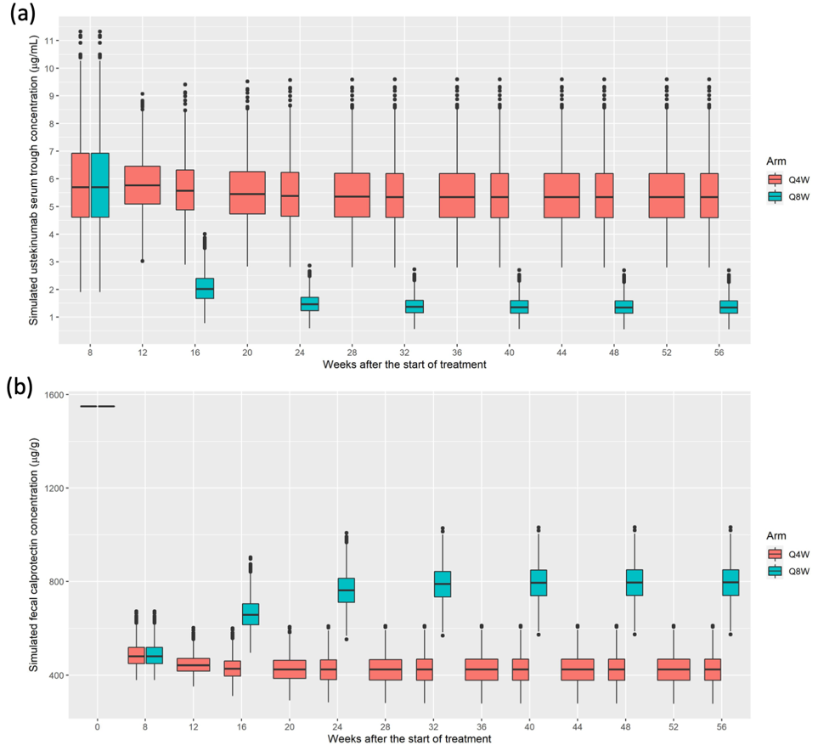
Figure 4. Simulated ustekinumab trough concentration and corresponding fecal calprotectin concentration. (a) Simulated ustekinumab serum trough concentrations at different treatment weeks following maintenance dosing every 4 weeks (q4w) or q8w in patients with Crohn’s disease. (b) Simulated fecal calprotectin concentrations at different treatment weeks following maintenance dosing every 4 weeks (q4w) or q8w in patients with Crohn’s disease.
[manuscript tracked: page 30 line 629-630]
[Supporting Information tracked: page 3 Figure S2]

Executive Editor Comments to the Author:
- Model evaluation needs some alternative presentation. The provided VPCs make interpretation of PK and PD endpoints difficult to see/interpret. Is there better way or an alternate software package available to present your VPCs to improve interpretation.
We thank the Editor for this relevant question. Unfortunately, the VPCs presented in the manuscript is the standard and commonly preferred way of presenting it. For example, the same style of VPCs have been published for infliximab and golimumab.^{7,8} Actually, instead of using it to identify PK/PD targets, it is designed to assess graphically whether simulations from a model can reproduce both the central trend and variability in the observed data, and it is plotted versus an independent variable (typically time).⁹ While the identification of a PD target, in our study a fCal target, should be based on the pre-determination of the endoscopic outcome targets we would like to aim for. The identified fCal target can then be translated into a PK (exposure) target through the popPK/PD model. Sequentially, the required dose for attaining the desired PK target can be calculated based on the popPK model.
- Dreesen E, Berends S, Laharie D, D'Haens G, Vermeire S, Gils A, Mathôt R. Modelling of the relationship between infliximab exposure, faecal calprotectin and endoscopic remission in patients with Crohn's disease. Br J Clin Pharmacol. 2021 Jan;87(1):106-118. doi: 10.1111/bcp.14364. Epub 2020 Jun 3. PMID: 32415677.
- Dreesen E, Kantasiripitak W, Detrez I, Stefanović S, Vermeire S, Ferrante M, Bouillon T, Drobne D, Gils A. A Population Pharmacokinetic and Exposure-Response Model of Golimumab for Targeting Endoscopic Remission in Patients With Ulcerative Colitis. Inflamm Bowel Dis. 2020 Mar 4;26(4):570-580. doi: 10.1093/ibd/izz144. PMID: 31372650.
- Bergstrand M, Hooker AC, Wallin JE, Karlsson MO. Prediction-corrected visual predictive checks for diagnosing nonlinear mixed-effects models. AAPS J. 2011;13(2):143-151. doi:10.1208/s12248-011-9255-z
- Figure 5. Where does the flowchart start and end? It takes a while to understand...where it starts. Can an optimised dosing table be generated to explain amounts doses need to change to achieve target fcal? Is this a better way to think about this problem?
We thank the Editor for this important question. The flowchart starts from PD monitoring and to PK monitoring (from left to right). The detailed description of the flowchart has been introduced in the Discussion (page 16 line 382-386). To avoid confusion, we also added an arrow in Figure 5 (as below) to point out the direction of the flowchart.
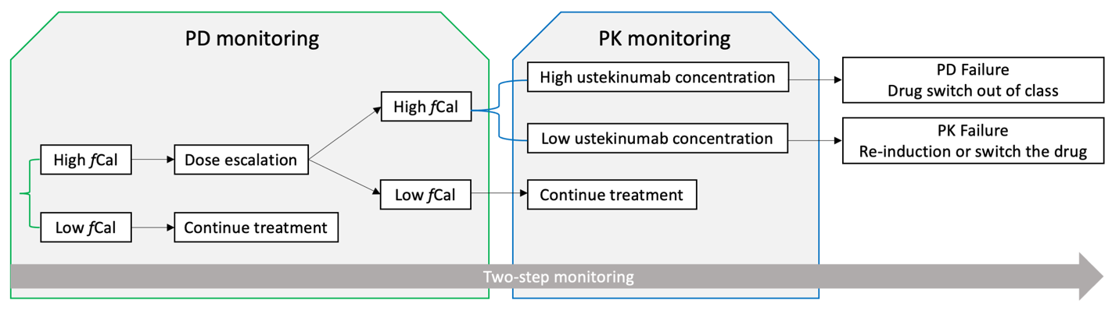
The TDM flowchart that we presented suggests an individualized, two-step monitoring strategy: while the current TDM of biologicals used in CD mainly focusing on PK monitoring, we suggest starting from PD monitoring (fCal monitoring) and only when fCal is/remains high, ustekinumab monitoring. Although we can generate a table to link the amount of dose with expected fCal concentration, such table cannot be directly used to support clinical decision-making due to 1) the relative large inter-individual variability in the popPK/PD model (ustekinumab concentration -> fCal) and 2) insufficient data to support this extrapolation and the identification of optimal concentration cut-offs. The optimal concentration cut-offs of fCal and ustekinumab are yet to be identified based on larger studies, considering the balance of treatment-cost, clinical feasibility (feasible dosing intervals), and endoscopic outcome gains.
- Do anti-drug antibodies have any significant impact on PD failure? Is the rate of ADAs similar to other indications registered for this compound?

In our study, only one out of 86 patients developed anti-ustekinumab antibodies (1.2% ADAs incidence rate) and the ustekinumab concentration in that patient was below the lower limit of quantification. Therefore, this patient was excluded from the modeling and we were not able to test the anti-ustekinumab antibody effect on ustekinumab PK/PD. According to the prescribing information of Stelara® (ustekinumab), the incidence rate of ADAs was 2.9% and 4.6% in patients with Crohn’s disease and ulcerative colitis.¹⁰ While in patients treated with Stelara® psoriasis and psoriatic arthritis, the incidence rate of ADAs was a little bit higher, of approximately 6-12.4%.¹⁰
- STELARA (ustekinumab) [Prescribing Information]. Horsham, PA: Janssen Biotech, Inc.; https://imedicalknowledge.veevavault.com/ui/approved_viewer?token=7994-c01041c4-36c8-4b5e-b8a9-f994917b4700.

