A fluconazole population pharmacokinetics study to improve target attainment in critically ill patients
My-Luong Vuong
Omar Elkayal
Ruth Van Daele
Jan-Willem C. Alffenaar
Sophie L. Stocker
Jason A. Roberts
Yves Debaveye
Joost Wauters
Beatrijs Mertens
Jasper M. Boonstra
Indy Sandaradura
Deborah J.E. Marriott
Roger J. Brüggemann
Jeroen A. Schouten
Raoul Bergner
Steven Buijk
Isabel Spriet
Erwin Dreesen
Abstract
Purpose Fluconazole is the recommended step-down therapy from echinocandins for fluconazole-susceptible Candida spp in critically ill patients with invasive candidiasis. However, standard fluconazole dosing does not achieve adequate exposure in these patients. We aimed to identify factors impacting fluconazole pharmacokinetic–pharmacodynamic (PKPD) target attainment and provide a dosing regimen ensuring adequate target attainment in critically ill patients.
Methods A population pharmacokinetics study (popPK) was conducted, combining fluconazole concentration data from eight studies. We used multiple imputation to handle missing covariate data, and Monte Carlo simulations to identify a dosing regimen with at least 90% probability of PKPD target attainment (PTA) in every patient. The PKPD target is the 24-hour area under the unbound concentration-time curve over the minimum inhibitory concentration of 100.
Results Data from 177 critically ill patients were included. A two-compartment popPK model with linear elimination described the data best. Continuous renal replacement therapy (CRRT) status, estimated glomerular filtration rate using the Chronic Kidney Disease Epidemiology Collaboration creatinine equation, and total body weight were statistically significant covariates. However, with standard dosing, only CRRT status and total body weight were clinically relevant, as PTA dropped below 90% for all patients on CRRT, and for patients off-CRRT above 60 kg. A weight-based loading dose and flat maintenance doses of 400mg (off-CRRT) and 800mg (CRRT) predicted ≥90% PTA across the weight range.
Conclusion We have developed a fluconazole dosing regimen, stratified by weight and CRRT status, that may achieve adequate PTA in critically ill patients. External validation is awaited.

1 Introduction
Invasive candidiasis, including candidaemia, remains a serious complication that most frequently occurs in patients who are immunocompromised, have undergone (abdominal) surgery, or are critically ill (Cornely et al. 2012). In patients admitted to the intensive care unit (ICU), candidaemia is associated with a crude mortality rate of 42% to 47% (Schroeder et al. 2020; Bassetti et al. 2019; Sbrana et al. 2018).
Fluconazole is a triazole antifungal drug used for treating invasive candidiasis and candidaemia (Pfizer 2012). It is recommended as a step-down therapy from echinocandins for candidaemia caused by fluconazole-susceptible Candida species (Pappas et al. 2015). In clinical practice, fluconazole is frequently administered because of its safety profile, satisfactory tissue penetration, and low cost compared with other antifungal agents (Pappas et al. 2015; Rubio-Rodríguez et al. 2015). Fluconazole is primarily excreted unchanged by the kidney (~80%), undergoing glomerular filtration and active tubular reabsorption (Pfizer 2012). Hepatic metabolism is minimal, with only 11% of the dose excreted as metabolites via the kidneys (Pfizer 2012). Protein binding is low (11–12%) (Pfizer 2012).
The primary pharmacokinetic–pharmacodynamic (PKPD) target of fluconazole is a ratio of the area under the unbound concentration-time curve for 24 hours over the minimum inhibitory concentration (fAUC₀₋₂₄/MIC) of 100 (Antimicrobial Susceptibility Testing 2020). This corresponds to an fAUC₀₋₂₄ of 200 mg×h/L for a MIC of 2 mg/L, which is the non-species-related susceptibility breakpoint for Candida [8]. Fluconazole-induced hepatotoxicity was documented in a case study, but there is no evidence of concentration-dependent hepatotoxicity of fluconazole (Jacobson, Hanks, and Ferrell 1994). Nevertheless, concentration-dependent toxicity related to fluconazole was documented in two case reports of patients developing clonic convulsions at a trough concentration (C_{trough}) of approximately 80 mg/L (Matsumoto et al. 2000; Lewis et al. 2015).
The manufacturer-recommended fluconazole dosing regimen for invasive candidiasis is an 800 mg loading dose on day 1, followed by a 400 mg daily maintenance dose from day 2 (Pfizer 2012). Additionally, a consensus of expert panels suggested a loading dose of 12 mg/kg followed by a maintenance dose of 6 mg/kg for ICU patients (Abdul-Aziz et al. 2020). Using the recommended dosing regimen, attainment of the PKPD target in patients admitted to the ICU is often inadequate or delayed, particularly in those who are overweight or undergoing continuous renal replacement therapy (CRRT) (Sandaradura, Marriott, et al. 2021; Boonstra et al. 2021; Muilwijk et al. 2020). Furthermore, several population pharmacokinetics (popPK) studies performed in this vulnerable patient population showed conflicting results regarding an optimised fluconazole dosing strategy (Sandaradura, Marriott, et al. 2021; Boonstra et al. 2021; Muilwijk et al. 2020; Alobaid et al. 2016). This could be attributed to the single-centre nature and low number of patients included in these reports.
Therefore, we performed a population pharmacokinetics analysis using data from eight published studies collected from patients receiving intravenous (IV) fluconazole. We aimed to (i) identify covariates with a clinically relevant impact on fluconazole fAUC₀₋₂₄ target attainment and (ii) provide an optimised dosing recommendation ensuring adequate, ICU-wide target attainment.

2 Material and methods

2.1 Patient population and study design
We identified studies reporting the plasma concentrations of IV fluconazole in patients admitted to the ICU through a literature search (PubMed) from inception to October 2022. We then contacted the authors to arrange the individual concentration-time data transfer upon contractual agreement. Next, we aggregated datasets for analysis. The study was approved by the Ethics Committee Research UZ / KU Leuven (S62242). Written informed consent for the secondary use of prospectively collected data was obtained from participants of the original studies in compliance with the approval of the (local) Ethics Committees.

2.2 Population pharmacokinetics modelling
We developed a popPK model from the aggregated dataset to describe the fluconazole concentration-time data. One-, two-, and three-compartment models with linear elimination processes were explored. The magnitude of differences in individual PK parameters from the typical value (i.e., interindividual variability) and differences between observed and model-predicted individual concentrations (i.e., residual variability) were estimated. The variability between occasions within the same individual (inter-occasion variability) was tested with two occasions defined as ≤day 7 and >day 7. We tested between-centre variability as a random effect and a fixed effect. The difference in analytical assays used among centres was tested by introducing different error models for each assay. Individual PK parameters were assumed to be log-normally distributed, which was achieved by using an exponential function. For example, the volume of distribution in the central compartment of subject i ($Vc_{i}$) was calculated following this equation:
$$Vc_{i}=Vc_{pop}×exp\left(η_{i}\right) \text{with} η_{i}∼N\left(0,ω^{2}\right) \left(1\right)$$
with $Vc_{pop}$ the typical population value of $Vc$, $η_{i}$ the deviation of the individual from the typical population value assuming a log-normal distribution, and $ω^{2}$ the variance of all $η_{i}$.
A final model including covariate effects was built through stepwise covariate modelling ($α_{\text{forward}}=0.05$, $α_{\text{backward}}=0.01$) (Mould and Upton 2013; Jonsson and Karlsson 1998). We assessed the covariates that are physiologically relevant to fluconazole PK. These included total body weight, body mass index (BMI), fat-free mass (FFM) at baseline (day of ICU admission), and time-varying CRRT (yes/no) and estimated glomerular filtration rate (eGFR). Among these covariates, FFM was approximated by lean body weight derived from total body weight and height (Boer 1984), while eGFR was calculated using the Chronic Kidney Disease Epidemiology Collaboration (CKD-EPI) equation without race (Sharma et al. 2021).
Continuous covariates (total body weight, BMI, FFM, and $eGFR_{CKD−EPI}$) were normalised to the median value in the population and introduced into the popPK model using a power function (Mould and Upton 2013), exemplified as follows:
$$Vc_{i}=Vc_{pop}×{\left(\frac{BW_{i}}{80 \text{kg}}\right)}^{BW_EFF}×exp\left(η_{i}\right) \text{with} η_{i}∼N\left(0,ω^{2}\right) \left(2\right)$$
with BW_EFF the effect of body weight on $Vc_{i}$ and the patient’s total body weight was normalised to the population median value of 80 kg.

2.3 Missing data handling
When at least one value of a variable was available in a dosing interval, we imputed the mean of the available value(s) in that dosing interval. When no value of a variable was available in a dosing interval, we employed multiple imputation, which has been shown to better reflect the uncertainty of the parameter estimate for the missing variable compared to single imputation (Vuong, Verbeke, and Dreesen 2025). Specifically, we built a multiple imputation model including variables that were in the aggregated dataset. We used two multiple imputation techniques, the two-level method using a linear mixed model, and the predictive mean matching method when missingness was >5% and ≤5%, respectively (Buuren 2018). We replaced the negative imputed values of a variable with the lowest value of that variable observed in the dataset. Multiply imputed datasets were created, and independent popPK analyses were conducted for each dataset. Results were then combined using Rubin’s rules for normally distributed parameter estimates (Buuren 2018). For non-normal, non-negative variance terms, log transformation was performed before pooling estimates to ensure the normality assumption holds (Buuren 2018). The delta method was used to obtain the variance of these log-transformed terms (Hosmer, Lemeshow, and May 2008). The number of imputations was chosen based on the magnitude of the missingness of the specific variable (Buuren 2018). The 95% confidence interval of the pooled estimates, which follow the Student’s t-distribution, was calculated (Buuren 2018).

2.4 Model selection and evaluation
We selected the most parsimonious popPK model based on a likelihood ratio test with a 5% significance level (delta objective function value ≥3.84 points, 1 degree of freedom), parameter precision (95% confidence interval), and physiological plausibility of the parameter estimates. Additionally, we used goodness-of-fit plots, including population and individual predictions versus observations, conditional weighted residuals versus time and versus population predictions, and prediction-corrected visual predictive check (pcVPC) plots (n = 1000 simulations) (Mould and Upton 2013). We used bootstrapping to acquire non-parametric estimates of uncertainty in parameter estimates (n = 2000 bootstraps) (Mould and Upton 2013).

2.5 Simulations

2.5.1 Dose-finding simulations
Selecting dosing regimens for testing
We conducted Monte Carlo simulations using the final popPK model to evaluate various fluconazole dosing regimens. These regimens were selected based on the manufacturer’s recommended standard loading and maintenance doses (800 mg on day one, then 400 mg daily) as a reference for comparison. Dose increments were based on the commercially available fluconazole IV dosage forms of 200 and 400 mg to avoid drug waste (Pfizer 2012). Considering a 200 mg increment in doses, we evaluated six loading doses ranging from 800 to 1800 mg on day 1 and three maintenance doses ranging from 400 to 800 mg daily. We also tested total body weight-based dosing (12 mg/kg on day 1, followed by 6 mg/kg daily), as suggested previously (Alobaid et al. 2016).
Creating virtual patient datasets
Virtual patients were defined exclusively by the covariates retained in the final popPK model (Supplementary Table). Correlation between the covariates was maintained similarly to that in the aggregated dataset. A total of 1000 simulations were performed per virtual patient.
Criteria for evaluating dosing regimens
A dosing regimen was considered acceptable if it achieved a 90% probability of target attainment (PTA) across the population (Committee for Medicinal Products for Human Use (CHMP) 2016). The adequacy of the loading dose was evaluated via the PTA 24 hours after its administration (day 1). Similarly, the adequacy of the maintenance dose was evaluated via the PTA on day 14 (Jacobson, Hanks, and Ferrell 1994). The sufficiency of the resulting dosing regimen throughout the entire 2-week treatment period was then confirmed via its PTA on days 2 and 7.

2.5.2 Real-world population simulations
The 14-day standard and optimised dosing regimens were compared for population-level PTA and drug exposure. Therefore, we created a virtual patient population of 1000 patients to represent the real-world population in our aggregated dataset, ensuring the proportions of categorical covariates and distributions of continuous covariates matched. Specifically, we randomly sampled continuous covariates from their empirical cumulative distribution functions obtained from the aggregated dataset (Ramachandran and Tsokos 2021). 1000 simulations were also performed per virtual patient.

2.6 Software
Dataset formatting and exploration were performed using R (v4.3.3; R Core Team, Vienna, Austria) in the RStudio integrated development environment (v 2024.04.0+735; RStudio, Inc., Boston, MA, USA). We used the tidyverse collection of packages for this purpose, while using the mice package to perform multiple imputation (Buuren 2018; Wickham, Cetinkaya-Rundel, and Grolemund 2023). NONMEM (v7.5.0; ICON Development Solutions, Gaithersburg, MD, USA) with differential equation solver ADVAN13 and the first-order conditional estimation with interaction method for parameter estimation was used for nonlinear mixed-effects modelling. All procedures were executed using the Perl-speaks-NONMEM (PsN; v5.3.0) toolkit on the Pirana modelling workbench (v21.11.1; Certara, Inc., Princeton, NJ, USA) (Keizer, Karlsson, and Hooker 2013). The NONMEM control stream is available in the Supplementary Code.

3 Results

3.1 Data
Data from eight studies included 177 ICU patients treated with IV fluconazole (Sandaradura, Marriott, et al. 2021; Boonstra et al. 2021; Muilwijk et al. 2020; Alobaid et al. 2016; Bergner et al. 2005; Buijk et al. 2001; Sinnollareddy et al. 2015; Van Daele et al. 2021). Patient characteristics are summarised in Table . Patients contributed 1616 total fluconazole plasma concentrations, with a median of seven concentrations per patient. None of the concentrations were below the lower limit of quantification. Total body weight at ICU admission ranged from 34 kg to 142 kg, eGFR_{CKD-EPI} when not undergoing CRRT ranged from 7 mL/min/1.73 m2 to 213 mL/min/1.73 m². Total body weight was missing in 2.8% of the cohort. CRRT status was available for all patients, of whom 19.2% received CRRT at least once during their treatment period. An eGFR_{CKD-EPI} was available only in 40.7% of the dosing intervals. Missing eGFR_{CKD-EPI} data were handled with multiple imputation at the dosing interval level, while missing total body weight data were handled at the patient level (m = 70 multiply imputed datasets). Multiple imputation performance is shown in Figs. S1-S2. The concentration-time courses for the per-centre and pooled datasets are shown in Figs. S3-S4.

3.2 Population pharmacokinetics modelling
A two-compartment popPK model with linear elimination best described the fluconazole concentration-time data (Table 2). Fluconazole clearance was estimated separately when a patient was on CRRT (CL_{on-CRRT}; 1.56 L/h [10.2% relative standard error; RSE]) and when off CRRT (CL_{off-CRRT}; 0.633 L/h [5.4% RSE]). Interindividual variability was estimated on CL_{on-CRRT}, CL_{off-CRRT}, and Vc, with a covariance relationship between CL_{off-CRRT} and Vc of 33.9%. A proportional error model best described the residual variability. Different analytical assays did not significantly impact the error model. The per-centre and overall goodness-of-fit plots are available in Figs. S5-S9.
The inclusion of the effects of baseline total body weight on Vc and time-varying eGFR_{CKD-EPI} on CL_{off-CRRT} significantly improved the goodness-of-fit of the popPK model. The pooled parameter estimates of the 70 multiply imputed models and the medians of 10 random bootstrap results (2000 bootstraps in total) are available in Table 2. Equations 3 and 4 demonstrate how fluconazole Vc and CL_{off-CRRT} of patient i increase with total body weight and eGFR_{CKD-EPI}, respectively:
$$Vc_{i}=39.4 \text{L}×{\left(\frac{BW_{i}}{80 \text{kg}}\right)}^{0.908}×exp\left(η_{i}\right) \text{with} η_{i}∼N\left(0, 0.312\right)$$
$$CL_{\text{off-CRRT}, i}=0.614 \text{L}×{\left(\frac{eGFR_{\text{CKD-EPI}, i}}{80 \text{mL}/\text{min}/1.73 {\text{m}}^{2}}\right)}^{0.532}×exp\left(η_{i}\right) \text{with} η_{i}∼N\left(0, 0.217\right)$$
Body weight and eGFR_{CKD-EPI} explained 7.1% and 8.1% of the interindividual variability in Vc and CL_{off-CRRT} of fluconazole, respectively. The unexplained interindividual variability in Vc and CL_{off-CRRT} remained high, i.e., 60.5% and 49.3%, respectively.
The per-centre and pooled data pcVPC plots show a good agreement between model simulations and observed data (Figs. S10-S11). The pcVPC stratified by CRRT status is available in Fig. S12. Median values of the non-parametric bootstrap were in good agreement with the pooled point estimates (Table 2).

3.3 Simulations
The standard loading dose did not result in clinically acceptable PTA of ≥90% when total body weight exceeded 60 kg and 30 kg, in patients off and on CRRT, respectively. Similarly, the weight-based regimen (12 mg/kg loading dose) failed to achieve adequate PTA in patients weighing less than 80 kg without CRRT and less than 120 kg with CRRT (panel a, Figs. 1-2). The statistically significant effect of eGFR_{CKD-EPI} on CL_{off-CRRT} did not have a clinically relevant impact on fluconazole fAUC₀₋₂₄ 200 mg×h/L target attainment across the eGFR_{CKD-EPI} range of 5 to 215 mL/min/1.73 m² under simulated loading doses. Moreover, using the standard maintenance dose of 400 mg, the PTA only fell slightly below 90% when eGFR_{CKD-EPI} exceeded 195 mL/min/1.73 m2 (Fig. 3). Figs. 4-5 shows the probability of attaining the fAUC₀₋₂₄ 400 mg×h/L target versus total body weight for the simulated dosing regimens.
The optimised stratified dosing regimen is presented in Table 3. The proposed loading dose was determined based on the patient’s total body weight and CRRT status. The selected doses were the smallest that ensured a clinically acceptable PTA 24 hours after administration. Daily maintenance doses of 400 mg and 800 mg were adequate for achieving at least 90% PTA across the studied total body weight range, off and on CRRT, respectively (Figs. 1-2, Figs. S13-S14).
Real-world population simulations confirmed that the standard dosing regimen of 800 mg on day 1 followed by 400 mg thereafter did not achieve 90% PTA in the first two days, but improved to a >90% PTA from day 3 of the treatment period (Fig. S15). Simulation of the optimised dosing regimen resulted in >90% PTA as early as day 1 up to day 14 of treatment (Fig. 6, Fig. S15). Less than 1.2% of patients had fluconazole C_{trough} of 80 mg/L or higher across the two-week treatment period. The characteristics of the real-world virtual population are shown in Figs. S16-S17. The R code and dataset used to generate this population are in the Supplementary Code and Supplementary Dataset.

4 Discussion
Our modelling and simulation results showed that total body weight and CRRT status were the two factors that clinically impacted the attainment of the fAUC₀₋₂₄ 200 mg×h/L target in critically ill patients under the standard fluconazole IV dosing regimen. Therefore, we proposed a pragmatic, optimised dosing regimen that could achieve a PTA of at least 90% over the entire two-week treatment course.
The PK of fluconazole in critically ill patients was best described by a two-compartment model with first-order elimination, consistent with studies that employed a rich-sampling technique (Muilwijk et al. 2020; Alobaid et al. 2016; Patel et al. 2011). In contrast, several studies that relied on (trough) samples collected during routine clinical practice identified a one-compartment model (Sandaradura, Marriott, et al. 2021; Boonstra et al. 2021; Aoyama et al. 2011). This disparity can be attributed to the sparse sampling in clinical practice, which limits the ability to fit a two-compartment model. Total body weight not only significantly influenced Vc, but it also had a clinically relevant impact on target attainment under the standard dosing regimen (800 mg loading dose and 400 mg maintenance dose). Specifically, a higher total body weight was associated with a lower PTA following the loading dose of 800 mg. This finding aligns with previous popPK studies, which reported that obesity is a risk factor for suboptimal exposure to fluconazole (Sandaradura, Marriott, et al. 2021; Alobaid et al. 2016; Chen et al. 2022). Although FFM may be a better surrogate for Vc of fluconazole, we found that total body weight improved the model fit the most. Furthermore, total body weight is preferred over BMI and FFM in clinical practice as it does not require guessing the patient’s height (Boer 1984). Fluconazole clearance was nearly three times higher when patients were on CRRT than when they were off CRRT. This accelerated on-CRRT clearance may be explained by the absence of tubular reabsorption in anuric patients, as fluconazole is extensively reabsorbed when kidney function is normal (Patel et al. 2011). Additionally, eGFR_{CKD-EPI} significantly impacted CL_{off-CRRT} in our model, which aligns with fluconazole’s primary renal clearance (Pfizer 2012). We chose the eGFR_{CKD-EPI} equation without race as the sole method for assessing kidney function because it is more accurate than equations like Cockcroft-Gault and performs better than the equation that includes race (Sharma et al. 2021).
We demonstrated that eGFR_{CKD-EPI} had no clinically relevant impact on PKPD target attainment under the proposed optimised dosing regimen; thus, our dosing recommendations were not based on renal function. Despite significantly improving the goodness-of-fit of the popPK model, eGFR_{CKD-EPI} did not affect PTA across its entire range with this optimised regimen. Our recommended maintenance dose for patients not undergoing CRRT was 400 mg q24h, aligning with the current standard. Although our simulation showed a slight decrease below the 90% PTA with this dose in patients with eGFR_{CKD-EPI} above 195 mL/min/1.73 m², we did not recommend increasing it, as this minor reduction was based on the unlikely assumption that eGFR_{CKD-EPI} would remain consistently above 195 mL/min/1.73 m² for 14 days. Huang et al. recently reported that kidney function is highly unstable in ICU patients (Huang et al. 2022).
Our study’s finding of no effect from kidney function contrasts with previous research, which suggested that increased doses are needed for patients with augmented renal clearance (Sandaradura, Marriott, et al. 2021; Muilwijk et al. 2020). This discrepancy probably reflects bias caused by inadequate missing data handling techniques. Unlike previous studies, we used multiple imputation, which is a superior method to single imputation or complete case analysis, especially when data is missing at random (Vuong, Verbeke, and Dreesen 2025). Unfortunately, despite significant evidence to the contrary, single imputation remains widely applied in pharmacometrics research. Such a method would falsely decrease the temporal variability in eGFR_{CKD-EPI} that we observed during critical illness (Huang et al. 2022). Multiple imputation fills in the missing data multiple times with many different plausible values, thereby accounting for the variability (Buuren 2018). Although we could not identify a clinically relevant effect of eGFR_{CKD-EPI} on PKPD target attainment, this should not be interpreted as a confirmation of the absence of a kidney function effect, but rather as a failure to confirm an effect with the current dataset. Therefore, a well-designed, prospective clinical trial with an intensive data collection scheme is necessary to validate our findings.
Our proposed dosing regimen may avoid the need to conduct TDM after being successfully confirmed in a future trial. TDM of fluconazole is not widely recommended nor implemented, but is advocated in rare circumstances such as for obese patients, patients on CRRT, and patients with sepsis (Lewis et al. 2015). However, fluconazole TDM is not always available, and when available, turnaround time and costs might hamper the feasibility of routine implementation (Sandaradura, Wojciechowski, et al. 2021). Therefore, the implementation of our recommended dosing regimen based on total body weight and CRRT status may potentially deliver personalised dosing of fluconazole whilst simultaneously simplifying workflows. Nevertheless, in clinical centres where neither drug cost nor integration of automated dose calculation in prescribing software tools is of concern, other dosing strategies and the availability of TDM may be considered.
It is worth noting that our recommended loading dose is not the lowest effective dose. Specifically, since there are challenges in accurately measuring the total body weight of patients confined to their beds in the ICU setting, we incorporated a precautionary measure of accounting for ~5–10 kg underestimation in total body weight (Darnis et al. 2012).
Our simulations also demonstrated the proposed regimen to be potentially safe (<1.2% risk of Ctrough ≥80 mg/L). As such, it is appropriate for introduction into ICUs worldwide to treat patients infected with Candida species with MIC ≤2 mg/L after being locally evaluated. However, for “susceptible, increased exposure” non–Candia glabrata species (MIC of 4 mg/L), our recommended regimen showed a poor target attainment, necessitating a much higher dose. The same applies to C. glabrata species with MICs up to 16 mg/L. Dose optimisation of fluconazole considering these MICs raises safety concerns, as the percentage of patients having Ctrough ≥80 mg/L will be much higher.
Unlike the label, we did not recommend a reduction of the loading or maintenance doses for patients with renal impairment (i.e., creatinine clearance ≤50 mL/min) (Pfizer 2012). While fluconazole is generally well tolerated, it may cause hepatotoxicity and QT prolongation on an electrocardiogram, posing a risk of life-threatening arrhythmias (Pfizer 2012). Therefore, future prospective studies should assess the safety profile of our proposed dosing regimen.
We acknowledge several limitations in our study. First, we did not conduct a systematic search to identify eligible studies in the literature; thus, we might not have included all the published study data (Wijk et al. 2023). The resource-intensive and time-consuming process of contacting authors, obtaining data, and preparing datasets may not always outweigh the benefits and should be seriously considered before initiation (Wijk et al. 2023). Nevertheless, we generated the largest IV fluconazole PK dataset in ICU patients to date. Second, we could not differentiate between types of CRRT, as this information was not fully recorded in our dataset. Each CRRT type has different implications for fluconazole elimination and could require different dosing strategies (Li et al. 2020). Nevertheless, we would not likely be able to determine the impact of CRRT types due to the limited representation of CRRT in our dataset, with only 19.2% of patients having at least one CRRT session. Third, our study integrates data from eight different studies, which increases the sample size but may introduce heterogeneity. Variations in patient selection, sampling times, and analytical methods across these studies could affect data consistency and the reliability of the results. For example, the recording of CRRT types and parameters may not have been consistent across studies. Fourth, we did not explore potential interaction terms between covariates in our model, which may improve model fit (Zwep et al. 2024). Fifth, although the study set fAUC₀₋₂₄/MIC = 100 as the target, MIC values can vary significantly across strains in clinical settings, which may limit the practical relevance of the target attainment rate. For strains with higher MICs (e.g., 4 mg/L), the proposed dosing regimen may be insufficient to achieve the desired exposure. Sixth, although our study proposes an optimised dosing regimen based on total body weight and CRRT status, frequent dose adjustments may be difficult to implement in clinical practice, particularly in ICU settings, where patients’ conditions and physiological parameters can change rapidly. Seventh, we applied the CKD-EPI equation to estimate the eGFR, of which the reliability remains questionable in critically ill patients (Gijsen et al. 2020). However, this is a general problem applicable to all eGFR estimates, and CKD-EPI has been shown to be the least worst (Gijsen et al. 2020). Finally, our studied population may not be representative of, and thus our study results may not be extrapolated to other patient populations. To address this issue, we included the model code in the Supplementary file, and we encourage other data owners to externally evaluate our model with their populations.
In conclusion, our popPK analysis identified total body weight and CRRT status as clinically relevant factors impacting fluconazole fAUC₀₋₂₄ target attainment in critically ill patients under the standard dosing regimen. We proposed a stratified fluconazole dosing regimen based on these two factors to potentially ensure an ICU-wide PKPD target attainment. A prospective clinical trial with more intensive data collection is necessary to provide robust evidence supporting our optimised fluconazole dosing recommendation.

Statements and Declarations

Funding
My-Luong Vuong is supported by a doctoral research grant from the Research Foundation – Flanders (FWO), Belgium (grant number: 1SH6A24N). Isabel Spriet is supported by the Clinical Research Fund, University Hospitals Leuven, Belgium.

Competing Interests
Ruth Van Daele contributed to this work while employed at KU Leuven and UZ Leuven. She is currently employed at Gilead Sciences.
Jan-Willem C. Alffenaar is a consultant for WHO and has received an honorarium from Pfizer for unrestricted educational activities.
Jason A. Roberts reported receiving personal fees from Qpex, Gilead, Advanz Pharma, Pfizer, Sandoz, MSD, Cipla, and bioMerieux, and grants from Qpex, Pfizer, bioMerieux, and the British Society for Antimicrobial Chemotherapy, Additionally, he was supported by a Leadership Fellowship from the National Health and Medical Research Council of Australia and an Advancing Queensland Clinical Fellowship. He is also a recipient of a Centre of Research Excellence from the National Health and Medical Research Council of Australia.
Yves Debaveye reports travel support from Pfizer and participation in advisory boards of Pfizer and MSD.
Joost Wauters reports investigator-initiated grants from Pfizer, Gilead, and MSD; consulting fees from Pfizer and Gilead; speakers’ fees from Pfizer, Gilead, and MSD; travel fees from Pfizer, Gilead, and MSD; participation in advisory boards of Pfizer and Gilead; receipt of study drugs from MSD.
Roger J. Brüggemann reports consultancy fees from Mundipharma, Cidara, Amplyx, F2G, Gilead, Pfizer, and MSD, speaker fees from Pfizer and Gilead; grants from Pfizer, Gilead, and MSD.
Jeroen A. Schouten reports unrestricted educational grants from MSD and Biomerieux.
Raoul Bergner has received speaker fees from Abbvie, BMS, Chugai, Galapagos, GSK, Janssen-Cilag, Lilly, MSD, Novartis, Vifor, and participation in advisory boards Abbvie, GSK, Vifor.
Isabel Spriet is supported by the Clinical Research Fund of UZ Leuven and reports consulting fees from Pfizer and Cidara; speakers’ fees from Pfizer; travel support from Pfizer.
Erwin Dreesen received consultancy fees from Alimentiv and argenx; lecture fees from Celltrion and Galapagos; and financial support from Celltrion, Janssen, Pfizer, Prometheus, R-Biopharm, and Sandoz outside the submitted work, with all honoraria/fees being paid to KU Leuven and not to any personal account of Erwin Dreesen.
My-Luong Vuong, Omar Elkayal, Sophie L. Stocker, Beatrijs Mertens, Jasper M. Boonstra, Indy Sandaradura, Deborah J.E. Marriott, and Steven Buijk declared no conflict of interest.

Ethics approval
The study was approved by the Ethics Committee Research UZ / KU Leuven (S62242).

Consent to participate
Written informed consent for the secondary use of prospectively collected data was obtained from participants of the original studies in compliance with the approval of the (local) Ethics Committees .

Tables

Table 1: Model parameter estimates
Parameters | Base model estimate  (% RSE)  [% shrinkage] | Final model pooled estimate  (95% CI) | Bootstrap median final model  (95% CI)ª
Structural parameters
CL_{on-CRRT} (L/h) | 1.56 (10.2) | 1.56 (1.25–1.87) | 1.58 (1.24–1.88)
CL_{off-CRRT} (L/h) | 0.633 (5.4) | 0.614 (0.548–0.679) | 0.614 (0.550–0.676)
eGFR_{CKD-EPI} on CL_{off-CRRT} |  | 0.532 (0.131–0.933) | 0.512 (0.222–0.879)
V_{c} (L) | 38.7 (8.1) | 39.4 (33.1–45.7) | 39.0 (32.0–45.7)
BW on Vc |  | 0.908 (0.498–1.317) | 0.906 (0.508–1.328)
Q (L/h) | 13.5 (32.8) | 12.1 (3.7–20.5) | 12.0 (3.8–28.2)
V_{p} (L) | 8.66 (32.9) | 8.47 (2.73–14.20) | 8.71 (2.64–15.82)
Variability parameters
IIV on CL_{on-CRRT} (%CV) | 57.9 (20.1) [58] | 57.1 (36.1–95.7) | 54.7 (31.2–90.7)
IIV on CL_{off-CRRT} (%CV) | 57.4 (8.3) [15] | 49.3 (39.5–62.1) | 49.7 (39.2–62.1)
IIV on V_{c} (%CV) | 67.6 (9.1) [15] | 60.5 (47.9–77.6) | 59.5 (45.1–75.9)
Cov(IIV on CL_{off-CRRT}–V_{c}) (%CV) | 33.9 (20.5) | 26.4 (9.4–39.3) | 27.3 (7.7–41.7)
Residual variability
Proportional error (%CV) | 16.9 (6.5) [8] | 16.7 (14.6–19.2) | 16.6 (14.4–18.9)
BW, body weight; CI, confidence interval; CRRT, continuous renal replacement therapy; CL_{on-CRRT}, clearance when patients were on CRRT; CL_{off-CRRT}, clearance when patients were not on CRRT; Cov, covariance; CV, coefficient of variation expressed as % CV = $\sqrt{e^{ω^{2}}−1}×100\%$; eGFR_{CKD-EPI}, estimated glomerular filtration rate (calculated using the Chronic Kidney Disease Epidemiology Collaboration equation); IIV, inter-individual variability; Q, inter-compartmental clearance; RSE, relative standard error; V_{c}, volume of distribution in the central compartment; V_{p}, volume of distribution in the peripheral compartment.
ªData are represented as the median of the 2000 bootstrap runs (2000 bootstrap runs × 10 multiple imputed datasets). The median successful minimization rate for the 2000 bootstrap runs was 96.5%.

Table 2: Fluconazole dosing strategy with $≥90$% probability of target attainment
Total body weight | Off-CRRT |  | On-CRRT
Total body weight | Loading dose  (day 1) | Maintenance dose  (from day 2) | Loading dose  (day 1) | Maintenance dose  (from day 2)
30.0 kg – 60.0 kg | 800 mg q24h |  | 1000 mg q24h
60.1 kg – 80.0 kg | 1000 mg q24h |  | 1200 mg q24h
80.1 kg – 100.0 kg | 1200 mg q24h | 400 mg q24h | 1400 mg q24h | 800 mg q24h
100.1 kg – 120.0 kg | 1400 mg q24h |  | 1600 mg q24h
120.1 kg – 150.0 kg | 1600 mg q24h |  | 1800 mg q24h
CRRT, continuous renal replacement therapy; q24h, every 24 hours.

Figures

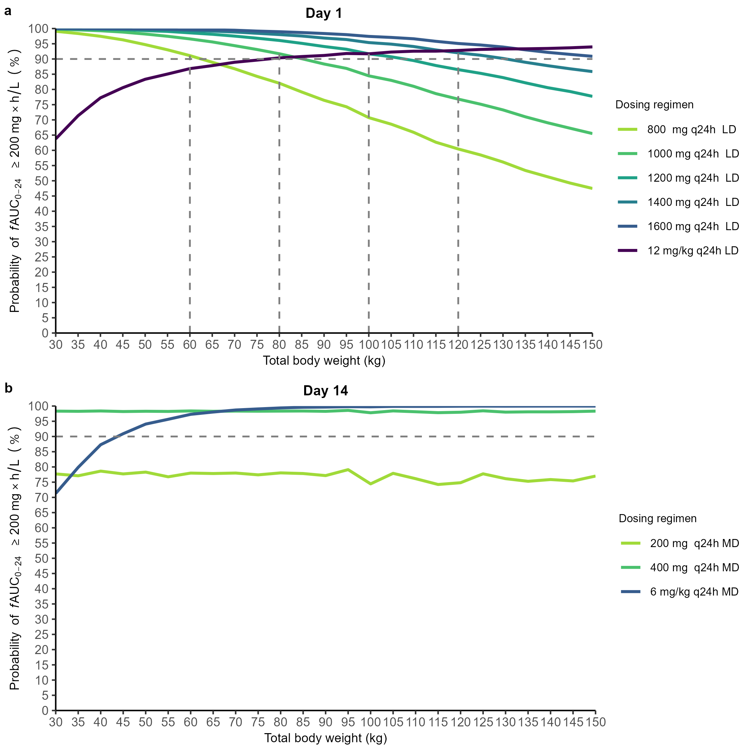
Figure 1: Probability of target attainment of fAUC₀₋₂₄ 200 mg×h/L vs body weight on day 1 (a) and day 14 (b) when not on CRRT. CRRT: continuous renal replacement therapy; fAUC₀₋₂₄: area under the unbound concentration-time curve for 24 hours; LD: loading dose; MD: maintenance dose. The dashed gray line represents the target probability of PKPD target attainment of 90%.

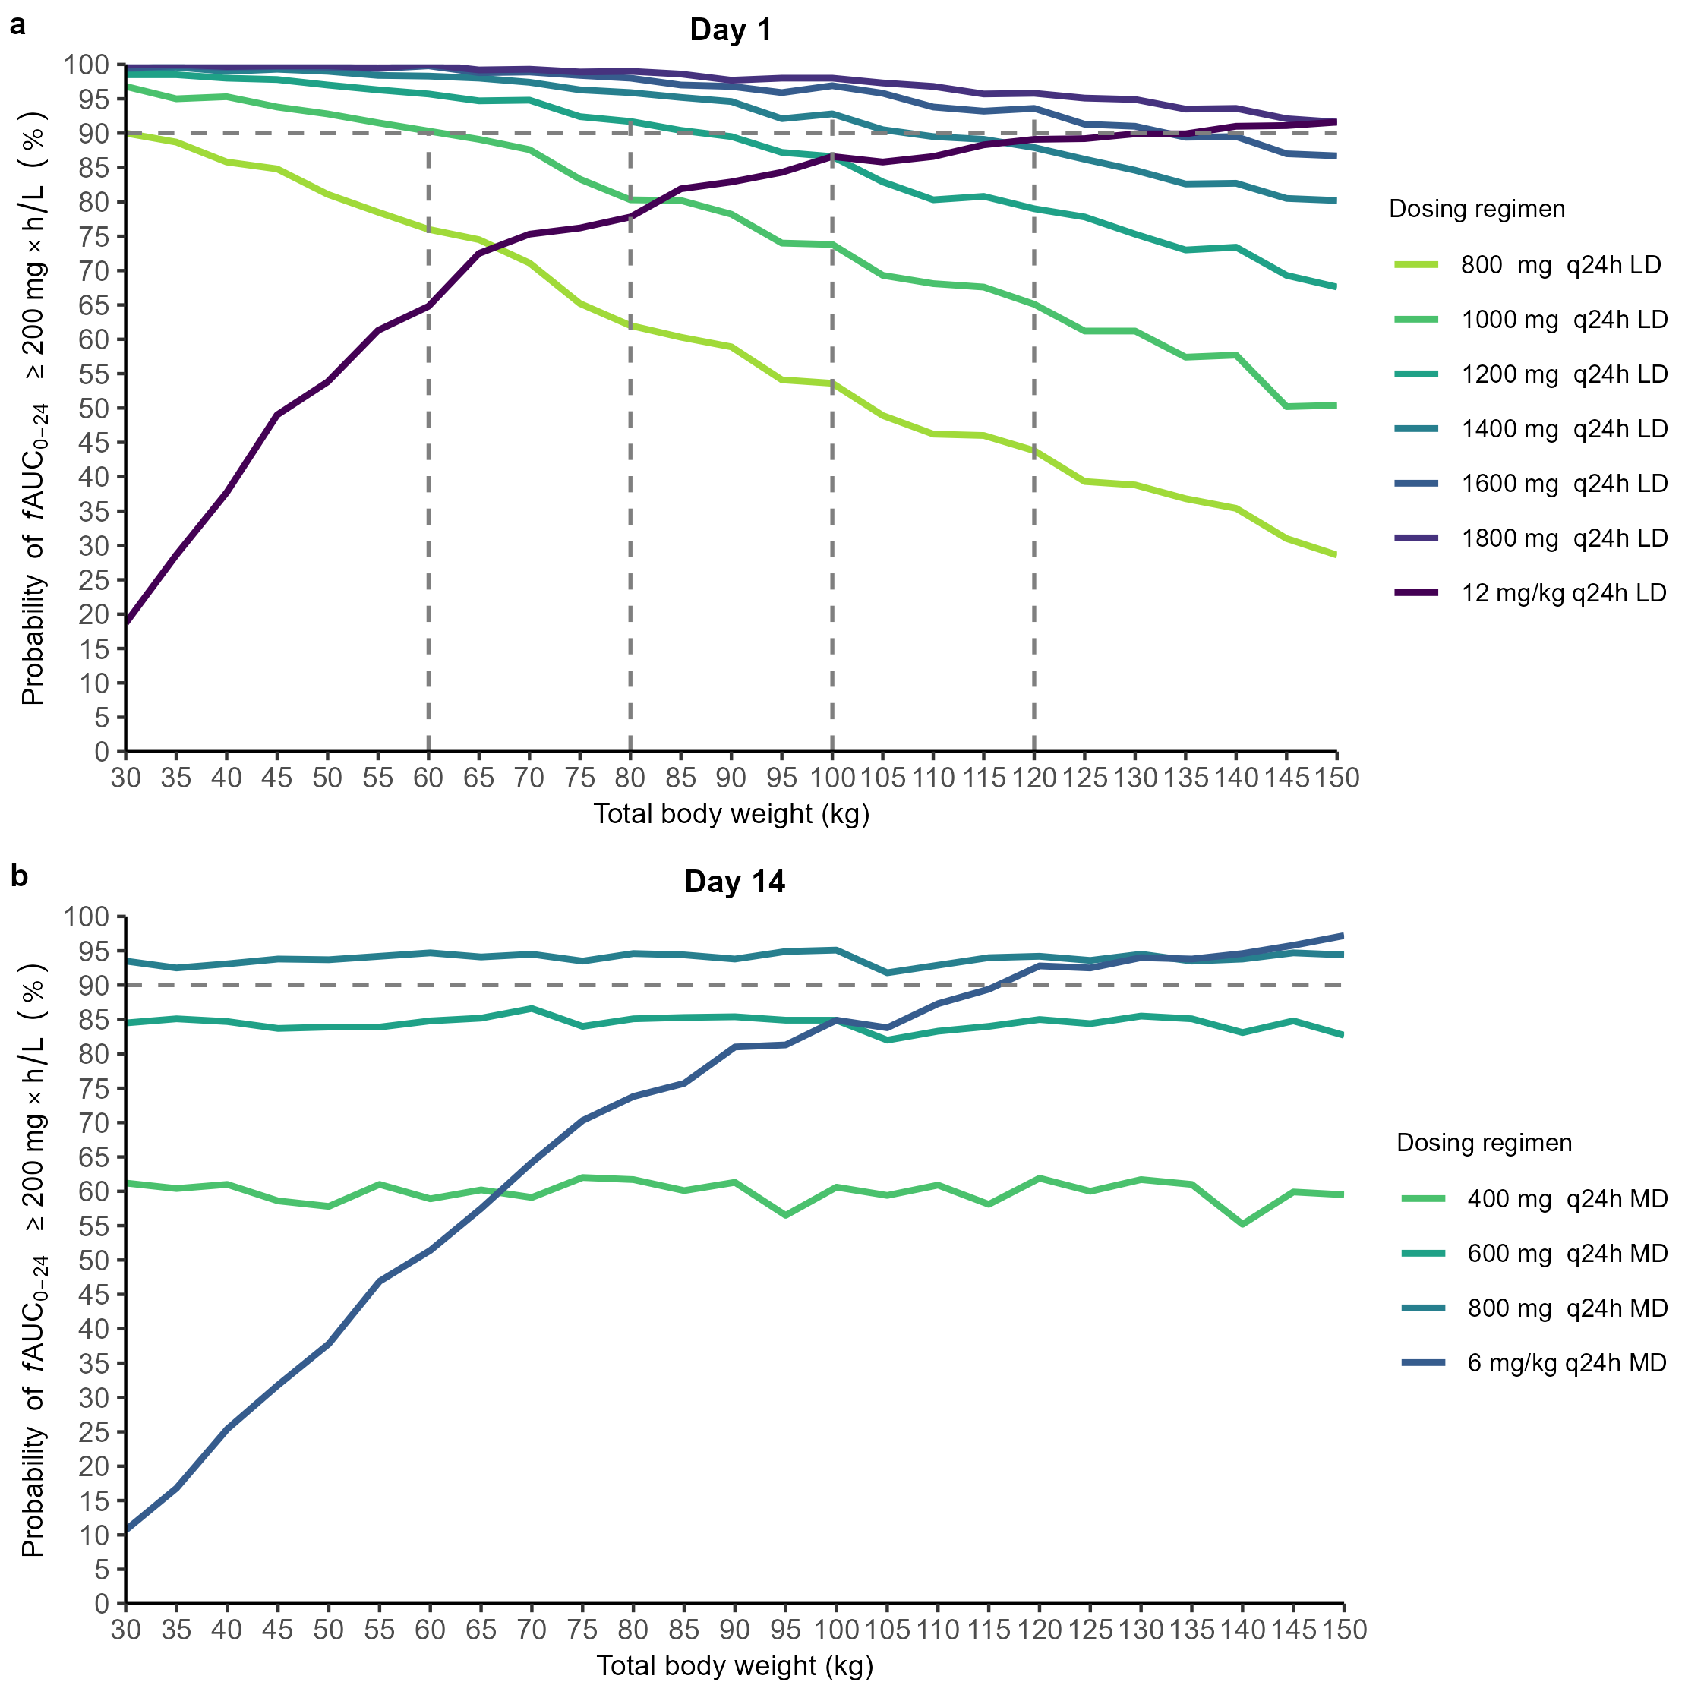
Figure 2: Probability of target attainment of fAUC₀₋₂₄ 200 mg×h/L vs body weight on day 1 (a) and day 14 (b) when on CRRT. CRRT: continuous renal replacement therapy; fAUC₀₋₂₄: area under the unbound concentration-time curve for 24 hours; LD: loading dose; MD: maintenance dose. The dashed gray line represents the target probability of PKPD target attainment of 90%.

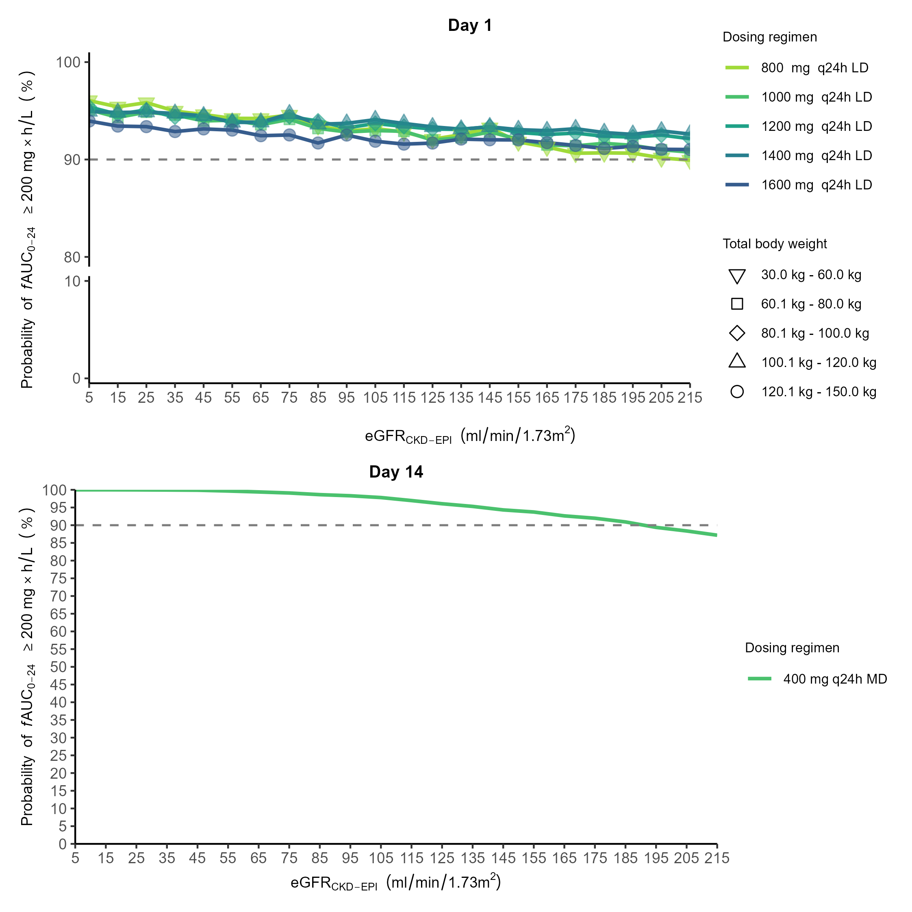
Figure 3: Probability of target attainment of fAUC₀₋₂₄ 200 mg×h/L vs eGFR_{CKD-EPI} on day 1 (a) and day 14 (b) when not on CRRT. eGFR_{CKD-EPI}: estimated glomerular filtration rate (calculated using the Chronic Kidney Disease Epidemiology Collaboration equation). CRRT: continuous renal replacement therapy; fAUC₀₋₂₄: area under the unbound concentration-time curve for 24 hours; LD: loading dose; MD: maintenance dose. The dashed gray line represents the target probability of PKPD target attainment of 90%.

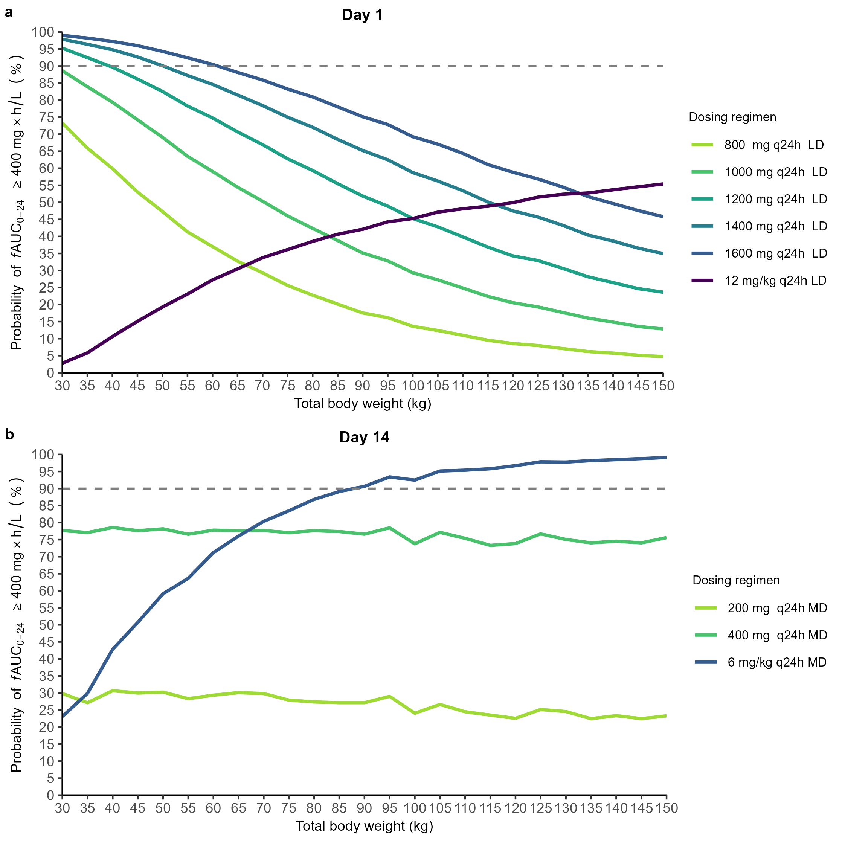
Figure 4: Probability of target attainment of fAUC₀₋₂₄ 400 mg×h/L vs body weight on day 1 (a) and day 14 (b) when not on CRRT. CRRT: continuous renal replacement therapy; fAUC₀₋₂₄: area under the unbound concentration-time curve for 24 hours; LD: loading dose; MD: maintenance dose. The dashed gray line represents the target probability of PKPD target attainment of 90%.

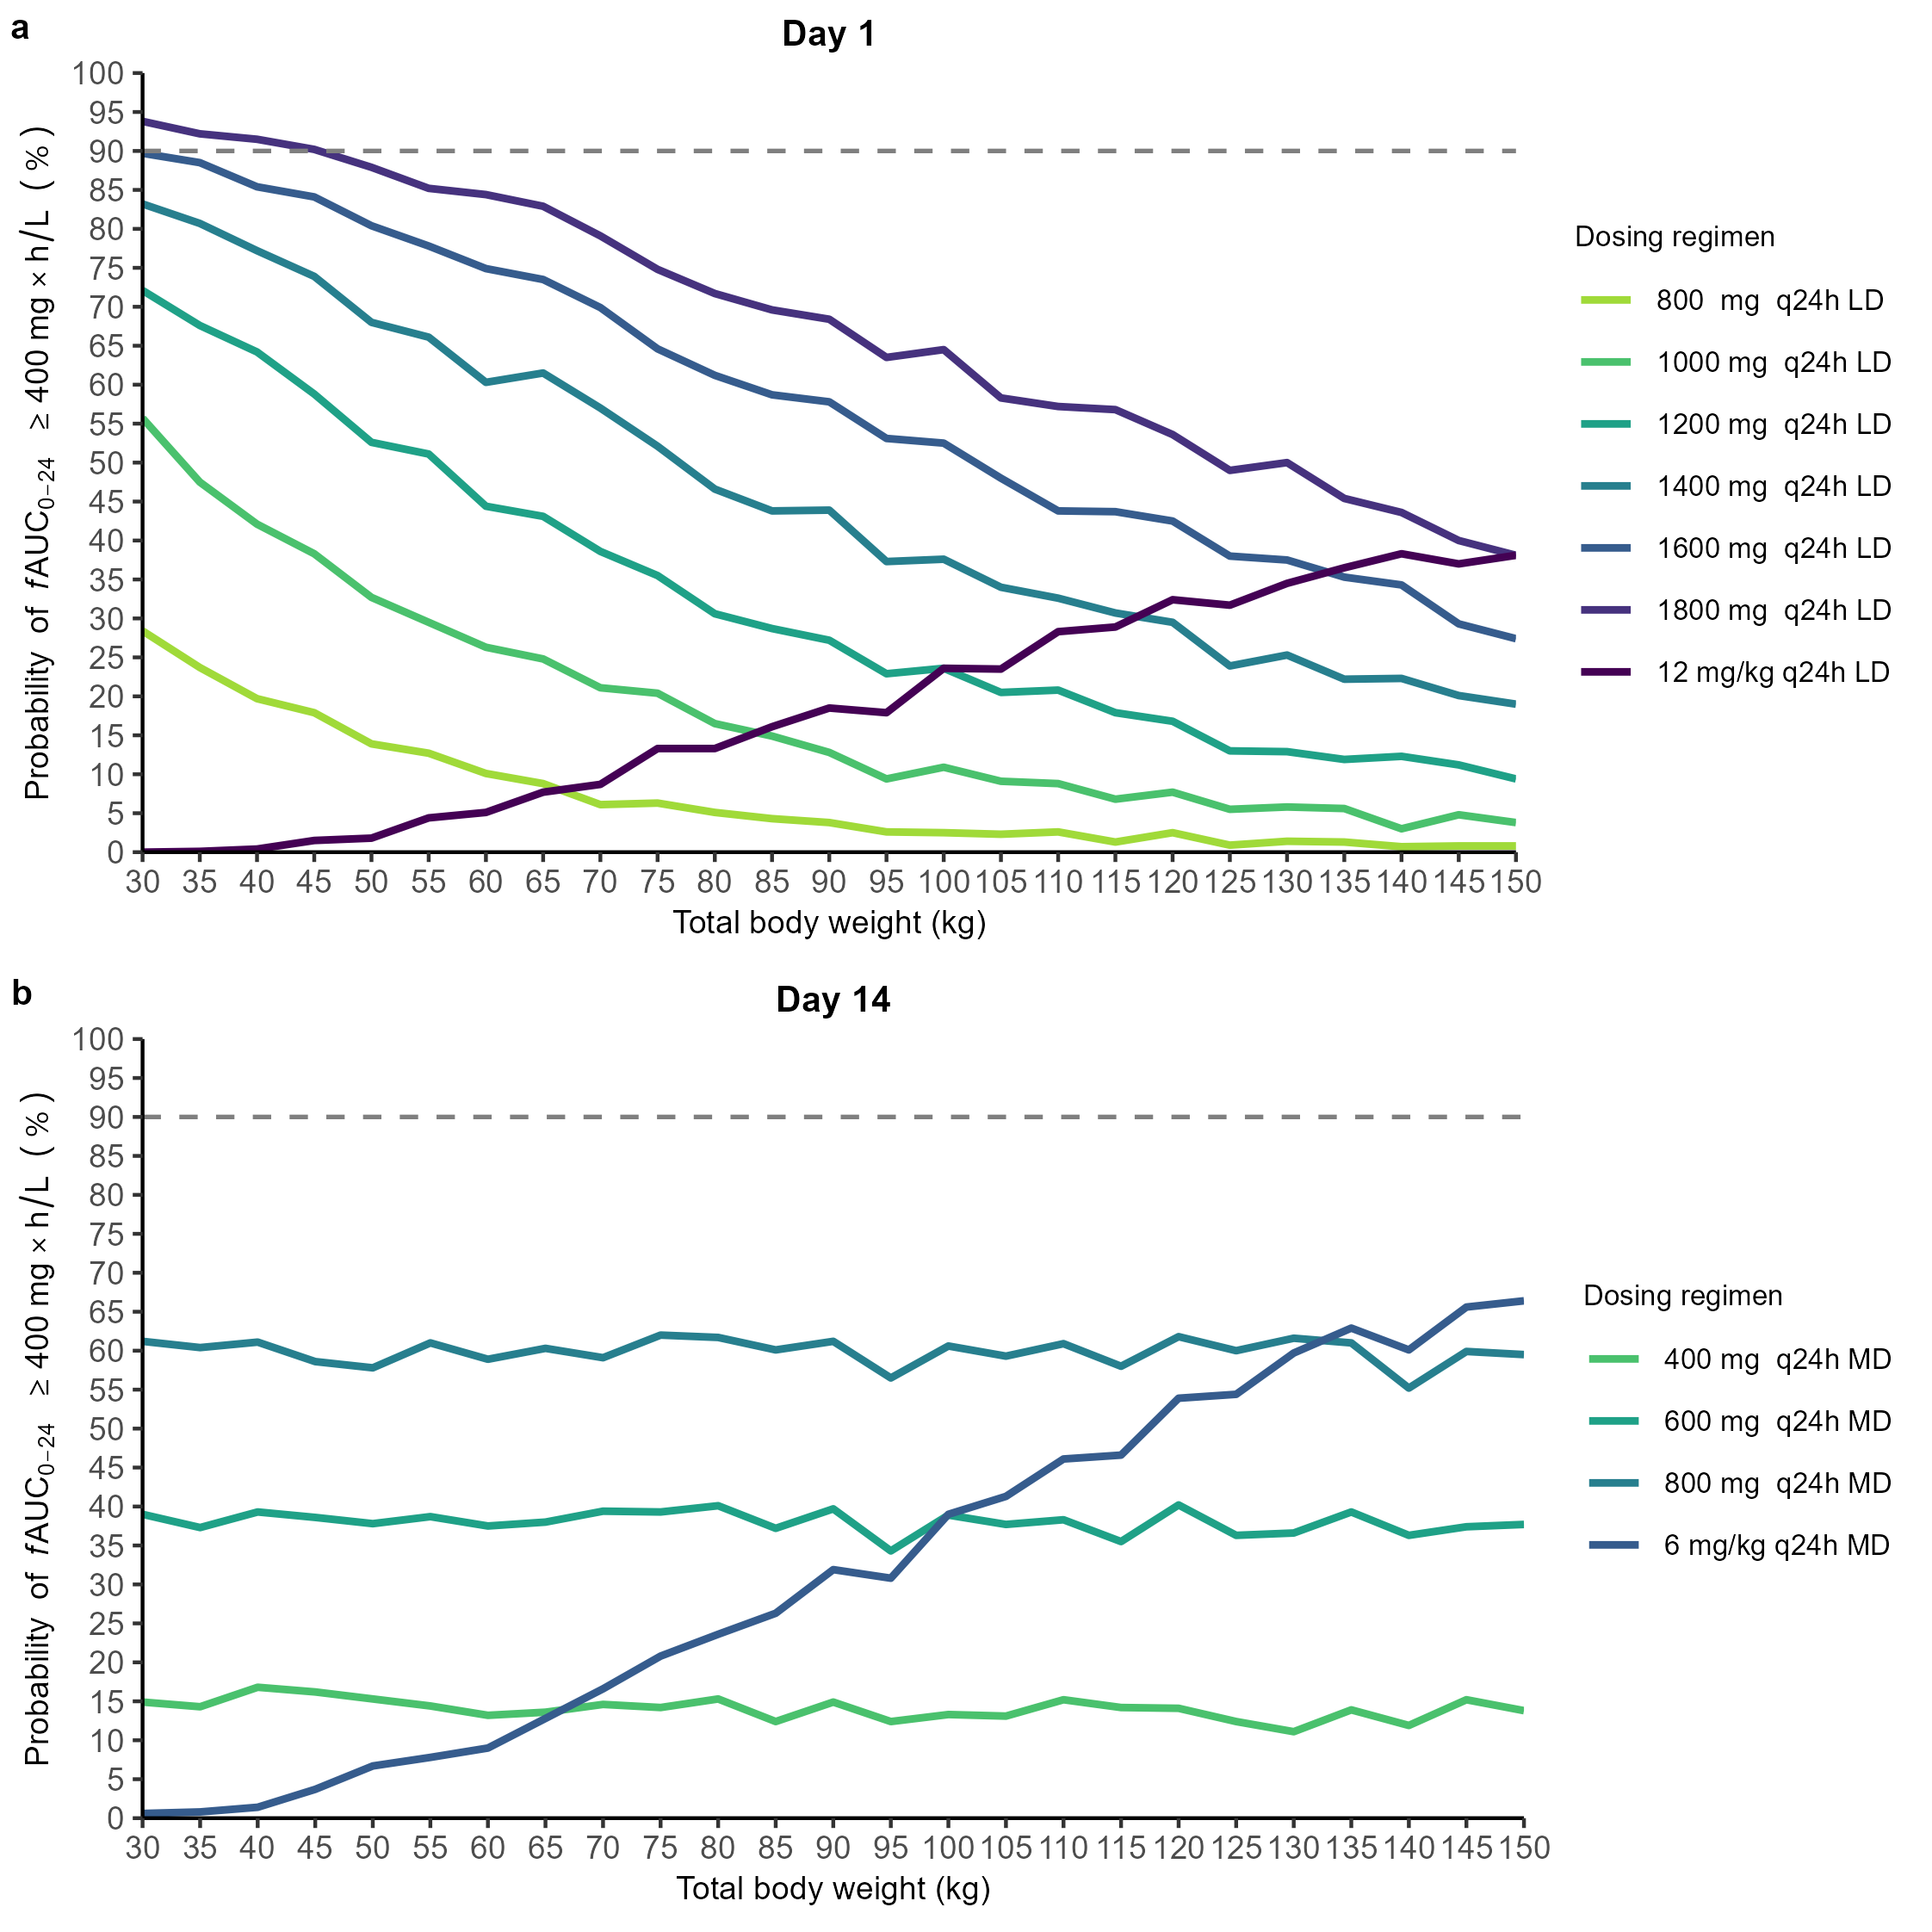
Figure 5: Probability of target attainment of fAUC₀₋₂₄ 400 mg×h/L vs body weight on day 1 (a) and day 14 (b) when on CRRT. CRRT: continuous renal replacement therapy; fAUC₀₋₂₄: area under the unbound concentration-time curve for 24 hours; LD: loading dose; MD: maintenance dose. The dashed gray line represents the target probability of PKPD target attainment of 90%.

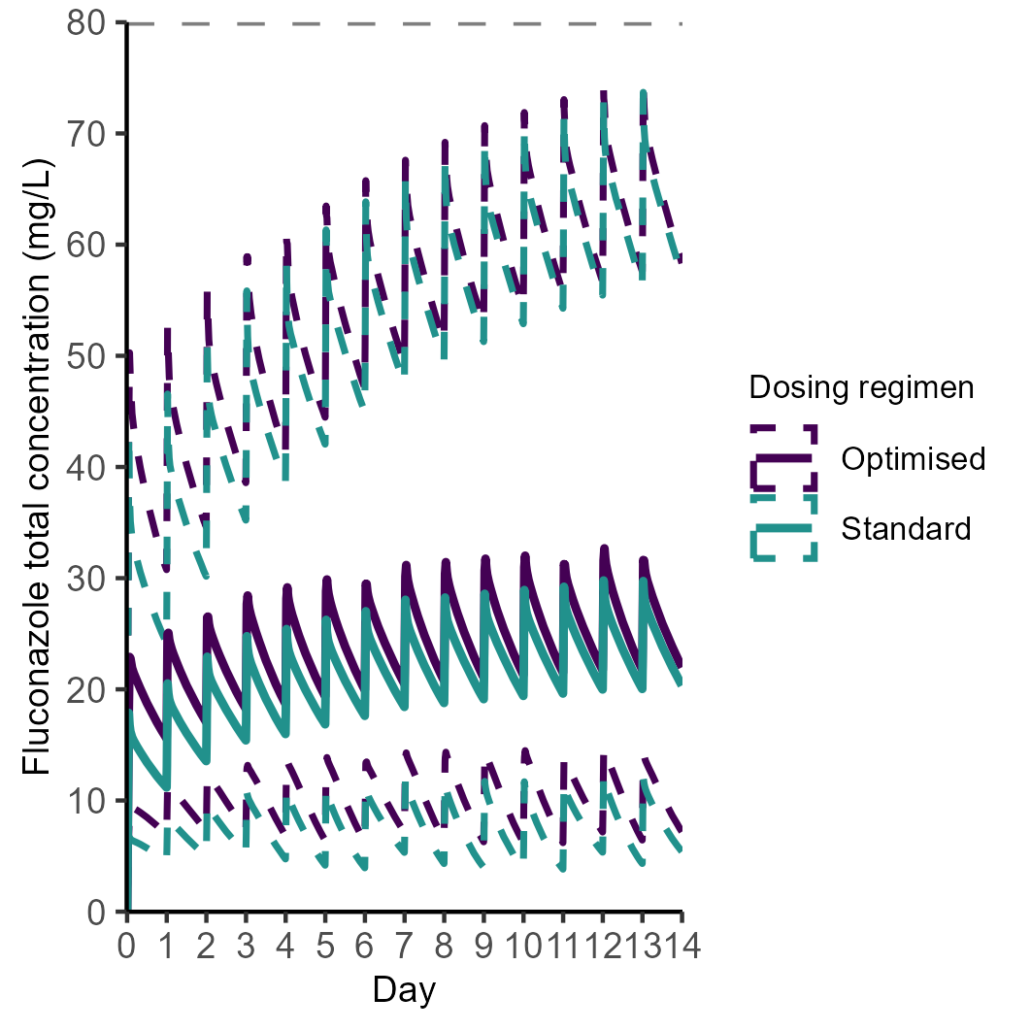
Figure 6: Fluconazole total concentration over time at the population level for standard and optimised dosing regimens. The concentration is represented by the median line, with dashed lines showing the range between the 5th and 95th percentiles of the population. The dashed gray line represents the threshold for fluconazole toxicity.

References
Abdul-Aziz, Mohd H., Jan-Willem C. Alffenaar, Matteo Bassetti, Hendrik Bracht, George Dimopoulos, Deborah Marriott, Michael N. Neely, et al. 2020. “Antimicrobial Therapeutic Drug Monitoring in Critically Ill Adult Patients: A Position Paper#.” Intensive Care Medicine 46 (6): 1127–53. https://doi.org/10.1007/s00134-020-06050-1.
Alobaid, Abdulaziz S., Steven C. Wallis, Paul Jarrett, Therese Starr, Janine Stuart, Melissa Lassig-Smith, Jenny Lisette Ordóñez Mejia, et al. 2016. “Effect of Obesity on the Population Pharmacokinetics of Fluconazole in Critically Ill Patients.” Antimicrobial Agents and Chemotherapy 60 (11): 6550–57. https://doi.org/10.1128/aac.01088-16.
Antimicrobial Susceptibility Testing, European Committee on. 2020. “Fluconazole: Rationale for the Clinical Breakpoints, Version 3.0.” https://www.eucast.org/fileadmin/src/media/PDFs/EUCAST_files/Rationale_documents/Fluconazole_RD_v3.0_final_18_02.pdf.
Aoyama, T., K. Hirata, R. Hirata, H. Yamazaki, Y. Yamamoto, H. Hayashi, and Y. Matsumoto. 2011. “Population Pharmacokinetics of Fluconazole After Administration of Fosfluconazole and Fluconazole in Critically Ill Patients.” Journal of Clinical Pharmacy and Therapeutics 37 (3): 356–63. https://doi.org/10.1111/j.1365-2710.2011.01297.x.
Bassetti, Matteo, Daniele R. Giacobbe, Antonio Vena, Cecilia Trucchi, Filippo Ansaldi, Massimo Antonelli, Vaclava Adamkova, et al. 2019. “Incidence and Outcome of Invasive Candidiasis in Intensive Care Units (ICUs) in Europe: Results of the EUCANDICU Project.” Critical Care 23 (1). https://doi.org/10.1186/s13054-019-2497-3.
Bergner, Raoul, Martin Hoffmann, Klaus-Dieter Riedel, Gerd Mikus, Dirk M. Henrich, Walter E. Haefeli, Michael Uppenkamp, and Ingeborg Walter-Sack. 2005. “Fluconazole Dosing in Continuous Veno-Venous Haemofiltration (CVVHF): Need for a High Daily Dose of 800mg.” Nephrology Dialysis Transplantation 21 (4): 1019–23. https://doi.org/10.1093/ndt/gfi284.
Boer, P. 1984. “Estimated Lean Body Mass as an Index for Normalization of Body Fluid Volumes in Humans.” American Journal of Physiology-Renal Physiology 247 (4): F632–36. https://doi.org/10.1152/ajprenal.1984.247.4.f632.
Boonstra, J. M., A. G. Märtson, I. Sandaradura, J. G. W. Kosterink, T. S. van der Werf, D. J. E. Marriott, J. G. Zijlstra, D. J. Touw, and J. W. C. Alffenaar. 2021. “Optimization of Fluconazole Dosing for the Prevention and Treatment of Invasive Candidiasis Based on the Pharmacokinetics of Fluconazole in Critically Ill Patients.” Antimicrobial Agents and Chemotherapy 65 (3). https://doi.org/10.1128/aac.01554-20.
Buijk, S. L. C. E., I. C. Gyssens, J. W. Mouton, H. A. Verbrugh, D. J. Touw, and H. A. Bruining. 2001. “Pharmacokinetics of Sequential Intravenous and Enteral Fluconazole in Critically Ill Surgical Patients with Invasive Mycoses and Compromised Gastro-Intestinal Function.” Intensive Care Medicine 27 (1): 115–21. https://doi.org/10.1007/s001340000771.
Buuren, Stef van. 2018. Flexible Imputation of Missing Data. 2nd ed. New York: CRC Press.
Chen, Lu, Koen P van Rhee, Roeland E Wasmann, Elke H J Krekels, Marinus J Wiezer, Eric P A van Dongen, Paul E Verweij, Paul D van der Linden, Roger J Brüggemann, and Catherijne A J Knibbe. 2022. “Total Bodyweight and Sex Both Drive Pharmacokinetic Variability of Fluconazole in Obese Adults.” Journal of Antimicrobial Chemotherapy 77 (8): 2217–26. https://doi.org/10.1093/jac/dkac160.
Committee for Medicinal Products for Human Use (CHMP), European Medicines Agency. 2016. “Guideline on the Use of Pharmacokinetics and Pharmacodynamics in the Development of Antimicrobial Medicinal Products.” United Kingdom: European Medicines Agency. https://www.tga.gov.au/sites/default/files/2024-08/guideline_on_the_use_of_pharmacokinetics_and_pharmacodynamics_in_the_development_of_antimicrobial_medicinal_products_.pdf.
Cornely, O. A., M. Bassetti, T. Calandra, J. Garbino, B. J. Kullberg, O. Lortholary, W. Meersseman, et al. 2012. “ESCMID Guideline for the Diagnosis and Management of Candida Diseases 2012: Non-Neutropenic Adult Patients.” Clinical Microbiology and Infection 18 (December): 19–37. https://doi.org/10.1111/1469-0691.12039.
Darnis, S., N. Fareau, C. E. Corallo, S. Poole, M. J. Dooley, and A. C. Cheng. 2012. “Estimation of Body Weight in Hospitalized Patients.” QJM 105 (8): 769–74. https://doi.org/10.1093/qjmed/hcs060.
Gijsen, Matthias, Alexander Wilmer, Geert Meyfroidt, Joost Wauters, and Isabel Spriet. 2020. “Can Augmented Renal Clearance Be Detected Using Estimators of Glomerular Filtration Rate?” Critical Care 24 (1). https://doi.org/10.1186/s13054-020-03057-4.
Hosmer, David W., Stanley Lemeshow, and Susanne May. 2008. Applied Survival Analysis: Regression Modeling of Time-to-Event Data. 2nd ed. New Jersey: John Wiley & Sons, Inc.
Huang, Chao-Yuan, Fabian Güiza, Greet De Vlieger, and Geert Meyfroidt. 2022. “Daily Fluctuations in Kidney Function in Critically Ill Adults.” Critical Care 26 (1). https://doi.org/10.1186/s13054-022-04226-3.
Jacobson, Mark A., Douglas K. Hanks, and Linda D. Ferrell. 1994. “Fatal Acute Hepatic Necrosis Due to Fluconazole.” The American Journal of Medicine 96 (2): 188–90. https://doi.org/10.1016/0002-9343(94)90141-4.
Jonsson, E. Niclas, and Mats O. Karlsson. 1998. “Automated Covariate Model Building Within NONMEM.” Pharmaceutical Research 15 (9): 1463–68. https://doi.org/10.1023/a:1011970125687.
Keizer, RJ, MO Karlsson, and A Hooker. 2013. “Modeling and Simulation Workbench for NONMEM: Tutorial on Pirana, PsN, and Xpose.” CPT: Pharmacometrics & Systems Pharmacology 2 (6): 1–9. https://doi.org/10.1038/psp.2013.24.
Lewis, R., R. Brüggemann, C. Padoin, J. Maertens, O. Marchetti, A. Groll, et al. 2015. “Triazole Antifungal Therapeutic Drug Monitoring.” Sixth European Conference on Infections in Leukaemia Meeting, Sophia Antipolis, France. https://www.ecil-leukaemia.com/images/resources/2015/5_ECIL6-Triazole-TDM-07-12-2015-Lewis-R-et-al.pdf.
Li, Lu, Xin Li, Yanzhe Xia, Yanqi Chu, Haili Zhong, Jia Li, Pei Liang, et al. 2020. “Recommendation of Antimicrobial Dosing Optimization During Continuous Renal Replacement Therapy.” Frontiers in Pharmacology 11 (May). https://doi.org/10.3389/fphar.2020.00786.
Matsumoto, Kana, Kazuyuki Ueno, Hironori Yoshimura, Megumi Morii, Mitsutaka Takada, Toyomitsu Sawai, Kotaro Mitsutake, and Masahiko Shibakawa. 2000. “Fluconazole-Induced Convulsions at Serum Trough Concentrations of Approximately 80 ??g/mL.” Therapeutic Drug Monitoring 22 (5): 635–36. https://doi.org/10.1097/00007691-200010000-00022.
Mould, DR, and RN Upton. 2013. “Basic Concepts in Population Modeling, Simulation, and Model-Based Drug DevelopmentPart 2: Introduction to Pharmacokinetic Modeling Methods.” CPT: Pharmacometrics & Systems Pharmacology 2 (4): 1–14. https://doi.org/10.1038/psp.2013.14.
Muilwijk, Eline W., Dylan W. de Lange, Jeroen A. Schouten, Roeland E. Wasmann, Rob ter Heine, David M. Burger, Angela Colbers, et al. 2020. “Suboptimal Dosing of Fluconazole in Critically Ill Patients: Time To Rethink Dosing.” Antimicrobial Agents and Chemotherapy 64 (10). https://doi.org/10.1128/aac.00984-20.
Pappas, Peter G., Carol A. Kauffman, David R. Andes, Cornelius J. Clancy, Kieren A. Marr, Luis Ostrosky-Zeichner, Annette C. Reboli, et al. 2015. “Clinical Practice Guideline for the Management of Candidiasis: 2016 Update by the Infectious Diseases Society of America.” Clinical Infectious Diseases 62 (4): e1–50. https://doi.org/10.1093/cid/civ933.
Patel, Kashyap, Jason A. Roberts, Jeffrey Lipman, Susan E. Tett, Megan E. Deldot, and Carl M. Kirkpatrick. 2011. “Population Pharmacokinetics of Fluconazole in Critically Ill Patients Receiving Continuous Venovenous Hemodiafiltration: Using Monte Carlo Simulations To Predict Doses for Specified Pharmacodynamic Targets.” Antimicrobial Agents and Chemotherapy 55 (12): 5868–73. https://doi.org/10.1128/aac.00424-11.
Pfizer. 2012. “Summary of Product Characteristics (SmPC) Diflucan.” https://www.ema.europa.eu/en/documents/referral/diflucan-article-30-referral-annex-iii_en.pdf.
Ramachandran, K. M., and C. P. Tsokos. 2021. “Chapter 5 – Statistical Estimation.” In Mathematical Statistics with Applications in r, edited by K. M. Ramachandran and C. P. Tsokos, 3rd ed., 179–251. London: Academic Press.
Rubio-Rodríguez, Darío, Santiago Grau, Juan Carlos Pozo, Eva Romá, Miguel Salavert, J. A. Barrueta, Carmen Peral, Irene Rodriguez, and C Rubio Terres. 2015. “Cost-Effectiveness of Three Echinocandins and Fluconazole in the Treatment of Candidemia and/or Invasive Candidiasis in Nonneutropenic Adult Patients.” ClinicoEconomics and Outcomes Research, October, 527. https://doi.org/10.2147/ceor.s91587.
Sandaradura, Indy, Deborah J. E. Marriott, Richard O. Day, Ross L. G. Norris, Edna Pang, Sophie L. Stocker, and Stephanie E. Reuter. 2021. “Current Fluconazole Treatment Regimens Result in Under-Dosing of Critically Ill Adults During Early Therapy.” European Journal of Clinical Microbiology & Infectious Diseases 40 (7): 1521–28. https://doi.org/10.1007/s10096-021-04201-w.
Sandaradura, Indy, Jessica Wojciechowski, Deborah J. E. Marriott, Richard O. Day, Sophie Stocker, and Stephanie E. Reuter. 2021. “Model-Optimized Fluconazole Dose Selection for Critically Ill Patients Improves Early Pharmacodynamic Target Attainment Without the Need for Therapeutic Drug Monitoring.” Antimicrobial Agents and Chemotherapy 65 (3). https://doi.org/10.1128/aac.02019-20.
Sbrana, Francesco, Emanuela Sozio, Matteo Bassetti, Andrea Ripoli, Filippo Pieralli, Anna Maria Azzini, Alessandro Morettini, et al. 2018. “Independent Risk Factors for Mortality in Critically Ill Patients with Candidemia on Italian Internal Medicine Wards.” Internal and Emergency Medicine 13 (2): 199–204. https://doi.org/10.1007/s11739-017-1783-9.
Schroeder, Maria, Theresa Weber, Timme Denker, Sarah Winterland, Dominic Wichmann, Holger Rohde, Ann-Kathrin Ozga, Marlene Fischer, and Stefan Kluge. 2020. “Epidemiology, Clinical Characteristics, and Outcome of Candidemia in Critically Ill Patients in Germany: A Single-Center Retrospective 10-Year Analysis.” Annals of Intensive Care 10 (1). https://doi.org/10.1186/s13613-020-00755-8.
Sharma, Ashish, Vaishali Sahasrabudhe, Luna Musib, Steven Zhang, Islam Younis, and Jitendra Kanodia. 2021. “Time to Rethink the Current Paradigm for Assessing Kidney Function in Drug Development and Beyond.” Clinical Pharmacology & Therapeutics 112 (5): 946–58. https://doi.org/10.1002/cpt.2489.
Sinnollareddy, Mahipal G, Jason A Roberts, Jeffrey Lipman, Murat Akova, Matteo Bassetti, Jan J De Waele, Kirsi-Maija Kaukonen, et al. 2015. “Pharmacokinetic Variability and Exposures of Fluconazole, Anidulafungin, and Caspofungin in Intensive Care Unit Patients: Data from Multinational Defining Antibiotic Levels in Intensive Care Unit (DALI) Patients Study.” Critical Care 19 (1). https://doi.org/10.1186/s13054-015-0758-3.
Van Daele, Ruth, Joost Wauters, Katrien Lagrou, Raphaël Denooz, Marie-Pierre Hayette, Matthias Gijsen, Roger J. Brüggemann, Yves Debaveye, and Isabel Spriet. 2021. “Pharmacokinetic Variability and Target Attainment of Fluconazole in Critically Ill Patients.” Microorganisms 9 (10): 2068. https://doi.org/10.3390/microorganisms9102068.
Vuong, My-Luong, Geert Verbeke, and Erwin Dreesen. 2025. “A Multiple Imputation Workflow for Handling Missing Covariate Data in Pharmacometrics Modeling.” CPT: Pharmacometrics & Systems Pharmacology 14 (6): 991–1005. https://doi.org/10.1002/psp4.70039.
Wickham, Hadley, Mine Cetinkaya-Rundel, and Garrett Grolemund. 2023. R for Data Science: Import, Tidy, Transform, Visualize, and Model Data. 2nd ed. California: O’Reilly Media.
Wijk, Rob C. van, Marjorie Z. Imperial, Radojka M. Savic, and Belén P. Solans. 2023. “Pharmacokinetic Analysis Across Studies to Drive Knowledge-Integration: A Tutorial on Individual Patient Data Meta-Analysis (IPDMA).” CPT: Pharmacometrics & Systems Pharmacology 12 (9): 1187–1200. https://doi.org/10.1002/psp4.13002.
Zwep, L. B., A. v. Rongen, K. Allegaert, C. A. J. Knibbe, and R. C. van Wijk. 2024. “Statistical Interaction Modeling in Non-Linear Mixed Effect Models: A Case Study in Neonatal Pharmacology.” PAGE 32 Meeting. https://www.page-meeting.org/?abstract=11035.

