We thank the Reviewer for the constructive comments. We have addressed the raised questions and comments below. Modifications are indicated in the “Manuscript tracked.docx” file using track changes. In our answers below, we refer to the corresponding page and line numbers in the “All Markup” display (with All Revisions Shown Inline) of the tracked files. The “Manuscript clean.docx” file is the corresponding clean version.
Editorial Comments

Comment 1: Please structure abstract with "Background and Objective, Methods, Results, Conclusion"
We have adapted the abstract as requested. [Page 2 of 27, lines 28–61]

Comment 2: Please confirm that the person mentioned in acknowledgments has provided written permission to be mentioned in the manuscript.
Permission was obtained and the confirmation e-mail is appended here (Figure A).
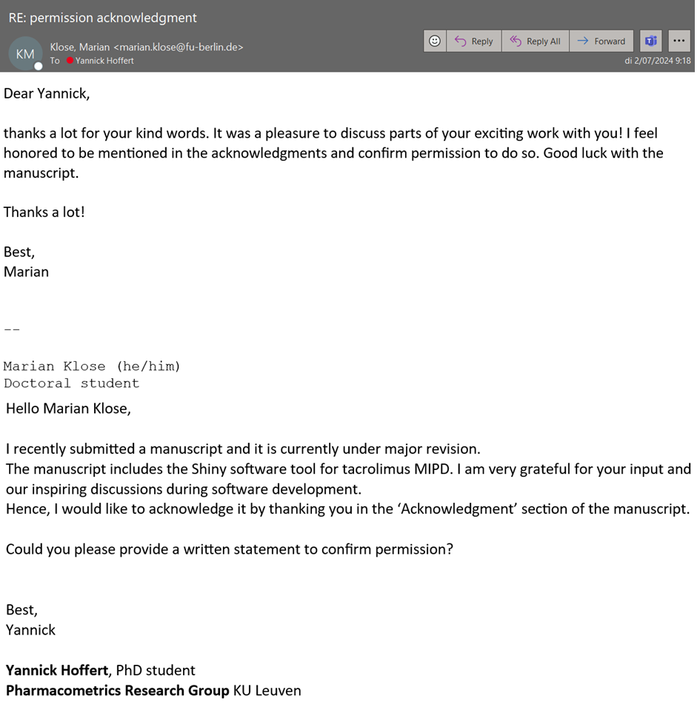
Figure A. Confirmation e-mail
Reviewer #1
In this paper the authors show a systematic literature search of all published tacrolimus popPK models (n= 80 models). Amazing to see that so many models have been developed, each for the specific population they are based upon. Furthermore, they identified 14 providers of model-informed precision dosing (MIPD) software tools and invited them to participate in a web survey that queried about tacrolimus modules and clinical integration.
It is the latter part of the paper that provides the novelty of this analysis. There are already more published papers that reviewed the popPK models on tacrolimus, also in this journal (Clin Pharmacokinet 2020 ;59(11):1357-1392). In my view it would have made for sense to start with a review of studies which have investigated whether or not patient outcomes improve with dosage prediction based on model-based dosing tools compared with traditional trough concentration monitoring.
The revised version of our manuscript includes descriptions of four prospective, controlled, randomized trials where tacrolimus dosing was model-guided. The primary outcome (trough concentration target attainment) was significantly better in the MIPD arm. We further elaborated on this in the discussion. [Page 4 of 27, line 115–116; Page 17 of 27, line 34–351]
The authors have developed their own interactive software tool to perform popPK model simulations and Bayesian forecasting, and this is now available through the website address mentioned on page 11/26.

Comment 1: Introduction, first sentence. Reference 1 (Thomson 1995) is not appropriate, as this paper focuses on the mechanism of action of tacrolimus, but is not in any way focused on the position of tacrolimus in the immunosuppressive regimens used in solid organ transplant patients.
We replaced the reference with a more appropriate one:
M.A. Sikma, E.M. van Maarseveen, E.A. van de Graaf, J.H. Kirkels, M.C. Verhaar, D.W. Donker, J. Kesecioglu, J. Meulenbelt, Pharmacokinetics and Toxicity of Tacrolimus Early After Heart and Lung Transplantation, Am J Transplant 15 (2015) 2301–2313. https://doi.org/10.1111/ajt.13309.
This paper describes the pharmacokinetics and toxicity of tacrolimus in heart and lung transplantation. [Page 4 of 27, line 95; Page 19 of 27, lines 402–404]

Comment 2: Figure 2: will this be published in full color? If not please check readability.
We confirm that Figure 2 will be printed in full color.

Comment 3: Paragraph 3.3 : One of the most frequently used tools is based at the University of Limoges, where the ISBA (ImmunoSuppressant Bayesian dose Adjustment) online expert system is offered. Was this tool included in the survey of the tool providers?
Thank you for this important comment. Based on its reputation and importance in the field of precision dosing of tacrolimus, we now include ISBA in our survey. The provider of ISBA participated in our survey and the results are included in the revised manuscript. [Page 2 of 27, lines 45–48; Page 11 of 27, lines 221−239]

Comment 4: Page 11: abbreviation PTA is used for first time, please explain
The term probability of target attainment is used for the first time in section 2.3 on page 5 of 27 (line 154), together with its abbreviation PTA. On page 14 of 27 (line 262) and page 15 of 27 (lines 289 and 291) we use the abbreviation.
Comment 5: The 6-question web survey that was sent to providers of software tools included a question on the estimated number of patients per year for which their tool was used. In Results it is mentioned that "The estimated number of patients that are dose individualized varied, between less than 100 patients per year up to more than 1,000 patients per year (MWPharm). Can authors provide more detailed information here?
Thank you for this comment. MWPharm indicated an estimate of more than 1,000 patients a year, ISBA provided an exact number of 1459 requests in 2023. The other software tool providers estimated fewer patients a year or did not disclose this information. [Page 12 of 27, line 237–239].

Comment 6: The authors have developed their own software tool, but this is not intended for dose individualization during clinical trials or in routine clinical care. The tool can be used "as a platform for transdisciplinary research collaborations to advance scientific knowledge on tacrolimus dosing." In the discussion the authors refer to their tool as "user-friendly" (twice). Have they performed a survey among the user of the tool? Or is the user-friendliness their own perception? Unless supported by data I would prefer to remove the qualification "user-friendly".
Thank you for this insightful comment. Since user-friendliness relies on our own perception rather than scientific evidence, we have now removed this term as suggested by the Reviewer. [Page 17 of 27, line 332; Page 18 of 27, line 391].

Comment 7: Discussion: Of the nine providers that offer a tacrolimus module, four declared that they performed a prospective validation of their tacrolimus module. It remains unclear what the result of his validation was, en which criteria were used to conclude that validation was successful
Only one provider gave a more detailed answer to this particular question, without further specifying the result of the validation in terms of criterion to assess a successful validation. DoseMe stated “All our models are published and validated. We do perform both internal and external validation to ensure it is implemented correctly in our software. Please refer to the published study”. However, the provided publication is a population pharmacokinetics model of tacrolimus including an external validation. DoseMe did not disclose the result of their prospective validation of their tacrolimus module.
Reviewer #2
In this study, Hoffert et al conducted a literature search on tacrolimus population pharmacokinetic models, benchmarked software that performs MIPD for tacrolimus, and developed a Shiny app that implemented 4 models for simulation and maximum a posteriori Bayesian estimation.

Comment 1: Overall, the work on cataloging tacrolimus literature is of interest, but the choice of the four models for the shiny interface seems arbitrary.
For computational reasons, it was not possible to include all 80 identified models. Hence, the sample/patient ratio served as an arbitrary selection criterion to include four models in the software tool. We acknowledge this limitation of our work and have therefore pointed it out in the Discussion. [Page 18 of 27, lines 381–385].

Comment 2: I am very surprised that ISBA (https://pharmaco.chu-limoges.fr/) was not compared to the other tools mentioned. Indeed, this publicly available website has been performing immunosupressant dose adjustment for over 20 years and offers numerous models for various indications of immunosuppressants (~1500 requests for tacrolimus per year). Addition of this program in benchmark is essential.
Thank you for this important comment, which was also raised by Reviewer #1 (Comment 3; cf. supra). The provider of ISBA participated in our survey and the results are included in the revised manuscript.

Comment 3: I am concerned that the program developed only considers C0, even though recent studies (PMID: 37082913) and consensus conferences have shown that AUC is a better marker of tacrolimus exposure.
The software tool offers a visual representation of the probability of target attainment (PTA) over time, which is indeed based on a C0 target. The user can define an exposure range (e.g., 5–10 ng/ml) and subsequently, the PTA is calculated. We acknowledge that overall tacrolimus exposure (AUC) may be a better predictor of treatment outcome. Nevertheless, C0 is still widely used as an exposure target in daily clinical care, also in UZ Leuven, which is why this first version of our software tool relies on (user-defined) C0 targets. We acknowledge this in the limitations section of the Discussion, and stressed the importance and need to validate the performance for AUC-targeted dosing as evidence is accumulating. [Page 17 of 27, lines 353−357]

Comment 4: The illustration in Figure 6 presents a very strange profile due to the fact that only the trough concentration is available. I would suggest representing only the trough instead of the entire curve, which cannot be accurately drawn from a single sample and could mislead readers.
We agree with the Reviewer that optimal sampling times are crucial in order to obtain reliable individual PK parameter estimates. Depending on the exposure metric of interest, AUC or C0, the user may or may not be interested in accurately estimating all individual PK parameters. While our software tool includes the default setting, where two trough concentrations are used to estimate PK parameters, the user can adjust these time point in the ‘Targets’ tab. We agree that the full concentration-time curves may be misleading when suboptimal sampling schedules are used, yet currently, in contrast to vancomycin, there is no consensus on optimal sampling time points for tacrolimus. We acknowledge the lack of validation of our software tool for C0 and AUC predictions in the Discussion. [Page 17 of 27, line 335−343]

Comment 5: The measurement of tacrolimus trough levels in routine care is noisy, and residual variability should be accounted for to show intra-individual variability. The positive aspect of this article is the development of a tool of pedagogical interest, but nothing is done to evaluate its predictive ability. It should be tested on real samples to assess its performance and, if possible, compared to other methods.
We agree with the Reviewer that external evaluation of the predictive performance is needed. However, this was outside the scope of our systematic review and benchmarking study. As mentioned in our manuscript, the research tool is not intended for dose individualization during clinical trials or in routine clinical care. In the absence of external retrospective evaluation of the predictive performance of our software tool, one should refrain from prospective use of the tool in clinical trials and, obviously, clinical practice. This limitation is mentioned in the discussion. [Page 17 of 27, line 342−346]

Comment 6: The authors wrote in the discussion, "Fourth, we did not externally validate our software tool since it is not intended for clinical use. It is a research tool that can be used to illustrate the behavior of previously published popPK models." However, the entire paper is written as if the tool would be useful in clinical practice.
The research tool is intended to explore the pharmacokinetic properties of tacrolimus in various solid organ transplantation settings allowing a priori and a posteriori simulations. We demonstrate the use of the research tool with hypothetical individuals rather than patients. In the absence of external retrospective evaluation of the predictive performance of our software tool, one should refrain from prospectively using the tool in clinical trials and, obviously, clinical practice. [Page 2 of 27, line 60−61; Page 6 of 27, line 163−165; Page 14 of 27, line 264−275; Page 15 of 27, line 289; Page 17 of 27, line 342−346; Page 18 of 27, line 385−387]

Comment 7: Additionally, they should have implemented all available models in the literature if it is meant to illustrate the behavior of published popPK models. This leaves the reader with ambiguity.
The integration of 80 popPK models in a single software tool was computationally too intensive. Hence we had to find an (arbitrary) selection criterion to reduce the amount of models. In the end four models (one per graft type) were included to allow the exploration of the pharmacokinetic behavior of tacrolimus in four different solid organ transplantation settings. Additionally, we believe four models are sufficient to underline the educational purpose of our research tool. This limitation was addressed in the Discussion section on line 381−385.

Comment 8: In the introduction, not all the adverse effects mentioned are explained by exposure; I would advise being more cautious. Additionally, CYP3A partially explains bioavailability and clearance, and hematocrit and protein explain distribution, but not the absorption rate constant (ka).
Thank you for this comment. Indeed, opportunistic infections are not a direct side effect caused by tacrolimus exposure Page 4 of 27, line 99]. Additionally, the mentioned factors that explain PK variability hold true for clearance and volume of distribution, but not the absorption rate constant. We apologize for the confusion and have removed the absorption rate constant (ka) from this sentence [Page 4 of 27, lines 101−102].

