CSC-30025 Advanced Web Technologies

Coursework Report: Online Bookstore Web Application

Student ID: 23023613

Login details
Email address: Leowillcock2004@gmail.com
Password: test123

Link to live website: //teach.cs.keele.ac.uk/users/y0b74/Assessment/bookstore/

Word count: 2636

Table 1: Task Template
Task | Comments
- Bookstore company webpage | Completed homepage with navigation and dynamic browsing of books by audience and category.
- Submit SQL files to generate the tables in the bookstore company | Completed SQL script to create books, users, and orders tables with sample book data.
- Registration page | Completed registration page with React client-side validation and PHP server-side validation.
- Login page with Captcha | Completed login page with CAPTCHA, password verification, and session management.
- Security aspects (preventing attacks) of the Registration and Login page | Used prepared statements, password hashing, CAPTCHA, validation, and sessions. CSRF protection and rate limiting were not implemented.
- Search engine optimization aspects in the bookstore company webpage | Added page titles, meta description, semantic HTML, and image alt text.
- User registration validation using React framework | Implemented live validation for name, phone, email, and password fields.
- Data management a)Customer registration table: b)Customer ordered table: | Created users and orders tables linked to users and books.
- RESTful webservice for the bookstore company Manager | Created an endpoint to retrieve order data by order ID in JSON format.
- Any other information (remarks), such as, usage of model view controllers (MVCs) | Organised the project using a modular multi-tier structure similar to MVC separation principles.

1. Introduction
The system is developed as a multi-tier web application, being so separates the application into layers: the presentation (what the users sees), application layer/business (all the business logic done to the page before its sent to the client), and the data layer (backend/database) (Lecture 3 – Server Side Programming with Database Integration, 2026).
I implemented the presentation layer using multiple languages/ frameworks, HTML5, CSS3, JavaScript, AJAX and React. The application layer was implemented with PHP for authentication, session management, validation, order processing, and API responses, while MySQL was used as the data layer to store books, users, and orders.

2. Site Structure and System Overview
Figure 1 illustrates the completed structure of the online bookstore multi-tier web application. The system begins at the homepage, where users can browse books by selecting an audience category.
Users may browse most of the web application as guests, or they may register and log in. During registration, user details are validated and stored securely in the database. During login, credentials are verified against stored records, and session variables are created to maintain the authenticated state.
Once logged in, the user returns to the homepage, where the ordering functionality becomes available. The user can then select a book and place an order, which is processed by the server and stored in the database together with customer details and pricing information.
The system also includes a RESTful web service that allows order details to be retrieved by order ID.
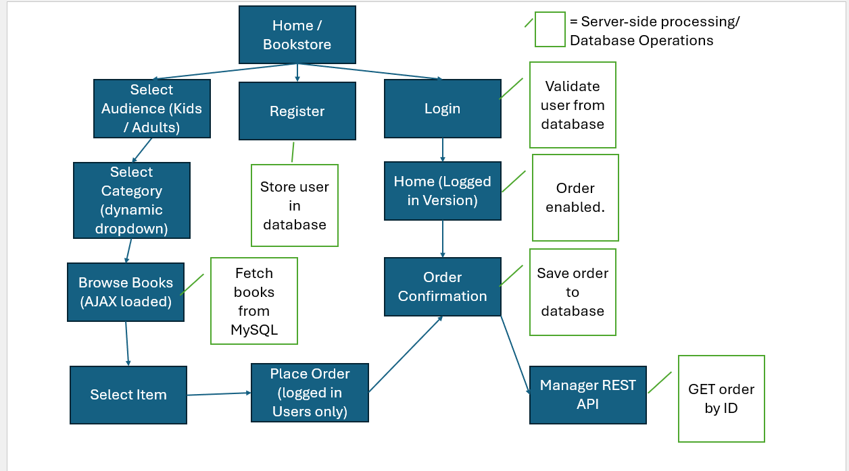
Figure 1: Functional and navigation structure of the bookstore web application.

3. Multi-Tier Architecture
The presentation layer operates in the client browser and was implemented using HTML5, CSS3, JavaScript, and React. This layer is responsible for rendering the user interface, accepting user input, displaying validation feedback, and sending AJAX requests to the server.
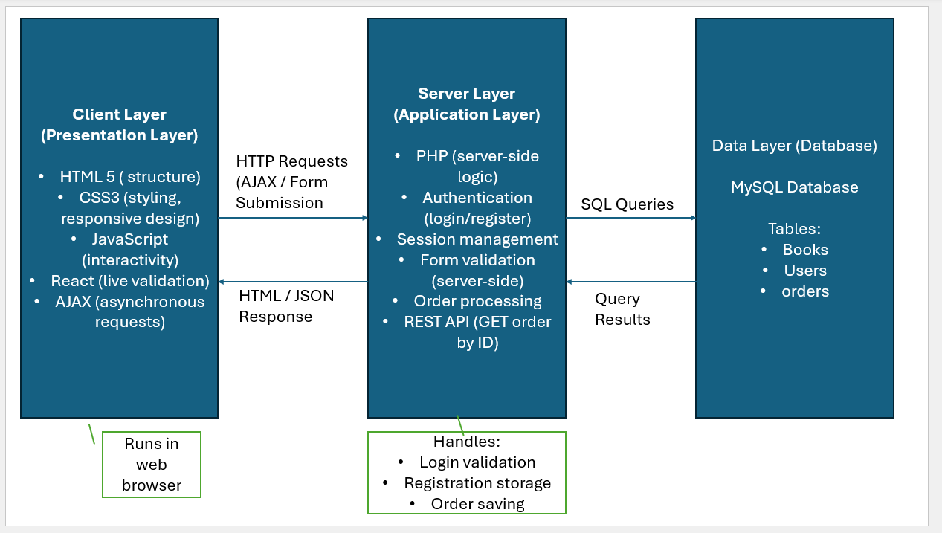
Figure 2: Multi-tier architecture of the bookstore web application.
The application layer was implemented using PHP. This layer handles form processing, registration, login, CAPTCHA validation, session management, order submission, and API processing.
The data layer was implemented using MySQL and stores all persistent application data. This includes the available books, registered user accounts, and order records.

4. Database Design

4.1 Books Table
The books table stores all book information displayed on the website. Each record represents a single book and includes fields such as id, audience, category, title, image, and price.
The audience and category fields support the filtering mechanism used by the AJAX-based browsing system. The price field is stored using a decimal type to preserve monetary accuracy.

4.2 Users Table
The users table stores customer registration details used for authentication and order processing. Each record includes id, name, phone, email, and password.
The email field is unique to prevent duplicate registrations. Passwords are stored in hashed form rather than plain text, improving security in the event of database exposure.

4.3 Orders Table
The orders table stores information relating to completed purchases. Each order includes id, user_id, customer_name, email, phone, book_id, ordered_item, price, and order_date.
The user_id and book_id fields associate each order with a specific user and book.

4.4 Relationships and Data Integrity
The relational design uses the orders table as the link between users and books. This structure improves consistency while reducing unnecessary duplication.

5. SQL Implementation
The script creates the required tables (books, users, and orders) together with appropriate primary keys and constraints.
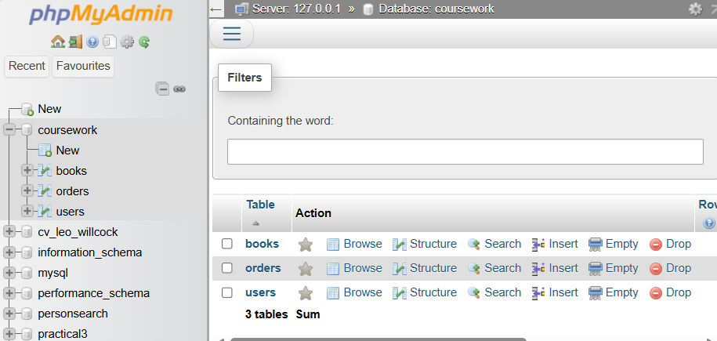
Figure 3: Database tables created successfully in phpMyAdmin.

6. Homepage and AJAX-Based Book Browsing
Users can browse books dynamically by selecting an audience and category from dropdown menus.
When the user selects a category, an asynchronous AJAX request is sent to the server without requiring a full page reload (Lecture 6 & 7 – Asynchronous Web Processes: AJAX and WebSockets, 2026). The PHP script ajax/get_books.php receives the selected values, queries the books table using a prepared statement, and returns matching book records.
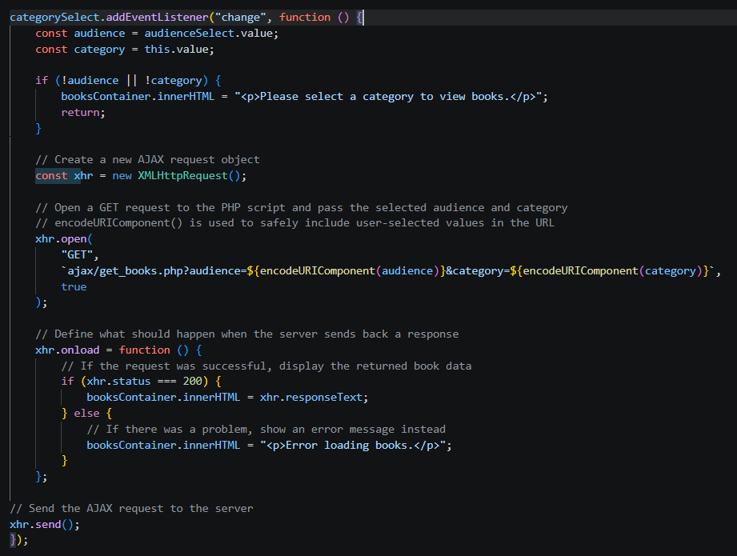
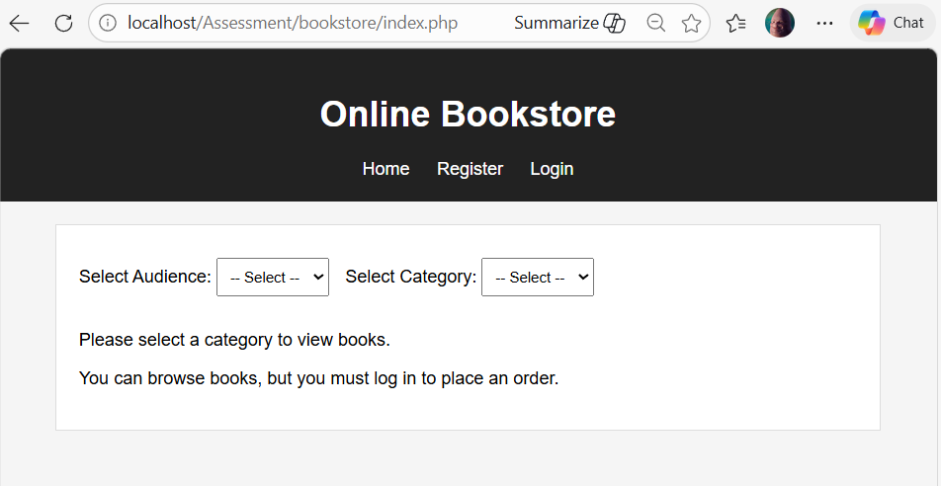
Figure 4: Homepage before category selection.
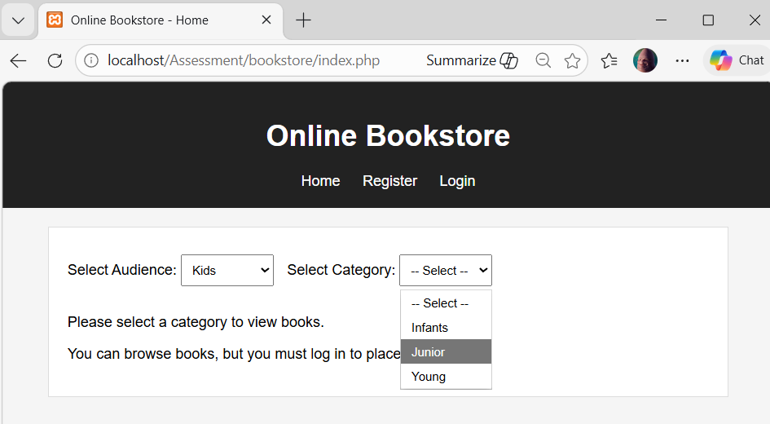
Figure 5: Dynamic population of category dropdown based on selected audience.
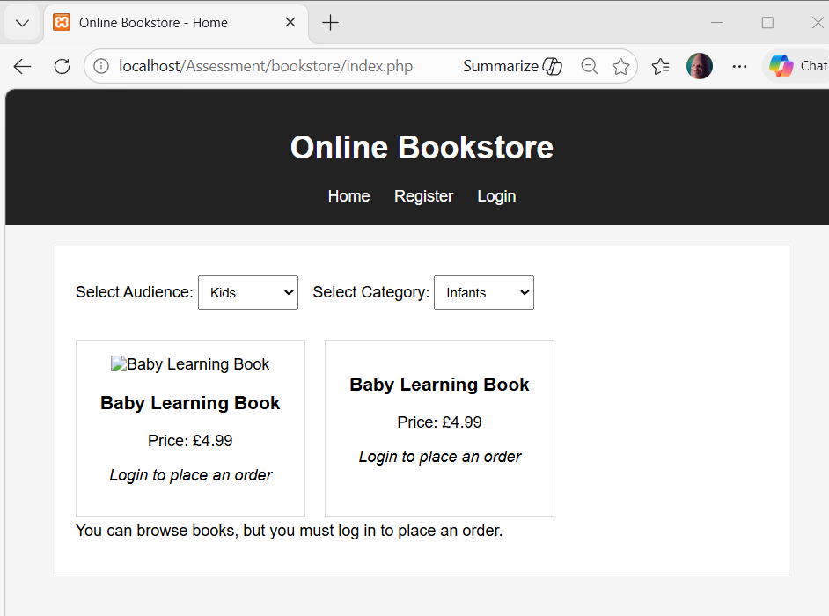
Figure 6: Books displayed dynamically using AJAX without page refresh.
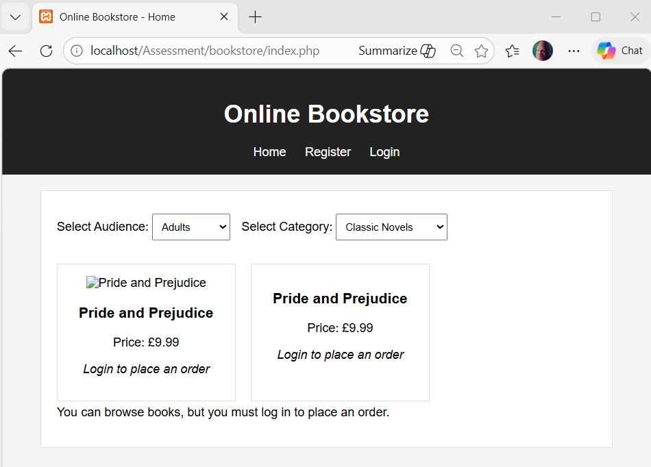
Figure 7: Example of books displayed for an adult category.

7. Registration Page and User Validation
The registration form combines client-side and server-side validation. React was used to provide live validation as the user types. Validation rules were applied to:
- restrict the name field to letters only
- require the phone number to contain exactly 10 digits
- validate the format of the email address
- enforce a minimum password length
Server-side validation was then implemented in PHP to ensure that invalid or manipulated data could not bypass the client-side checks. The email address is checked against the users table before insertion so that duplicate accounts are rejected. If the data passes validation, the password is hashed using PHP before being stored in the database.
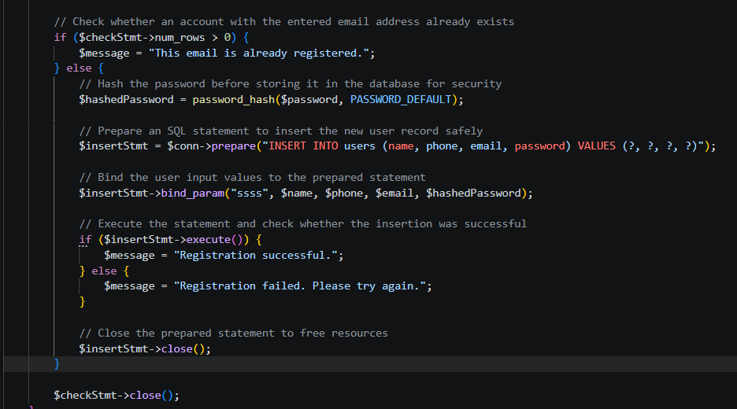
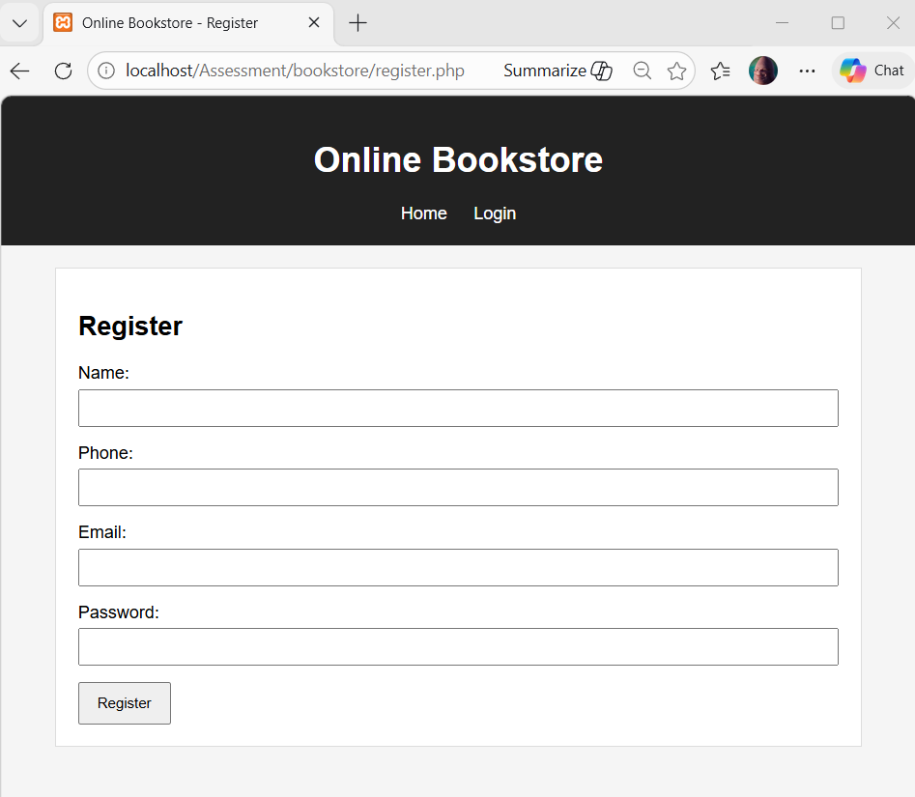
Figure 8: Initial registration page layout.
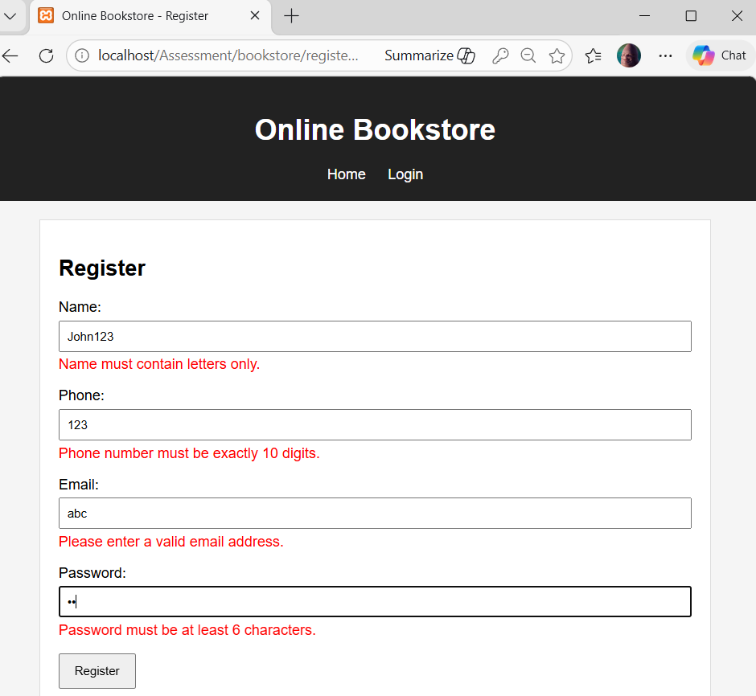
Figure 9: React-based validation displaying invalid input messages.
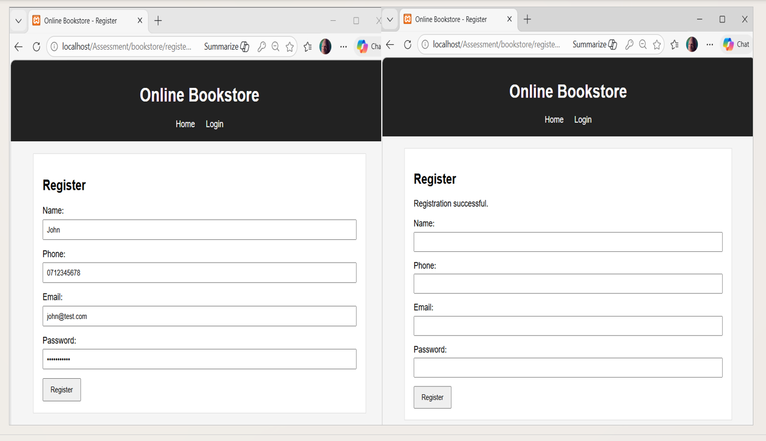
Figure 10: Successful registration using valid input values.
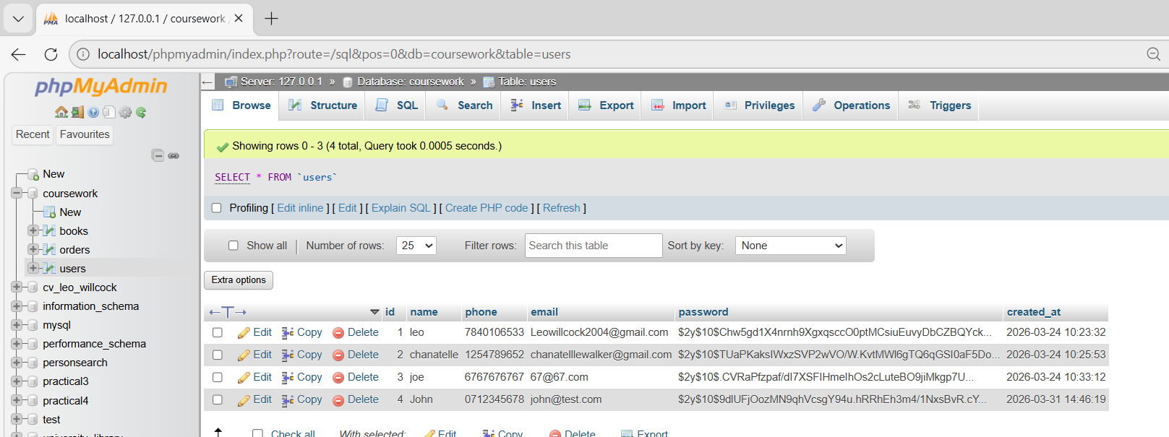
Figure 11: Registered user stored in the database with hashed password.

8. Login Page, CAPTCHA, and Session Management
During login, the submitted email address is checked against the records stored in the users table. The submitted password is then verified against the stored hashed password (GeeksforGeeks, 2025) using PHP password verification functions.
As an additional security measure, CAPTCHA validation was included in the login process. A random CAPTCHA code is generated on the server side and stored in a session variable. The user must enter the displayed value correctly before authentication is allowed to proceed. If the CAPTCHA is incorrect, the login attempt is rejected.
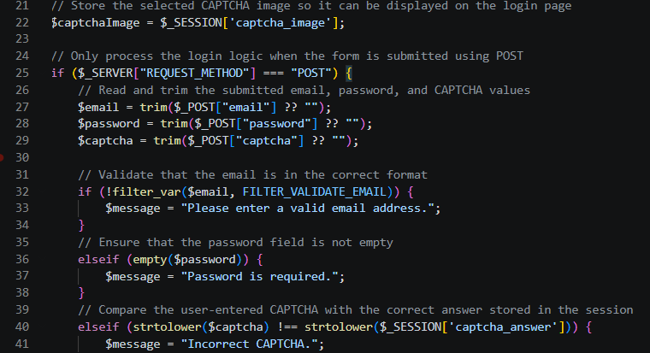
When login is successful, PHP session variables are created to store user information including user_id, name, phone, and email.
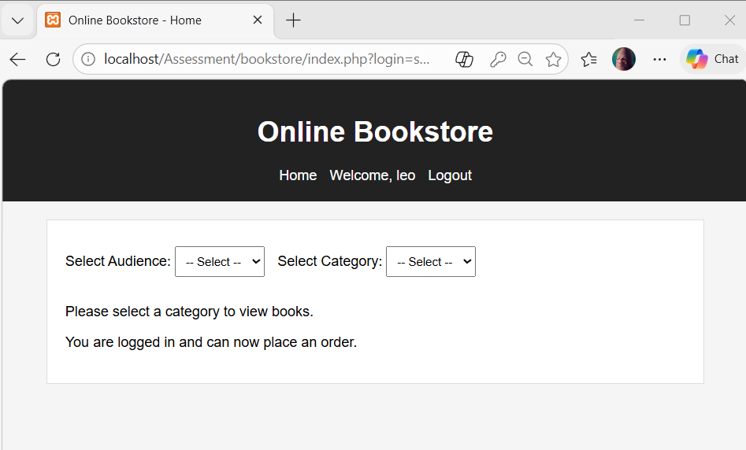
Figure 12: Successful login using valid email, password, and CAPTCHA.
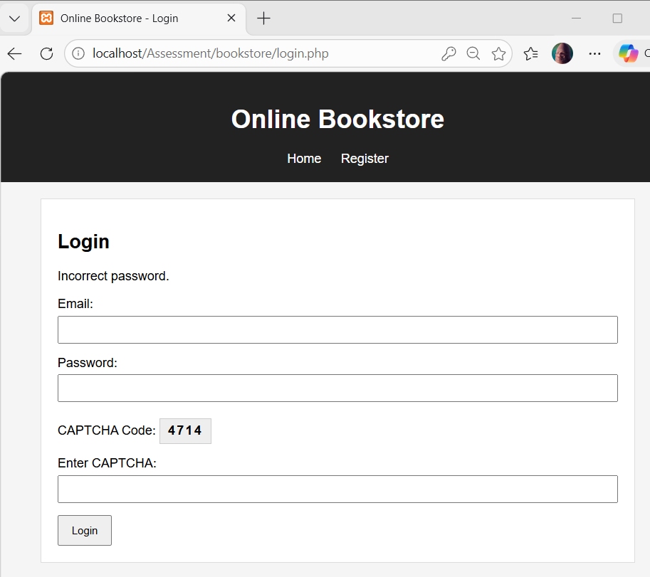
Figure 13: Login attempt with incorrect password.
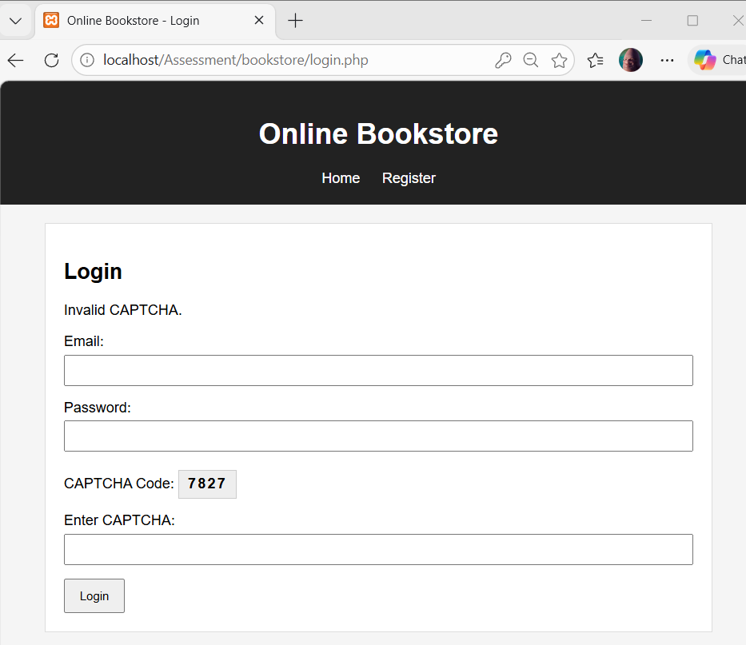
Figure 14: Login attempt with incorrect CAPTCHA.
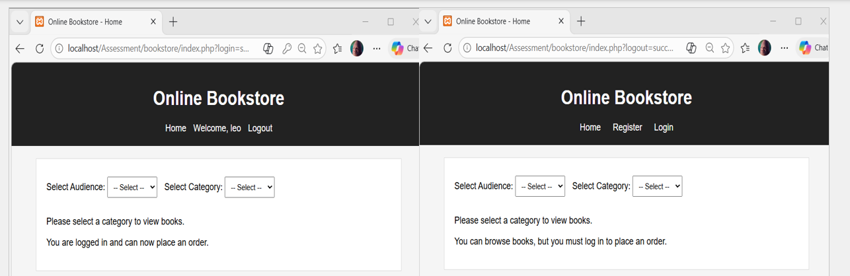
Figure 15: Logout returning the user to the unauthenticated homepage.

9. Security Considerations
Prepared statements were used in PHP for database queries in order to reduce the risk of SQL injection (GeeksforGeeks, 2025). Passwords were stored in hashed form, preventing sensitive user credentials (GeeksforGeeks, 2025) from being stored as plain text. CAPTCHA was added to the login process as a defence against automated login attempts.
Session variables were used to maintain the authenticated state of the user securely. During order submission, customer information was taken from the session rather than from editable client-side fields, reducing the possibility of user manipulation. Input validation was also applied on both the client side and the server side to improve robustness and data integrity.

10. Order Submission System
When books are displayed on the homepage, logged-in users are shown an Order button beneath each book, while guests are shown a message stating that login is required.
When the form is submitted, order.php first verifies that the user is logged in by checking the session. The user's name, email, phone, and user_id are then read directly from the session variables established during login.
A prepared statement is used to insert the order into the orders table. Once the insertion succeeds, an order confirmation page is displayed showing the ordered book and the price.
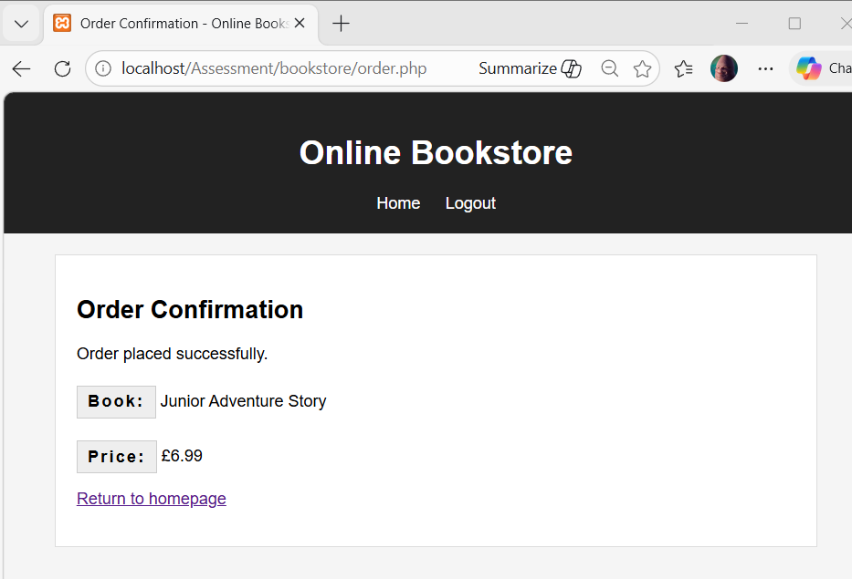
Figure 16: Order confirmation page displayed after successful purchase.
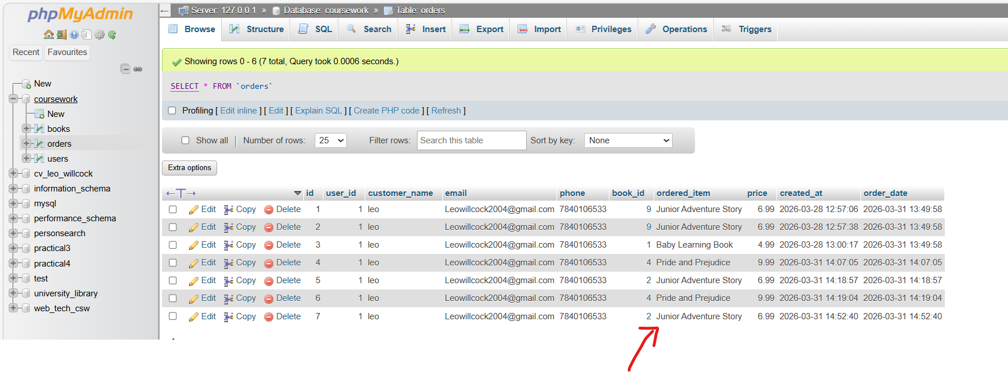
Figure 17: Order record stored in the MySQL orders table.

11. RESTful Web Service Implementation
When a request is received, the script first validates that the id parameter is present and contains a valid numeric value. A prepared statement is then used to retrieve the corresponding order record from the orders table.
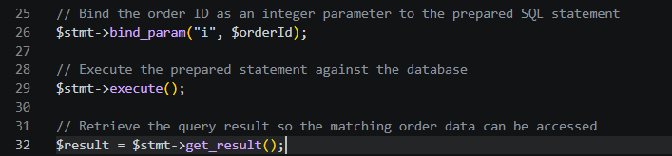
If the order exists, the API returns the order details in JSON format. If the order ID is missing, invalid, or not found, the script returns an appropriate JSON error response.
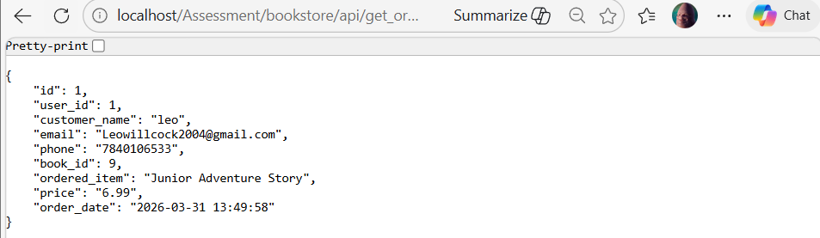
Figure 18: JSON response returned by the RESTful web service for a valid order ID.

12. Search Engine Optimisation (SEO)
Descriptive page titles were used on the website so that each page clearly communicates its purpose. Meta tags, including the viewport tag and meta descriptions, were added to support better rendering and search engine interpretation.
Semantic HTML elements such as <header>, <nav>, <main>, and <section> were used to improve the structure of the documents (Lecture 11 & 12 – SEO, 2026) for both users and search engines. Alternative text was also added to book images through the alt attribute. This improves accessibility for screen readers and helps search engines interpret image content more effectively.
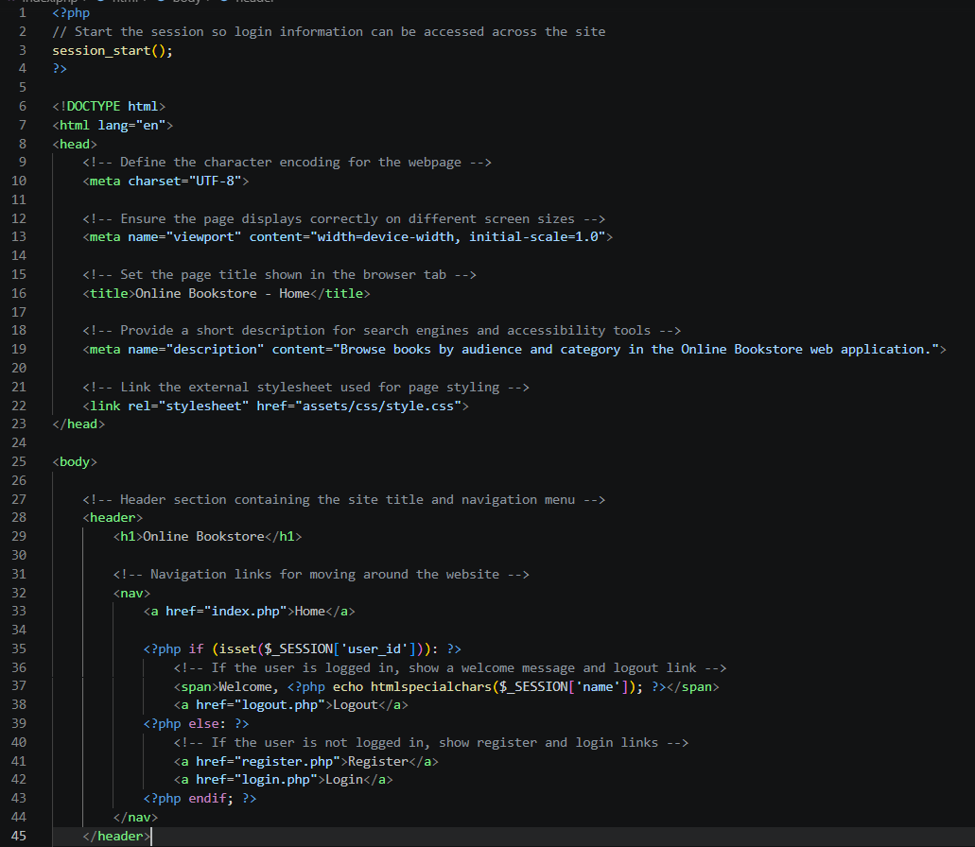
Figure 19: Example of SEO-related HTML elements used in the online bookstore.
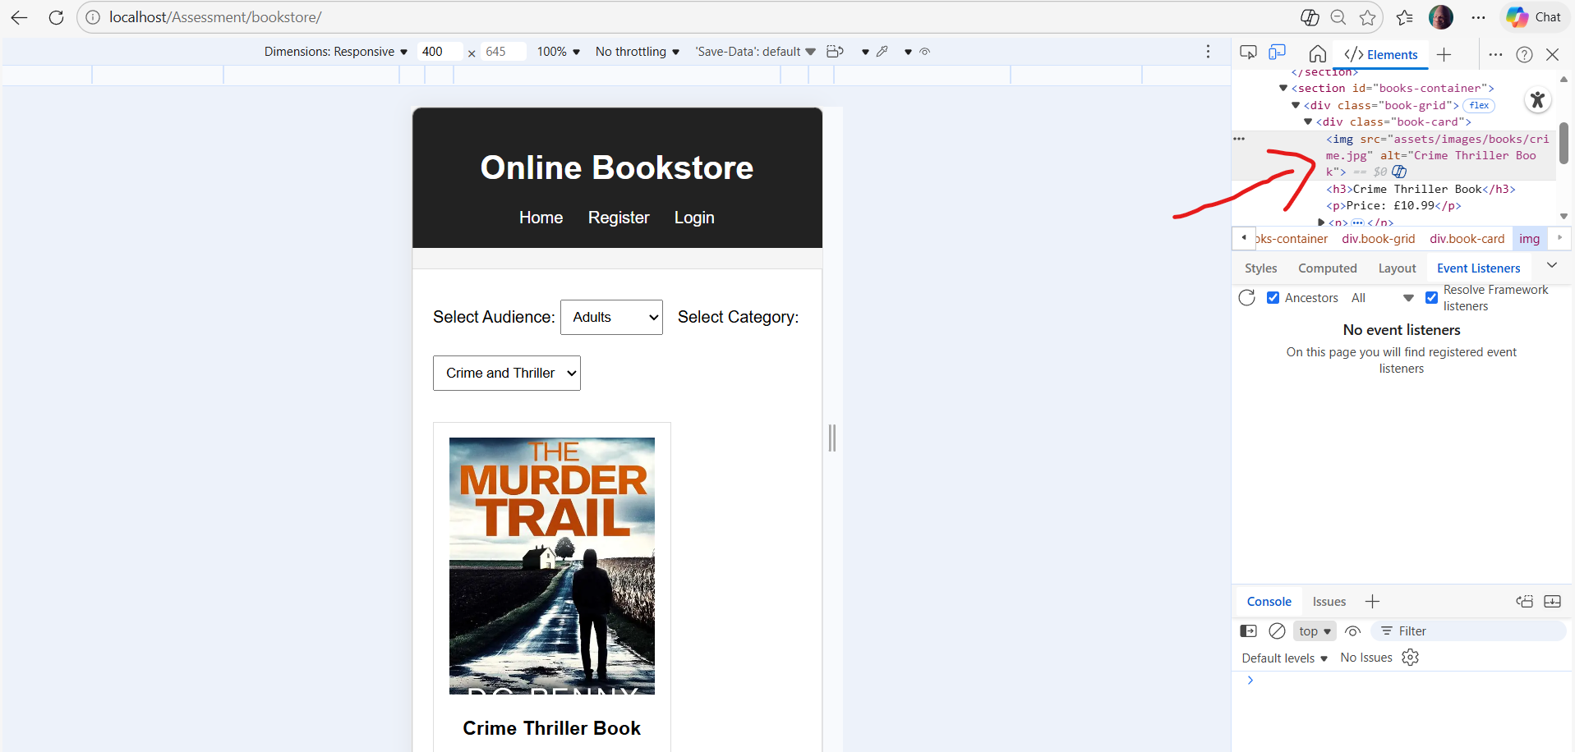
Figure 20: Example of alt text applied to book images to support accessibility and SEO.

13. Design and Code Quality
Although the project was not implemented using a full PHP framework, the solution was organised in a modular way that reflects layered and MVC-style design principles.
Presentation concerns were separated into page files, CSS stylesheets, and JavaScript scripts. HTML and CSS handled layout and interface design, while JavaScript and React handled dynamic client-side behaviour and validation. Server-side logic was separated into dedicated PHP scripts such as register.php, login.php, logout.php, order.php, and api/get_order.php.
Database connectivity was centralised in includes/db.php, allowing configuration and connection logic to be reused across multiple files. AJAX handling was separated into ajax/get_books.php, and API functionality was placed in a dedicated API folder. This improved readability, reduced duplication, and made the system easier to maintain and extend.
The user interface was designed with standard usability and accessibility principles in mind. Navigation was kept simple and consistent between pages so users could move easily from browsing, to registration, login, and ordering so users could move through the system with minimal confusion. The form validation provides instant feedback to users, helping them identify errors quickly. HTML elements such as <header>, <nav>, <main>, and <section> were used to improve page structure for users and for technologies. Alternative text was added to book images to support different abilities of users, and responsive layout improves usability for different screen sizes.

14. working procedure / user guide
The application starts at the homepage index.php acting as the main entry point for guests and authenticated users. Visitors on the webpage can browse books without logging in via selecting an audience, and then a type from the next dropdown menu labelled category. Once both dropdowns have been selected the system sends an AJAX request to the server and the matching books are displayed dynamically.
If the visitor wants to place an order by navigating to the login page login.php or the register page register.php. On the register page the user enters a name, phone number, email address, and password. React creates immediate client-side validation of user inputs.
Once a registered account is created the user can proceed to the login page login.php. The user enters the email, password, and CAPTCHA value, to login. The server validates the fields, checking CAPTCHA value, and verifies password against the stored hash value on the user table. A session variable is created to maintain authenticated state.
Once a user is logged in on the homepage an order button becomes available beneath each book displayed. The request is sent to order.php. The script checks if the user is authenticated and stores the order in the database through a prepared statement.
In addition to the main workflow, the application has a RESTful service for retrieving order details. By visiting api/get_odrer.php?id=1, the system returns the JSON format of the order record specified.

Table 2. Main system inputs and outputs
Feature | Input | Processing | Output
Book browsing | Audience and category selected by the user | AJAX requests sent to ajax/get_books.php | Matching books displayed dynamically on the homepage
Registration | Name, phone number, email, password | React validation, PHP validation, duplicate email check, password hashing, database insert | Success message or validation error message
Login | Email, password CAPTCHA | Server-side validation, CAPTCHA comparison, password verification, session creation | Login success or error message
Order submission | Selected book and logged-in session | Session check, order details processed, database insert using prepared statement | Order confirmation page and stored order record
REST API | Order ID in URL | Validate ID, execute prepare SQL query, convert result to JSON | JSON order data or JSON error response

15. Testing and Validation

Table 3: Main Test of the System Performed During Development
Test ID | Feature Tested | Input | Expected Result | Actual Result
T1 | Ajax book browsing | Select Kids -> Infants | Books load dynamically | Passed
T2 | Registration validation | Invalid phone number | Validation error shown | Passed
T3 | Registration success | Valid user data | User stored in database | Passed
T4 | Login authentication | Correct email/password | Login successful | Passed
T5 | Login security | Incorrect password | Error message displayed | Passed
T6 | CAPTCHA validation | Incorrect CAPTCHA | Login rejected | Passed
T7 | Order submission | Logged-in user orders book | Order stored in database | Passed
T8 | REST API | Api/get_order.php?id=1 | JSON order data returned | Passed
The results show major features worked correctly under normal use, like asynchronous browsing, validation, authentication, order storage, and REST API retrieval.
Figure 21: AJAX browsing with unchanged URL demonstrating asynchronous loading.
Figure 22: React client-side validation showing registration errors.
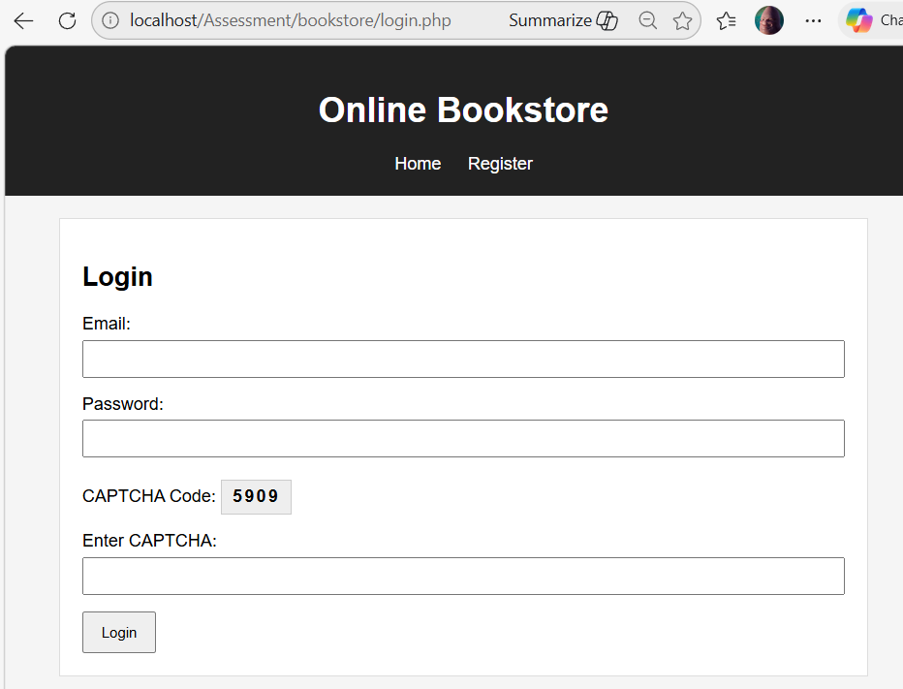
Figure 23: Login form showing CAPTCHA verification.
Figure 24: Order confirmation output.
Figure 25: Orders table in phpMyAdmin.
Figure 26: JSON response from the REST API.

16. Suggested Improvements
A shopping cart feature could be introduced to allow users to purchase multiple books within a single transaction instead of placing separate orders. An administrative dashboard could also be developed to enable managers to view, edit, search, and manage users, books, and orders through a graphical interface.
Security could be improved further through the addition of CSRF protection, rate limiting, and stronger anti-automation measures. The user interface could also be enhanced with more advanced responsive design, improved mobile support, and more polished visual styling.

17. Conclusion
In conclusion, this project successfully implemented an online bookstore web application using HTML5, CSS3, JavaScript, React, PHP, AJAX, and MySQL. The system demonstrates a multi-tier architecture and includes dynamic book browsing, user registration with live validation, secure login with CAPTCHA, authenticated order submission, and a RESTful API for retrieving order information.

References
GeeksforGeeks (2025) How to Implement Authentication in Your Web App: Choosing the Right Authentication Method.
Available at: https://www.geeksforgeeks.org/blogs/how-to-implement-authentication-in-your-web-app-choosing-the-right-authentication-method/
(Accessed: 10 April 2026).

GeeksforGeeks (2025) Mitigation of SQL Injection Attack using Prepared Statements.
Available at: https://www.geeksforgeeks.org/sql/mitigation-sql-injection-attack-using-prepared-statements-parameterized-queries/
(Accessed: 10 April 2026).

Mandal, B. (2026) Server Side Programming with Database Integration.
Advanced Web Technologies Lecture 3. Keele University.

Mandal, B. (2026) RESTful Web Services and APIs.
Advanced Web Technologies Lecture 4–5. Keele University.

Mandal, B. (2026) Asynchronous Web Processes: AJAX and WebSockets.
Advanced Web Technologies Lecture 6–7. Keele University.

Mandal, B. (2026) Search Engine Optimisation.
Advanced Web Technologies Lecture 11–12. Keele University.

