Dropdown Control
Represents a Windows dropdown control
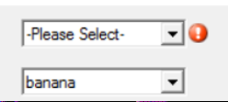

Syntax
Get-UIControl dropdown $value [$Width] [mode] [Attributes]

Examples
- Insert a dropdown control for a selection from 4 list items
$ctrl = Get-UIControl dropdown "GRS" 300 "edit" @{Name="ddlType";Elements="LRS,ZRS,GRS,RAGRS "}

Attributes
Name | Description
DefaultIndex | Specifies the default index number
DefaultText | Specifies the default text (i.e. “-Please Select-“)
Elements | Specifies items to be displayed in the DropdownList
ElementsDataSource
Help | Specifies the descriptive information
Required | Specifies this field is the mandatory field. Use Validation routine to check this attribute.

