Link Control
Represents a hyperlink control
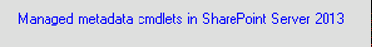

Syntax
Get-UIControl link $value [$Width] [mode] [Attributes]

Examples
- Show a hyperlink “test” with redirection to http://test.com 220px width
$ctrl = Get-UIControl link “http://test.com” 0 "" @{Text="test"}

Attributes
Name | Description
Appearance | Button
Help
Text | The display text
Underline
UrlFormat

