Listbox Control
Represents a Windows listbox control
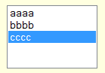

Syntax
Get-UIControl listbox $value [$Width] [mode] [Attributes]

Examples
- Insert a regular button with caption “Hello” with 220px width
Get-UIControl listbox "bbb" 0 "edit" @{Elements="aaa,bbb,ccc"}

Attributes
Name | Description
Required | Indicates the selection is required for this mandatory field
Help
Elements | The display text

