ListView Control
Represents a Windows listview control
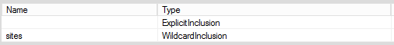

Syntax
Get-UIControl listview $value [$Width] [mode] [Attributes]

Examples
- Insert a regular button with caption “Hello” with 220px width
Get-UIControl Button “Hello” 220

Attributes
Name | Description
BackColor | Specified background color
Opposite
Text | The display text

