RichTextBox Control
Represents a Windows richtextbox control
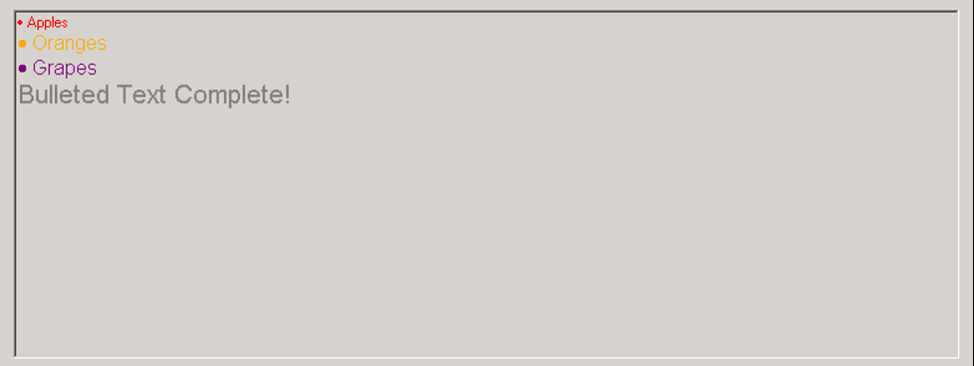

Syntax
Get-UIControl richtextbox $value [$Width] [mode] [Attributes]

Examples
- Insert a RichTextbox control with contents read from the file
Get-UIControl "richtextbox" "" 760,280 "view" @{File="c:\ TestContentDatabase.rtf"}

Attributes
Name | Description
File | Specifies the local file with its contents loaded to the control

