TabControl Control
Represents a Windows tabcontrol control
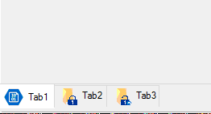

Syntax
Get-UIControl tabcontrol $value [$Width] [mode] [Attributes]

Examples
- Insert a regular button with caption “Hello” with 220px width
Get-UIControl Button “Hello” 220

Attributes
Name | Description
Alignment | Specifies the aligned position of tab controls. The available values are 'Left','Top','Right','Bottom'
IconElements
Multiline | Show multi lines while showing multiple tabs
PageColor | Specifies page's forecolor
PageBackColor | Specifies page's background color
Help | Specifies additional description represented inside the tooltip

