Textbox Control
Represents a Windows textbox control
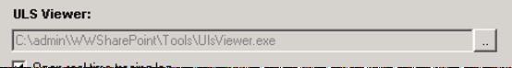

Syntax
Get-UIControl textbox $value [$Width] [mode] [Attributes]

Examples
- Present a textbox for password input
$ctrls = Get-UIControl Textbox "" 0 "edit" @{Password=1}
- Convert all characters to uppercase
$ctrls = Get-UIControl Textbox "" 0 "edit" @{CharacterCasing="Upper"}
- Convert all characters to lowercase
$ctrls = Get-UIControl Textbox "" 0 "edit" @{CharacterCasing="Lower"}
- Resctict numeric input only
$ctrls = Get-UIControl Textbox "" 0 "edit" @{Number=1}
- Restrict maximum number of input characters
$ctrls = Get-UIControl Textbox "" 0 "edit" @{MaxLength=10}
- Allow help tooltip
$ctrls = Get-UIControl Textbox "" 0 "edit" @{Help="Input assisting description"}
- Present additional icon for text copy
$ctrls = Get-UIControl Textbox "test" 0 "" @{Copy=1}
- Make this textbox as mandatory input
$ctrls = Get-UIControl Textbox "test" 0 "edit" @{Required=1}

Attributes
Name | Description
Appearance | Button
Opposite
Text | The display text

