UpDown Control
Represents a Windows DomainUpDown control
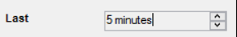

Syntax
Get-UIControl Updown $value [$Width] [mode] [Attributes]

Examples
$ctrl = Get-UIControl DomainUpDown "5 minutes" 0 "edit" @{Name="dudFilter";Text="4 hours,2 hours,1 hours,30 minutes,15 minutes,5 minutes"}

Attributes
Name | Description
Text | Specifies the display elements separated by semi-colon

