1.Because we want to get the rate which this value occupies in total values with the absolute value, so we shouldn’t make the standardization process. However, to avoid the bug when getting the log value, we should make the process of data translation as follows:

For the benefit type indicator, we define the data translation is:

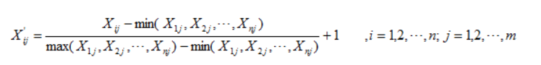

Instead of it, the cost type indicator’s data translation is:

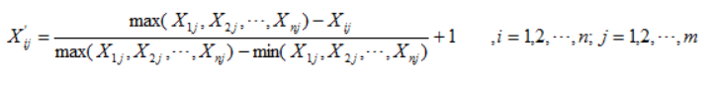

Obviously, here the rotate speed and population are benefit type indicators and the distance is cost type indicator.

2.caculate the rate of the indicator j in drone i:

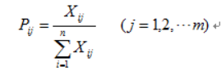

3.caculate the entropy of the indicator j:

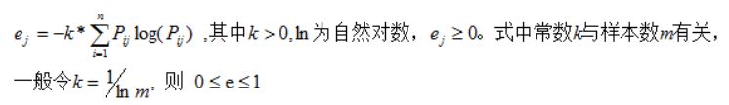

4.caculate the diversity factor:

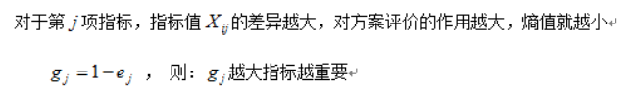

5.caculate the weight:

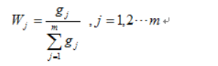

So the wj are the weight for the fuzzy synthetic evaluation model.

Here the weights are is[0.27 0.23 0.50]