Web Programming Language Project

Project Short Description

Group Name: TopSpaceHL

Group Member: Li He

Yuchuan Liu

# Project Application

We are going to create a sports website.

# Architecture Diagram

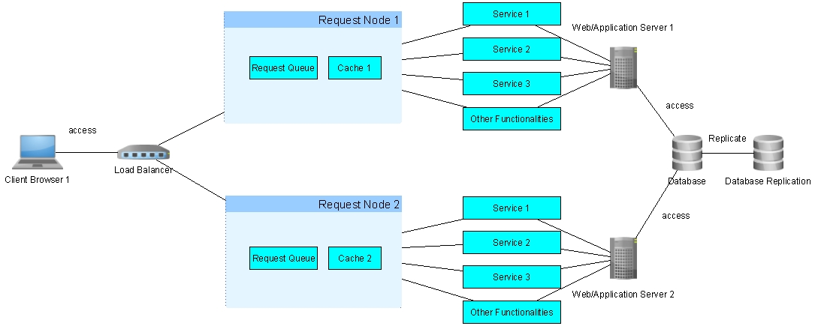

# Services

1. Search sport news. For example, service will search for sport news in our database based on keyword or dates or other parameters.
2. Get game schedule/scoreboard information. For example, when request this service, it will return a set of game schedules/scoreboards stored in our database with team names, the time when the game start, and score information if available.
3. Get Team Information. For example, this service will search and return the team information based on team name. The team information may include roster of that team.

# Other Functionalities

1. Users can sign up accounts.
2. Users can login to their accounts.
3. Users can view comments for sports news.
4. Users can post comments for sports news.
5. Users can subscribe sports news.