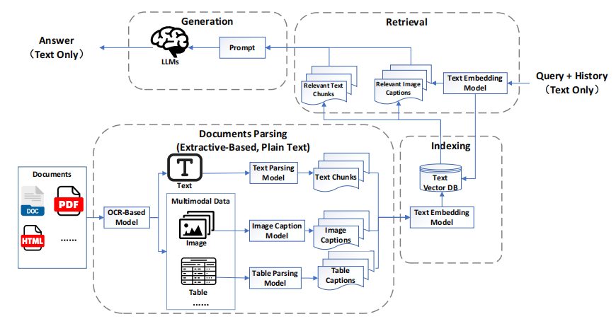
Fig. 1. The architecture of MRAG1.0（<Desc>1.png</Desc>）, often termed "pseudo-MRAG", closely resembles traditional RAG, consisting of three modules: Document Parsing and Indexing, Retrieval, and Generation. While the overall process remains largely unchanged, the key distinction lies in the Document Parsing stage. In this stage, specialized models are employed to convert diverse modal data into modality-specific captions. These captions are then stored alongside textual data for utilization in subsequent stages.

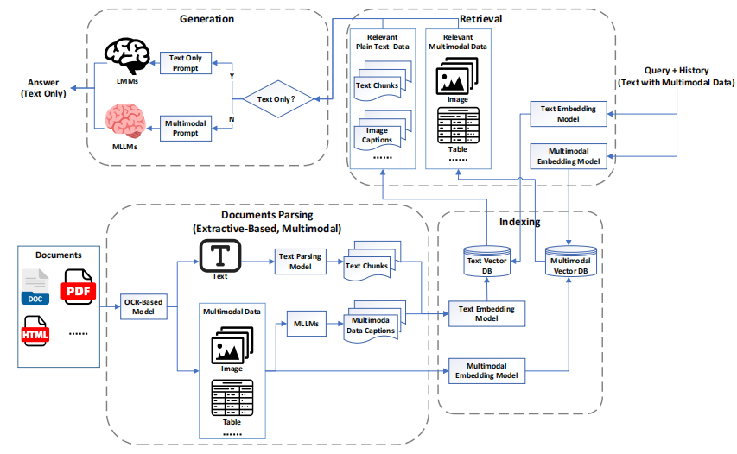
Fig. 2. The architecture of MRAG2.0 （<Desc>2.png</Desc>）retains multimodal data through document parsing and indexing, while introducing multimodal retrieval and MLLMs for answer generation, truly entering the multimodal era.

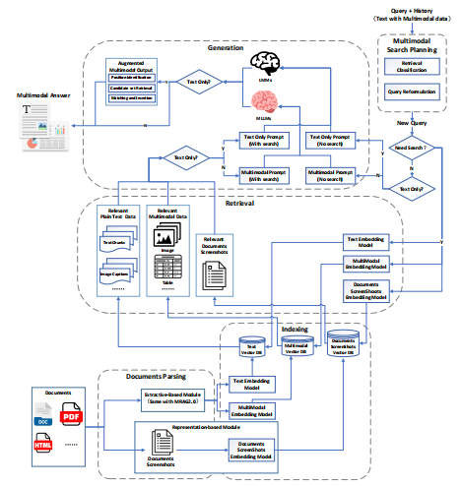
Fig. 3. MRAG3.0 architecture （<Desc>3.png</Desc>） integrates document screenshots during the document parsing and indexing stages to minimize information loss. At the input stage, it incorporates a Multimodal Search Planning module, unifying Visual Question Answering (VQA) and Retrieval-Augmented Generation (RAG) tasks while refining user query precision. At the output stage, the Multimodal Retrieval-Augmented Composition module enhances answer generation by transforming plain text into multimodal formats, thereby enriching information deliver

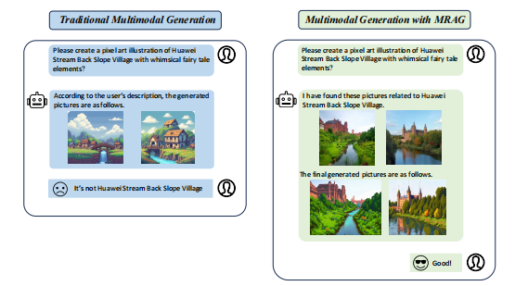
Fig. 4. （<Desc>4.png</Desc>） The user aims to generate images depicting "Huawei Stream Back Slope Village." Due to the location’s obscurity and the model’s limited knowledge, it may produce inaccurate representations, such as images of houses by a stream. By integrating retrieval-augmented capabilities, the model can access relevant information beforehand, enabling the generation of precise and contextually accurate images.

