**Web Developer Study Plan.**

Who is a Backend Dev?

 A back-end developer builds and maintains the technology that **powers** those components which, together, enable the user-facing side of the website to even exist in the first place.

Study Material

Our main focus will be on the web, and due to insufficient funds and time our study will be principally focus on be a web backend developer using a specific technology which is highly on demand in the Cameroonian Tech industry which is PHP.

To be a Web Backend developer in PHP and to be prosper in the Industry you need to have knowledge on the following technology (we assume all our students are newbies) :-

1. **HTML 5**

**HTML 5** (formerly spelled **HTML5**[[a]](https://en.wikipedia.org/wiki/HTML5#cite_note-name-6)) is a [markup language](https://en.wikipedia.org/wiki/Markup_language) used for structuring and presenting content on the [World Wide Web](https://en.wikipedia.org/wiki/World_Wide_Web). It is the fifth and current major version of the [HTML](https://en.wikipedia.org/wiki/HTML) standard, and subsumes [XHTML](https://en.wikipedia.org/wiki/XHTML). It currently exists in two standardized forms: *HTML 5.2 Recommendation*[[4]](https://en.wikipedia.org/wiki/HTML5#cite_note-W3C_HTML_5-4) by the [World Wide Web Consortium](https://en.wikipedia.org/wiki/World_Wide_Web_Consortium) (W3C, a broad coalition of organizations), intended primarily for Web content developers; and *HTML Living Standard*[[5]](https://en.wikipedia.org/wiki/HTML5#cite_note-WHATWG_LS-5) by [WHATWG](https://en.wikipedia.org/wiki/WHATWG) (a small consortium of four browser vendors), intended primarily for browser developers, though it also exists in an abridged Web developer version.[[6]](https://en.wikipedia.org/wiki/HTML5#cite_note-WHATWG_LS_DE-7) There are minor conflicts between the two groups' specifications.(Wikipedia definitions)



Html is very important for someone aiming high in the web field since it helps you understand the basic on how the web functions.

1. **CSS3**

**CSS3** is the latest evolution of the Cascading Style Sheets language and aims at extending CSS2.1. It brings a lot of long-awaited novelties, like rounded corners, shadows, [gradients](https://developer.mozilla.org/en-US/docs/Web/Guide/CSS/Using_CSS_gradients), [transitions](https://developer.mozilla.org/en-US/docs/Web/Guide/CSS/Using_CSS_transitions) or [animations](https://developer.mozilla.org/en-US/docs/Web/Guide/CSS/Using_CSS_animations), as well as new layouts like [multi-columns](https://developer.mozilla.org/en-US/docs/Web/Guide/CSS/Using_multi-column_layouts), [flexible box](https://developer.mozilla.org/en-US/docs/Web/Guide/CSS/Flexible_boxes) or grid layouts.(

<https://developer.mozilla.org/en/docs/Web/CSS/CSS3>

)

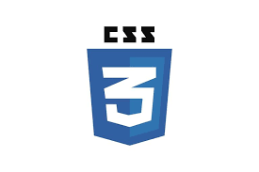

Css will help you understand how the web is style and further your knowledge about it.

1. **JavaScript**

**JavaScript** ([/ˈdʒɑːvəˌskrɪpt/](https://en.wikipedia.org/wiki/Help:IPA/English)),[[7]](https://en.wikipedia.org/wiki/JavaScript#cite_note-7) often abbreviated as **JS**, is a [high-level](https://en.wikipedia.org/wiki/High-level_programming_language), [interpreted](https://en.wikipedia.org/wiki/Interpreted_language) [programming language](https://en.wikipedia.org/wiki/Programming_language). It is a language which is also characterized as [dynamic](https://en.wikipedia.org/wiki/Dynamic_programming_language), [weakly typed](https://en.wikipedia.org/wiki/Weak_typing), [prototype-based](https://en.wikipedia.org/wiki/Prototype-based_programming) and [multi-paradigm](https://en.wikipedia.org/wiki/Multi-paradigm_programming_language).

Alongside [HTML](https://en.wikipedia.org/wiki/HTML) and [CSS](https://en.wikipedia.org/wiki/CSS), JavaScript is one of the three core technologies of the [World Wide Web](https://en.wikipedia.org/wiki/World_Wide_Web).[[8]](https://en.wikipedia.org/wiki/JavaScript#cite_note-8) JavaScript enables interactive [web pages](https://en.wikipedia.org/wiki/Web_page) and thus is an essential part of [web applications](https://en.wikipedia.org/wiki/Web_application). The vast majority of [websites](https://en.wikipedia.org/wiki/Website) use it,[[9]](https://en.wikipedia.org/wiki/JavaScript#cite_note-deployedstats-9) and all major [web browsers](https://en.wikipedia.org/wiki/Web_browser) have a dedicated [JavaScript engine](https://en.wikipedia.org/wiki/JavaScript_engine) to execute it.



1. **PHP**

**PHP: Hypertext Preprocessor** (or simply **PHP**) is a [server-side scripting](https://en.wikipedia.org/wiki/Server-side_scripting) language designed for [Web development](https://en.wikipedia.org/wiki/Web_development), but also used as a [general-purpose programming language](https://en.wikipedia.org/wiki/General-purpose_programming_language). It was originally created by [Rasmus Lerdorf](https://en.wikipedia.org/wiki/Rasmus_Lerdorf) in 1994,[[5]](https://en.wikipedia.org/wiki/PHP#cite_note-History_of_PHP-5) the PHP [reference implementation](https://en.wikipedia.org/wiki/Reference_implementation) is now produced by The PHP Group.[[6]](https://en.wikipedia.org/wiki/PHP#cite_note-about_PHP-6) PHP originally stood for *Personal Home Page*,[[5]](https://en.wikipedia.org/wiki/PHP#cite_note-History_of_PHP-5) but it now stands for the [recursive initialism](https://en.wikipedia.org/wiki/Recursive_initialism) *PHP: Hypertext Preprocessor*.[[7]](https://en.wikipedia.org/wiki/PHP#cite_note-7)

PHP code may be embedded into [HTML](https://en.wikipedia.org/wiki/HTML) code, or it can be used in combination with various [web template systems](https://en.wikipedia.org/wiki/Web_template_system), web content management systems, and [web frameworks](https://en.wikipedia.org/wiki/Web_framework). PHP code is usually processed by a PHP [interpreter](https://en.wikipedia.org/wiki/Interpreter_(computing)) implemented as a [module](https://en.wikipedia.org/wiki/Plugin_(computing)) in the web server or as a [Common Gateway Interface](https://en.wikipedia.org/wiki/Common_Gateway_Interface) (CGI) executable. The web server combines the results of the interpreted and executed PHP code, which may be any type of data, including images, with the generated web page. PHP code may also be executed with a [command-line interface](https://en.wikipedia.org/wiki/Command-line_interface) (CLI) and can be used to implement [standalone](https://en.wikipedia.org/wiki/Computer_software) [graphical applications](https://en.wikipedia.org/wiki/Graphical_user_interface).[[8]](https://en.wikipedia.org/wiki/PHP#cite_note-8)

The standard PHP interpreter, powered by the [Zend Engine](https://en.wikipedia.org/wiki/Zend_Engine), is [free software](https://en.wikipedia.org/wiki/Free_software) released under the [PHP License](https://en.wikipedia.org/wiki/PHP_License). PHP has been widely ported and can be deployed on most web servers on almost every [operating system](https://en.wikipedia.org/wiki/Operating_system) and [platform](https://en.wikipedia.org/wiki/Computing_platform), free of charge.[[9]](https://en.wikipedia.org/wiki/PHP#cite_note-foundations-9)

(Wikipedia)



This will be our main focus on this training since you will be train mostly on been a php backend developer.

Frameworks

In computer programming, a software **framework** is an abstraction in which software providing generic functionality can be selectively changed by additional user-written code, thus providing application-specific software.

Framework will help us move faster in projects that we will be building. These are the following framework that will be using: -

Bootstrap 4

Bootstrap is an open source toolkit for developing with HTML, CSS, and JS. Quickly prototype your ideas or build your entire app with our Sass variables and mixins, responsive grid system, extensive prebuilt components, and powerful plugins built on jQuery.

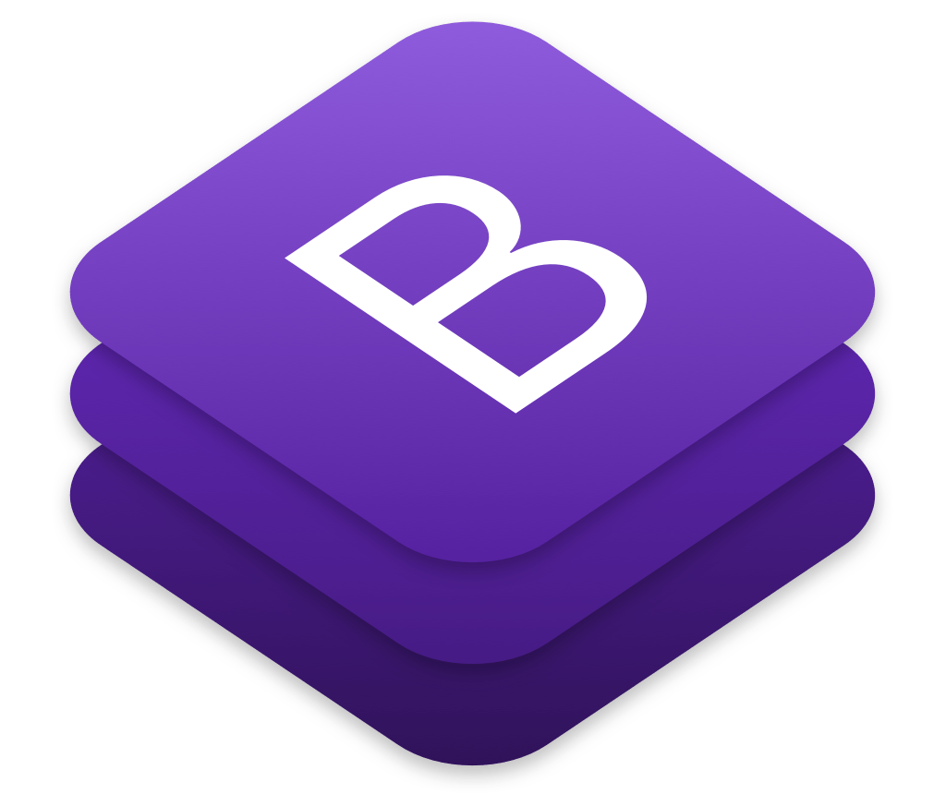

With bootstrap we will be handling our frontend part since we are not designers we just want the basics to help us build are UI fasters and also beautiful so we will not go deeper into it.

**Laravel**

**Laravel** is a [free](https://en.wikipedia.org/wiki/Free_software), open-source[[3]](https://en.wikipedia.org/wiki/Laravel#cite_note-3) PHP [web framework](https://en.wikipedia.org/wiki/Web_framework), created by Taylor Otwell and intended for the development of web applications following the [model–view–controller](https://en.wikipedia.org/wiki/Model%E2%80%93view%E2%80%93controller) (MVC) [architectural pattern](https://en.wikipedia.org/wiki/Architectural_pattern) and based on [Symfony](https://en.wikipedia.org/wiki/Symfony" \o "Symfony). Some of the features of Laravel are a modular [packaging system](https://en.wikipedia.org/wiki/Application-level_package_manager) with a dedicated dependency manager, different ways for accessing [relational databases](https://en.wikipedia.org/wiki/Relational_database), utilities that aid in [application deployment](https://en.wikipedia.org/wiki/Application_deployment) and maintenance, and its orientation toward [syntactic sugar](https://en.wikipedia.org/wiki/Syntactic_sugar).



This will be our main core study work since it’s php running in the background. Why Laravel ?

Laravel in one of the most used php framework in the world and particularly in Cameroon so studying it gives you a 50% guarantee of having access in work here in Cameroon, and also for it well and rapidly accessibility it will be easy for you get started with it and others framework at the end of your training.

What will you mostly be done in this training?

In this training we will be mostly working on projects since working on real life projects helps understand programming instead of just talking and doing little exercise, so the student is advice of following instructions and applying what’s so ever will be given to him during the training. Saying so by the end of this Training the student will build two Major projects as follows: -

**Main Projects**

1. Rebranding of <https://welcominghomestay.com/>
2. Creating a web application from scratch using Laravel at the backend and Vuejs at the front end. All this will be done by the Student.

**Sub Projects**

Here it will be decided by the Mentor on the project to be done during the cause study, but it will be small projects on the cause been study during the day.

**Notice: Failing to complete sub projects and main projects will not give you access to the next phase of work so you are advice to complete all that for your personal interest.**

**Days of work**

Our working days our schedule as follows: -

Monday

Friday

Time unschedule

Location: Ecole publique bonamoussadi

Absenting will not be tolerated except in case of illness and burial ceremony or any other better excuses.

**Planning**

|  |  |
| --- | --- |
| **Weeks** | **Language** |
| **1** | **HTML** |
| **1** | **CSS** |
| **1** | **Javascript** |
| **1** | **Bootstrap** |
| **4** | **Angualar js** |
| **4** | **Php** |
| **4** | **Laravel** |