Blind / Time-Based SQL Injection and Database Extraction

Tools Used:
- Kali Linux
- DVWA
- MariaDB
- Web Browser
- Terminal

1. Objective
The objective of this task was to identify and test a Blind SQL Injection vulnerability, enumerate the DVWA database, tables and columns, and identify the password hashing algorithm.

2. Blind SQL Injection Testing
DVWA's SQL Injection (Blind) page was used for the practical.

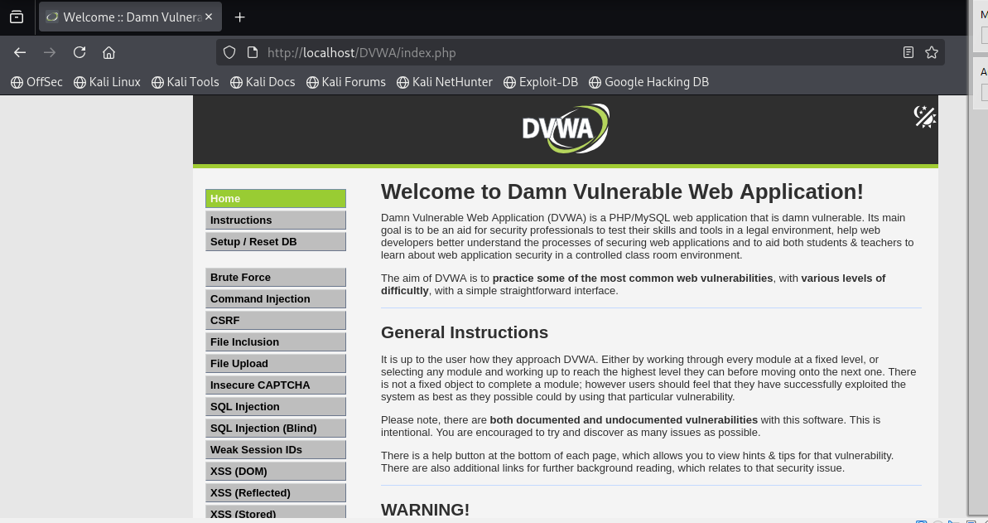
Figure 1

DVWA Blind SQL Injection page.

Figure 2
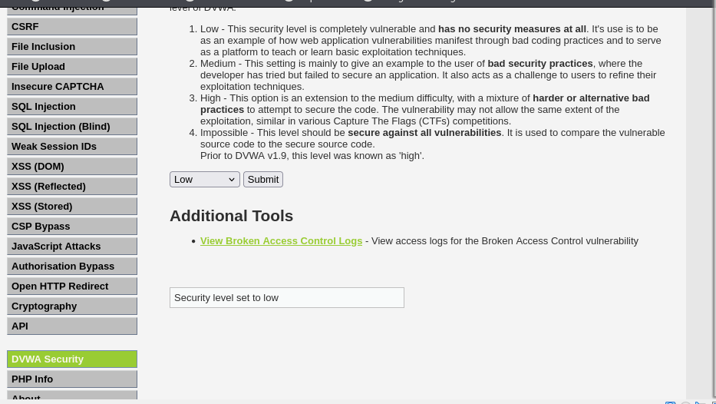

Normal User ID test.

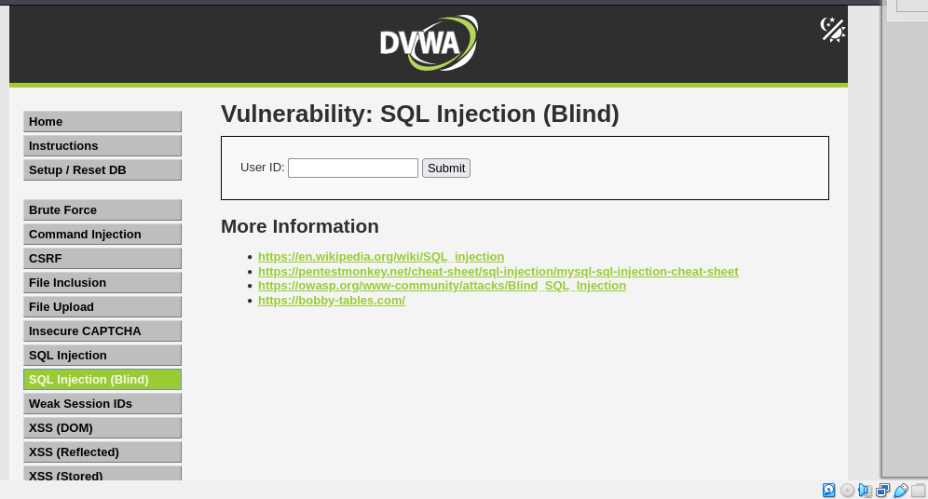
Figure 3

Initial SQL Injection test.

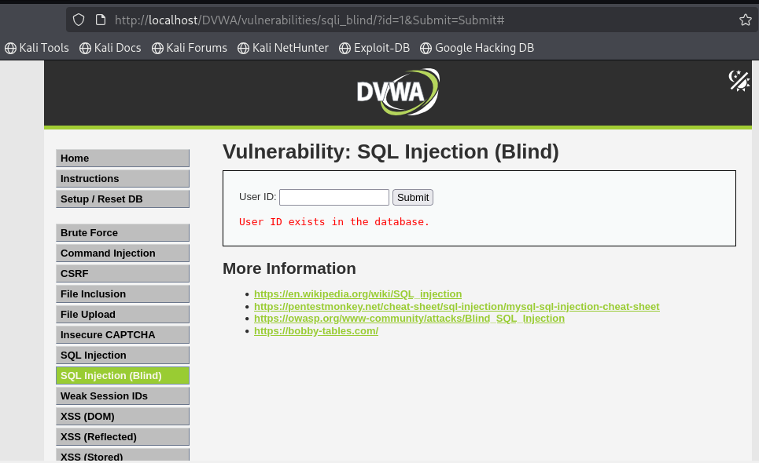
Figure 4

Boolean-Based Blind SQL Injection – True condition.

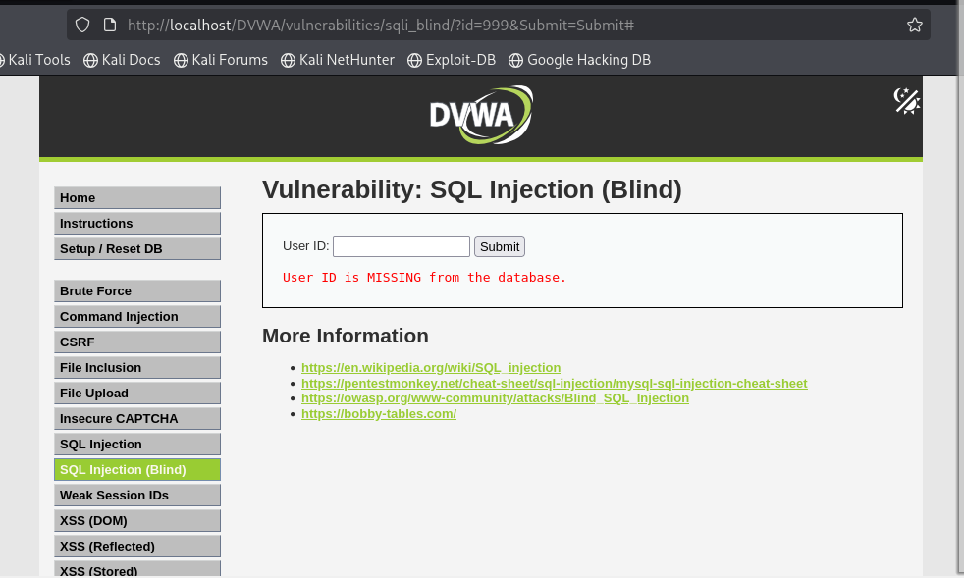
Figure 5

Boolean-Based Blind SQL Injection – False condition.

Figure 6
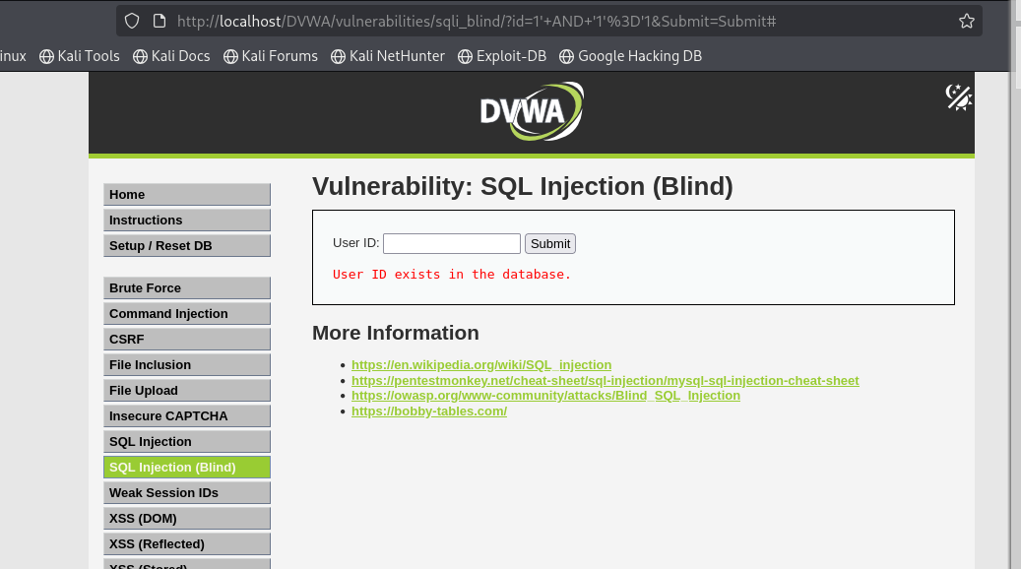

Time-Based Blind SQL Injection test using SLEEP(5).
The application displayed:
User ID is MISSING from the database.

3. Database Configuration
The DVWA configuration was examined and the following information was identified:
- Database Server: 127.0.0.1
- Database Name: dvwa
- Database User: dvwa
- Database Port: 3306

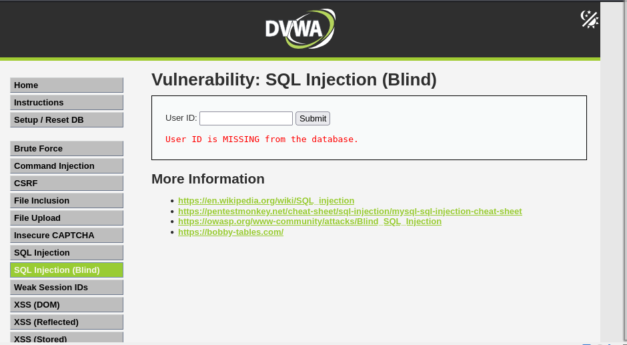
Figure 7

DVWA database configuration.

4. Accessing MariaDB
MariaDB was successfully accessed using:
sudo mysql

Figure 8
Successful access to MariaDB.

5. Database User Enumeration
The following command was used:
SELECT User, Host FROM mysql.user;
Users identified:
- dvwa
- mariadb.sys
- mysql
- root

Figure 9
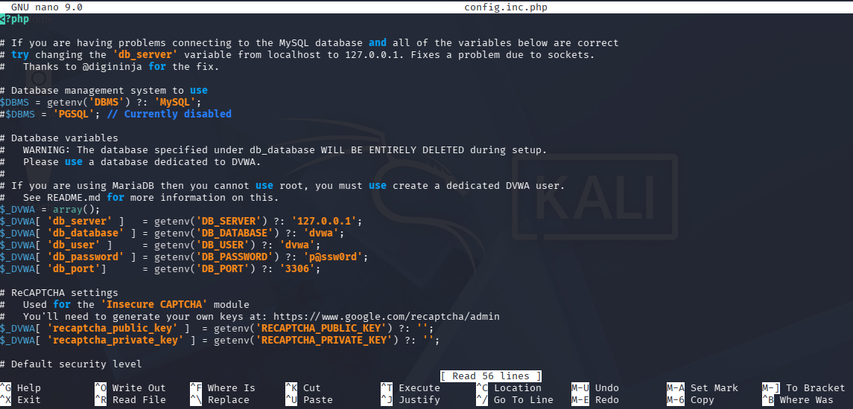

Database user enumeration.

6. Database Enumeration
The following command was used:
SHOW DATABASES;
Databases identified:
- dvwa
- information_schema
- mysql
- performance_schema
- sqli_lab
- sys

Figure 10
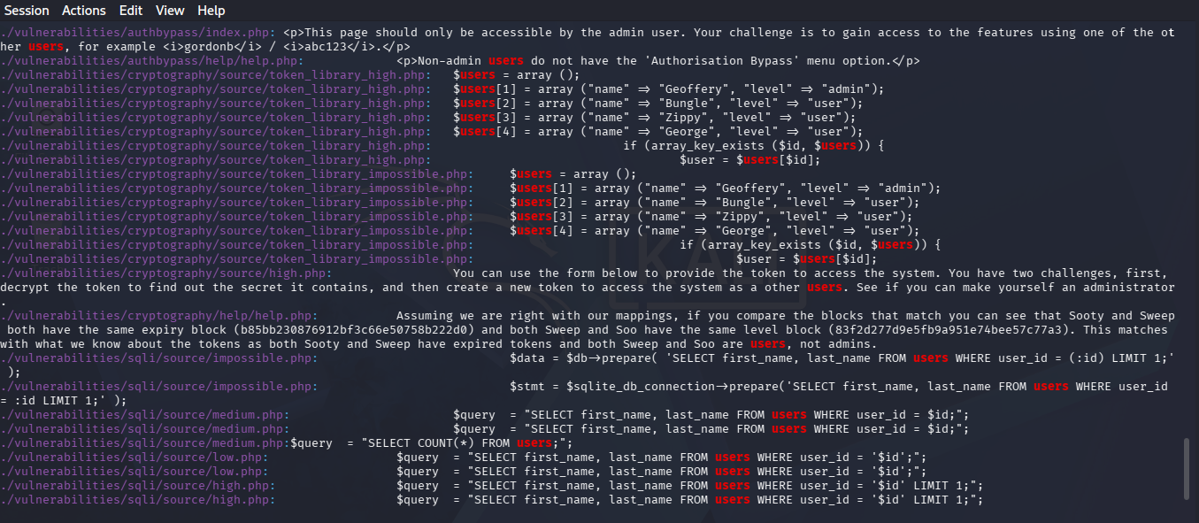

Database enumeration showing dvwa.

7. Selecting the Database
The DVWA database was selected using:
USE dvwa;
Result:
Database changed

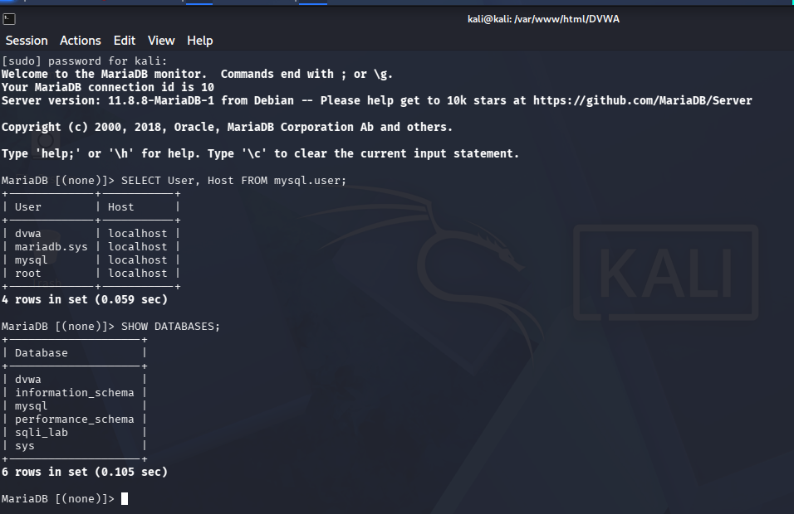
Figure 11

DVWA database selected successfully.

8. Table Enumeration
The following command was used:
SHOW TABLES;
Tables identified:
- access_log
- guestbook
- security_log
- users

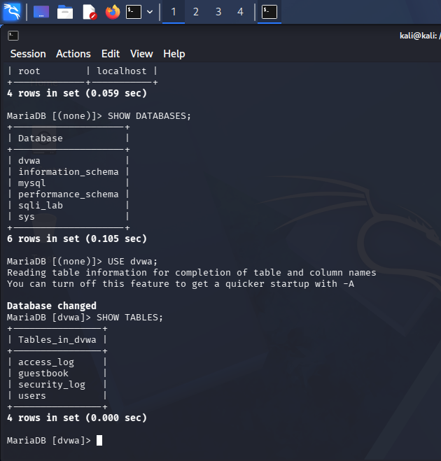
Figure 12

Tables inside the DVWA database.

9. Column Enumeration
The following command was used:
DESCRIBE users;
Columns identified:
- user_id
- first_name
- last_name
- user
- password
- avatar
- last_login
- failed_login
- role
- account_enabled

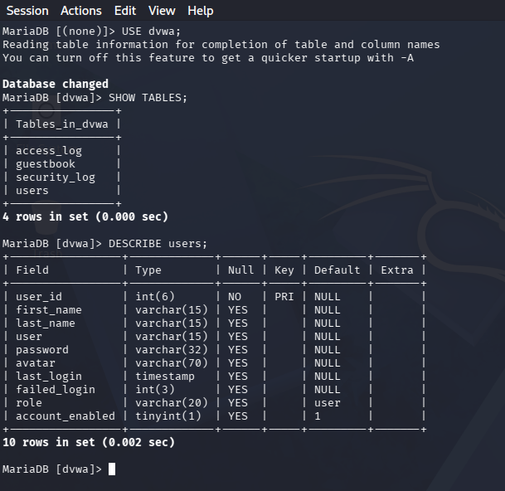
Figure 13

Columns of the users table.

10. Password Hashing Algorithm
The DVWA source code was searched using:
grep -Rni "md5(" .
The results showed multiple uses of:
MD5()
Therefore, the password hashing algorithm used in this DVWA environment is:

MD5

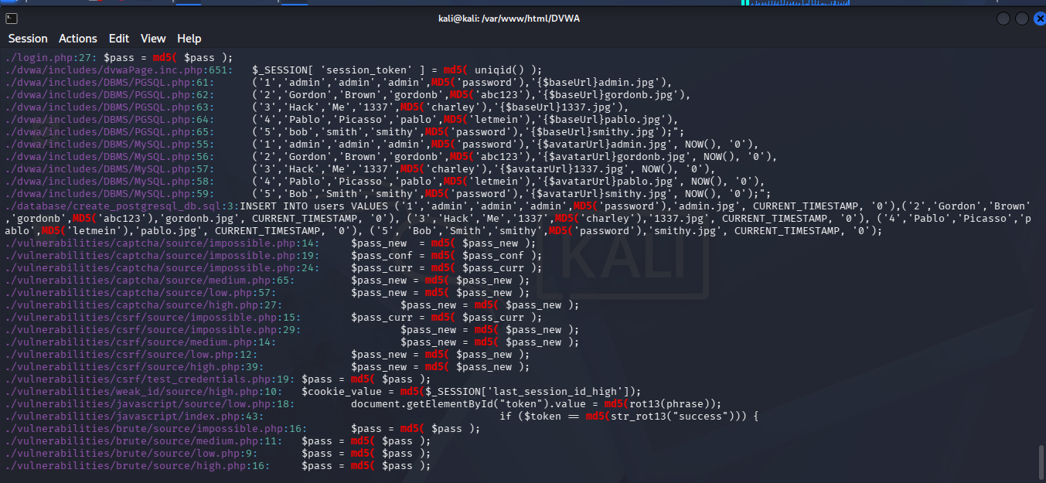
Figure 14

Source code showing MD5 password hashing.

11. SQL Injection Types

Error-Based SQL Injection
Uses database error messages to obtain information.

Boolean-Based Blind SQL Injection
Uses true and false conditions and compares application responses.

Time-Based Blind SQL Injection
Uses time delays such as:
SLEEP(5)
to infer information.

Results

Item | Result
Vulnerability | Blind SQL Injection
Database | dvwa
Tables Found | 4
Users Table Columns | 10
Password Hashing | MD5

13. Conclusion
The Blind SQL Injection practical was successfully completed in the authorized DVWA laboratory environment. The dvwa database was identified, four tables were found, and ten columns were identified in the users table. The password hashing algorithm used in the DVWA environment was identified as MD5.
The practical showed the importance of using prepared statements, parameterized queries, input validation, and secure password hashing algorithms to protect web applications.

